Experiment 8
Analyze Discrete and Continuous Probability Distributions Using R
PART A

Aim: To analyze discrete and continuous probability distributions using R, calculate probabilities and cumulative probabilities, generate random observations, and visualize the resulting distributions.

Outcomes
- Apply R programming to probability problems.
- Use built-in statistical functions.
- Visualize probability distributions.
- Interpret statistical results in real-world contexts.

Theory
A probability distribution describes how possible values of a random variable are associated with probabilities. Random variables may be discrete or continuous.

Discrete Random Variable
A discrete random variable takes countable values such as 0, 1, 2, 3. Examples include number of heads, patients arriving in an hour, or defective products.

Continuous Random Variable
A continuous random variable can take any value within an interval. Examples include height, weight, temperature, blood pressure and measured marks Important R Probability Functions

Prefix | Purpose | Examples
d | Probability/density at a value | dbinom(), dpois(), dnorm()
p | Cumulative probability | pbinom(), ppois(), pnorm()
q | Quantile | qbinom(), qpois(), qnorm()
r | Random generation | rbinom(), rpois(), rnorm()

- The Binomial distribution is suitable for a fixed number of trials with two outcomes.
- The Poisson distribution is useful for counting events in a fixed interval at an average rate.
- The Normal distribution is suitable for many continuous measurements that are approximately bell-shaped.
- d-, p-, q- and r-functions represent density/probability, cumulative probability, quantile and random generation.
- Simulation helps compare theoretical distributions with repeated random experiments.

Real-World Applications
- Binomial: quality control, survey responses, pass/fail outcomes, diagnostic test outcomes.
- Poisson: hospital patient arrivals, network packet arrivals, server requests and call-center arrivals.
- Normal: examination marks, measurement errors, biological and manufacturing measurements.
- Healthcare analytics: patient-arrival modeling and analysis of clinical measurements.
- Computer networks: modeling packet/request arrival counts.

Procedure

Part 1 – Binomial Distribution
The Binomial distribution models the number of successes in a fixed number of independent trials when each trial has two outcomes and a constant probability of success.
Example: A fair coin is tossed 10 times. Find the probability of obtaining exactly 6 heads.
dbinom(6, size = 10, prob = 0.5)

Generate All Binomial Probabilities
x <- 0:10
prob <- dbinom(x, size = 10, prob = 0.5)
print(prob)
barplot(prob,
names.arg = x,
main = "Binomial Distribution",
xlab = "Number of Heads",
ylab = "Probability")

Cumulative Binomial Probability
Find P(X ≤ 6):
pbinom(6, size = 10, prob = 0.5)
Find P(X > 6):
pbinom(6, size = 10, prob = 0.5, lower.tail = FALSE)

Binomial Simulation
set.seed(123)
sim_binom <- rbinom(1000, size = 10, prob = 0.5)
head(sim_binom)
hist(sim_binom,
breaks = seq(-0.5, 10.5, 1),
main = "Simulation of Binomial Distribution",
xlab = "Number of Heads",
ylab = "Frequency")

Part 2 – Poisson distribution
The Poisson distribution models the number of events occurring during a fixed interval when events occur independently at an average rate.
Example: A hospital emergency department receives an average of 4 patients per hour. Find the probability that exactly 6 patients arrive in one hour.
dpois(6, lambda = 4)

Generate Poisson Probabilities
x <- 0:15
prob <- dpois(x, lambda = 4)
print(prob)
barplot(prob,
names.arg = x,
main = "Poisson Distribution",
xlab = "Number of Patients",
ylab = "Probability")

Cumulative Poisson Probability
Find P(X ≤ 6):
ppois(6, lambda = 4)
Find P(X > 6):
ppois(6, lambda = 4, lower.tail = FALSE)

Poisson Simulation
set.seed(123)
sim_pois <- rpois(1000, lambda = 4)
head(sim_pois)
hist(sim_pois,
breaks = seq(-0.5, max(sim_pois) + 0.5, 1),
main = "Simulation of Poisson Distribution",
xlab = "Number of Patients",
ylab = "Frequency")

Part 3 – Normal Distribution
The Normal distribution is a continuous, symmetric, bell-shaped distribution characterized by its mean and standard deviation.
Example: Examination marks are normally distributed with mean 70 and standard deviation 10. Find P(X < 80).
pnorm(80, mean = 70, sd = 10)

Probability Between Two Values
Find P(60 < X < 80):
pnorm(80, mean = 70, sd = 10) -
pnorm(60, mean = 70, sd = 10)
Expected result: approximately 0.6826895.

Probability Greater Than a Value
pnorm(80, mean = 70, sd = 10, lower.tail = FALSE)

Normal Density
dnorm() gives density at a point; for a continuous variable it is not the probability of exactly that point.
dnorm(80, mean = 70, sd = 10)

Generate Random Normal Data
set.seed(123)
marks <- rnorm(1000, mean = 70, sd = 10)
hist(marks,
probability = TRUE,
main = "Normal Distribution of Simulated Marks",
xlab = "Marks")
curve(dnorm(x, mean = 70, sd = 10), add = TRUE)

Quantile Calculation
Find the 95th percentile:
qnorm(0.95, mean = 70, sd = 10)

Comparison of Distributions
Feature | Binomial | Poisson | Normal
Type | Discrete | Discrete | Continuous
Typical use | Fixed number of trials | Count of events | Measured variables
Parameters | n, p | lambda | mean, sd
Probability function | dbinom() | dpois() | dnorm()
Cumulative function | pbinom() | ppois() | pnorm()
Simulation function | rbinom() | rpois() | rnorm()

PART B

(PART B: TO BE COMPLETED BY STUDENTS)
(Students must submit the soft copy as per following segments within two hours of the practical. The soft copy must be uploaded on the ERP or emailed to the concerned lab in charge faculties at the end of the practical in case the there is no ERP access available)
Roll No. C - 63 | Name: Mayuresh Shelke
Class : SE – C | Batch : CO2
Date of Experiment: | Date of Submission
Grade :

Observation : (Paste screenshots of each implementation steps given in the procedure)

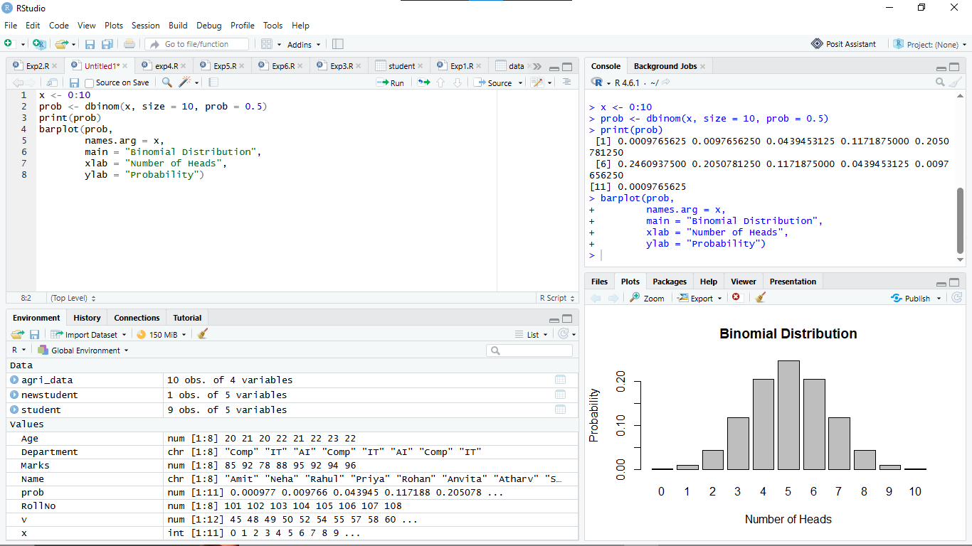

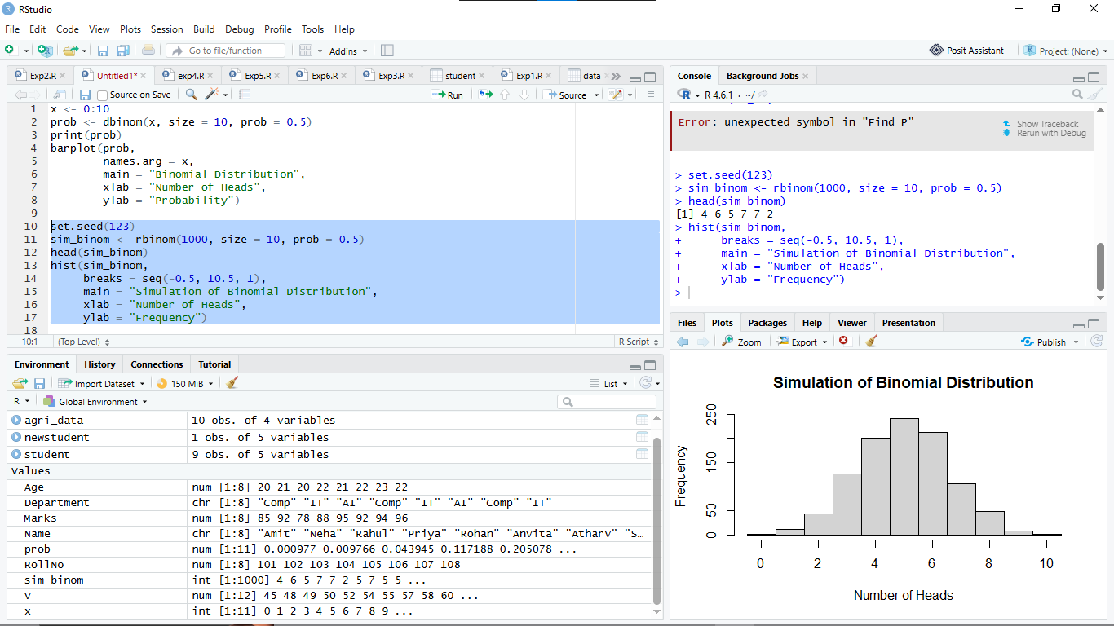

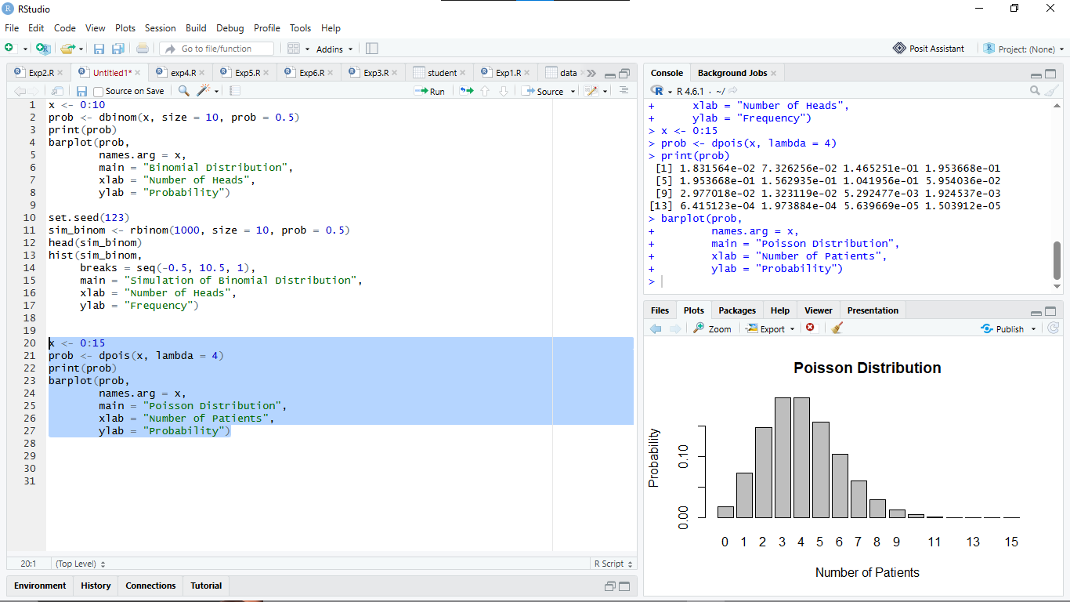

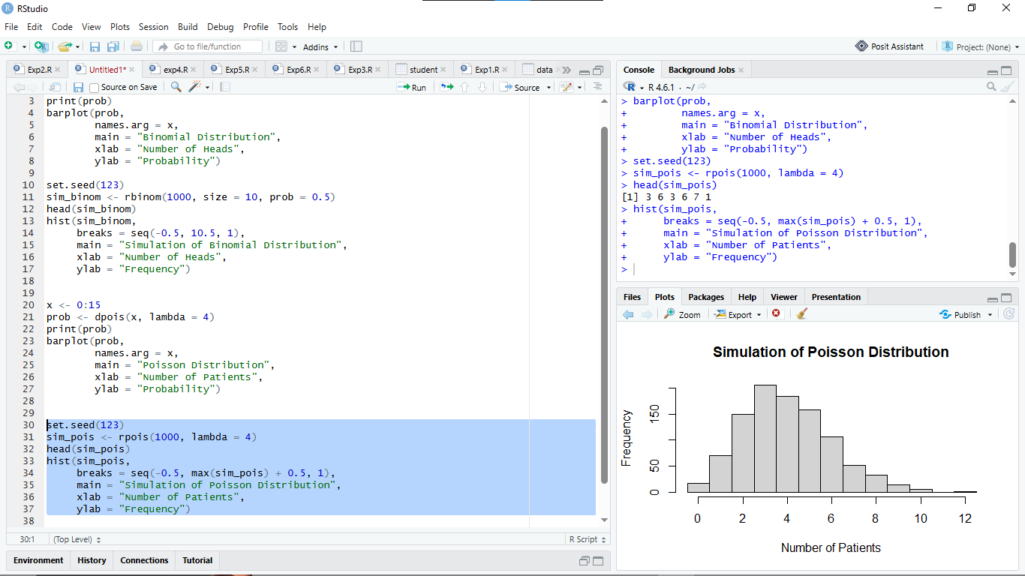

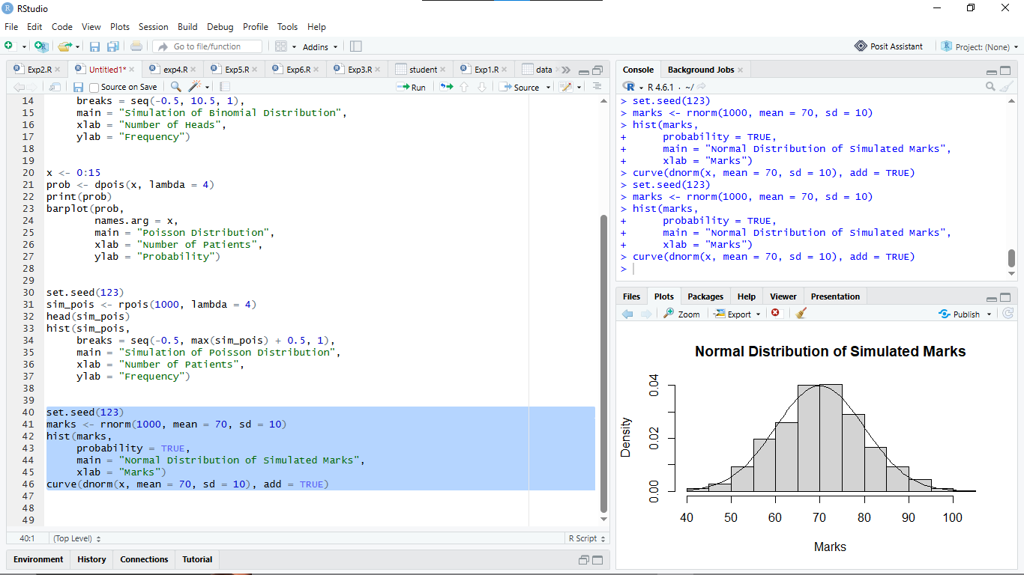

Observation Table: (Execute the procedure part and complete the observation table with results)

Experiment | Parameter | R Function | Observation / Result
Binomial | P(X = 6), n=10, p=0.5 | dbinom() | 0.2050781
Binomial | P(X ≤ 6) | pbinom() | 0.8281250
Poisson | P(X = 6), lambda=4 | dpois() | 0.1041956
Poisson | P(X ≤ 6) | ppois() | 0.8893260
Normal | P(X < 80), mean=70, sd=10 | pnorm() | 0.8413447
Normal | P(60 < X < 80) | pnorm() | 0.6826895
Normal | 95th percentile | qnorm() | 86.44854

2. R Programs for Observation Table

A. Binomial Distribution
1. Calculate P(X = 6) for n = 10 and p = 0.5.
R Program:
dbinom(6, size = 10, prob = 0.5)
Result: 0.2050781
2. Calculate P(X ≤ 6).
R Program:
pbinom(6, size = 10, prob = 0.5)
Result: 0.828125

B. Poisson Distribution
3. Calculate P(X = 6) for λ = 4.
R Program:
dpois(6, lambda = 4)
Result: 0.1041956
4. Calculate P(X ≤ 6).
R Program:
ppois(6, lambda = 4)
Result: 0.8893260

C. Normal Distribution
5. Calculate P(X < 80), given mean = 70 and standard deviation = 10.
R Program:
pnorm(80, mean = 70, sd = 10)
Result: 0.8413447
6. Calculate P(60 < X < 80).
R Program:
pnorm(80, mean = 70, sd = 10) -
pnorm(60, mean = 70, sd = 10)
Result: 0.6826895
7. Calculate the 95th percentile of the Normal distribution.
R Program:
qnorm(0.95, mean = 70, sd = 10)
Result: 86.44854

Result:
The discrete Binomial and Poisson distributions and the continuous Normal distribution were analyzed using R. Their probabilities, cumulative probabilities, and percentile values were calculated successfully using built-in statistical functions.
Conclusion:
The experiment helped us understand discrete and continuous probability distributions using R programming. We learned to calculate probabilities using dbinom(), pbinom(), dpois(), ppois(), and pnorm(), and calculate percentiles using qnorm(). These functions are useful in statistical analysis and real-world applications.

Curiosity Questions
Q1. What is a random variable?
A random variable is a variable that assigns a numerical value to each possible outcome of a random experiment. For example, the number of heads obtained when tossing a coin.
Q2. What is the difference between discrete and continuous random variables?
- Discrete random variable: Takes countable values, such as 0, 1, 2, 3.
- Continuous random variable: Takes any value within a given range, such as height, weight, or temperature.
Q3. When is the Binomial distribution used?
The Binomial distribution is used to calculate the probability of obtaining a certain number of successes in a fixed number of independent trials, with two possible outcomes and a constant probability of success.
Q4. What do n and p represent in a Binomial distribution?
- n: Total number of trials.
- p: Probability of success in each trial.
Q5. When is the Poisson distribution used?
The Poisson distribution is used to calculate the probability of a given number of events occurring in a fixed interval at an average rate, such as the number of calls received per hour.
Q6. What does lambda represent in the Poisson distribution?
Lambda (\(\lambda\)) represents the average number of events occurring in a fixed interval.
Q7. What is the difference between dbinom() and pbinom()?
- dbinom() calculates the probability of exactly a specified number of successes.
- pbinom() calculates the cumulative probability of obtaining at most a specified number of successes.
Q8. What is the purpose of rbinom()?
The rbinom() function generates random observations from a Binomial distribution. It is useful for simulating repeated random experiments.
Q9. What is the difference between pnorm() and dnorm()?
- pnorm() calculates the cumulative probability for a Normal distribution.
- dnorm() calculates the probability density at a specified value.
Q10. Why is probability at an exact point zero for a continuous random variable?
For a continuous random variable, probability is measured over an interval. A single point has zero width, so its probability is zero.
Q11. What does qnorm() calculate?
The qnorm() function calculates the quantile corresponding to a given cumulative probability in a Normal distribution. For example, it can calculate the 95th percentile.
Q12. Why is set.seed() used?
The set.seed() function ensures that random results can be reproduced when the same code is executed again.
Q13. How can a probability distribution be visualized in R?
A probability distribution can be visualized using graphs such as bar plots and histograms. Functions like barplot() and hist() are used to display the distribution.
Q14. Give one healthcare application of Poisson distribution.
The Poisson distribution can be used to model the number of patients arriving at a hospital emergency department per hour.
Q15. Give one real-world application of Normal distribution.
The Normal distribution can be used to model examination marks when they approximately follow a bell-shaped distribution.

