Experiment 9
Perform a t-Test Using a Dataset

Aim: To perform a one-sample t-test in R programming using a dataset imported from a CSV file and interpret the statistical results.

Objectives
- Import a CSV dataset into R.
- Understand the concept of a t-test.
- Perform a one-sample t-test using R.
- Interpret the t-value and p-value.
- Make a statistical decision using a 5% significance level.

Theory
A t-test is a statistical hypothesis test used to determine whether there is a significant difference between a sample mean and a known value, or between the means of two groups. It is commonly used when the population standard deviation is unknown and the data is approximately normally distributed.
Common types of t-tests in R:
- One-sample t-test
- Independent two-sample t-test
- Paired t-test
This experiment demonstrates a one-sample t-test using student marks stored in a CSV file.

Problem Statement
A college wants to determine whether the average marks obtained by students in a programming test are significantly different from 60 marks. The marks of 20 students are stored in a CSV file named student_marks.csv. Dataset
Create a CSV file named student_marks.csv with the following data:
Student_ID,Marks
1,65
2,58
3,72
4,61
5,55
6,68
7,74
8,59
9,63
10,70
11,52
12,67
13,64
14,57
15,69
16,62
17,71
18,56
19,66
20,60
Variable | Description
Student_ID | Unique ID of the student
Marks | Marks obtained by the student

6. Hypothesis
Null Hypothesis (H₀): The average marks are equal to 60.
H₀: μ = 60
Alternative Hypothesis (H₁): The average marks are not equal to 60.
H₁: μ ≠ 60
Significance level: α = 0.05
Decision rule: If p-value < 0.05, reject H₀. If p-value ≥ 0.05, fail to reject H₀.

Software Requirements
- R
- RStudio (recommended)
- CSV dataset
No additional R packages are required.

Procedure
- Create and save student_marks.csv in the R working directory.
- Check the current working directory using getwd().
- Set the working directory using setwd() if required.
- Import the CSV file using read.csv().
- Display and inspect the dataset.
- Extract the Marks column.
- Calculate the sample mean and standard deviation.
- Perform the one-sample t-test using t.test().
- Observe the t-value, degrees of freedom, p-value, confidence interval, and sample mean.
- Make a decision based on the p-value at the 5% significance level.

Important R Functions
Function | Purpose
getwd() | Displays current working directory
setwd() | Changes working directory
read.csv() | Reads a CSV file
print() | Displays data/output
str() | Displays structure of dataset
mean() | Calculates mean
sd() | Calculates standard deviation
t.test() | Performs t-test
length() | Finds number of observations

Understanding t.test()
Basic syntax:
t.test(x, mu = value)
For this experiment:
t.test(marks, mu = 60)
Here, marks represents the sample data and mu = 60 specifies the hypothesized population mean. The default alternative hypothesis is that the mean is not equal to 60, with a default 95% confidence level.

One-Tailed t-Test (Extension)
To test whether the average marks are greater than 60:
t.test(marks, mu = 60, alternative = "greater")
To test whether the average marks are less than 60:
t.test(marks, mu = 60, alternative = "less")

R Program

# R Programming Lab
# Experiment: One-Sample t-Test Using CSV Dataset
# Step 1: Read CSV file
data <- read.csv("student_marks.csv")
# Step 2: Display the dataset
print(data)
# Step 3: Display structure of dataset
str(data)
# Step 4: Extract Marks column
marks <- data$Marks
# Step 5: Calculate basic statistics
cat("Number of students:", length(marks), "\n")
cat("Mean marks:", mean(marks), "\n")
cat("Standard deviation:", sd(marks), "\n")
# Step 6: Perform one-sample t-test
result <- t.test(marks, mu = 60)
# Step 7: Display t-test result
print(result)
# Step 8: Display p-value
cat("P-value:", result$p.value, "\n")
# Step 9: Decision
if(result$p.value < 0.05) {
cat("Reject the Null Hypothesis.\n")
cat("The average marks are significantly different from 60.\n")
} else {
cat("Fail to Reject the Null Hypothesis.\n")
cat("There is insufficient evidence to conclude that the average marks are different from 60.\n")
}

PART B

PART B: TO BE COMPLETED BY STUDENTS)
(Students must submit the soft copy as per following segments within two hours of the practical. The soft copy must be uploaded on the ERP or emailed to the concerned lab in charge faculties at the end of the practical in case the there is no ERP access available)
Roll No. C – 63 | Name: Mayuresh Shelke
Class : SE – C | Batch : C2
Date of Experiment: | Date of Submission
Grade :

Observation : (Paste the screenshots here)

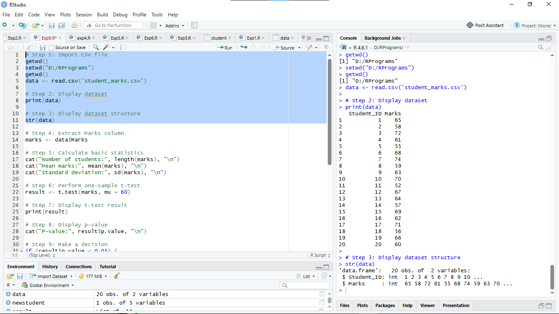

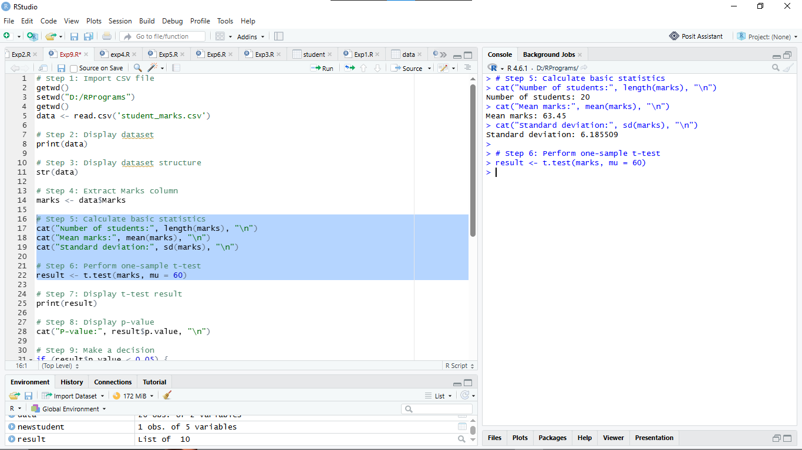

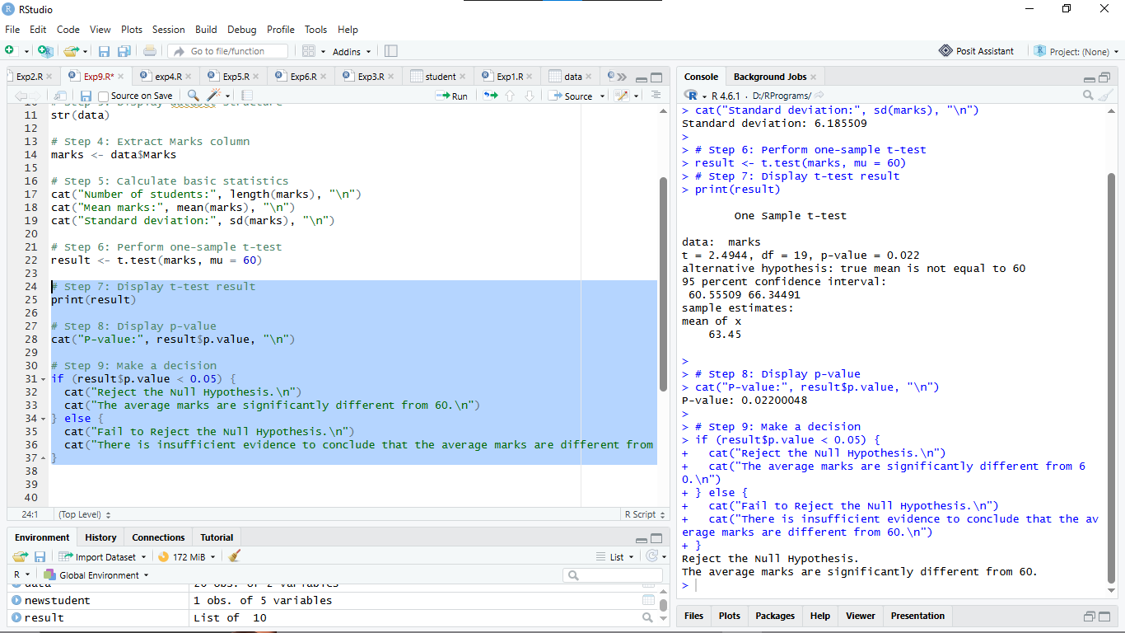

Result:

The output will display the imported dataset, its structure, descriptive statistics, and the t-test result. A typical t-test output contains:
One Sample t-test
data: marks
t = 2.4944
df = 19
p-value = 0.0220
alternative hypothesis: true mean is not equal to 60
95 percent confidence interval: 60.5551 to 66.3449
mean of x: : 63.45
Note: The exact t-value, p-value, confidence interval, and standard deviation should be taken from the R output generated on the student's system.

Conclusion:

If p-value < 0.05: Reject the null hypothesis. There is statistically significant evidence that the average marks are different from 60.

Curiosity Questions
Q1. What is a t-test?
A t-test is a statistical test used to determine whether there is a significant difference between means.
Q2. Why is a t-test used?
A t-test is used to compare sample means and determine whether an observed difference is statistically significant, especially when the population standard deviation is unknown.
Q3. What are the types of t-tests?
The three common types of t-tests are:
- One-sample t-test
- Independent two-sample t-test
- Paired t-test
Q4. Which R function is used for a t-test?
The t.test() function is used to perform a t-test in R.
Q5. What is a one-sample t-test?
A one-sample t-test compares the mean of a single sample with a specified or hypothesized population mean.
Q6. What is the null hypothesis?
The null hypothesis (H₀) is a statement that assumes there is no significant difference or effect. In this experiment, H₀: μ = 60.
Q7. What is the alternative hypothesis?
The alternative hypothesis (H₁) states that the population mean is different from the hypothesized value. In this experiment, H₁: μ ≠ 60.
Q8. What is the significance level?
The significance level (α) is the threshold used to decide whether to reject the null hypothesis. In this experiment, α = 0.05 or 5%.
Q9. What is a p-value?
A p-value is the probability, assuming the null hypothesis is true, of obtaining a test statistic at least as extreme as the observed one.
Q10. When do we reject the null hypothesis?
We reject the null hypothesis when the p-value is less than the significance level, usually 0.05.
Q11. What does mu = 60 mean in t.test()?
It specifies the hypothesized population mean as 60 marks.
Q12. What is a t-statistic?
The t-statistic measures how far the sample mean is from the hypothesized population mean relative to the estimated standard error.
Q13. What are degrees of freedom?
Degrees of freedom represent the number of independent values available for estimating statistical quantities.
Q14. How are degrees of freedom calculated for a one-sample t-test?
The formula is:
\[ df = n - 1 \]
For 20 students, \(df = 20 - 1 = 19\).
Q15. How do you import a CSV file in R?
The read.csv() function is used to import a CSV file.
data <- read.csv("student_marks.csv")
Q16. How do you calculate the mean in R?
The mean() function calculates the arithmetic mean.
mean(marks)
Q17. How do you calculate standard deviation in R?
The sd() function calculates the sample standard deviation.
sd(marks)
Q18. What is a two-tailed t-test?
A two-tailed t-test checks whether a population mean is significantly different from a specified value in either direction (greater or smaller).
Q19. What is a paired t-test?
A paired t-test compares two related measurements, such as students' marks before and after training.
Q20. What is an independent two-sample t-test?
An independent two-sample t-test compares the means of two separate, independent groups.
Q21. What are the assumptions of a t-test?
The main assumptions are:
- Observations are independent.
- Data are approximately normally distributed, particularly for small samples.
- The data are numerical.
- For the standard pooled two-sample t-test, the two groups have equal population variances.
Q22. What is a confidence interval?
A confidence interval is a range of values used to estimate an unknown population parameter at a specified confidence level.
Q23. What is the default confidence level in t.test()?
The default confidence level is 95%.
Q24. How do you perform a one-tailed t-test in R?
Use the alternative argument.
For testing whether the mean is greater than 60:
t.test(marks, mu = 60, alternative = "greater")
For testing whether the mean is less than 60:
t.test(marks, mu = 60, alternative = "less")
Q25. What is the conclusion of a t-test based on the p-value?
If the p-value is less than 0.05, reject the null hypothesis. If the p-value is greater than or equal to 0.05, fail to reject the null hypothesis.
- What is the conclusion of a t-test based on the p-value?

