EXPERIMENT 10
Chi-Square Test Using dataset

Aim
To perform a Chi-Square Test of Independence on categorical data stored in a CSV file using R programming in RStudio.

Learning Objectives
- Import a CSV dataset into RStudio.
- Explore categorical data using R.
- Construct a contingency table.
- Apply the Chi-Square test using chisq.test().
- Interpret the Chi-Square statistic, degrees of freedom, and p-value.
- Make a statistical decision at the 5% significance level.

PART B

(PART B: TO BE COMPLETED BY STUDENTS)
(Students must submit the soft copy as per following segments within two hours of the practical. The soft copy must be uploaded on the ERP or emailed to the concerned lab in charge faculties at the end of the practical in case the there is no ERP access available)
Roll No. C – 60 | Name: Avdhut Parish Madhavi
Class : SE - C | Batch : C2
Date of Experiment: | Date of Submission

Observation: (Paste screenshots of the program and output)

Expected Frequencies
# Display expected frequencies
chi_result$expected

Automated Decision
if (chi_result$p.value < 0.05) {
print("Reject the Null Hypothesis")
} else {
print("Fail to Reject the Null Hypothesis")
}

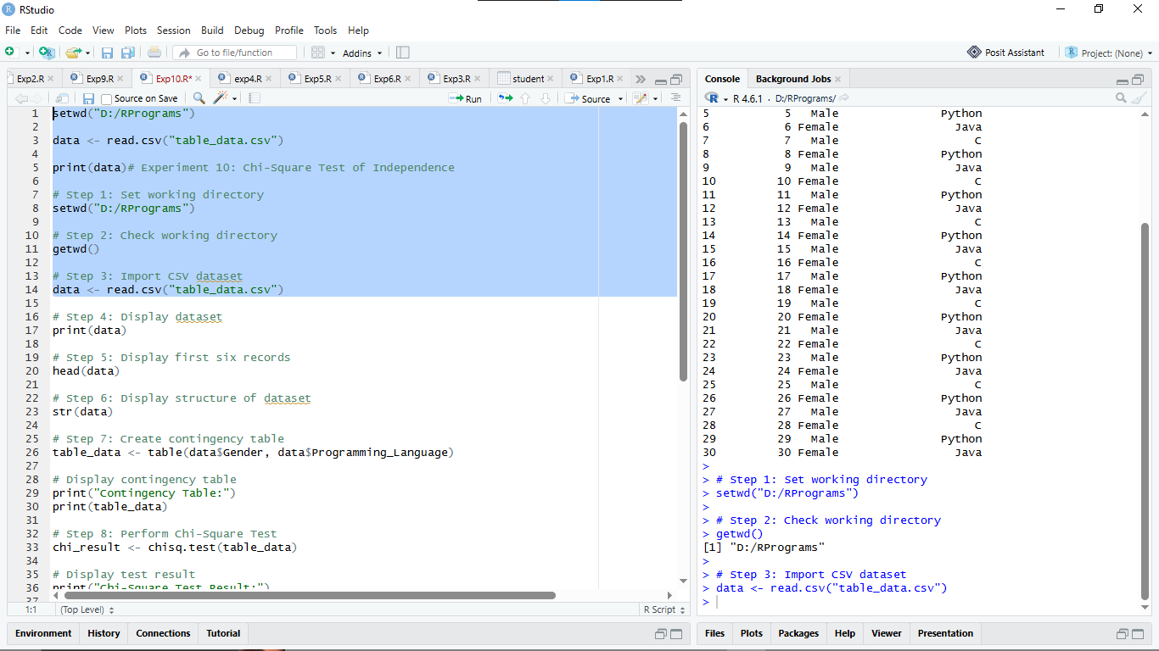

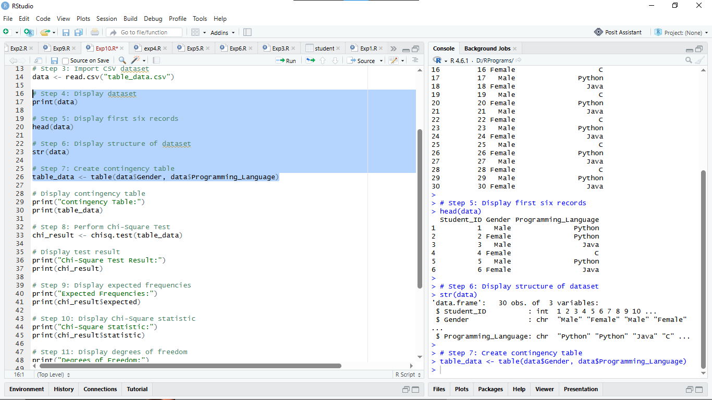

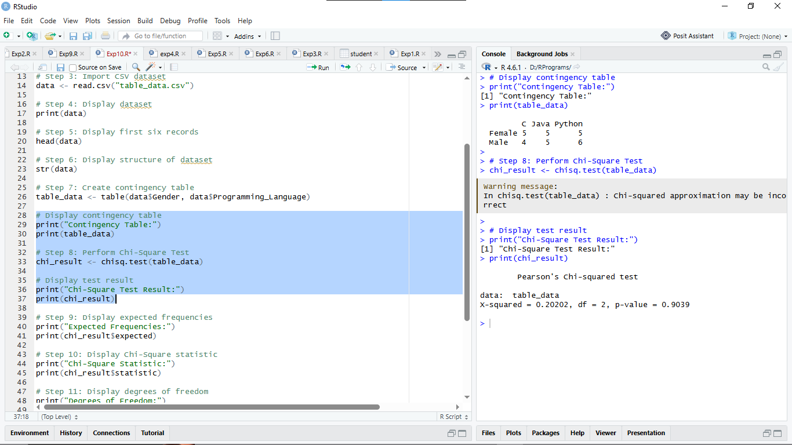

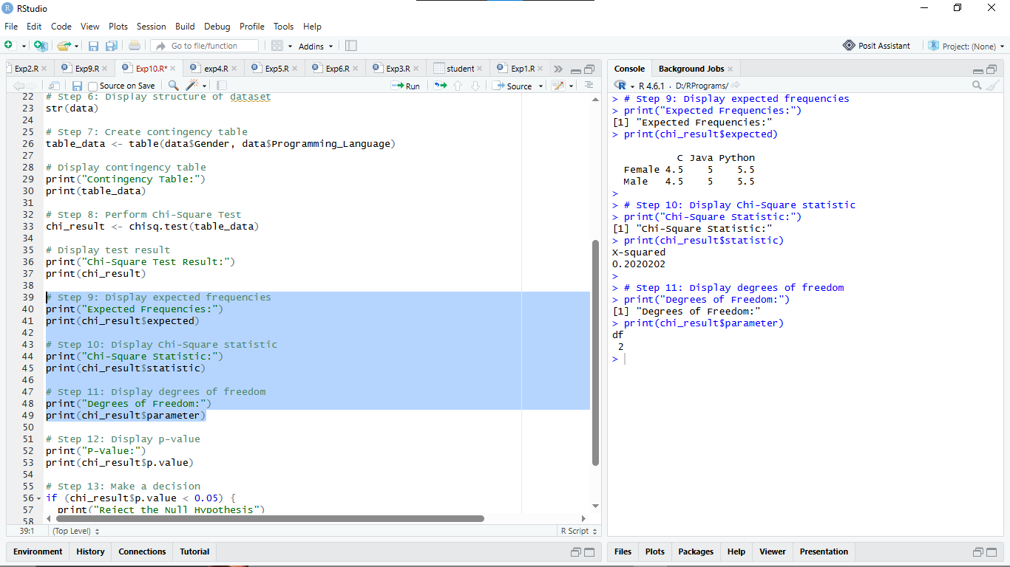

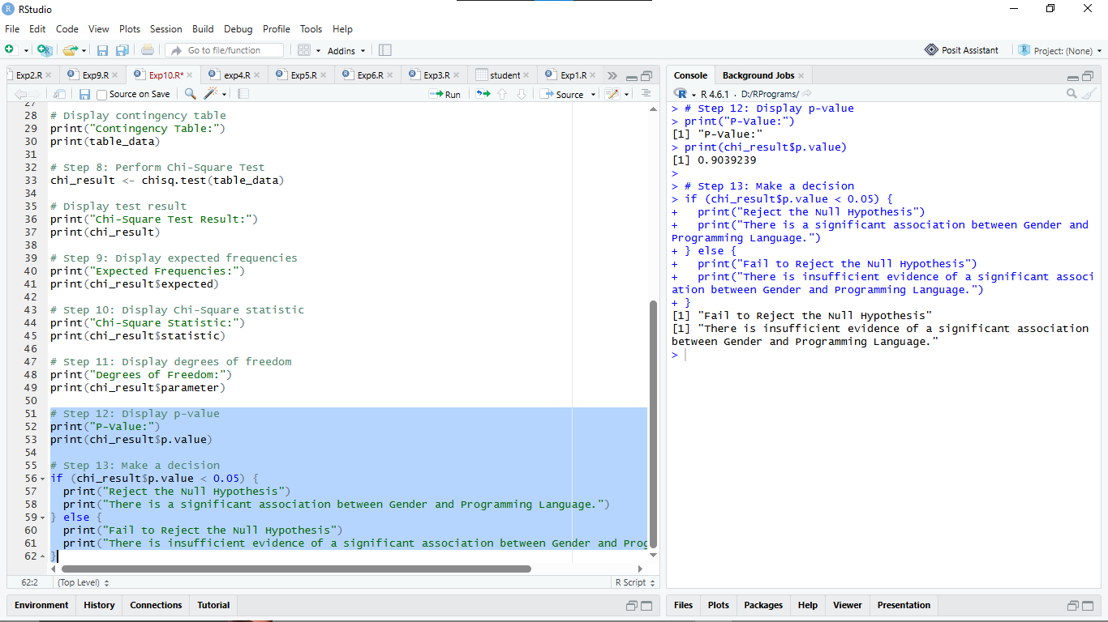

Result
The Chi-Square Test of Independence was successfully performed on the given CSV dataset using RStudio. The association between Gender and Programming Language Preference was tested at a 5% level of significance.
Chi-Square statistic = 0.2020____________________
Degrees of freedom = 2____________________
p-value = 0.9039____________________
Decision = Fail to Reject the Null Hypothesis.

Conclusion

The Chi-Square Test of Independence was successfully implemented using R programming. Since the p-value (0.9039) is greater than the significance level (0.05), we fail to reject the null hypothesis. Therefore, there is insufficient statistical evidence to conclude that Gender and Preferred Programming Language are significantly associated in the given dataset.

Curiosity Questions

Q1. What is a Chi-Square test?
A Chi-Square test is a statistical test used to determine whether there is a significant association between categorical variables or whether observed frequencies differ from expected frequencies.
Q2. What type of data is required for a Chi-Square test?
A Chi-Square test requires categorical data expressed as frequencies or counts, such as gender, preferences, or pass/fail results.
Q3. What is the difference between a Chi-Square Test of Independence and a goodness-of-fit test?
- Test of Independence: Determines whether two categorical variables are associated.
- Goodness-of-Fit Test: Determines whether observed frequencies fit an expected distribution.
Q4. What is the null hypothesis in this experiment?
The null hypothesis (H₀) states that there is no significant association between the categorical variables.
Q5. What is the alternative hypothesis?
The alternative hypothesis (H₁) states that there is a significant association between the categorical variables.
Q6. What does a p-value less than 0.05 indicate?
A p-value less than 0.05 indicates statistically significant evidence against the null hypothesis. Therefore, we reject the null hypothesis.
Q7. What is a contingency table?
A contingency table is a table that displays the frequency distribution of two or more categorical variables using rows and columns.
Q8. Which R function is used to perform the Chi-Square test?
The chisq.test() function is used to perform the Chi-Square test in R.
Q9. What does chisq.test() return?
The chisq.test() function returns the Chi-Square statistic, degrees of freedom, p-value, and expected frequencies.
Q10. How do you obtain expected frequencies in R?
Expected frequencies can be obtained using the $expected component of the test result.
result <- chisq.test(data)
result$expected
Q11. What significance level is used in this experiment?
The significance level used is 0.05 or 5%.
Q12. What are degrees of freedom?
Degrees of freedom represent the number of independent values available for statistical calculations. For a contingency table, the formula is:
[ df=(r-1)(c-1) ]
where (r) is the number of rows and (c) is the number of columns.
Q13. Why should expected frequencies generally not be too small?
Expected frequencies should not be too small because the Chi-Square approximation may become inaccurate, leading to unreliable results.
Q14. What happens if the p-value is greater than 0.05?
If the p-value is greater than 0.05, we fail to reject the null hypothesis because there is insufficient evidence of a significant association.
Q15. How can you import a CSV file into R?
A CSV file can be imported using the read.csv() function.
data <- read.csv("data.csv")
print(data)
This imports the CSV file into R and displays the dataset.

