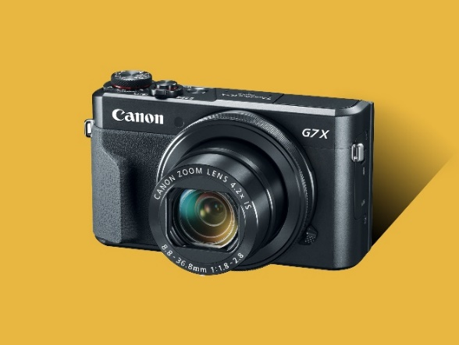

* A digital camera has basically three functions, to capture, to store and to display.
* In digital cameras, first image is captured then converted to digital form to store.
* This stored image can be transferred to other devices.
* Components of a smart camera include:
  + Image sensor
  + Analog to digital converter
  + Image processor
  + Memory
  + Lens
  + Led or other illuminating devices
  + Communication interface
* There are various algorithms used to process the image. That’s the reason different cameras have different image quality even with same specifications.
* Cameras that we use today are smart and have a lot of features that were not present in early cameras all because of the embedded systems used in them.
* There is no need of film for storing images, like in olden cameras, because the data is stored in digital data in bits, it has increased the storage capacity and made it easy to transfer images.
* It is used in various applications: integrated in PCs and mobiles, surveillance cameras etc.
* Camera is one of the important embedded systems. Its has its own processor, sensors, actuators and also memory for storage purpose.