**One page report on intro to IoT and how it could be related to embedded systems**

* IoT stands for Internet of Things, which means accessing and controlling daily usable equipment’s and devices using Internet.
* The term "Things" in the Internet of Things refers to anything and everything in day to day life which is accessed or connected through the internet.

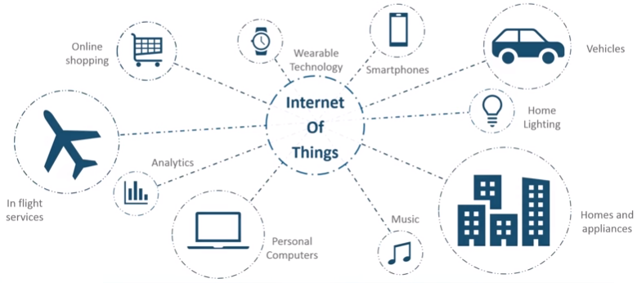

* Connecting everyday things embedded with electronics, software, and sensors to internet enabling to collect and exchange data without human interaction called as the Internet of Things (IoT).
* It is essential to know about the embedded devices while learning the IoT or building the projects on IoT. The embedded devices are the objects that build the unique computing system. These systems may or may not connect to the Internet.
* An embedded device system generally runs as a single application. However, these devices can connect through the internet connection, and able communicate through other network devices.
* Embedded systems are a subset of the Internet of Things (IoT), an integration of devices connected to the internet. Small software programs that implement a few functions tend to be embedded systems. The IoT is a process in which objects are equipped with sensors, processors for the hardware development, software systems, protocols and web APIs, which together create a connected environment of embedded systems.
* The Internet of Things products can be used for home automation, and the embedded systems are within the products networked together to automate and control air conditioning, heating, etc.
* Embedded systems and IoT usually work together: while IoT connects a set of embedded devices, these embedded devices with sensors collect and exchange data regarding the changes in device and capturing relevant data, such as sound, motion, temperature, etc. This data is sent via the internet to a smartphone that has an internet connection.
* Embedded systems do not introduce privacy and security concerns into devices because they are not able to transmit data on their own.