Machine Learning Operations (MLOps) - AIMLCZG523
Assignment 01
End-to-End ML Model Development, CI/CD and Production Deployment

Heart Disease Risk Prediction (UCI Heart Disease Dataset)

Student: Durgesh Verma (ID: 2025AE05155)
Code repository: https://github.com/avdurgesh/MlOps-heart-diseae-durgesh-verma-AIMLCZG523

1. Introduction and objectives
This report describes an end-to-end MLOps solution that predicts the risk of heart disease from patient health data. The classifier is trained and tracked reproducibly, tested and trained automatically in a CI pipeline, packaged as a Docker image, deployed to Kubernetes, and monitored with Prometheus and Grafana.
Objectives:
- Acquire, clean and explore the UCI Heart Disease (Cleveland) dataset.
- Build and compare at least two classifiers with cross-validation and proper metrics.
- Track every experiment (parameters, metrics, plots, models) with MLflow.
- Package the model together with its preprocessing so serving is fully reproducible.
- Automate linting, unit tests and training with GitHub Actions.
- Serve the model through a containerised REST API and deploy it on Kubernetes.
- Log API requests and expose metrics for monitoring.

Repository layout
Path | Content
src/ | data loading and cleaning, EDA, features, training, inference
app/ | FastAPI service (/predict, /health, /metrics)
tests/ | pytest unit tests for data, model and API (14 tests)
models/ | saved pipeline (model.joblib) and metrics.json
k8s/ | Kubernetes Deployment, Service and Ingress manifests
monitoring/ | Prometheus config and provisioned Grafana dashboard
.github/workflows/ | GitHub Actions CI workflow

2. Setup and installation
The project runs from a clean checkout using only requirements.txt (Python 3.12).
git clone https://github.com/avdurgesh/MlOps-heart-diseae-durgesh-verma-AIMLCZG523.git
cd MlOps-heart-diseae-durgesh-verma-AIMLCZG523
python3 -m venv .venv && source .venv/bin/activate # Windows: .\.venv\Scripts\Activate.ps1
pip install -r requirements.txt
Pipeline commands:
python -m src.data # download + clean dataset
python -m src.eda # EDA figures
python -m src.train # tune, evaluate, log to MLflow, save model
pytest # unit tests
flake8 src tests app # lint
The cleaned dataset is committed to the repository, so training also works when the machine has no internet access; src.data re-downloads the raw file from the UCI repository when needed.
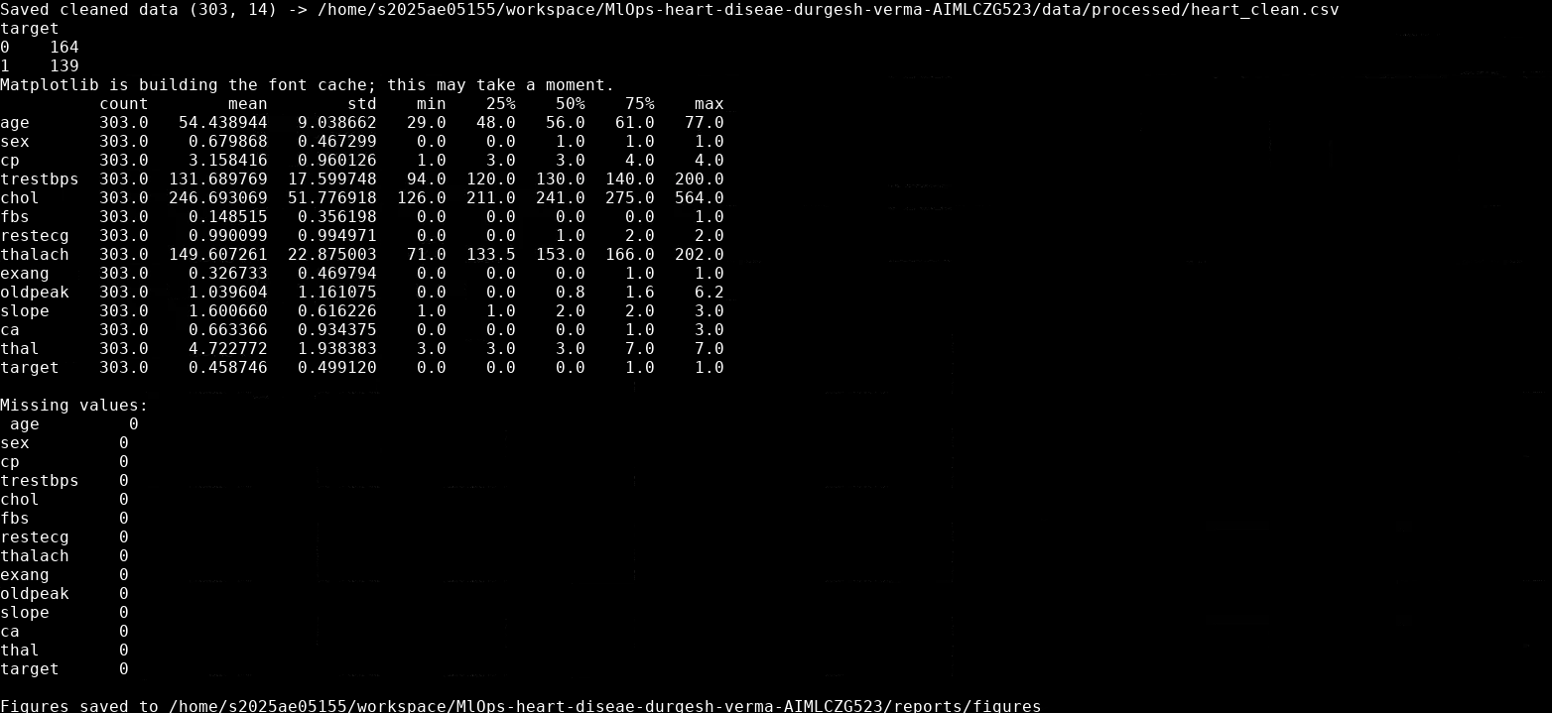
Figure 1 - Output of src.data and src.eda
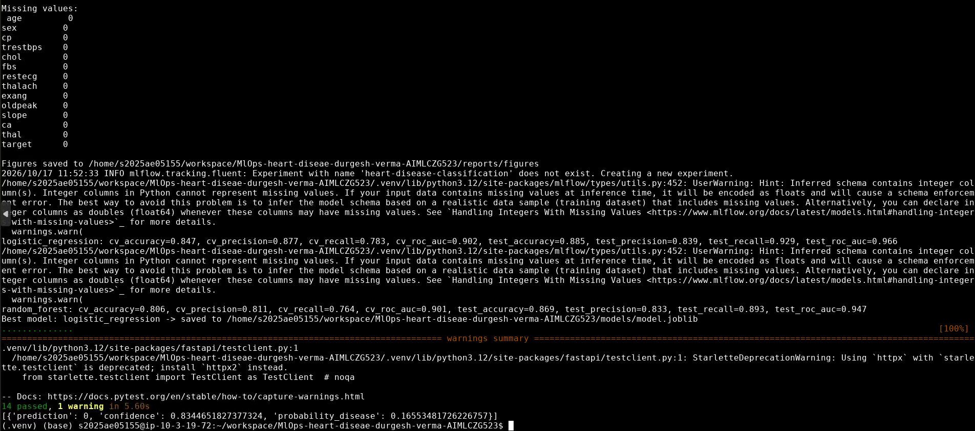
Figure 2 - Output of src.train, pytest and src.predict

3. Data acquisition and exploratory data analysis
Source: UCI Machine Learning Repository, Heart Disease dataset (Cleveland subset): 303 patients, 13 input features and one target. Missing values are encoded as '?' in the raw file (4 values in 'ca' and 2 in 'thal').

3.1 Cleaning and preprocessing
- Duplicates removed; the file contains none, but the step keeps the pipeline safe for new data.
- The original target has values 0-4 (disease severity); it is collapsed to a binary label (0 = no disease, 1 = disease), matching the problem statement.
- Missing 'ca' and 'thal' values are imputed with the column mode (categorical features).
- Categorical codes are cast to integers; no missing values remain after cleaning (303 rows x 14 columns).

3.2 Findings
- Class balance: 164 patients without disease and 139 with disease (54% / 46%), so the classes are roughly balanced and no resampling is needed.
- Strongest positive correlations with the target: thal (0.52), ca (0.46), exang (0.43), oldpeak (0.42) and cp (0.41). Strongest negative: thalach (-0.42), i.e. a lower maximum heart rate goes with disease.
- Weak signals: fbs (0.03) and chol (0.09), and cholesterol also contains a few high outliers.
- Numeric features are on very different scales (chol up to 564, oldpeak up to 6.2), which motivates standardisation for the linear model.
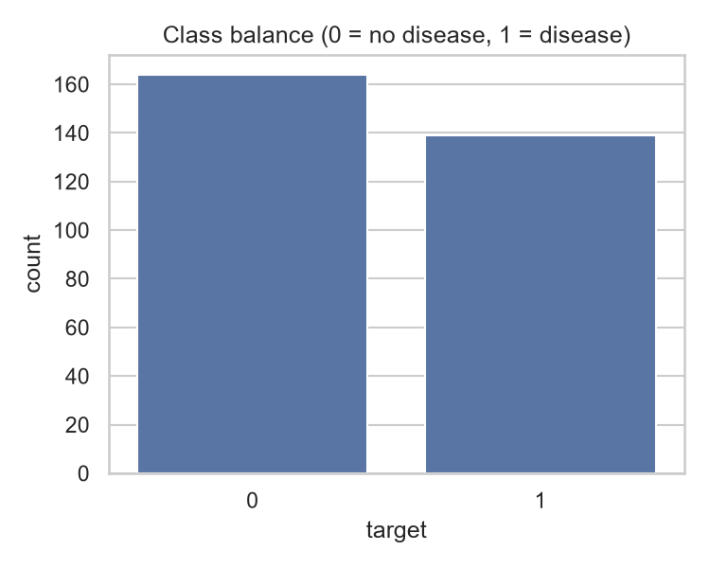
Figure 3 - Class balance of the binary target
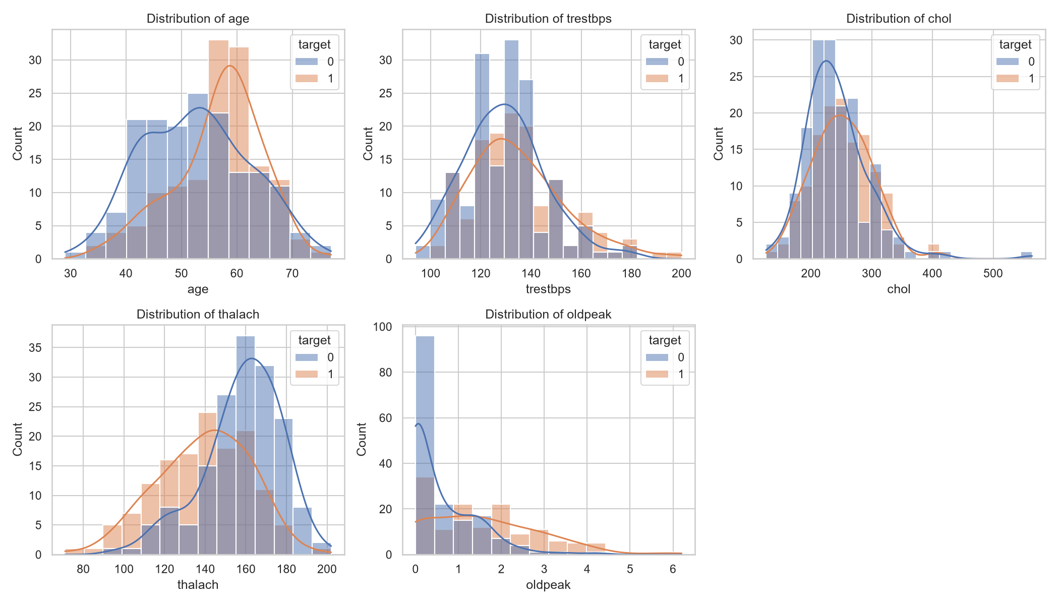
Figure 4 - Distribution of numeric features by class
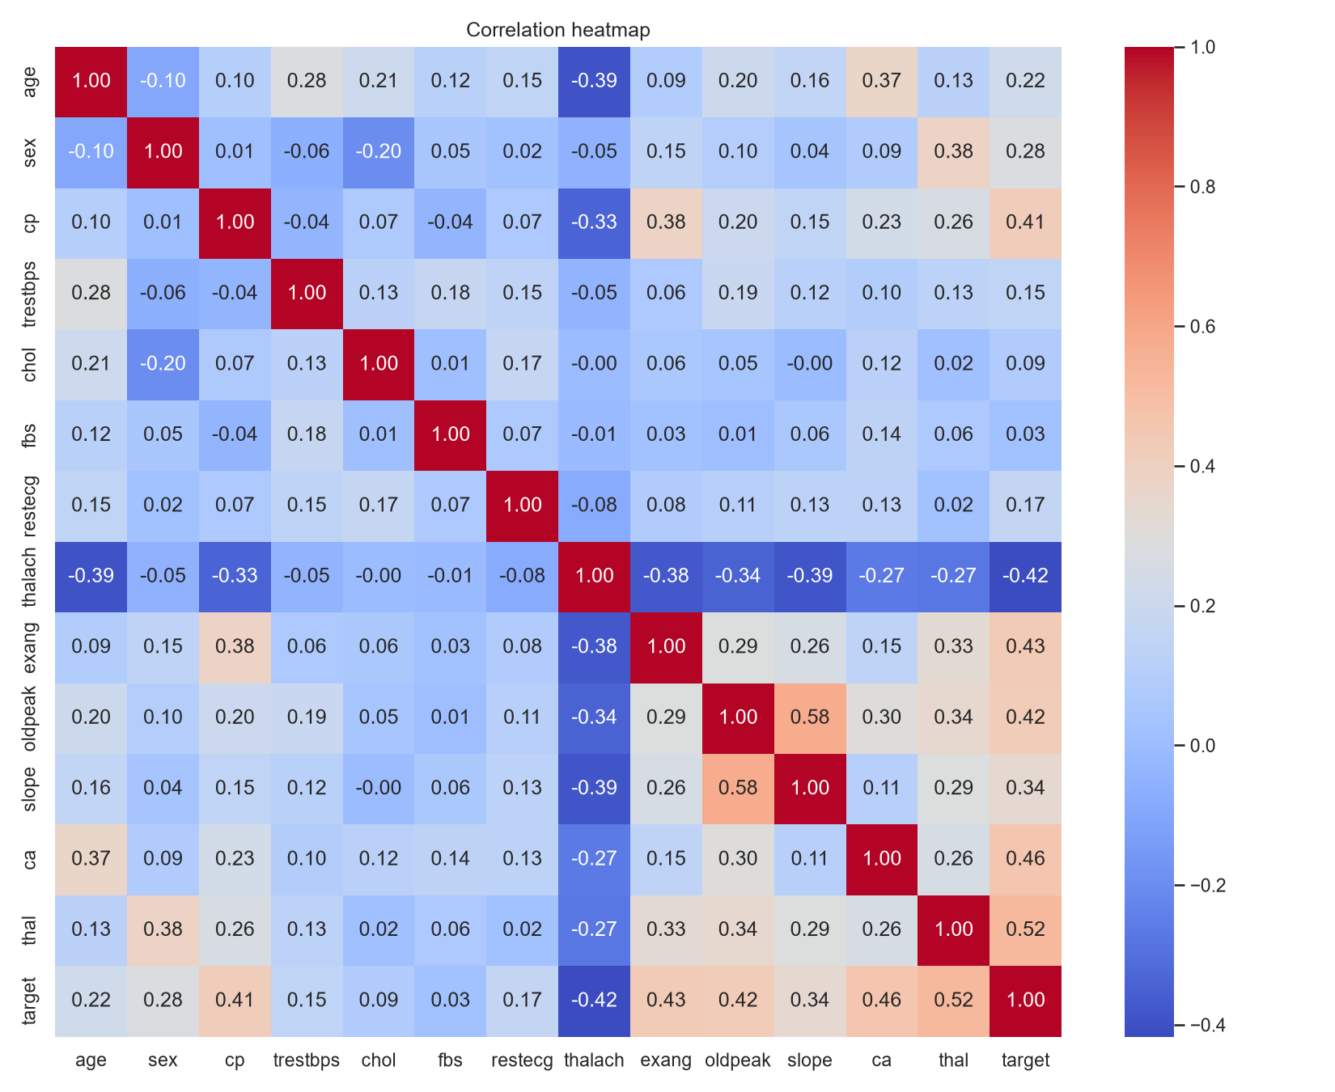
Figure 5 - Correlation heatmap
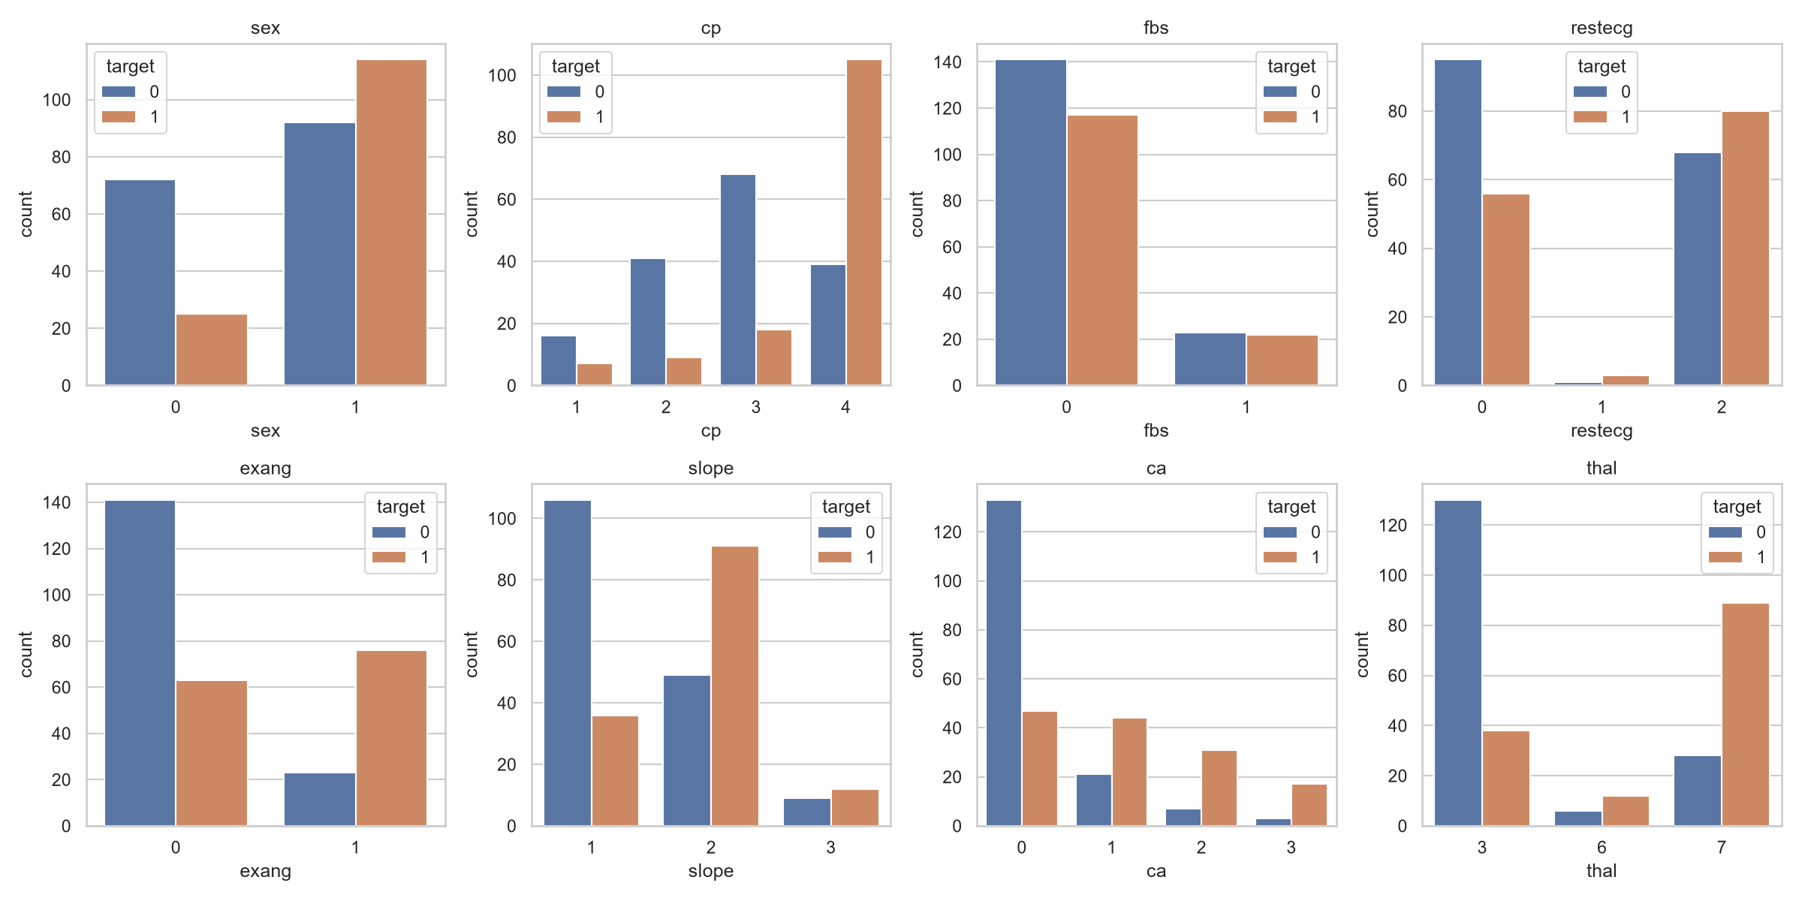
Figure 6 - Categorical features versus the target

4. Feature engineering and model development

4.1 Feature pipeline
All preprocessing lives inside a single scikit-learn Pipeline (src/features.py), so exactly the same transformations are applied at training time and at serving time:
- Numeric features (age, trestbps, chol, thalach, oldpeak): StandardScaler.
- Categorical features (sex, cp, fbs, restecg, exang, slope, ca, thal): OneHotEncoder with handle_unknown='ignore', so an unseen category cannot crash the API (covered by a unit test).

4.2 Models, tuning and evaluation
Two classifiers were trained on a stratified 80/20 split (random_state=42): Logistic Regression as an interpretable baseline and Random Forest as a non-linear model. Hyper-parameters were tuned with GridSearchCV using 5-fold stratified cross-validation and ROC-AUC as the selection metric. The tuned pipeline was then evaluated with cross-validation (accuracy, precision, recall, ROC-AUC) on the training data and once on the held-out test set.
Model | Search grid | Best parameters
Logistic Regression | C in {0.01, 0.1, 1, 10} | C = 1
Random Forest | n_estimators {100, 300}, max_depth {3, 5, None}, min_samples_leaf {1, 3} | n_estimators = 100, max_depth = 5, min_samples_leaf = 3

Model | CV acc | CV prec | CV recall | CV ROC-AUC | Test acc | Test recall | Test ROC-AUC
Logistic Regression | 0.847 | 0.877 | 0.783 | 0.902 | 0.885 | 0.929 | 0.966
Random Forest | 0.806 | 0.811 | 0.764 | 0.901 | 0.869 | 0.893 | 0.947

Model selection: both models reach almost the same cross-validated ROC-AUC (0.902 versus 0.901). Logistic Regression has higher cross-validated accuracy, precision and recall, a higher test ROC-AUC (0.966 versus 0.947), is simpler and is easier to explain, so it was selected as the final model. For a screening use case recall matters, and it reaches 0.93 on the test set. With only 303 samples the test set holds 61 patients, so these test numbers have wide uncertainty and the cross-validated figures are the more reliable comparison.

5. Experiment tracking with MLflow
Each model is trained inside an MLflow run (experiment 'heart-disease-classification'). A run logs:
- Parameters: model type, best hyper-parameters and number of features.
- Metrics: cross-validated accuracy, precision, recall and ROC-AUC, plus the same four on the test set.
- Artifacts: ROC curve, confusion matrix and the fitted pipeline as an MLflow model with an input example (and therefore an inferred signature).
The UI is started with: mlflow ui --backend-store-uri ./mlruns.
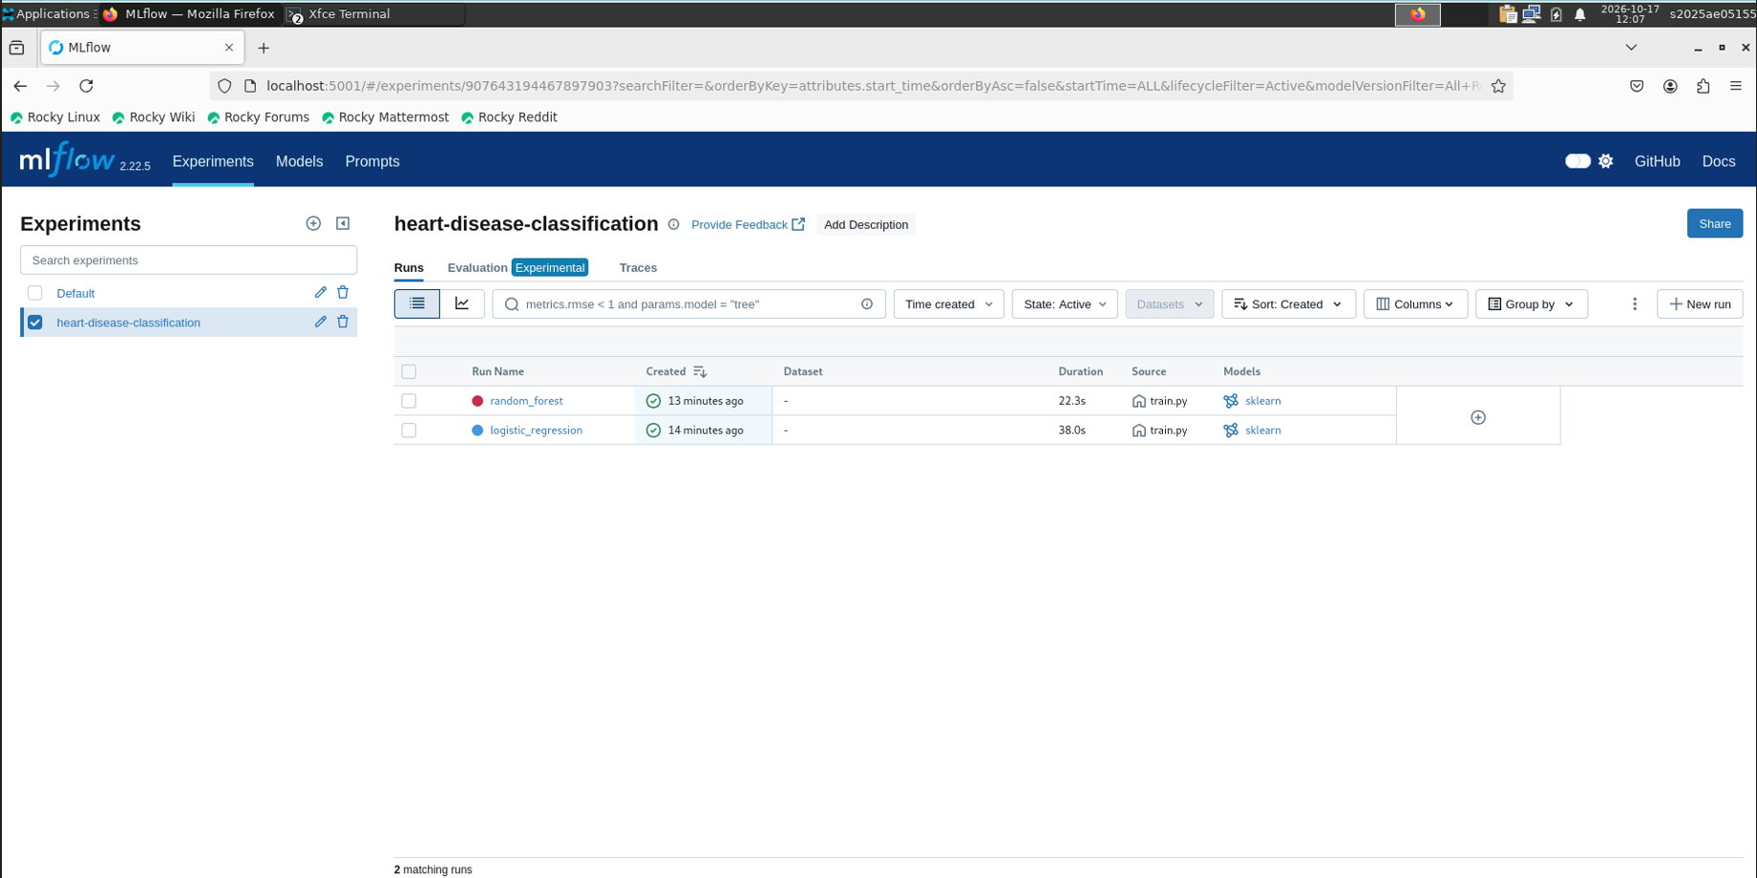
Figure 7 - MLflow experiment with both runs
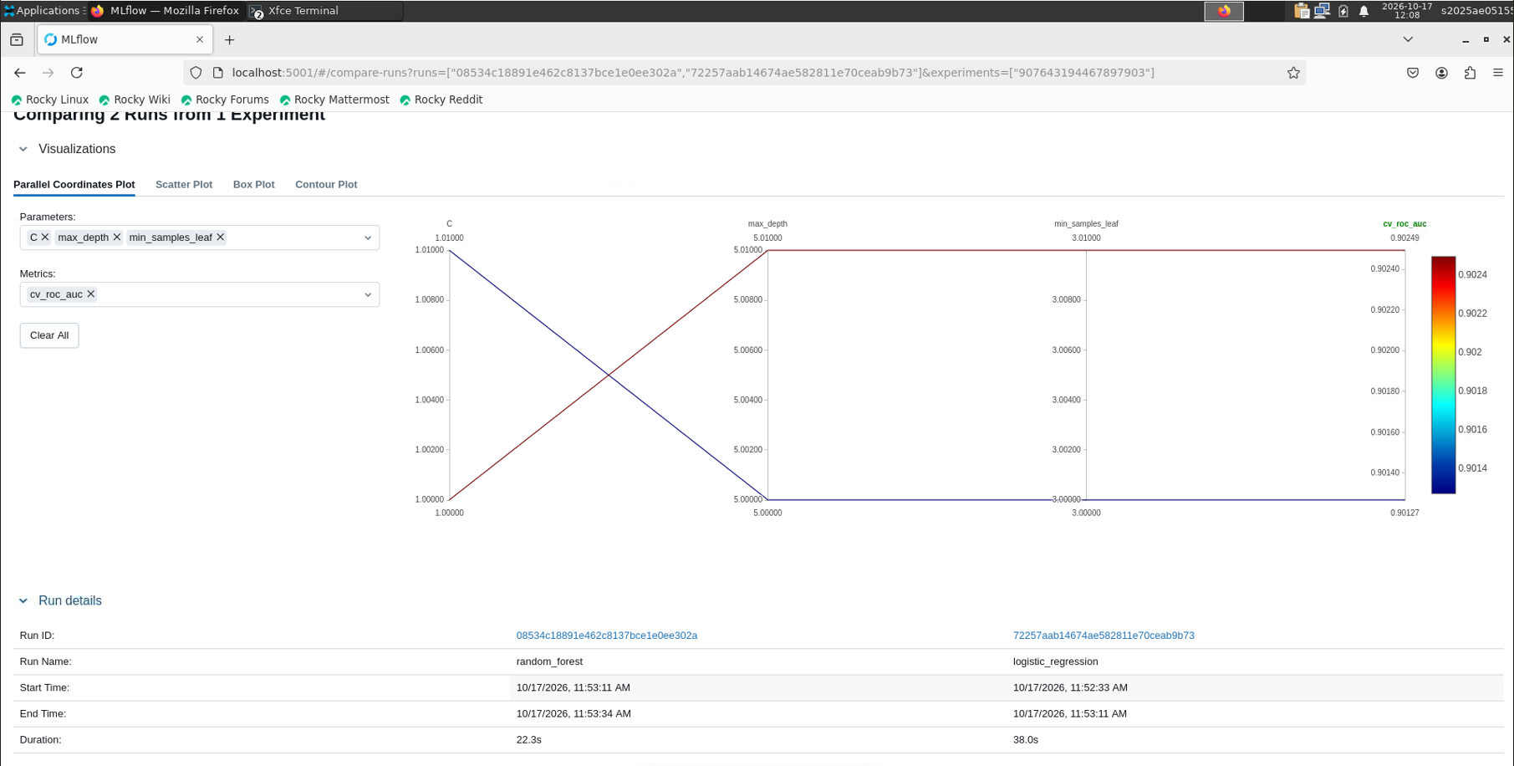
Figure 8 - Run comparison
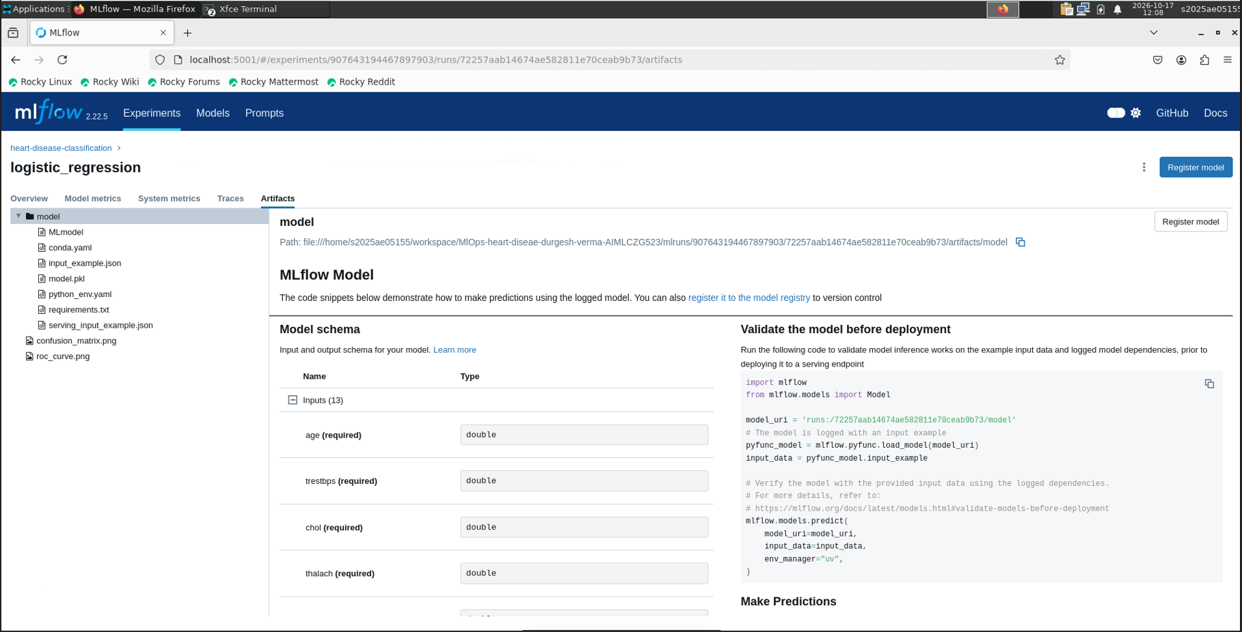
Figure 9 - Artifacts of the selected run (ROC curve, confusion matrix, model)

6. Model packaging and reproducibility
- The final pipeline (preprocessing + Logistic Regression) is saved with joblib as models/model.joblib and is also stored as an MLflow model. metrics.json records the winning model and its scores.
- requirements.txt pins version ranges for the full development environment; requirements-api.txt pins exact versions (scikit-learn 1.9.1, numpy, pandas, scipy) for the serving image, because a pickled model must be loaded with the same scikit-learn version it was trained with.
- A fixed random_state (42) and a deterministic split make training repeatable; the CI pipeline proves that training runs from a clean environment.
- src/predict.py is the single inference entry point used by both the command line and the API.

7. CI/CD pipeline and automated testing
Unit tests (pytest, 14 tests) cover three areas:
- Data: cleaning removes duplicates, binarises the target, fills missing values and does not mutate its input.
- Model: shape of the processed dataset, preprocessor output without NaNs, a fitted pipeline beats a sanity threshold, valid prediction and confidence range, and robustness to an unseen category.
- API: /health, /predict with valid input, rejection of invalid or missing fields (HTTP 422) and the Prometheus /metrics endpoint.
The GitHub Actions workflow (.github/workflows/ci.yml) runs on every push and pull request on ubuntu-latest with Python 3.12: install requirements, lint with flake8, run pytest with coverage, prepare the data, train the models, and upload models, MLflow runs, the training log, test results and coverage as the 'ml-artifacts' artifact. The training step runs under bash with pipefail, so the job fails if training fails even though the log is piped through tee. Any lint, test or training error fails the pipeline.
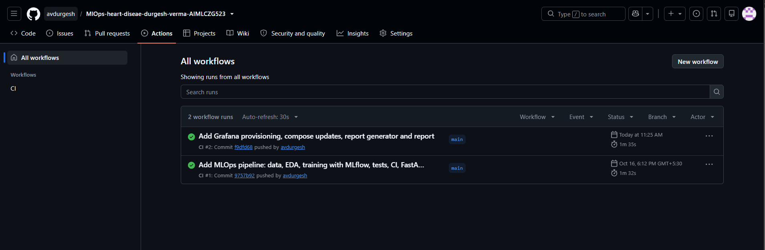
Figure 10 - Successful GitHub Actions runs (CI #1 and CI #2)

8. Model containerisation
The model is served by a FastAPI application (app/main.py):
Endpoint | Description
POST /predict | JSON with the 13 features; returns prediction (0/1), confidence and probability_disease
GET /health | liveness/readiness check; reports whether the model is loaded
GET /metrics | Prometheus metrics
GET /docs | interactive Swagger UI

Inputs are validated with Pydantic (type and range constraints), so malformed requests return HTTP 422 instead of reaching the model. The Dockerfile uses python:3.12-slim, installs only requirements-api.txt, copies the source and the saved model, runs as a non-root user and defines a HEALTHCHECK. The resulting image is about 470 MB.
docker build -t heart-disease-api:1.0 .
docker run -d -p 8000:8000 heart-disease-api:1.0
curl -X POST http://localhost:8000/predict -H "Content-Type: application/json" \
-d '{"age":63,"sex":1,"cp":1,"trestbps":145,"chol":233,"fbs":1,"restecg":2,"thalach":150,"exang":0,"oldpeak":2.3,"slope":3,"ca":0,"thal":6}'
Response: {"prediction": 0, "confidence": 0.834, "probability_disease": 0.166}
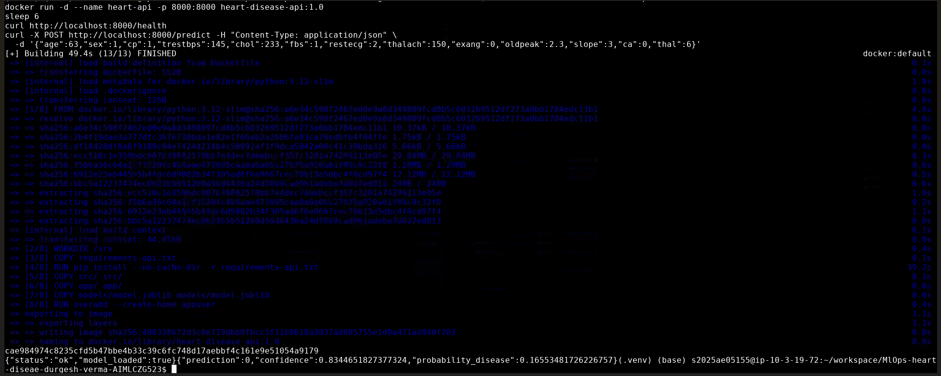
Figure 11 - Docker build, run and a /predict request
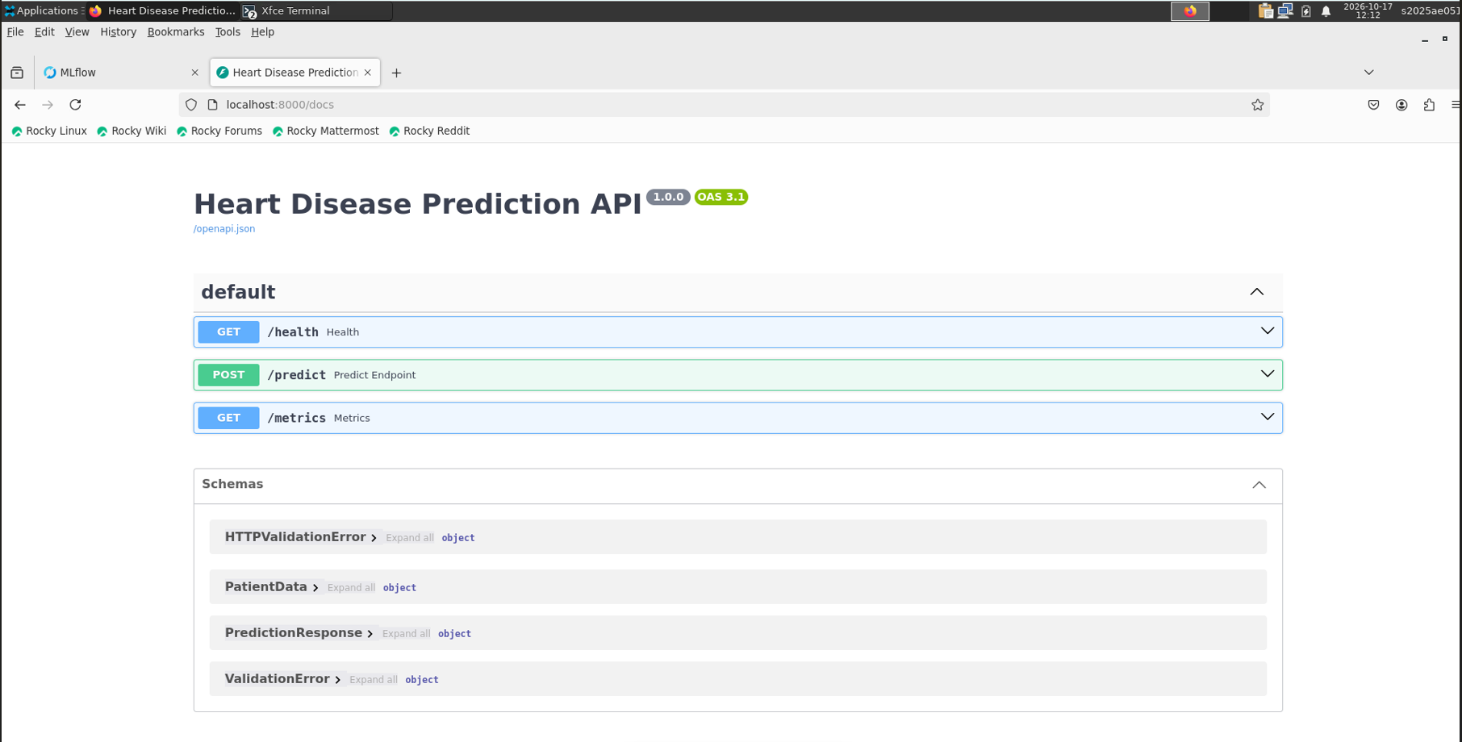
Figure 12 - Swagger UI for the API

9. Production deployment on Kubernetes
The image is deployed to a Minikube cluster (Docker driver) using the manifests in k8s/:
- Namespace heart-disease and a Deployment with 2 replicas, readiness and liveness probes on /health, and CPU/memory requests and limits.
- A Service of type LoadBalancer on port 80 forwarding to container port 8000.
- An nginx Ingress routing / to the Service.
minikube start -p heart-disease --driver=docker
minikube -p heart-disease image load heart-disease-api:1.0
kubectl apply -f k8s/deployment.yaml
minikube -p heart-disease addons enable ingress
kubectl apply -f k8s/ingress.yaml
curl http://$(minikube -p heart-disease ip)/health
Verification: both pods reach Running and the Ingress receives the address of the Minikube node. /health and /predict called through the Ingress return the same results as the plain Docker container (prediction 0, confidence 0.834). The LoadBalancer Service keeps an EXTERNAL-IP of <pending> because Minikube has no cloud load balancer; the Ingress is the access path.
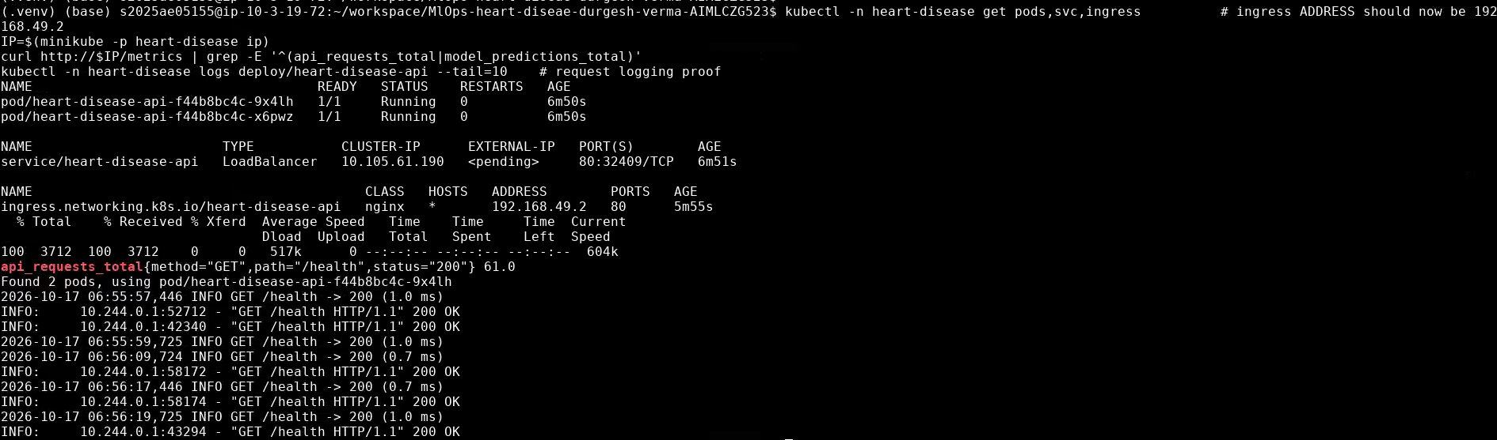
Figure 13 - kubectl get pods, svc and ingress, the /metrics counters and the request logs of the pods

10. Monitoring and logging
Logging: a middleware logs every request (method, path, status, latency in ms) and every prediction (label and confidence) to standard output, which is collected by 'docker logs' / 'kubectl logs'.
Metrics: the API exposes Prometheus metrics at /metrics:
- api_requests_total{method, path, status} - request counter.
- api_request_latency_seconds{path} - latency histogram.
- model_predictions_total{label} - predictions served per class.
docker compose starts the API, Prometheus (scraping the API every 15 s) and Grafana. The Prometheus data source and a 'Heart Disease API' dashboard are provisioned from files in monitoring/grafana/, so no manual setup is needed. The dashboard shows total requests and predictions, predictions by class, request rate per path and p95 latency.
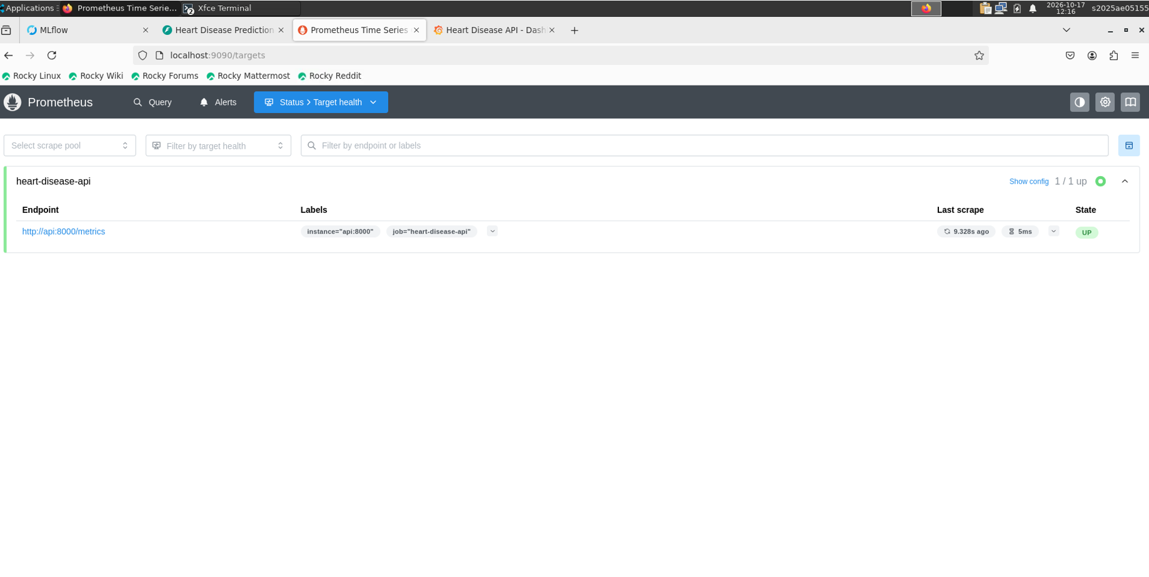
Figure 14 - Prometheus target heart-disease-api is UP
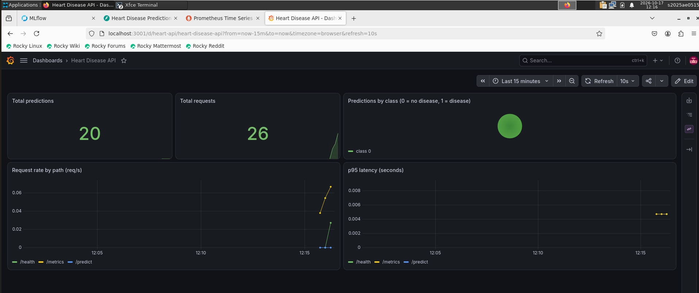
Figure 15 - Grafana dashboard

11. Architecture
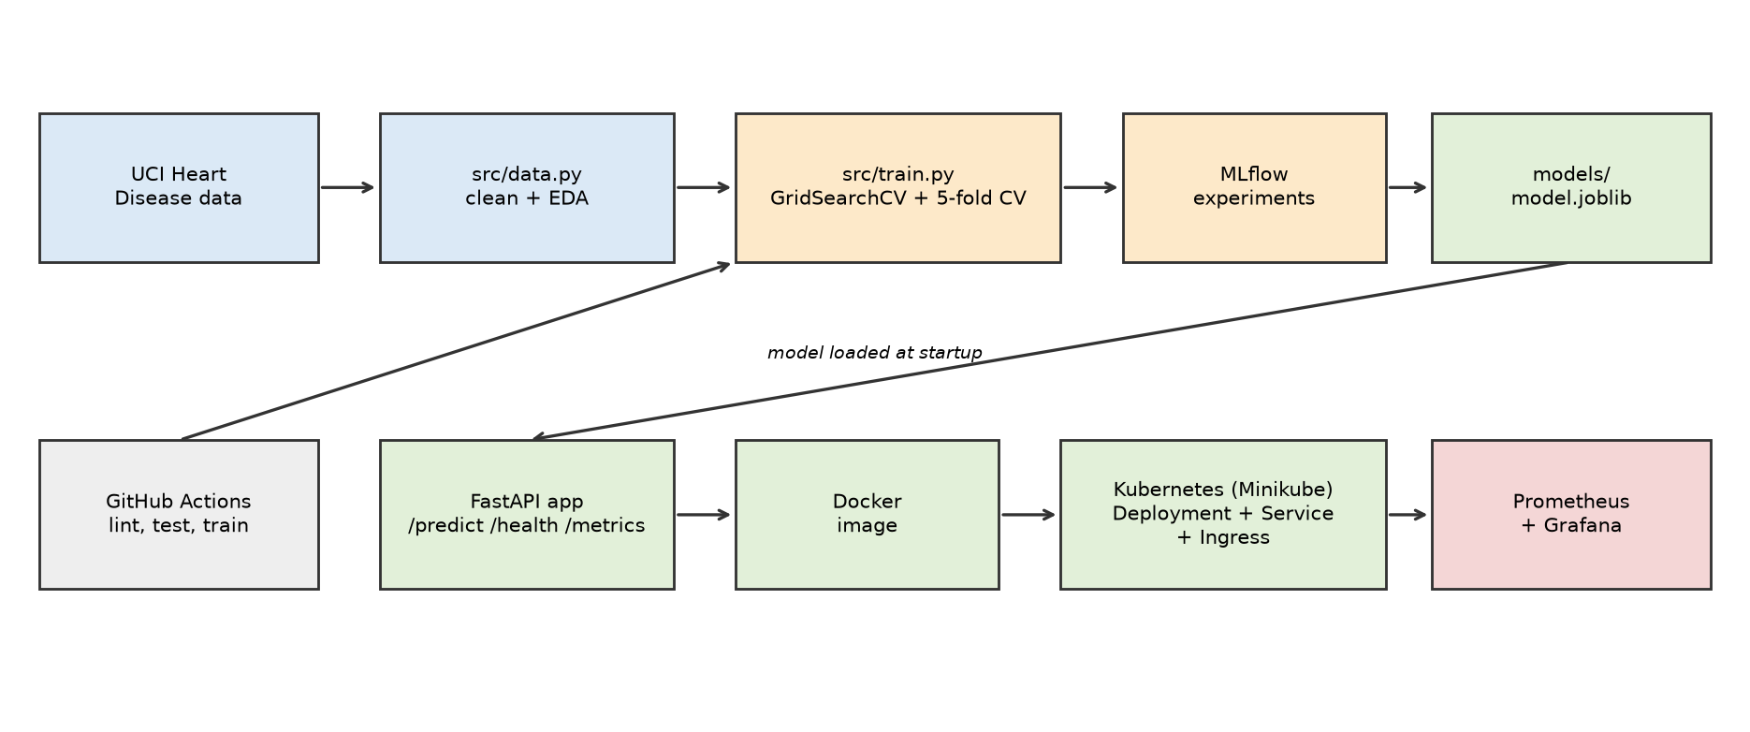
Figure 16 - End-to-end architecture
Data flows from the UCI source through cleaning and EDA into training. Training logs to MLflow and produces the packaged pipeline, which the FastAPI service loads at start-up. The service is built into a Docker image, deployed to Kubernetes, and observed by Prometheus and Grafana. GitHub Actions validates every change by linting, testing and re-training.

12. Issues encountered and how they were solved
The code was first developed and tested on a Windows machine with Docker Desktop and Minikube. The screenshots in this report were taken on the course Linux virtual machine. Where an issue only occurred on one of the two, this is stated.
- Pickle compatibility: the serving image pins the exact scikit-learn version used for training.
- Deprecated scikit-learn argument: the 'penalty' parameter of LogisticRegression was removed from the grid and the default L2 regularisation is used.
- CI : 'tee' would hide a failing training step, so the step runs with 'shell: bash' (pipefail) and the job fails when training fails.

13. Conclusion
The project delivers a reproducible pipeline: a clean dataset and EDA, two tuned and cross-validated models tracked in MLflow, a packaged preprocessing + model pipeline, an automated CI pipeline that lints, tests and trains, a containerised API deployed on Kubernetes behind an Ingress, and request logging with Prometheus and Grafana monitoring. The selected Logistic Regression model reaches a cross-validated ROC-AUC of 0.90 and a test ROC-AUC of 0.97.
Possible improvements: a larger multi-site dataset, probability calibration, a model registry with automated promotion, image push to a container registry in CI (continuous delivery), and drift monitoring of the input features.
Disclaimer: this model is a learning exercise and is not a medical device.

Access instructions
- Code repository: https://github.com/avdurgesh/MlOps-heart-diseae-durgesh-verma-AIMLCZG523
- API (Docker): http://localhost:8000 (docs at /docs).
- Kubernetes: through the Ingress at the Minikube IP ('minikube ip'), or 'kubectl -n heart-disease port-forward svc/heart-disease-api 8080:80'.
- Grafana: http://localhost:3001 (admin/admin), Prometheus: http://localhost:9090, MLflow: http://localhost:5001.

