Setting up an ElasticSearch, Fluentd, Kibana (EFK) logging stack on Kubernetes

Overview-

Sometimes when running your Kubernetes cluster, you would want to record and analyse cluster-level events to gain insights upon it’s performance, health and services. This is where a cluster-level logging solution comes in handy. An Elasticsearch, Fluentd, Kibana (EFK) stack is a popular logging solution. Here we explore how this stack works and logs data and how to set it up on your own kubernetes cluster.

This project was made on Minikube local cluster. It can be used to run on a live actual kubernetes cluster with barely any changes.

Prerequisites-

Before starting a running instance of Minikube is required. If you have Minikube installed you can skip to the next section.

Installing Minikube-

Reference: https://kubernetes.io/docs/tasks/tools/install-minikube/

- Check if virtualisation is enabled

To check if virtualization is supported on Linux, run the following command and verify that the output is non-empty:

grep -E --color 'vmx|svm' /proc/cpuinfo

- Installing kubectl

Run the following command to install the latest version of kubectl:
curl -LO https://storage.googleapis.com/kubernetes-release/release/`curl -s https://storage.googleapis.com/kubernetes-release/release/stable.txt`/bin/linux/amd64/kubectl
Make the kubectl binary executable.
chmod +x ./kubectl
Move the binary in to your PATH.

sudo mv ./kubectl /usr/local/bin/kubectl
Test to ensure the version you installed is up-to-date:
kubectl version –client
- Install a hypervisor

Download the KVM or VirtualBox hypervisor from their respective official sites.

- Install minikube using homebrew
brew install minikube

- Confirm your installation by running the following commands

minikube start --vm-driver=<driver_name>

Once minikube start finishes, run the command below to check the status of the cluster:
minikube status
If your cluster is running, the output from minikube status should be similar to:
host: Running
kubelet: Running
apiserver: Running
kubeconfig: Configured

The EFK stack-

Elasticsearch: Elasticsearch is a distributed, open source search and analytics engine for all types of data, including textual, numerical, geospatial, structured, and unstructured. Known for its simple REST APIs, distributed nature, speed, and scalability, Elasticsearch is the central component of the Elastic Stack, a set of open source tools for data ingestion, enrichment, storage, analysis, and visualization.

Fluentd: Fluentd is an open source data collector, which lets you unify the data collection and consumption for a better use and understanding of data.

Kibana: Kibana is an open source frontend application that sits on top of the Elastic Stack, providing search and data visualization capabilities for data indexed in Elasticsearch.

Together this creates a powerful logging solution where Fluentd collects the logs, Elasticsearch stores and fetches the log data and Kibana is finally used to better represent and analyse data through the use of a convenient GUI and visualisation options.

Now since we’re familiar with the components and have minikube running, we can begin to actually create this EFK stack.

Creating a new namespace-

Kubernetes lets you separate objects running in your cluster using a “virtual cluster” abstraction called Namespaces. This Namespace will also allow us to quickly clean up and remove the logging stack without any loss of function to the Kubernetes cluster.

To create the logging Namespace, first open and edit a file called namespace-logging.yaml using your favorite editor, such as nano:
$ nano namespace-logging.yaml
Inside your editor, paste the following Namespace object YAML:
kube-logging.yaml
kind: Namespace
apiVersion: v1
metadata:
name: logging
Then, save and close the file.
Here, we specify the Kubernetes object’s kind as a Namespace object. To learn more about Namespace objects, consult the Namespaces Walkthrough in the official Kubernetes documentation. We also specify the Kubernetes API version used to create the object (v1), and give it a name, “logging”.
Once we have created namespace-logging.yaml we now create the namespace with the create command and -f flag to specify the file.
$ kubectl create -f kube-logging.yaml

You should see the following output:
Output:
namespace/logging created
You can then confirm that the Namespace was successfully created:
$ kubectl get namespaces
We can now deploy an Elasticsearch cluster into this isolated logging Namespace.
Creating the Elasticsearch stateful set-
In this guide, we use 3 Elasticsearch Pods to avoid the “split-brain” issue that occurs in highly-available, multi-node clusters. At a high-level, “split-brain” is what arises when one or more nodes can’t communicate with the others, and several “split” masters get elected. With 3 nodes, if one gets disconnected from the cluster temporarily, the other two nodes can elect a new master and the cluster can continue functioning while the last node attempts to rejoin. To learn more, consult “A new era for cluster coordination in Elasticsearch” and “Voting configurations”.

Creating the Headless Service
To start, we’ll create a headless Kubernetes service called elasticsearch that will define a DNS domain for the 3 Pods.
Open a file called elastic-service.yaml using your favorite editor:
$ nano elasticsearch_svc.yaml
elastic-service.yaml:
apiVersion: v1
kind: Service
metadata:
name: elasticsearch
namespace: logging
labels:
service: elasticsearch
spec:
selector:
component: elasticsearch
clusterIP: None
ports:
- port: 9200
name: rest
- port: 9300
name: inter-node

We define a Service called elasticsearch in the logging Namespace, and give it the app: elasticsearch label. We then set the .spec.selector to component: elasticsearch so that the Service selects Pods with the component: elasticsearch label. When we associate our Elasticsearch StatefulSet with this Service, the Service will return DNS A records that point to Elasticsearch Pods with the component: elasticsearch label.
We then set clusterIP: None, which renders the service headless. Finally, we define ports 9200 and 9300 which are used to interact with the REST API, and for inter-node communication, respectively.

Create the service using kubectl:
$ kubectl create -f elastic-service.yaml
Now that we’ve set up our headless service and a stable .elasticsearch.kube-logging.svc.cluster.local domain for our Pods, we can go ahead and create the StatefulSet.

Creating the StatefulSet
A Kubernetes StatefulSet allows you to assign a stable identity to Pods and grant them stable, persistent storage. Elasticsearch requires stable storage to persist data across Pod rescheduling and restarts.
Open a file called elasticsearch_statefulset.yaml in your favorite editor:
$ nano elasticsearch_statefulset.yaml
We will move through the StatefulSet object definition section by section, pasting blocks into this file.
Begin by pasting in the following block:
apiVersion: apps/v1
kind: StatefulSet
metadata:
name: es-cluster
namespace: logging
spec:
serviceName: elasticsearch
replicas: 3
selector:
matchLabels:
component: elasticsearch

In this block, we define a StatefulSet called es-cluster in the kube-logging namespace. We then associate it with our previously created elasticsearch Service using the serviceName field. This ensures that each Pod in the StatefulSet will be accessible using the following DNS address: es-cluster-[0,1,2].elasticsearch.kube-logging.svc.cluster.local, where [0,1,2] corresponds to the Pod’s assigned integer ordinal.

We specify 3 replicas (Pods) and set the matchLabels selector to app: elasticseach, which we then mirror in the .spec.template.metadata section. The .spec.selector.matchLabels and .spec.template.metadata.labels fields must match.
We can now move on to the object spec. Paste in the following block of YAML immediately below the preceding block:

...
spec:
containers:
- name: elasticsearch
image: docker.elastic.co/elasticsearch/elasticsearch:7.2.0
resources:
limits:
cpu: 1000m
requests:
cpu: 100m
ports:
- containerPort: 9200
name: rest
protocol: TCP
- containerPort: 9300
name: inter-node
protocol: TCP
volumeMounts:
- name: data
mountPath: /usr/share/elasticsearch/data
env:
- name: cluster.name
value: k8s-logs
- name: node.name
valueFrom:
fieldRef:
fieldPath: metadata.name
- name: discovery.seed_hosts
value: "es-cluster-0.elasticsearch,es-cluster-1.elasticsearch,es-cluster-2.elasticsearch"
- name: cluster.initial_master_nodes
value: "es-cluster-0,es-cluster-1,es-cluster-2"
- name: ES_JAVA_OPTS
value: "-Xms512m -Xmx512m"

Here we define the Pods in the StatefulSet. We name the containers elasticsearch and choose the docker.elastic.co/elasticsearch/elasticsearch:7.2.0 Docker image. We then use the resources field to specify that the container needs at least 0.1 vCPU guaranteed to it, and can burst up to 1 vCPU (which limits the Pod’s resource usage when performing an initial large ingest or dealing with a load spike). You should modify these values depending on your anticipated load and available resources.

We then open and name ports 9200 and 9300 for REST API and inter-node communication, respectively. We specify a volumeMount called data that will mount the PersistentVolume named data to the container at the path /usr/share/elasticsearch/data. We will define the VolumeClaims for this StatefulSet in a later YAML block.

Finally, we set some environment variables in the container:
- cluster.name: The Elasticsearch cluster’s name, which in this guide is k8s-logs.
- node.name: The node’s name, which we set to the .metadata.name field using valueFrom. This will resolve to es-cluster-[0,1,2], depending on the node’s assigned ordinal.
- discovery.seed_hosts: This field sets a list of master-eligible nodes in the cluster that will seed the node discovery process. In this guide, thanks to the headless service we configured earlier, our Pods have domains of the form es-cluster-[0,1,2].elasticsearch.kube-logging.svc.cluster.local, so we set this variable accordingly. Using local namespace Kubernetes DNS resolution, we can shorten this to es-cluster-[0,1,2].elasticsearch.
- cluster.initial_master_nodes: This field also specifies a list of master-eligible nodes that will participate in the master election process. Note that for this field you should identify nodes by their node.name, and not their hostnames.
- ES_JAVA_OPTS: Here we set this to -Xms512m -Xmx512m which tells the JVM to use a minimum and maximum heap size of 512 MB. You should tune these parameters depending on your cluster’s resource availability and needs.

In this next block, we define several Init Containers that run before the main elasticsearch app container. These Init Containers each run to completion in the order they are defined.
...
initContainers:
- name: fix-permissions
image: busybox
command: ["sh", "-c", "chown -R 1000:1000 /usr/share/elasticsearch/data"]
securityContext:
privileged: true
volumeMounts:
- name: data
mountPath: /usr/share/elasticsearch/data
- name: increase-vm-max-map
image: busybox
command: ["sysctl", "-w", "vm.max_map_count=262144"]
securityContext:
privileged: true
- name: increase-fd-ulimit
image: busybox
command: ["sh", "-c", "ulimit -n 65536"]
securityContext:
privileged: true
The first, named fix-permissions, runs a chown command to change the owner and group of the Elasticsearch data directory to 1000:1000, the Elasticsearch user’s UID. By default Kubernetes mounts the data directory as root, which renders it inaccessible to Elasticsearch.

The second, named increase-vm-max-map, runs a command to increase the operating system’s limits on mmap counts, which by default may be too low, resulting in out of memory errors.

The next Init Container to run is increase-fd-ulimit, which runs the ulimit command to increase the maximum number of open file descriptors.

In this next block, we define the StatefulSet’s volumeClaimTemplates. Kubernetes will use this to create PersistentVolumes for the Pods. In the block above, we name it data (which is the name we refer to in the volumeMounts defined previously), and give it the same app: elasticsearch label as our StatefulSet.

...
volumeClaimTemplates:
- metadata:
name: data
labels:
app: elasticsearch
spec:
accessModes: [ "ReadWriteOnce" ]
resources:
requests:
storage: 1Gi

We then specify its access mode as ReadWriteOnce, which means that it can only be mounted as read-write by a single node. Finally, we specify that we’d like each PersistentVolume to be 1GiB in size. You should adjust this value depending on your production needs.

The complete script for the elasticsearch_statefulset.yaml looks like-
apiVersion: apps/v1
kind: StatefulSet
metadata:
name: es-cluster
namespace: logging
spec:
serviceName: elasticsearch
replicas: 3
selector:
matchLabels:
component: elasticsearch
template:
metadata:
labels:
component: elasticsearch
spec:
containers:
- name: elasticsearch
image: docker.elastic.co/elasticsearch/elasticsearch:7.2.0
resources:
limits:
cpu: 1000m
requests:
cpu: 100m
ports:
- containerPort: 9200
name: rest
protocol: TCP
- containerPort: 9300
name: inter-node
protocol: TCP
volumeMounts:
- name: data
mountPath: /usr/share/elasticsearch/data
env:
- name: cluster.name
value: k8s-logs
- name: node.name
valueFrom:
fieldRef:
fieldPath: metadata.name
- name: discovery.seed_hosts
value: "es-cluster-0.elasticsearch,es-cluster-1.elasticsearch,es-cluster-2.elasticsearch"
- name: cluster.initial_master_nodes
value: "es-cluster-0,es-cluster-1,es-cluster-2"
- name: ES_JAVA_OPTS
value: "-Xms512m -Xmx512m"
initContainers:
- name: fix-permissions
image: busybox
command: ["sh", "-c", "chown -R 1000:1000 /usr/share/elasticsearch/data"]
securityContext:
privileged: true
volumeMounts:
- name: data
mountPath: /usr/share/elasticsearch/data
- name: increase-vm-max-map
image: busybox
command: ["sysctl", "-w", "vm.max_map_count=262144"]
securityContext:
privileged: true
- name: increase-fd-ulimit
image: busybox
command: ["sh", "-c", "ulimit -n 65536"]
securityContext:
privileged: true
volumeClaimTemplates:
- metadata:
name: data
labels:
app: elasticsearch
spec:
accessModes: [ "ReadWriteOnce" ]
resources:
requests:
storage: 1Gi
Now, deploy the StatefulSet using kubectl:
$ kubectl create -f elasticsearch_statefulset.yaml
Once all the Pods have been deployed, you can check that your Elasticsearch cluster is functioning correctly by performing a request against the REST API.
To do so, first forward the local port 9200 to the port 9200 on one of the Elasticsearch nodes (es-cluster-0) using kubectl port-forward:
$ kubectl port-forward es-cluster-0 9200:9200 --namespace=logging
Then, in a separate terminal window, perform a curl request against the REST API:
$ curl http://localhost:9200/_cluster/state?pretty
You shoulds see the following output:
{
"cluster_name" : "k8s-logs",
"cluster_uuid" : "3AKfHCAkRQalXSFrrUSh7A",
"version" : 37,
"state_uuid" : "vaOo3_BiT3itNAIWQUwmAQ",
"master_node" : "-RhbFID-Soi7PNZZKP7nUQ",
"blocks" : { },
"nodes" : {
"EXRZoEvcR7G4cQ2nvJZ7pg" : {
"name" : "es-cluster-2",
"ephemeral_id" : "PuPAW9nlTO-ew4FP8ceTKQ",
"transport_address" : "172.17.0.7:9300",
"attributes" : {
"ml.machine_memory" : "12346703872",
"ml.max_open_jobs" : "20",
"xpack.installed" : "true"
}
},
"2I02yZOpR72VHX0gXmC6uQ" : {
"name" : "es-cluster-1",
"ephemeral_id" : "IGAMdIIITEONUXsW30I2Nw",
"transport_address" : "172.17.0.2:9300",
"attributes" : {
"ml.machine_memory" : "12346703872",
"ml.max_open_jobs" : "20",
"xpack.installed" : "true"
}
},
"-RHbFID-Soi7PNZZKP7nUQ" : {
"name" : "es-cluster-0",
"ephemeral_id" : "wOtC2eNXQE21Fx0jYJFkGA",
"transport_address" : "172.17.0.8:9300",
"attributes" : {
"ml.machine_memory" : "12346703872",
"xpack.installed" : "true",
"ml.max_open_jobs" : "20"
}
}
}

This indicates that our Elasticsearch cluster k8s-logs has successfully been created with 3 nodes: es-cluster-0, es-cluster-1, and es-cluster-2. The current master node is es-cluster-0.
Now that your Elasticsearch cluster is up and running, you can move on to setting up a Kibana frontend for it.

Creating the Kibana Deployment and Service

To launch Kibana on Kubernetes, we’ll create a Service called kibana, and a Deployment consisting of one Pod replica. You can scale the number of replicas depending on your production needs, and optionally specify a LoadBalancer type for the Service to load balance requests across the Deployment pods.
We’ll create the Service and Deployment. Open up a file called kibana-service.yaml in your favorite editor:
$ nano kibana-service.yaml

apiVersion: v1
kind: Service
metadata:
name: kibana
namespace: logging
labels:
service: kibana
spec:
ports:
- port: 5601
selector:
component: kibana

In this spec we’ve defined a service called kibana in the kube-logging namespace, and gave it the app: kibana label.
We’ve also specified that it should be accessible on port 5601 and use the app: kibana label to select the Service’s target Pods.

And now the deployment file:
$ nano kibana-deployment.yaml
apiVersion: apps/v1
kind: Deployment
metadata:
name: kibana
namespace: logging
labels:
component: kibana
spec:
replicas: 1
selector:
matchLabels:
component: kibana
template:
metadata:
labels:
component: kibana
spec:
containers:
- name: kibana
image: docker.elastic.co/kibana/kibana:7.2.0
resources:
limits:
cpu: 1000m
requests:
cpu: 100m
env:
- name: ELASTICSEARCH_URL
value: http://elasticsearch:9200
ports:
- containerPort: 5601

In the Deployment spec, we define a Deployment called kibana and specify that we’d like 1 Pod replica.
We specify that we’d like at the very least 0.1 vCPU guaranteed to the Pod, bursting up to a limit of 1 vCPU. You may change these parameters depending on your anticipated load and available resources.
Next, we use the ELASTICSEARCH_URL environment variable to set the endpoint and port for the Elasticsearch cluster. Using Kubernetes DNS, this endpoint corresponds to its Service name elasticsearch. This domain will resolve to a list of IP addresses for the 3 Elasticsearch Pods.
Finally, we set Kibana’s container port to 5601, to which the kibana Service will forward request.
Now we can roll out our service and deployment now-
$ kubectl create -f kibana-service.yaml
$ kubectl create -f kibana-deployment.yaml

To access the Kibana interface, we’ll once again forward a local port to the Kubernetes node running Kibana. Grab the Kibana Pod details using:

$ kubectl get pods --namespace=logging
NAME READY STATUS RESTARTS AGE
kibana-95b99dfd8-fckpl 1/1 Running 17 21d
Here we observe that our Kibana Pod is called “kibana-95b99dfd8-fckpl”.
Forward the local port 5601 to port 5601 on this Pod:
$ kubectl port-forward kibana-6c9fb4b5b7-plbg2 5601:5601 --namespace=logging
You should see the following output:
Now, in your web browser, visit the following URL:
http://localhost:5601
If you see the following Kibana welcome page, you’ve successfully deployed Kibana into your Kubernetes cluster:


You can now move on to rolling out the final component of the EFK stack: the log collector, Fluentd.

Creating the Fluentd DaemonSet
We’ll set up Fluentd as a DaemonSet, which is a Kubernetes workload type that runs a copy of a given Pod on each Node in the Kubernetes cluster. Using this DaemonSet controller, we’ll roll out a Fluentd logging agent Pod on every node in our cluster.
Begin by opening a file called fluentd-service-account.yaml:
$ nano fluentd-service-account.yaml

apiVersion: v1
kind: ServiceAccount
metadata:
name: fluentd
namespace: logging
labels:
component: fluentd

Here, we create a Service Account called fluentd that the Fluentd Pods will use to access the Kubernetes API. We create it in the logging Namespace and once again give it the label component: fluentd.

Now we give cluster role:

$ nano fluentd-cluster-role.yaml

apiVersion: rbac.authorization.k8s.io/v1
kind: ClusterRole
metadata:
name: fluentd
labels:
component: fluentd
rules:
- apiGroups:
- ""
resources:
- pods
- namespaces
verbs:
- get
- list
- watch

Here we define a ClusterRole called fluentd to which we grant the get, list, and watch permissions on the pods and namespaces objects. ClusterRoles allow you to grant access to cluster-scoped Kubernetes resources like Nodes.

Now we define a ClusterRoleBinding called fluentd which binds the fluentd ClusterRole to the fluentd Service Account. This grants the fluentd ServiceAccount the permissions listed in the fluentd Cluster Role.

kind: ClusterRoleBinding
apiVersion: rbac.authorization.k8s.io/v1
metadata:
name: fluentd
roleRef:
kind: ClusterRole
name: fluentd
apiGroup: rbac.authorization.k8s.io
subjects:
- kind: ServiceAccount
name: fluentd
namespace: logging

Now we write the actual daemon-set for fluentd.

$ nano fluentd-daemon.yaml

apiVersion: apps/v1
kind: DaemonSet
metadata:
name: fluentd
namespace: logging
labels:
component: fluentd
spec:
selector:
matchLabels:
component: fluentd
template:
metadata:
labels:
component: fluentd
spec:
serviceAccount: fluentd
serviceAccountName: fluentd
tolerations:
- key: node-role.kubernetes.io/master
effect: NoSchedule
containers:
- name: fluentd
image: fluent/fluentd-kubernetes-daemonset:v1.4.2-debian-elasticsearch-1.1
env:
- name: FLUENT_ELASTICSEARCH_HOST
value: "elasticsearch.logging.svc.cluster.local"
- name: FLUENT_ELASTICSEARCH_PORT
value: "9200"
- name: FLUENT_ELASTICSEARCH_SCHEME
value: "http"
- name: FLUENTD_SYSTEMD_CONF
value: disable
resources:
limits:
memory: 512Mi
requests:
cpu: 100m
memory: 200Mi
volumeMounts:
- name: varlog
mountPath: /var/log
- name: varlibdockercontainers
mountPath: /var/lib/docker/containers
readOnly: true
terminationGracePeriodSeconds: 30
volumes:
- name: varlog
hostPath:
path: /var/log
- name: varlibdockercontainers
hostPath:
path: /var/lib/docker/containers

Here, we match the component: fluentd label defined in .metadata.labels and then assign the DaemonSet the fluentd Service Account. We also select the component: fluentd as the Pods managed by this DaemonSet.
Next, we define a NoSchedule toleration to match the equivalent taint on Kubernetes master nodes. This will ensure that the DaemonSet also gets rolled out to the Kubernetes masters. If you don’t want to run a Fluentd Pod on your master nodes, remove this toleration.
Next, we begin defining the Pod container, which we call fluentd.
Next, we configure Fluentd using some environment variables:
- FLUENT_ELASTICSEARCH_HOST: We set this to the Elasticsearch headless Service address defined earlier: elasticsearch.kube-logging.svc.cluster.local. This will resolve to a list of IP addresses for the 3 Elasticsearch Pods. The actual Elasticsearch host will most likely be the first IP address returned in this list.
- FLUENT_ELASTICSEARCH_PORT: We set this to the Elasticsearch port we configured earlier, 9200.
- FLUENT_ELASTICSEARCH_SCHEME: We set this to http.
- FLUENTD_SYSTEMD_CONF: We set this to disable to suppress output related to systemd not being set up in the container.
Here we specify a 512 MiB memory limit on the FluentD Pod, and guarantee it 0.1vCPU and 200MiB of memory. You can tune these resource limits and requests depending on your anticipated log volume and available resources.

Next, we mount the /var/log and /var/lib/docker/containers host paths into the container using the varlog and varlibdockercontainers volumeMounts. These volumes are defined at the end of the block.
The final parameter we define in this block is terminationGracePeriodSeconds, which gives Fluentd 30 seconds to shut down gracefully upon receiving a SIGTERM signal. After 30 seconds, the containers are sent a SIGKILL signal. The default value for terminationGracePeriodSeconds is 30s, so in most cases this parameter can be omitted.
Now we roll out our fluentd daemon set:
$ kubectl create -f fluentd-service-account.yaml
$ kubectl create -f fluentd-cluster-role.yaml
$ kubectl create -f fluentd-cluster-rolebinding.yaml
$ kubectl create -f fluentd-daemon.yaml

Verify the DaemonSet is now up and running by running the following command:

$ kubectl get ds --namespace=logging

NAME DESIRED CURRENT READY UP-TO-DATE AVAILABLE NODE SELECTOR AGE
fluentd 1 1 1 1 1 <none> 22d

This indicates that there is 1 fluentd Pod running, which corresponds to the number of nodes in our Kubernetes cluster. Since we’re working in a minikube cluster, we have only 1 node.

We can now check Kibana to verify that log data is being properly collected and shipped to Elasticsearch.
With the kubectl port-forward still open, navigate to http://localhost:5601.
Click on Discover in the left-hand navigation menu:
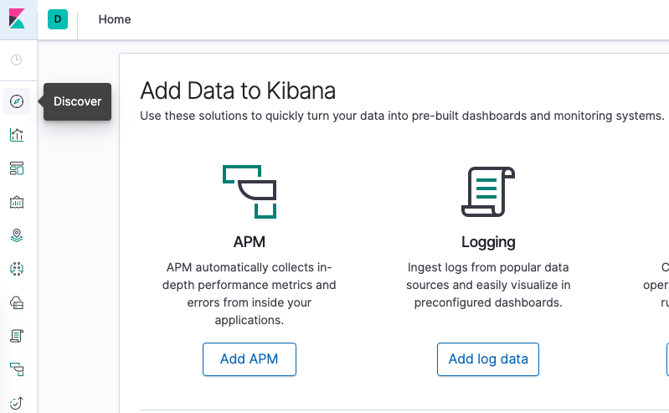
You should see the following configuration window:

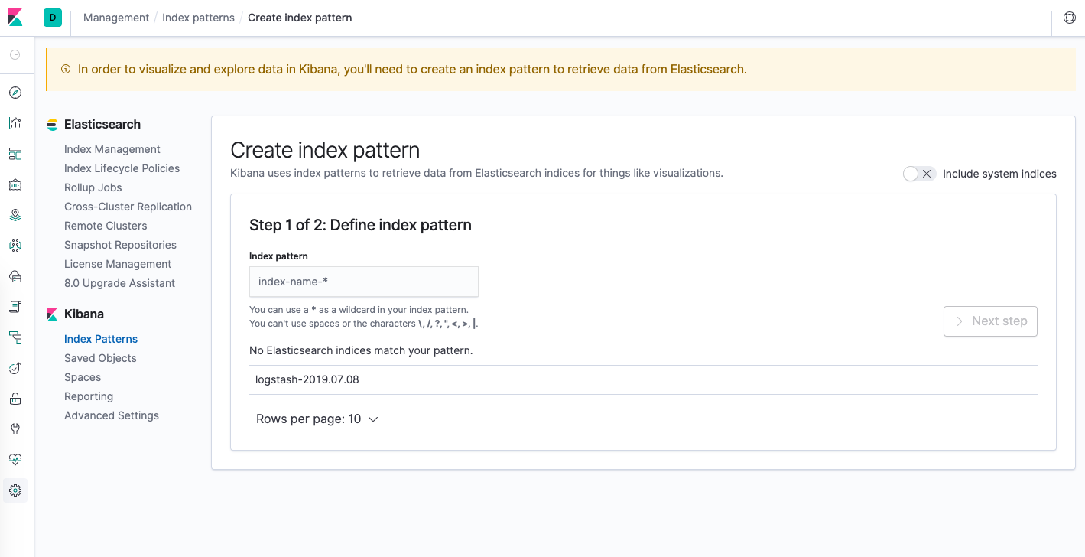
This allows you to define the Elasticsearch indices you’d like to explore in Kibana. For now, we’ll just use the logstash-* wildcard pattern to capture all the log data in our Elasticsearch cluster. Enter logstash-* in the text box and click on Next step.

You’ll then be brought to the following page:
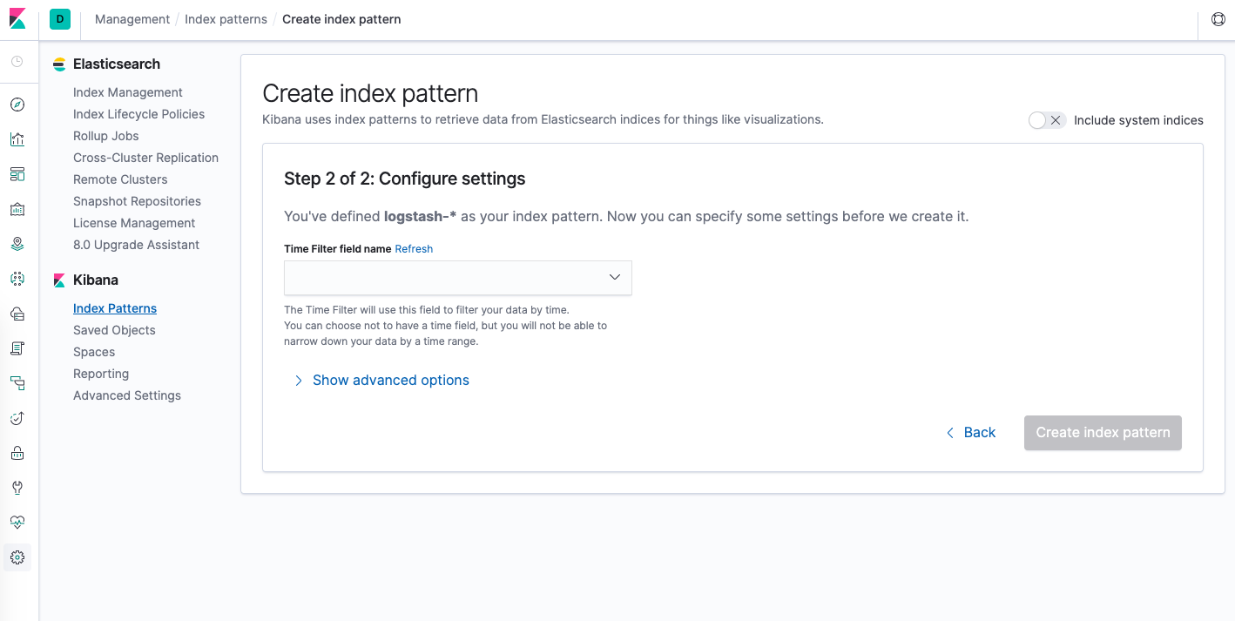
This allows you to configure which field Kibana will use to filter log data by time. In the dropdown, select the @timestamp field, and hit Create index pattern.
Now, hit Discover in the left hand navigation menu.
You should see a histogram graph and some recent log entries:

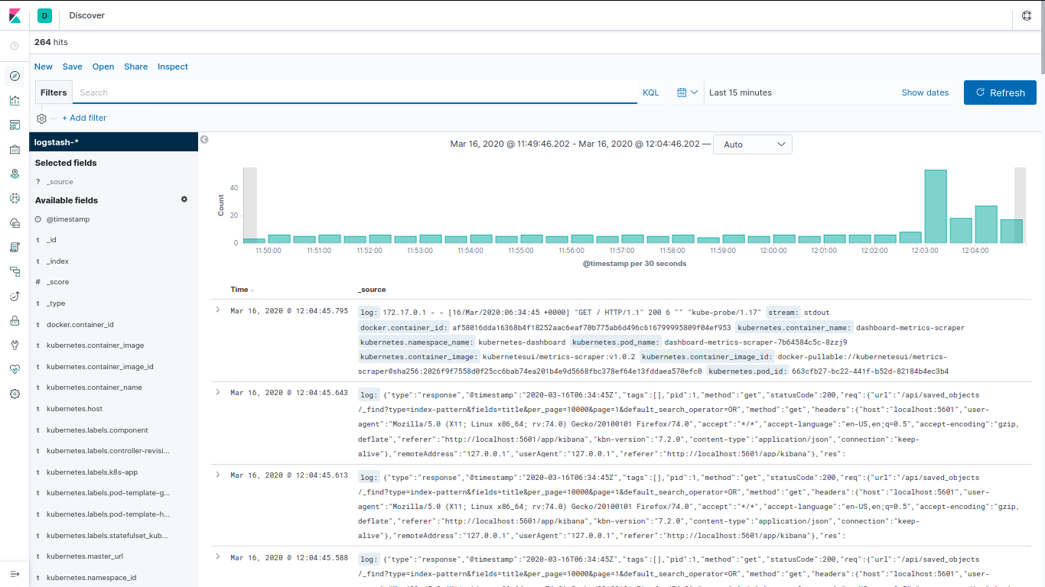
At this point you’ve successfully configured and rolled out the EFK stack on your Kubernetes cluster.

