Deploying custom docker image on Kubernetes with rolling updates and load-balancing

Introduction-

In this project we deploy our own basic static website on an nginx server by building our own custom docker image on kubernetes. Then we implement load-balancing and rolling updates on our deployment to emulate conditions of a real-time project.

Prerequisites-

Before getting started you need to make sure that you have docker engine, a running instance of a kubernetes cluster (we use minikube) and kubectl installed. If you already have these setup, you may skip to the next section.

Installing Docker engine-

First, update your existing list of packages:

$ sudo apt update

Next, install a few prerequisite packages which lets apt use packages over HTTPS:

$ sudo apt install apt-transport-https ca-certificates curl software-properties-common

Then add the GPG key for the official Docker repository to your system:

$ curl -fsSL https://download.docker.com/linux/ubuntu/gpg | sudo apt-key add -

Add the Docker repository to APT sources:

$ sudo add-apt-repository "deb [arch=amd64] https://download.docker.com/linux/ubuntu bionic stable"
Next, update the package database with the Docker packages from the newly added repo:

$ sudo apt update

Make sure you are about to install from the Docker repo instead of the default Ubuntu repo:

$ apt-cache policy docker-ce

Finally, install Docker:

$ sudo apt install docker-ce

Docker should now be installed, the daemon started, and the process enabled to start on boot. Check that it’s running:

$ sudo systemctl status docker

The output should be similar to the following, showing that the service is active and running:
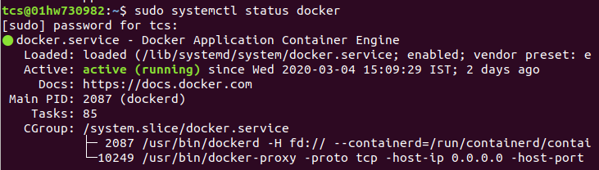
Installing Minikube-

Reference: https://kubernetes.io/docs/tasks/tools/install-minikube/

- Check if virtualisation is enabled

To check if virtualization is supported on Linux, run the following command and verify that the output is non-empty:
$ grep -E --color 'vmx|svm' /proc/cpuinfo
- Installing kubectl

Run the following command to install the latest version of kubectl:
$ curl -LO https://storage.googleapis.com/kubernetes-release/release/`curl -s https://storage.googleapis.com/kubernetes-release/release/stable.txt`/bin/linux/amd64/kubectl
Make the kubectl binary executable.
$ chmod +x ./kubectl
Move the binary in to your PATH.

$ sudo mv ./kubectl /usr/local/bin/kubectl
Test to ensure the version you installed is up-to-date:
$ kubectl version --client
- Install a hypervisor

Download the KVM or VirtualBox hypervisor from their respective official sites.

- Install minikube using homebrew
$ brew install minikube

- Confirm your installation by running the following commands

$ minikube start --vm-driver=<driver_name>

Once minikube start finishes, run the command below to check the status of the cluster:
$ minikube status
If your cluster is running, the output from minikube status should be similar to:
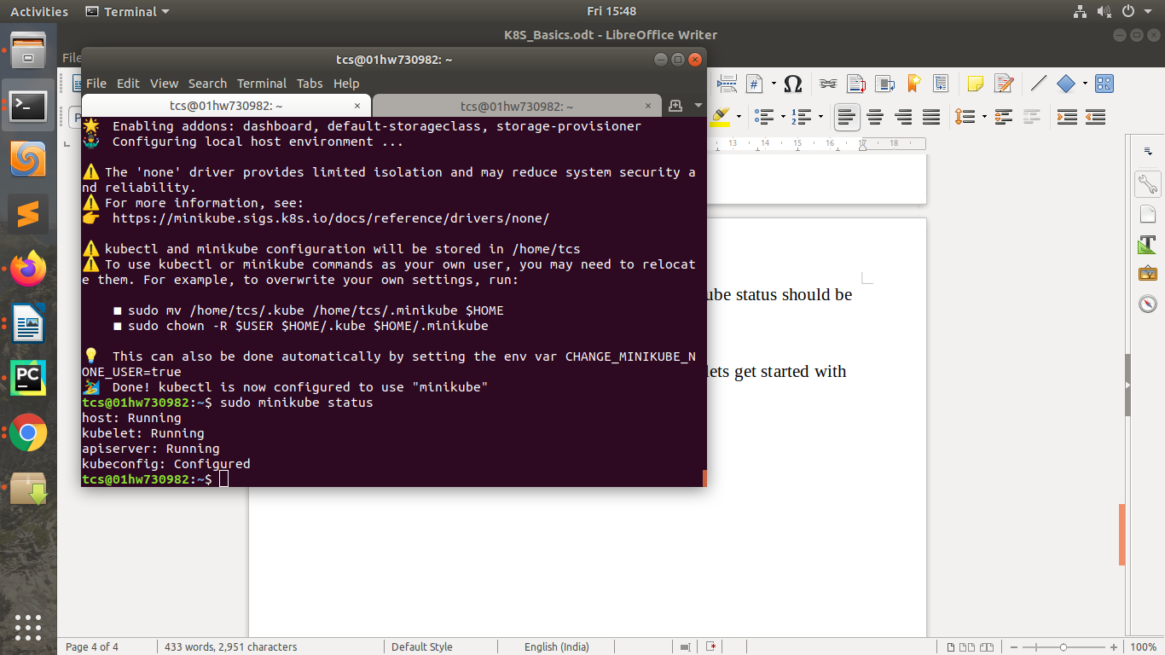

Now that we have a minikube cluster up and running lets get started with our custom website and docker image.
Making the custom docker image-
Create a separate directory in which we’re going to keep all our files.
First we begin by writing our simple static website. Create a file named index.html
$ nano index.html
Paste the following into the file:
<!DOCTYPE html>
<html>
<body>
<H1> Hello</H1>
<UL>
<LI>Apple</LI>
<LI>Orange</LI>
<LI>Banana</LI>
</UL>
</body>
</html>

Now we are going to write our DockerFile

$ nano Dockerfile

Paste the following into the Dockerfile:

FROM nginx:alpine
COPY index.html /usr/share/nginx/html

In this Dockerfile we first import the nginx:alpine image from DockerHub as our base image and then copy our index file into the nginx image’s /usr/share/nginx/hmtl directory.

Now we will build this Dockerfile-

$ sudo docker build -t myimage .

We build the Dockerfile and giving it the name of “myimage”.

Now we have our website as a custom image on our local docker repository.

Now all we need to do is provide this image to our deployment on our kubernetes cluster.

Deploying our custom image on Minikube-

Now we write the deployment YAML file-

$ nano my_deployment.yaml

Paste the following into the file:

apiVersion: apps/v1
kind: Deployment
metadata:
name: mynginx-deployment
labels:
app: mynginx-deployment
spec:
replicas: 3
selector:
matchLabels:
app: test
template:
metadata:
labels:
app: nginx
spec:
containers:
- name: nginx
image: myimage
imagePullPolicy: Never

Now when we have created our YAML file we can now create the deployment on our cluster-

$ kubectl create -f my_deployment.yaml

We have created a deployment for our custom image with 3 replicas.

Now on to create a service to expose the deployment for public access-

$ nano my-service.yaml

Paste the following into the yaml file:

apiVersion: v1
kind: Service
metadata:
name: my-service
spec:
selector:
app: mynginx-deployment
ports:
- protocol: TCP
port: 80
targetPort: 80
nodePort: 30033
type: LoadBalancer

This exposes our deployment in such a way that all requests on the port 30033 would be sent to port 80 inside the container.

Now to access the webpage hosted on the container, simply run the following command-

$ curl localhost:30033

You should see the following output:

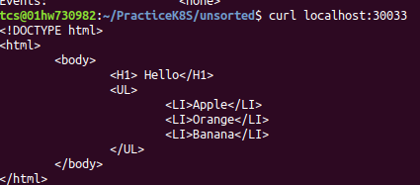

As of now we have successfully hosted our custom docker image on our kubernetes cluster.

Now to perform rolling updates on the deployment, let’s assume we need to change the image of the deployment to the nginx:alpine version. Run the following command-

$ kubectl set image deployments/mynginx-deployment myimage=nginx:alpine

Run the following command to see the pods being updated-

$ kubectl get pods

You should see the following output-
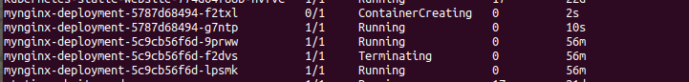
You can confirm that the image has been updated by running the following command and looking in the image section-

$ kubectl describe pods

To confirm if the rolling update went successfully you can also run the command:

$ kubectl rollout status deployments/mynginx-deployment

You should see the following output:

deployment "mynginx-deployment" successfully rolled out

To undo the rollout run the following command:

$ kubectl rollout undo deployments/mynginx-deployment

As of now we have completed hosting our custom docker image on a kubernetes server, complete with load-balancing and roll out updates.

GitHub Link: https://github.com/aveepsit/K8S-Basics

