OBD Modes Requirements Document

Contents
Document Control 3
Document History 4
Introduction 5
Functional Description 5
Requirements 5
References 5

Document Control
- Document Title: OBD Stack
- Version: 1.0
- Date: 31-03-2025
- Author: Shweta Masali, Soumya Ganagi
- Reviewed by: [Enter Reviewer Name]
- Approved by: [Enter Approver Name]

Document History
Author | Date | Revision | Changes
Shweta Masali  Soumya Ganagi | 31-03-2025 | 1

Introduction

Service $09 is used to retrieve essential vehicle-specific information from the ECU. This service allows external diagnostic tools to request data such as the Vehicle Identification Number (VIN), Calibration Identifications (Cal IDs), and Calibration Verification Numbers (CVN). The retrieved information is crucial for regulatory compliance, vehicle maintenance, and performance analysis.
When a diagnostic tool sends a request with Service ID 09 followed by an Information Type (InfoType) ID, the ECU responds with the requested data. This enables mechanics, engineers, and regulatory authorities to access vehicle identification details in a standardized format.

Functional Description
This document captures the requirements related to the Service/Mode $09 for the OBD stack. All functional requirements are captured in this document

Requirements

RS_OBD_01
P2 and P2* timings are as follows
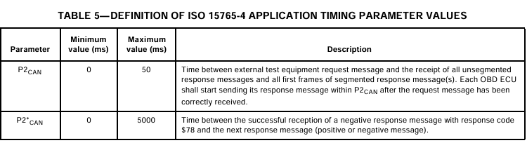

RS_OBD_02
Request Vehicle Information Request Message Definition
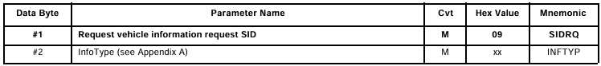

RS_OBD_03
Request Vehicle Information Response Message Definition
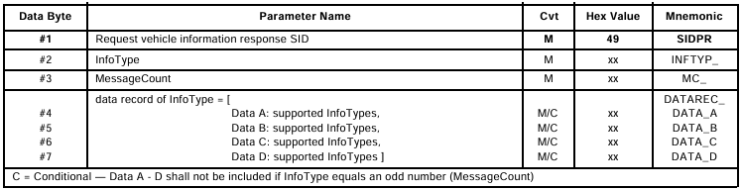

RS_OBD_04
Request Vehicle Information Request Message Definition
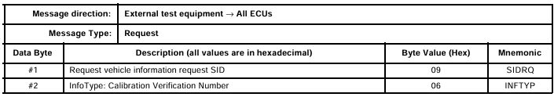

RS_OBD_05
Request Vehicle Information Response Message Definition
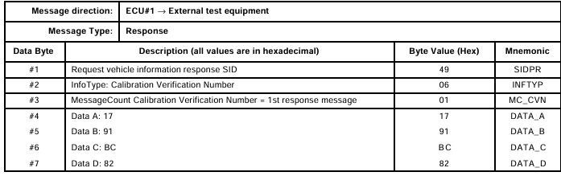

RS_OBD_06
Data Not Available Within P2 Timing
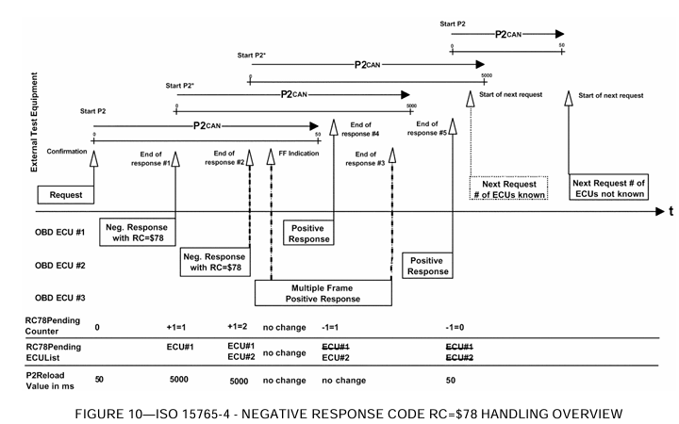

- The ECU(s) shall respond with a negative response message with response code $78 RequestCorrectlyReceived-ResponsePending within P2 timing.
- After correct reception of the negative response message with response code $78 the P2CANmax parameter timing value shall be set to P2*CAN (5000 ms) by the external test equipment and the ECU which has sent the negative response message.
- If another ECU also sends a negative response message with response code $78 the P2CANmax timing parameter value shall be reset to P2*CAN.
- ECUs which require more than P2*CAN to perform the requested action shall repeat the negative response message with response code $78 prior to expiration of P2*CAN until correct reception of the positive response message.

RS_OBD_07
Negative Response Message Format
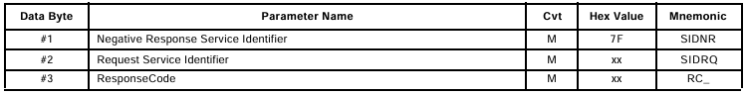
- For service $09 the use of negative response code $22 is allowed only during conditions specified by OBD regulations

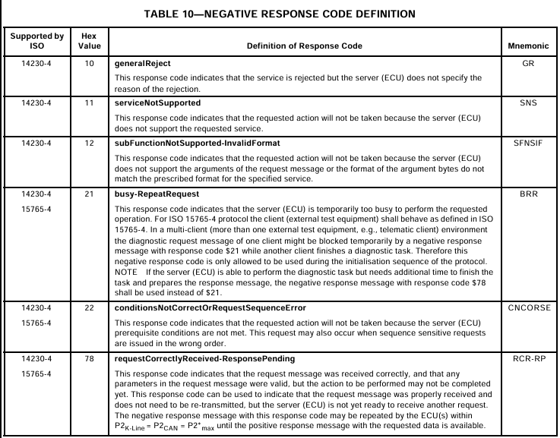

References
- SAE-J1979-2002-ISO-DIS-15031-5-2002

