BOS AIDE Knowledge-Centric Loop Engineering
  - Architecture and Detailed Design
BOS AIDE Engineering
20 August 2026
Subtitle: Graph-Governed Spec-Driven Development for Single- and Multi-Microservice Delivery
Version: 1.0.1
Date: 20 August 2026
Deployment baseline: Native Windows 11 x64

1. Executive summary
BOS AIDE Knowledge-Centric Loop Engineering combines three disciplines:
- Spec-Driven Development defines the destination: requirements, design, tasks, acceptance criteria, and traceability.
- Loop Engineering executes bounded Goal -> Action -> Observation -> Adjustment cycles until deterministic evidence produces PASS, a decision requires ESCALATE, or limits produce FAIL.
- Graph Engineering provides connected enterprise context: services, repositories, APIs, events, schemas, data, user flows, tests, ADRs, owners, deployments, incidents, and provenance.
A multi-service change does not use one unrestricted global coding loop. It starts with one enterprise specification and graph-derived impact context, derives one local specification per affected service, and executes separate service, contract, integration, and E2E loops.
The Knowledge Plane is Markdown-first:
- Git-backed wiki/ pages are governed artifacts.
- Neo4j is the exact typed relationship index.
- Graphiti adds temporal and semantic context.
- OpenWiki compiles user-readable documentation.
- Kiro retrieves bounded context through indexed resources and a custom MCP server.
- Only reviewed and merged outcomes become canonical learning.

2. Architecture principles
- Kiro proposes; deterministic gates and human-governed delivery systems decide.
- Markdown is durable; the graph is rebuildable.
- Deterministic extraction precedes LLM synthesis.
- Declared, contracted, implemented, and observed evidence remain distinct.
- Context is assembled for the task, not dumped wholesale.
- Loops have explicit scope, gates, budgets, escalation, and terminal states.
- The enterprise orchestrator coordinates and routes; it does not edit all repositories freely.
- OpenWiki and temporal memory are derived and lower trust.
- Learning is merge-gated.
- The exact graph remains usable when Graphiti or an LLM provider is unavailable.

3. Goals and non-goals

Goals
- Support new and legacy systems from one repository to enterprise service graphs.
- Keep knowledge predominantly in Markdown.
- Give Kiro exact contract and schema evidence.
- Provide graph-based impact analysis and failure routing.
- Bound agent execution and cost.
- Preserve provenance and history.
- Generate readable documentation without weakening authority.
- Run natively on Windows without containers.

Non-goals
- Fine-tune a model on every source change.
- Replace Git, CI, Jira, architecture review, or CODEOWNERS.
- Allow Kiro to deploy directly to production.
- Treat OpenWiki, Graphiti, or Mem0 as canonical truth.
- Add a separate vector platform before scale measurements justify it.

4. Operating model

Single microservice
Feature Spec -> task loop -> service loop -> deterministic gates -> PR -> approved learning

Multiple microservices
Enterprise Spec -> graph impact/context -> bounded service-local specs
-> service loops -> contract loop -> integration loop -> E2E loop
-> coordinated PRs -> approved learning

5. System context
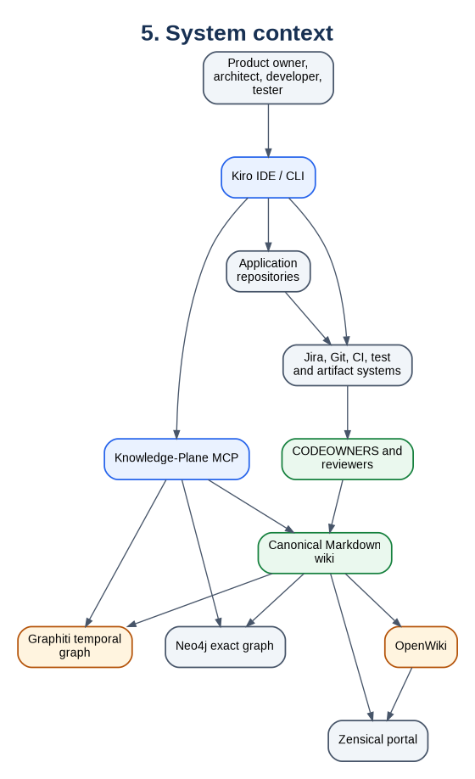
5. System context
Mermaid source is preserved in the Markdown edition.

6. Layered reference architecture
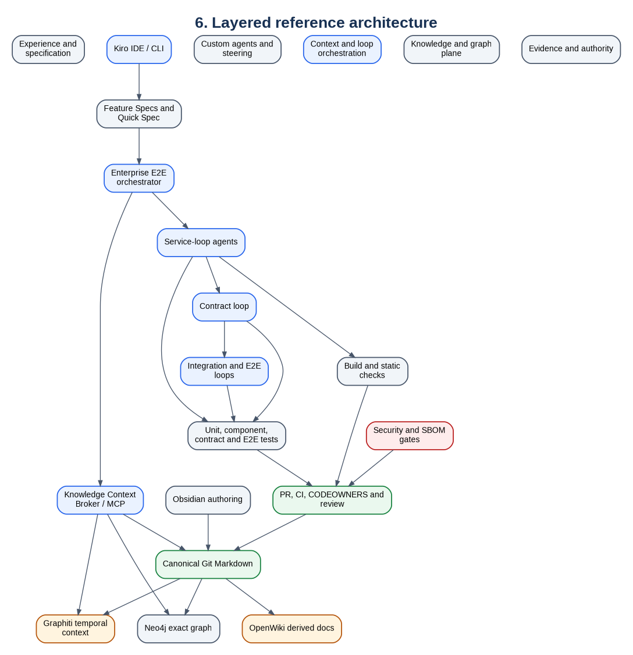
6. Layered reference architecture
Mermaid source is preserved in the Markdown edition.

7. Final component stack
Capability | Choice | Architectural role
Specification | Kiro Feature Specs | Requirements, design, tasks and acceptance traceability
Loop orchestration | Kiro agents + YAML contracts + CI | Bounded execution and deterministic termination
Canonical knowledge | Git Markdown + YAML | Governed, human-readable knowledge
Exact graph | Neo4j 5.26 LTS | Typed traversal and deterministic provenance
Temporal graph | Graphiti | Changing facts, episodes and hybrid retrieval
Context interface | Custom MCP server | Policy boundary between Kiro and knowledge systems
Documentation | OpenWiki + Zensical | Derived explanations and Mermaid portal
Authoring | Obsidian | Human navigation and editing
Authority | Git/Jira/CI/CODEOWNERS | Acceptance and publication control

8. Loop state model
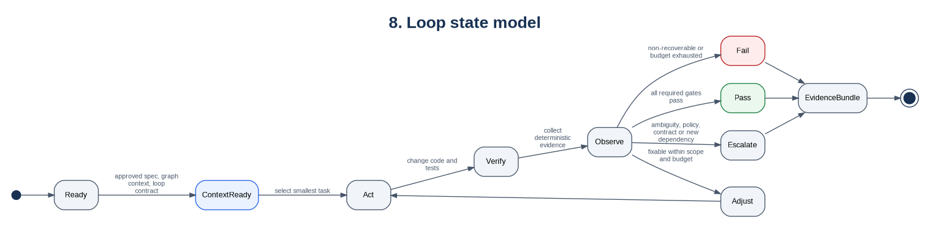
8. Loop state model
Mermaid source is preserved in the Markdown edition.
Every loop contract defines goal, allowed repositories and paths, forbidden actions, escalation conditions, verification gates, budgets, and exactly three terminal states.

9. Single-service sequence
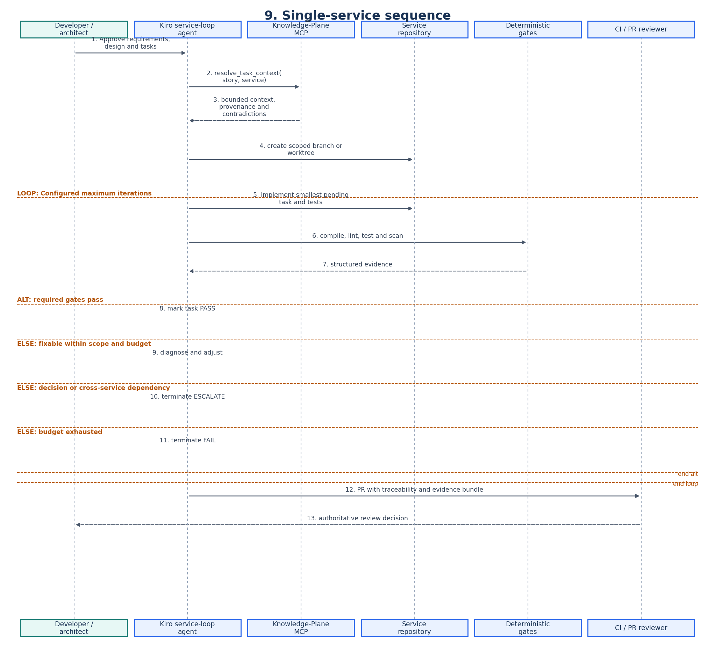
9. Single-service sequence
Mermaid source is preserved in the Markdown edition.

10. Multi-service nested loops
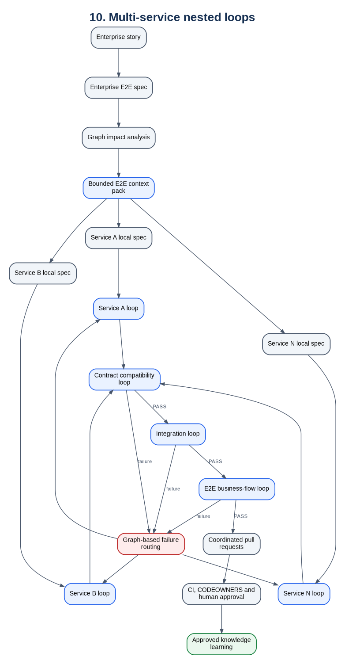
10. Multi-service nested loops
Mermaid source is preserved in the Markdown edition.

11. Enterprise orchestration sequence
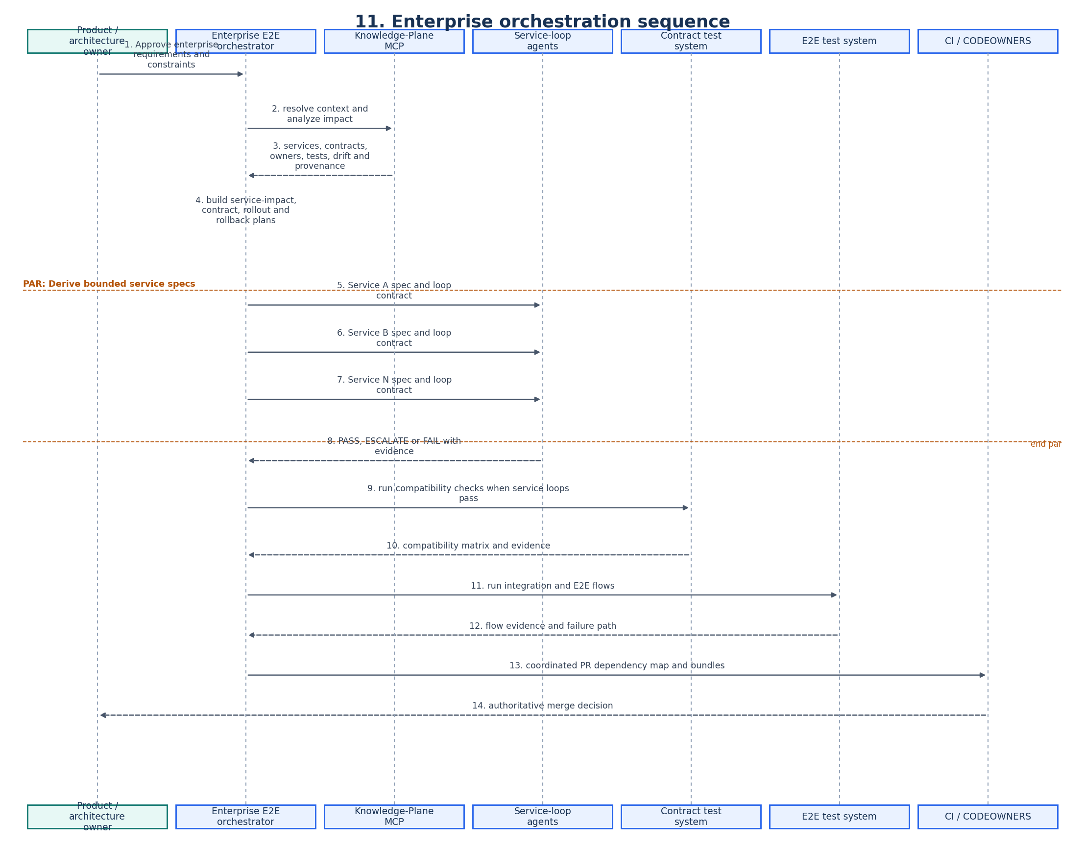
11. Enterprise orchestration sequence
Mermaid source is preserved in the Markdown edition.

12. Graph Engineering lifecycle
Graph Engineering comprises:
- Ontology engineering.
- Deterministic extraction.
- Entity resolution.
- Relationship and provenance validation.
- Context retrieval and impact analysis.
- Graph evolution after approved delivery.
It is not merely loading Markdown into Neo4j.
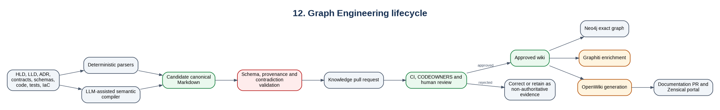
12. Graph Engineering lifecycle
Mermaid source is preserved in the Markdown edition.

13. Context assembly
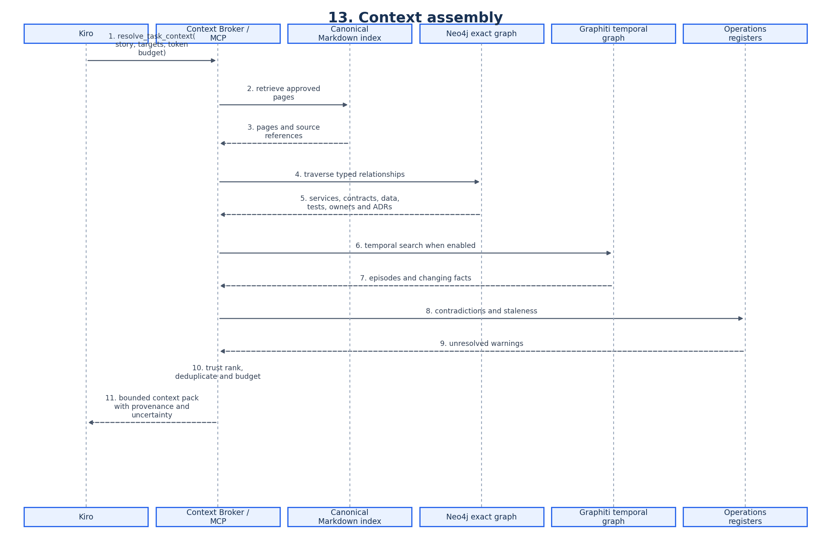
13. Context assembly
Mermaid source is preserved in the Markdown edition.
Context packs are disposable views, not canonical knowledge.

14. Context-pack model
generated/context-packs/<story-id>/
|-- objective.md
|-- acceptance-criteria.md
|-- affected-services.md
|-- user-flow.md
|-- current-contracts.md
|-- data-impact.md
|-- code-entry-points.md
|-- relevant-adrs.md
|-- existing-tests.md
|-- dependency-order.md
|-- rollout-and-rollback.md
|-- contradictions.md
`-- provenance.md

15. Core ontology
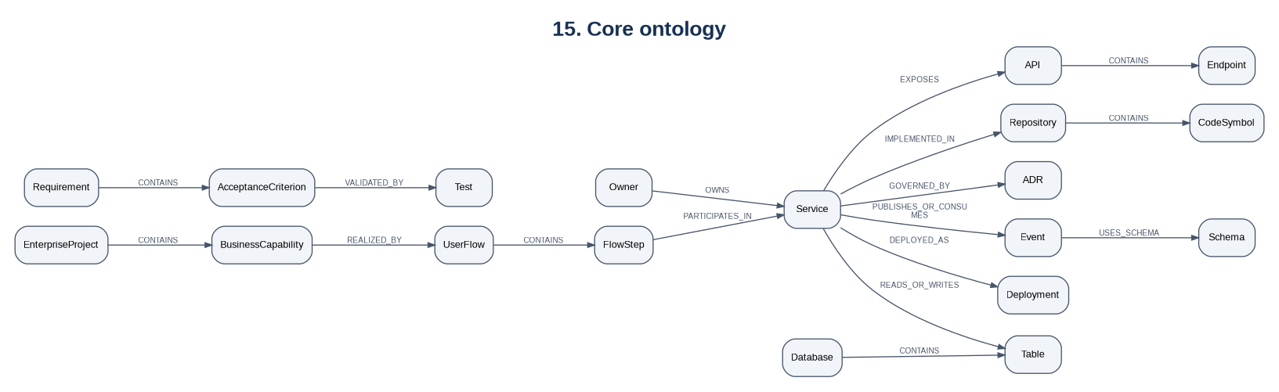
15. Core ontology
Mermaid source is preserved in the Markdown edition.
Every fact should preserve source, commit, location or pointer, evidence class, confidence, review status, validity interval, last verification, extractor, and access scope.

16. Contract change sequence
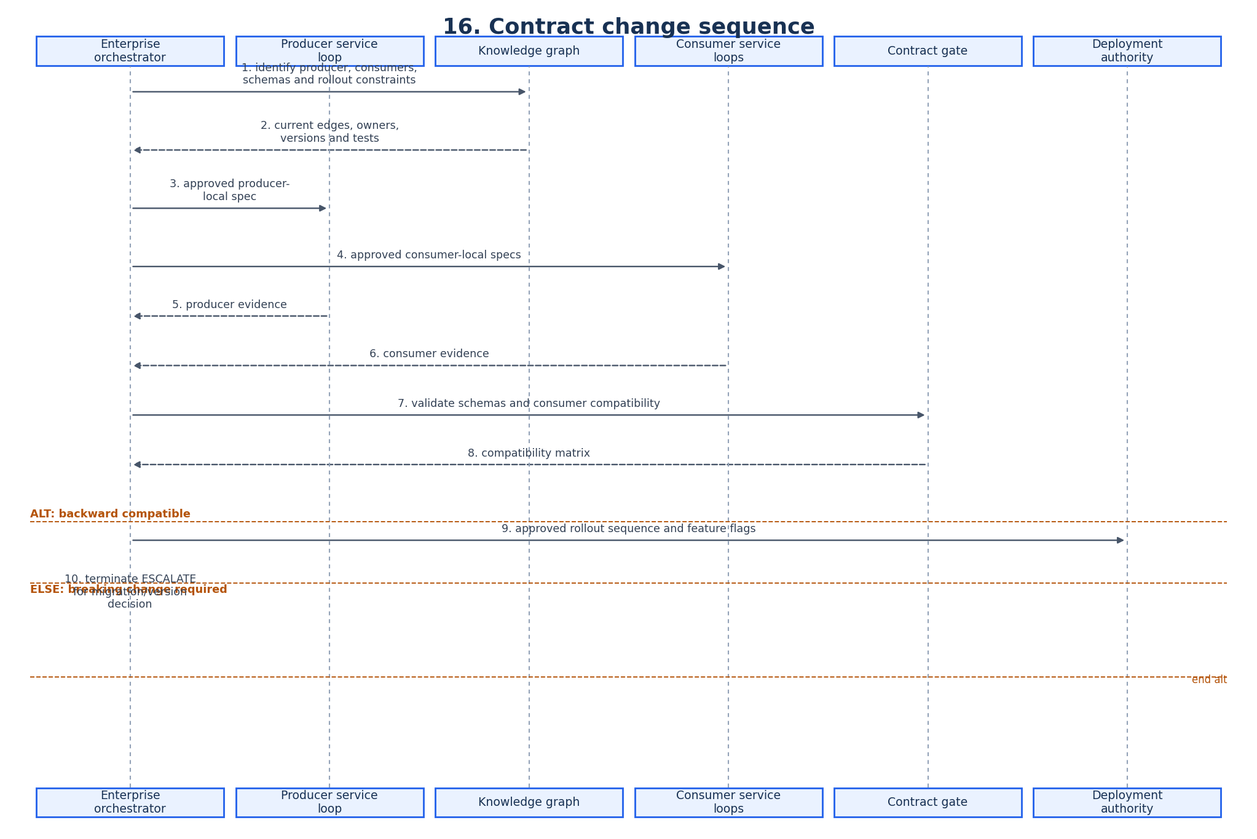
16. Contract change sequence
Mermaid source is preserved in the Markdown edition.

17. Self-learning model
Self-learning means evidence-driven improvement of knowledge and procedure, not unsupervised rewriting of architectural truth.
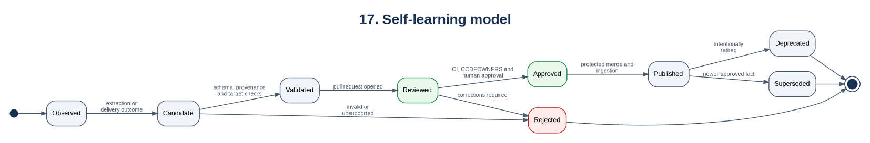
17. Self-learning model
Mermaid source is preserved in the Markdown edition.
Learning domain | Examples | Rule
Semantic knowledge | APIs, schemas, dependencies, ownership | Source-backed PR required
Episodic memory | Attempt, incident, task discussion | Advisory and retention-controlled
Procedural knowledge | Testing or migration convention | Promote to steering after reviewed evidence
Retrieval learning | Query misses and accepted context | Improve ranking, not canonical facts

18. Trust and security boundaries
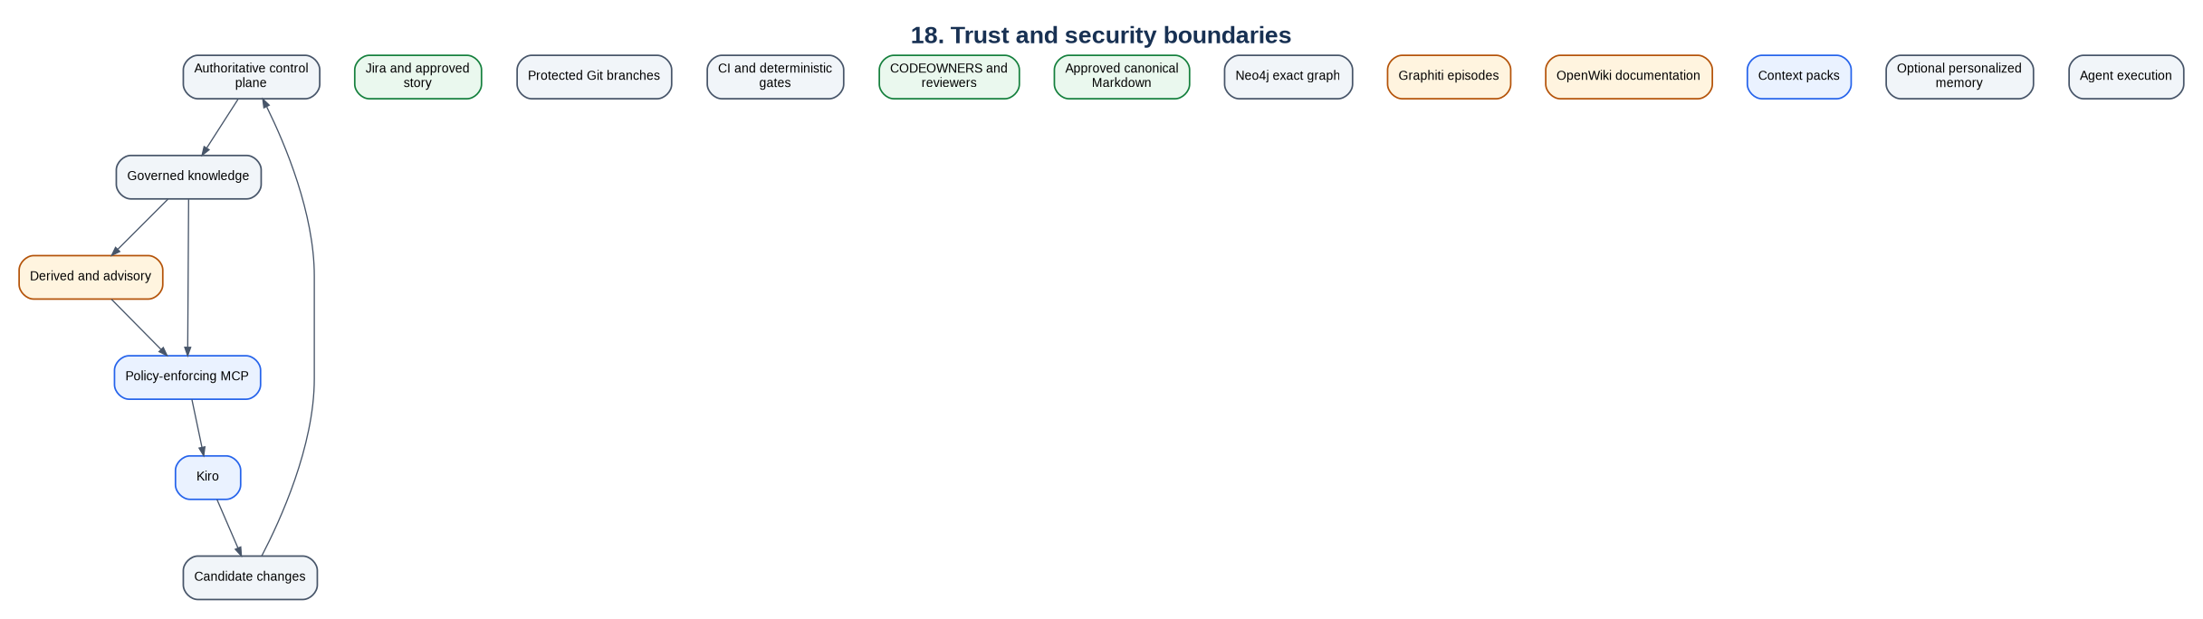
18. Trust and security boundaries
Mermaid source is preserved in the Markdown edition.
The transition from candidate changes to authority always crosses validation and human review.

19. Windows native deployment
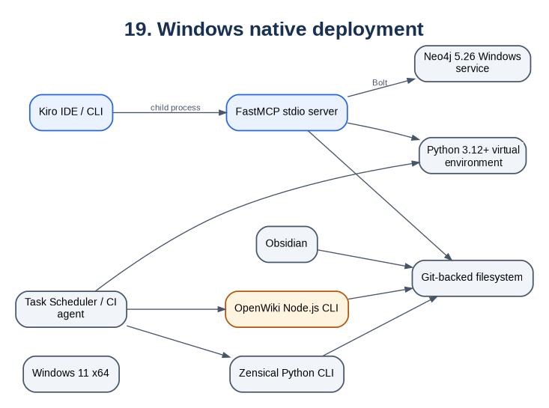
19. Windows native deployment
Mermaid source is preserved in the Markdown edition.

20. MCP design
Read tools:
health
list_knowledge_pages
read_knowledge_page
get_entity
search_knowledge
trace_dependencies
analyze_change_impact
resolve_task_context
list_contradictions
Controlled write tool:
propose_knowledge_delta
The write tool may create a candidate only under generated/candidates/. It cannot write to wiki/, merge a branch, or publish graph facts.

21. OpenWiki architecture
Approved wiki and source evidence
-> OpenWiki generation
-> openwiki/ derived Markdown
-> documentation PR
-> review
-> Zensical portal
OpenWiki pages may orient a reader or agent. Exact code, contract, and schema decisions must rely on canonical and source evidence.

22. Failure routing
Failure | Required response
Local build/test failure | Continue local loop within scope and budget
New service dependency | Terminate ESCALATE and update enterprise impact
Contract incompatibility | Route to contract loop and owners
E2E failure with graph path | Route to responsible service or edge loop
Unknown failure owner | ESCALATE and create a knowledge-gap candidate
Graphiti provider unavailable | Continue with Markdown and exact Neo4j graph
Neo4j unavailable | Stop graph-dependent planning; do not invent impact
Contradictory current facts | Surface both with provenance
OpenWiki hallucination | Reject derived documentation
Loop budget exhausted | Terminate FAIL or ESCALATE; never continue indefinitely

23. Observability and evaluation
Collect:
- MCP request count, latency, errors, and tool use.
- Neo4j query latency and result size.
- Graphiti provider cost, latency, and failures.
- Ingestion duration, nodes, edges, contradictions, and staleness.
- Loop iterations, elapsed time, terminal state, gates, files, and credits.
- OpenWiki changed pages and PR acceptance.
Measure:
Metric | Purpose
Context precision and recall | Useful context without missing critical facts
Provenance coverage | Claims with resolvable evidence
Contract hallucination rate | Invented endpoint/event/field/table references
Impact-analysis accuracy | Correct affected services and consumers
Loop convergence | PASS rate and iterations
Escalation quality | Correct owner, evidence, and decision request
Knowledge-delta acceptance | Candidate learning approved after review
Delivery outcome | CI, defects, rollback, and lead-time results

24. Scalability

Small service
Use local Kiro specs, bounded loops, direct Markdown indexing, and optionally a lightweight graph.

Six to seven services
Use the complete design: enterprise spec, Neo4j, Graphiti, MCP, service loops, contract loop, E2E loop, OpenWiki, and merge-gated learning.

Large legacy estate
Add Tree-sitter/SCIP-style code intelligence, incremental ingestion, repository federation, access-control propagation, and stronger evidence-class separation.

Enterprise federation
Use globally unique IDs and a shared ontology while allowing domain-owned knowledge repositories and graph groups.

25. Architecture decisions

ADR-001 - Git Markdown is canonical
Graphs are rebuildable; publication uses ordinary PR governance.

ADR-002 - Exact and temporal graphs coexist
Neo4j stores deterministic facts; Graphiti supplies temporal and semantic context.

ADR-003 - Custom MCP policy facade
Kiro receives task-oriented tools, not unrestricted Cypher or graph administration.

ADR-004 - Multi-service work uses nested loops
The enterprise orchestrator coordinates bounded service, contract, integration, and E2E loops.

ADR-005 - OpenWiki is derived
Generated documentation cannot override canonical knowledge.

ADR-006 - Native Windows baseline
Neo4j runs as a service; Python and Node tools run natively without containers.

ADR-007 - Zensical for new portals
Use a current Mermaid-capable documentation generator while preserving Markdown portability.

26. Delivery roadmap
- Standardize Kiro Feature Specs and deterministic local loops.
- Normalize canonical Markdown and build the exact Neo4j graph.
- Add graph-backed impact and bounded service-local specs.
- Add contract, integration, and E2E loops.
- Enable Graphiti with an approved provider.
- Add OpenWiki and the Zensical portal.
- Add access-control propagation, evaluation, and federation.

27. Architecture acceptance criteria
- ☐ Exact graph rebuilds from approved Markdown.
- ☐ Every published graph fact has provenance and review status.
- ☐ Single-service loops enforce repository, path, gate, and budget scope.
- ☐ Multi-service changes have one enterprise spec and one local spec per affected service.
- ☐ Contract and E2E loops pass before coordinated merge.
- ☐ Kiro cannot silently expand a service loop into another repository.
- ☐ Exact retrieval works during Graphiti/provider degradation.
- ☐ OpenWiki cannot overwrite canonical knowledge.
- ☐ Candidate learning cannot bypass CI and review.
- ☐ The developer topology runs natively on Windows.

28. Summary
The specification defines the destination.
The graph identifies the connected route and evidence.
Bounded loops implement, observe, adjust, and prove the journey.
Deterministic gates and humans decide what is accepted and learned.

29. Primary references
- Kiro Feature Specs: https://kiro.dev/docs/specs/feature-specs/
- Kiro MCP: https://kiro.dev/docs/mcp/
- Kiro custom agents: https://kiro.dev/docs/cli/custom-agents/configuration-reference/
- Neo4j Windows installation: https://neo4j.com/docs/operations-manual/current/installation/windows/
- Graphiti: https://github.com/getzep/graphiti
- MCP Python SDK: https://github.com/modelcontextprotocol/python-sdk
- OpenWiki: https://github.com/langchain-ai/openwiki
- Zensical: https://zensical.org/docs/get-started/

