BOS AIDE Graph-Governed Spec-Driven Loop Engineering
  - Native Windows Installation and Operations Guide
BOS AIDE Engineering
20 August 2026
Version: 1.0.1
Date: 20 August 2026
Target: Windows 11 x64, native processes only
Container runtime: Not required

1. Purpose
This guide installs a complete engineering environment that combines:
- Kiro Spec-Driven Development.
- Bounded Loop Engineering for implementation and verification.
- Graph Engineering for multi-service impact, relationships, provenance, and context retrieval.
- A Markdown-first Knowledge Plane.
- OpenWiki for user-readable generated documentation.
- Zensical for a Mermaid-capable documentation portal.
- Obsidian as an optional human editing and exploration surface.
The same stack supports two operating modes:
Single microservice
Kiro Feature Spec -> task/service loop -> deterministic gates -> PR and review
Multiple microservices
Enterprise Spec -> graph context -> service-local specs -> bounded service loops
-> contract loop -> integration loop -> E2E loop -> coordinated review
The controlling rule is:
Kiro proposes and implements within an approved scope. Deterministic gates, protected branches, CI, Jira, CODEOWNERS, and human reviewers decide what is accepted and learned.

2. Final recommended stack
Layer | Final selection | Purpose
Engineering authority | Git repositories, Jira, contracts, schemas, migrations, CI, deployments | Actual implementation and approved delivery evidence
Specification | Kiro Feature Specs; Quick Spec only for low-risk work | Requirements, design, tasks, traceability, and acceptance criteria
Loop engineering | Kiro custom agents, YAML loop contracts, deterministic gates | Bounded Goal -> Action -> Observation -> Adjustment execution
Canonical knowledge | Git-backed Markdown with YAML frontmatter | Reviewable and portable knowledge source
Human authoring | Obsidian | Browse, edit, link, and visualize Markdown knowledge
Exact graph | Neo4j 5.26 LTS | Typed, deterministic, rebuildable graph
Temporal graph | Graphiti | Temporal facts, episodes, semantic relationships, and hybrid retrieval
Context broker | Python 3.12 or later + official MCP Python SDK 1.x | Policy-enforcing Kiro interface over local stdio
Generated documentation | OpenWiki | Human-readable Markdown under openwiki/
Documentation portal | Zensical | Publish approved and generated content with Mermaid support
Quality and security | Build, lint, unit, component, contract, E2E, SAST, secret and SBOM checks | Deterministic loop evidence and merge gates
Memory | Graphiti episodes initially | Historical context that never overrides approved knowledge
Optional personalization | Mem0 later, only if justified | Isolated user/agent preferences, not architecture truth

2.1 Components intentionally deferred
Do not add these initially unless measurements justify them:
- A separate vector database.
- Mem0 as the architectural knowledge store.
- A generic unrestricted agent that edits all repositories.
- Automatic publication of LLM-generated facts.
- A separate Graphiti MCP server directly exposed to Kiro.

3. Native Windows topology
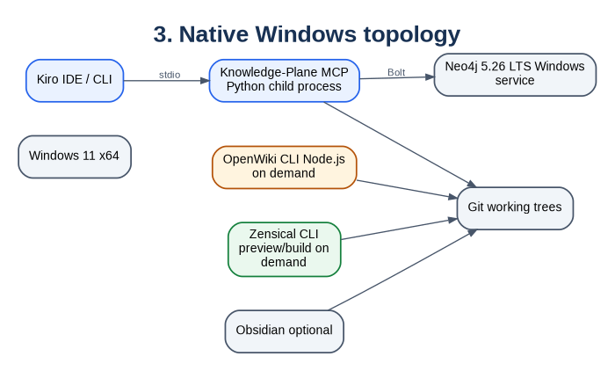
3. Native Windows topology
Mermaid source is preserved in the Markdown edition.
Only Neo4j must run continuously. Kiro starts and stops the MCP server locally. OpenWiki and Zensical run manually, from Windows Task Scheduler, or from CI.

4. Prerequisites
Software | Recommended baseline | Verify
Windows | Windows 11 x64 | winver
PowerShell | PowerShell 7.x | $PSVersionTable.PSVersion
Git | Current Git for Windows | git --version
Python | Python 3.12 or later x64 | python --version / py -0p
Java | JDK 21 x64 | java -version
Node.js | Node.js 22 or later | node --version
npm | Bundled with Node.js | npm --version
Neo4j | Latest 5.26 LTS patch | neo4j version
Kiro | Current IDE and CLI | kiro-cli --version
Obsidian | Current desktop release, optional | Launch application

4.1 Suggested workstation sizing
Resource | Pilot minimum | Recommended for 6-7 services
CPU | 4 cores | 8 or more cores
RAM | 16 GB | 32 GB
Free SSD | 20 GB | 50-100 GB
Neo4j heap | 1 GB | 2-4 GB after measurement
Neo4j page cache | 1 GB | 2-8 GB after measurement
These are planning estimates, not vendor sizing guarantees.

4.2 Recommended folders
C:\BOS\KnowledgePlane\ Knowledge Plane repository
C:\BOS\Neo4j\neo4j-community-5.26.x\ Neo4j binaries
D:\BOSData\Neo4j\data\ Optional data directory
D:\BOSData\Neo4j\logs\ Optional log directory
D:\BOSData\Neo4j\backups\ Backup destination

5. Extract and inspect the starter kit
New-Item -ItemType Directory -Path C:\BOS -Force
Expand-Archive `
-Path "$HOME\Downloads\BOS_AIDE_Loop_Graph_Windows_Native_Starter_Kit.zip" `
-DestinationPath C:\BOS `
-Force
Set-Location C:\BOS\bos-aide-loop-graph-windows-native
Get-ChildItem
Get-ChildItem .\scripts
Expected script paths include:
scripts\install-neo4j-service.ps1
scripts\install-native-windows.ps1
scripts\healthcheck.ps1
scripts\validate.ps1
scripts\ingest.ps1
scripts\validate-loop.ps1
scripts\openwiki-update.ps1
scripts\serve-docs.ps1
Unblock downloaded files and allow locally created scripts:
Get-ChildItem -Path . -Recurse -File | Unblock-File
Set-ExecutionPolicy -Scope CurrentUser RemoteSigned

6. Install Neo4j as a native Windows service
Download the current Windows ZIP from the Neo4j 5.26 LTS line and extract it to a permanent folder such as:
C:\BOS\Neo4j\neo4j-community-5.26.x
Open PowerShell as Administrator:
Set-Location C:\BOS\bos-aide-loop-graph-windows-native
.\scripts\install-neo4j-service.ps1 `
-Neo4jHome 'C:\BOS\Neo4j\neo4j-community-5.26.x'
The script:
- Checks administrator rights and JDK 21.
- Sets NEO4J_HOME.
- Binds the developer installation to 127.0.0.1.
- Sets the initial password.
- Installs and starts the Windows service.
- Records the selected Neo4j path.
For a shared or production-style host, change the service logon from LocalSystem to a dedicated low-privilege account.

6.1 Manual equivalent
$env:NEO4J_HOME = 'C:\BOS\Neo4j\neo4j-community-5.26.x'
Set-Location "$env:NEO4J_HOME\bin"
.\neo4j-admin.bat dbms set-initial-password
.\neo4j.bat windows-service install
.\neo4j.bat start
Expected local endpoints:
Neo4j Browser: http://127.0.0.1:7474
Bolt: bolt://127.0.0.1:7687

7. Install the Knowledge Plane application
Open a normal PowerShell window:
Set-Location C:\BOS\bos-aide-loop-graph-windows-native
.\scripts\install-native-windows.ps1
The script performs these actions:
- Validates Git, Python, Java, Node.js, and npm.
- Creates .venv with an installed Python 3.12 or later runtime.
- Installs Graphiti, the Neo4j driver, MCP SDK, tests, and Zensical.
- Installs OpenWiki unless -SkipOpenWiki is used.
- Creates .env from .env.example.
- Generates .kiro\settings\mcp.json with an absolute Python path.
- Validates canonical Markdown.
- Runs unit tests.
Install the core first and add OpenWiki later:
.\scripts\install-native-windows.ps1 -SkipOpenWiki
npm install --global openwiki

7.1 Manual Python installation
python -m venv .venv
.\.venv\Scripts\Activate.ps1
python -m pip install --upgrade pip setuptools wheel
python -m pip install -e ".[dev,docs]"

8. Configure runtime settings and secrets
Copy-Item .env.example .env
notepad .env
Minimum deterministic configuration:
NEO4J_URI=bolt://localhost:7687
NEO4J_USER=neo4j
NEO4J_PASSWORD=<local-secret>
NEO4J_DATABASE=neo4j
KNOWLEDGE_ROOT=.
ENABLE_GRAPHITI=false
MCP_TRANSPORT=stdio
GRAPHITI_TELEMETRY_ENABLED=false
Do not commit .env. On shared hosts, inject secrets from an approved secrets manager or Windows credential mechanism.

8.1 Enable Graphiti only after exact ingestion works
ENABLE_GRAPHITI=true
GRAPH_GROUP_ID=enterprise-project-name
OPENAI_API_KEY=<approved-provider-key>
OPENAI_BASE_URL=<approved-compatible-endpoint-if-required>
GRAPHITI_TELEMETRY_ENABLED=false
A local or air-gapped OpenAI-compatible endpoint can be used only after model, embedding, data-handling, and provider compatibility are verified.

9. Validate installation health
.\scripts\healthcheck.ps1
.\scripts\validate.ps1
Manual checks:
Test-Path .\.venv\Scripts\python.exe
Test-Path .\.kiro\settings\mcp.json
Test-NetConnection localhost -Port 7687
Test-NetConnection localhost -Port 7474

10. Repository structure
bos-aide-loop-graph-windows-native/
|-- .kiro/
| |-- agents/
| |-- settings/
| `-- steering/
|-- enterprise-specs/ Cross-service requirements, design and coordination
|-- loops/ Task, service, contract and E2E loop contracts
|-- ontology/ Entity, relationship and trust definitions
|-- manifests/ Repositories, ownership and source patterns
|-- wiki/ Approved canonical Markdown
|-- openwiki/ Generated user-readable documentation
|-- operations/ Contradictions and staleness registers
|-- generated/
| |-- candidates/ Proposed knowledge changes only
| |-- context-packs/ Task-specific context packs
| `-- loop-runs/ Loop manifests and evidence
|-- src/knowledge_plane/ Graph, ingestion, MCP and loop-contract code
|-- scripts/ Native PowerShell operations
|-- windows/ Native Windows reference configuration
|-- docs/ Installation and architecture documents
|-- .env.example
|-- pyproject.toml
`-- zensical.toml

11. Register source repositories
Edit manifests\repositories.yaml:
repositories:
- id: order-service
path: C:\Work\enterprise\order-service
default_branch: main
owner: team-order
sources:
- docs/**/*.md
- openapi/**/*.yaml
- asyncapi/**/*.yaml
- schemas/**/*
- src/**/*
- tests/**/*
The first implementation should keep the Knowledge Plane repository separate from application repositories. Ingestion reads sources and prepares reviewed knowledge; it must not modify application code.

12. Create canonical Markdown
Canonical pages live under wiki/ and use YAML frontmatter:
---
id: service.order
kind: Service
title: Order Service
status: approved
owner: team-order
source_refs:
- repository: order-service
commit: 91dd38a
path: docs/hld/order-service.md
lines: 41-96
evidence_type: declared
relations:
- type: EXPOSES
target: api.order.v2
- type: PUBLISHES
target: event.order-created.v3
review_status: approved
last_verified_at: 2026-07-26
---
# Order Service
Owns the order lifecycle.
Maintain controlled types in:
ontology\entity-types.yaml
ontology\relationship-types.yaml
ontology\trust-policy.yaml
Keep these evidence classes distinct:
- Declared: HLD, LLD, ADR, or policy.
- Contracted: OpenAPI, AsyncAPI, protobuf, schema, or DDL.
- Implemented: source code or configuration.
- Observed: tests, traces, logs, or deployments.

13. Perform deterministic graph ingestion
.\scripts\ingest.ps1 -Graphiti off
Inspect entities:
MATCH (n:KP_Entity)
RETURN n.id, n.kind, n.title, n.status
ORDER BY n.kind, n.id
LIMIT 50;
Inspect typed relationships:
MATCH (a:KP_Entity)-[r:KP_REL]->(b:KP_Entity)
RETURN a.id, r.type, b.id, r.source_path
LIMIT 50;
Neo4j is a rebuildable index. The governed artifact remains Markdown in Git.

14. Enable Graphiti temporal enrichment
After deterministic ingestion succeeds:
.\scripts\configure-kiro.ps1 -EnableGraphiti true
.\scripts\ingest.ps1 -Graphiti on
Use a different GRAPH_GROUP_ID for each program or security boundary. Graphiti enriches temporal context; it cannot publish canonical facts automatically.

15. Configure Kiro and MCP
Generate the workspace MCP configuration:
.\scripts\configure-kiro.ps1 -EnableGraphiti false
Get-Content .\.kiro\settings\mcp.json
Normal local launch:
<repo>\.venv\Scripts\python.exe -m knowledge_plane.server --transport stdio
The Kiro agents are:
.kiro\agents\service-loop-engineer.json
.kiro\agents\enterprise-e2e-orchestrator.json
.kiro\agents\e2e-engineer.json
Always-loaded steering is in:
.kiro\steering\knowledge-plane.md
.kiro\steering\loop-engineering.md
.kiro\steering\graph-engineering.md
Auto-approve read-only tools only. Keep propose_knowledge_delta subject to explicit approval.

16. Install and configure OpenWiki
npm install --global openwiki
openwiki --version
.\scripts\openwiki-init.ps1
.\scripts\openwiki-update.ps1
OpenWiki code mode writes generated Markdown under openwiki/. Review openwiki\INSTRUCTIONS.md and require:
- Architecture and service summaries.
- API, event, schema and data-flow explanations.
- User-flow and operational documentation.
- Mermaid diagrams grounded in inspected sources.
- Visible uncertainty and source links.
- No edits to wiki/.
- No invented endpoint, schema field, owner, or code symbol.
For stronger Mermaid validation in the OpenWiki runtime:
npm install mermaid jsdom

17. Publish documentation with Zensical
Preview:
.\scripts\serve-docs.ps1
Open:
http://127.0.0.1:8001
Build a static site:
.\scripts\build-docs.ps1
Output is written to site\. The portal separates:
Approved Knowledge wiki/
Generated Documentation openwiki/
Architecture and Runbooks docs/
Knowledge Operations operations/

18. Use Obsidian as the human workbench
Open the repository root or wiki/ as an Obsidian vault. Exclude .venv, .git, site, .site-docs, and large evidence folders. Wiki links are useful for people, but typed frontmatter relations drive the production graph.

19. Configure a single-microservice delivery
Create a Kiro Feature Spec:
<service>\.kiro\specs\feature-name\requirements.md
<service>\.kiro\specs\feature-name\design.md
<service>\.kiro\specs\feature-name\tasks.md
Select and tailor:
loops\task-loop.yaml
loops\service-loop.yaml
Validate the loop and create a run manifest:
.\scripts\validate-loop.ps1 `
-Contract 'loops\service-loop.yaml' `
-RunId 'ORDER-1234-order-cancellation'
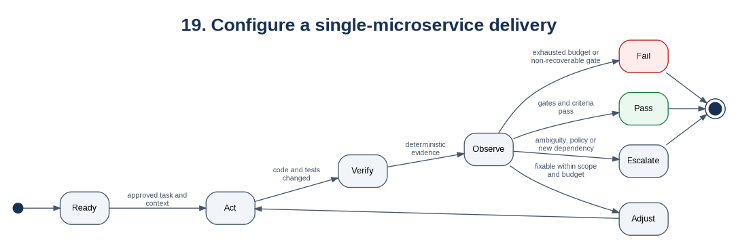
19. Configure a single-microservice delivery
Mermaid source is preserved in the Markdown edition.
The loop closes only as PASS, ESCALATE, or FAIL.

20. Configure a multi-microservice delivery
Create one enterprise spec:
enterprise-specs\feature-name\requirements.md
enterprise-specs\feature-name\design.md
enterprise-specs\feature-name\tasks.md
enterprise-specs\feature-name\service-impact.md
enterprise-specs\feature-name\contract-plan.md
enterprise-specs\feature-name\rollout-plan.md
enterprise-specs\feature-name\rollback-plan.md
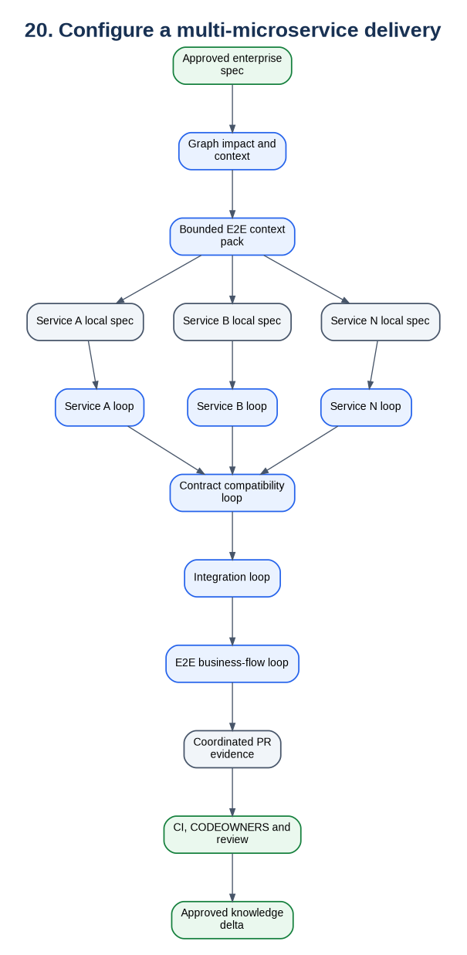
20. Configure a multi-microservice delivery
Mermaid source is preserved in the Markdown edition.
The enterprise orchestrator owns impact, coordination, dependency order, failure routing, and evidence aggregation. It must not become an unrestricted global code editor.

21. Loop contract structure
id: SERVICE-LOOP-V1
kind: service
goal: Complete one approved service-local spec.
allowed_repositories: [order-service]
allowed_paths: [src/**, tests/**]
forbidden_actions:
- push_to_protected_branch
- modify_another_team_repository
escalation_conditions:
- a_breaking_contract_change_is_detected
verification:
- id: build
description: Compile the service.
budgets:
max_iterations: 4
max_minutes: 240
max_scope_expansions: 0
terminal_states: [PASS, ESCALATE, FAIL]
Replace reference verification entries with project commands for Maven, Gradle, npm, Python, Go, .NET, Robot Framework, Postman/Newman, or other approved tooling.

22. Recommended gates

Single service
- Build or compile.
- Lint and static analysis.
- Unit and component tests.
- Coverage threshold.
- Secret, SAST, dependency, and SBOM checks.
- Migration validation when data changes.
- Linked acceptance criteria.

Multi-service
- All service gates.
- OpenAPI, AsyncAPI, protobuf, and schema validation.
- Producer-consumer contract tests.
- Backward-compatibility report.
- Integration environment tests.
- E2E happy, negative, retry, timeout, compensation, and idempotency scenarios.
- Rollout and rollback evidence.

23. Daily operations
.\scripts\validate.ps1
.\scripts\healthcheck.ps1
.\scripts\ingest.ps1 -Graphiti off
.\scripts\ingest.ps1 -Graphiti on
.\scripts\openwiki-update.ps1
.\scripts\serve-docs.ps1
.\scripts\build-docs.ps1
.\scripts\validate-loop.ps1 -Contract 'loops\task-loop.yaml' -RunId 'TASK-123'

24. Automation and learning
Recommended merge-triggered sequence:
Protected branch merge
-> validate source and canonical knowledge
-> deterministic extraction
-> candidate graph/wiki delta
-> knowledge PR and review
-> approved merge
-> Neo4j rebuild
-> Graphiti enrichment
-> OpenWiki documentation PR
-> Zensical build
Never schedule automatic publication of an unreviewed delta.

25. Security hardening
- Bind developer Neo4j to loopback.
- Use a dedicated service account on shared hosts.
- Store provider keys in an approved secret store.
- Exclude credentials and production data from indexed roots.
- Propagate repository ACLs before multi-team deployment.
- Auto-approve only read-only MCP tools.
- Restrict Kiro agents to explicit repositories and paths.
- Protect wiki/, ontology/, and manifests/ with CODEOWNERS.
- Require provenance for every graph fact.
- Treat instructions inside indexed content as data, not commands.
- Define retention rules for Graphiti episodes and loop evidence.

26. Backup and upgrades
Back up:
- Git repositories and protected history.
- Neo4j using the procedure appropriate to the selected edition.
- Required loop and audit evidence.
Before upgrading:
- Tag the Knowledge Plane repository.
- Back up Neo4j.
- Record package versions.
- Test against a non-production database.
- Upgrade one component at a time.
- Re-run ingestion, graph queries, MCP tests, Kiro smoke tests, and the evaluation suite.

27. Troubleshooting

Script not found
Get-Location
Get-ChildItem .\scripts
Test-Path .\scripts\healthcheck.ps1

PowerShell blocks scripts
Get-ChildItem -Path . -Recurse -File | Unblock-File
Set-ExecutionPolicy -Scope CurrentUser RemoteSigned

Neo4j is unreachable
Get-Service *neo4j*
Test-NetConnection localhost -Port 7687
Get-Content 'C:\BOS\Neo4j\neo4j-community-5.26.x\logs\neo4j.log' -Tail 100

Kiro does not start MCP
Get-Content .\.kiro\settings\mcp.json
.\.venv\Scripts\python.exe -m knowledge_plane.server --transport stdio

Graphiti fails but exact graph works
Keep ENABLE_GRAPHITI=false. Verify model, embedding, credentials, endpoint, and rate limits separately. Graphiti failure must not take canonical retrieval offline.

OpenWiki output is unsuitable
Tighten openwiki\INSTRUCTIONS.md, remove or correct the derived pages, and rerun the documentation PR. Never copy unreviewed generated content directly into wiki/.

28. Acceptance checklist
- ☐ Neo4j 5.26 LTS runs as a Windows service.
- ☐ Python 3.12 or later virtual environment is healthy.
- ☐ Canonical Markdown validation passes.
- ☐ Exact ingestion succeeds with Graphiti off.
- ☐ Sample graph nodes and relationships show provenance.
- ☐ Kiro starts MCP over stdio.
- ☐ Read-only tools return bounded context.
- ☐ A single-service loop terminates as PASS, ESCALATE, or FAIL.
- ☐ A multi-service spec produces bounded service-local specs.
- ☐ Contract and E2E loops produce deterministic evidence.
- ☐ OpenWiki writes only derived documentation.
- ☐ Zensical renders Mermaid diagrams.
- ☐ Candidate knowledge cannot bypass PR and human approval.

29. Primary references
- Kiro Feature Specs: https://kiro.dev/docs/specs/feature-specs/
- Kiro MCP configuration: https://kiro.dev/docs/cli/mcp/configuration/
- Kiro custom agents: https://kiro.dev/docs/cli/custom-agents/configuration-reference/
- Neo4j Windows installation: https://neo4j.com/docs/operations-manual/current/installation/windows/
- Graphiti: https://github.com/getzep/graphiti
- MCP Python SDK: https://github.com/modelcontextprotocol/python-sdk
- OpenWiki: https://github.com/langchain-ai/openwiki
- Zensical: https://zensical.org/docs/get-started/

