Lapse Pre-Lapse Automation
  - Proof of Concept (POC) Document
Date: May 26, 2026
Developed using Cursor AI

1. Executive Summary
This Proof of Concept automates the daily NASU lapse pre-lapse workflow. The solution downloads PDF workflow files from Tango, packages them into billing and letters zip archives, uploads them to SharePoint with required metadata, and optionally sends Slack alerts when expected files are missing.
The POC was designed and implemented with Cursor AI, an AI-assisted IDE that accelerated browser automation development, debugging of SharePoint UI flows, and integration of Tango, SharePoint, and Slack components.

2. Objectives
- Automate login and navigation to Tango PDF Workflow Approval.
- Search for lapse letter files using the previous US business day date (MMDDYY).
- Download all output PDFs for billing and letters file types.
- Create P{date}NASU_BILLING.zip and P{date}NASU_LETTERS.zip archives.
- Upload zip files to NassauRe SharePoint and set document metadata.
- Notify stakeholders via Slack when file types are missing.
- Support unattended runs with polling after 4:30 PM IST when files become available.

3. Solution Architecture
The automation uses Python 3 with Playwright for browser control. Chromium is used for Tango; Microsoft Edge with a saved profile is used for SharePoint SSO.
Component | Technology / URL
Tango download | Playwright → https://tango.se2.com
SharePoint upload | Playwright + Edge profile → se2office365.sharepoint.com
Slack alerts | Incoming Webhook or Bot Token (chat.postMessage)
Scheduling | Manual or Windows Task Scheduler

3.1 High-Level Flow
- 1. Calculate previous US business day → date code (e.g. 052226).
- 2. Log in to Tango → PDF Workflow Approval.
- 3. For each file type: Search (Under Review) → Detail → Download all outputs.
- 4. Zip billing PDFs → P{date}NASU_BILLING.zip; letters → P{date}NASU_LETTERS.zip.
- 5. Upload zips to SharePoint → set Item Type, Service, Phase, etc.
- 6. Send Slack alert if any expected file types were not found.

4. Tango PDF Workflow Automation
The script logs into Tango, opens PDF Workflow Approval, clicks the search icon, sets status to Under Review, and searches by file name prefix.

4.1 File Naming Convention
Category | Search prefix example
Billing (GRC) | P052226NASULFGRCLETTER
Billing (FLPS) | P052226NASULFFLPSLETTER
Letters | P052226NASUANCMDLETTER, P052226ANNUITYMLTLRLETTER, etc.

4.2 Business Day Logic
The date code XXXXXX is the previous US business day (Monday–Friday). Weekends are skipped. Example: running on Monday uses Friday's date; running on Saturday or Sunday uses Friday's date.
[Screenshot: Tango PDF Workflow Approval — search with Under Review status]
Capture with: py tango_billing_download.py --headed --billing-only --single-pass --no-wait --no-sharepoint --no-slack

5. SharePoint Upload Automation
Zip files are uploaded to the NassauRe Phase 1 Implementation Library. Metadata is applied via the Properties panel. New uploads appear under Unassigned until Item Type is set to Test Results, after which files move to the Test Results section.

5.1 Metadata Applied
Field | Value
Item Type | Test Results
Service | Correspondence
Phase | Solution Launch
Product | Both
Workstream | QAS
Phase 1 to Done | Phase 1 to Done

Figure 1: SharePoint Properties panel — Item Type selection
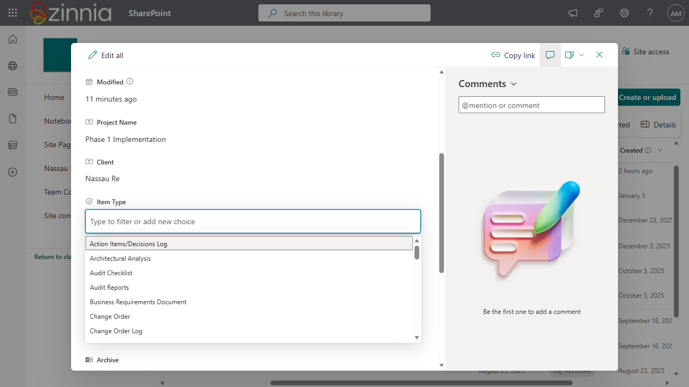

Figure 2: SharePoint document properties panel
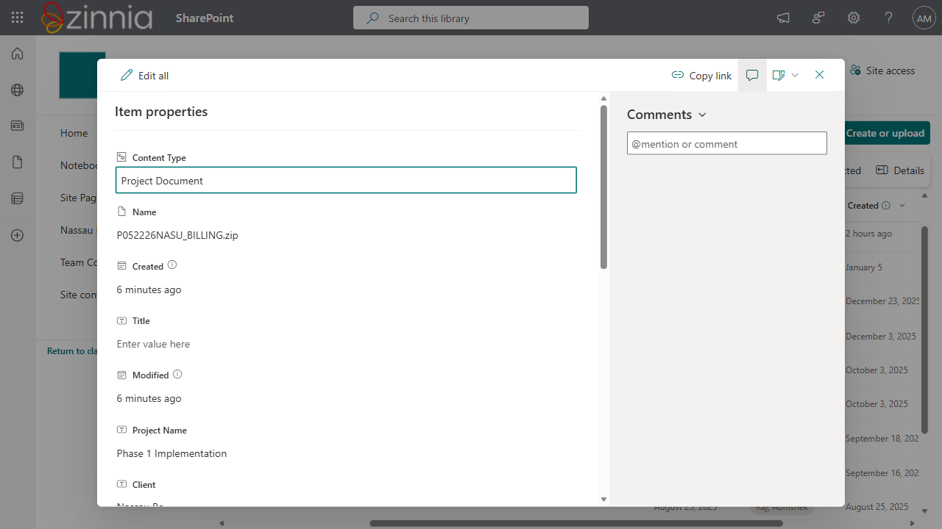

Figure 3: SharePoint library after upload
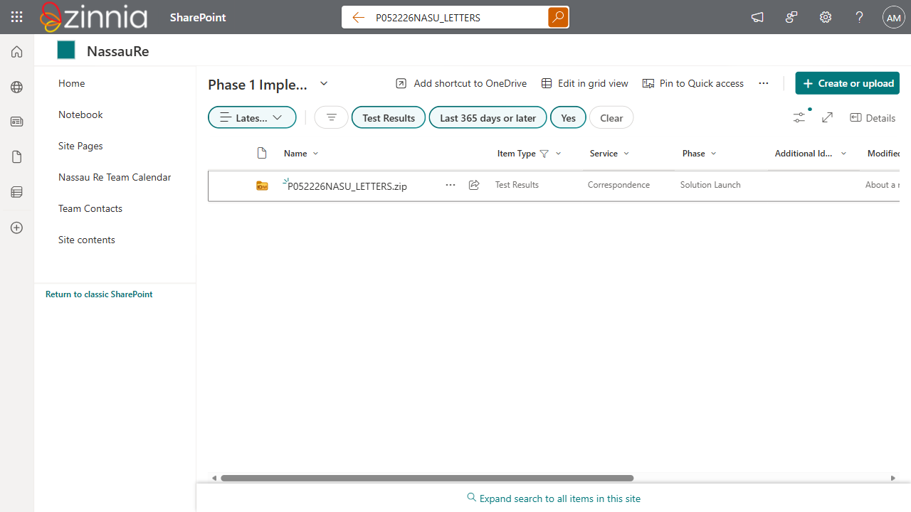

6. Slack Notifications
When expected Tango file types are missing after a run, the script sends an alert to a configured Slack channel. Messages are built in Python and posted directly via Incoming Webhook (hooks.slack.com/services/...) or Bot Token.
Sample alert content:
*Tango Pre-Lapse — Missing Files*
Business date code: `052226`
@here The following file types were not found in Tango PDF Workflow Approval (status: Under Review):
• P052226NASULFGRCLETTER
• P052226NASULFFLPSLETTER

7. Development with Cursor AI
This POC was developed using Cursor AI, which provided:
- Playwright automation for Tango login, search, detail view, and multi-file download.
- SharePoint UI automation including Unassigned/Test Results navigation and metadata fields.
- Previous US business day date calculation and zip archive creation.
- Slack webhook and bot token integration with missing-file alert formatting.
- Iterative debugging of SharePoint dialog handling (sign-in prompts, upload overlays).
- Project documentation (README) and command-line entry points.

8. How to Run
Setup: pip install -r requirements.txt && playwright install chromium
SharePoint login (once): py sharepoint_upload.py --save-login
Billing download (test): py tango_billing_download.py --billing-only --single-pass --no-wait --no-sharepoint
Full run: py tango_billing_download.py
SharePoint upload only: py sharepoint_upload.py --headed output\P052226NASU_BILLING.zip
Slack test: py slack_notify.py --test-webhook

9. Deliverables / Output
output/downloads/ — Individual PDFs from Tango
output/P{date}NASU_BILLING.zip — Billing letter PDFs
output/P{date}NASU_LETTERS.zip — Letters PDFs
output/screenshots/ — SharePoint upload confirmation screenshots

10. Conclusion
The Lapse Pre-Lapse Automation POC successfully demonstrates end-to-end automation from Tango file retrieval through SharePoint publication with metadata. Cursor AI significantly reduced development time for browser automation, error handling, and cross-system integration. The solution is ready for pilot scheduling via Windows Task Scheduler or enterprise job runner.

— End of POC Document —

