Delete the hints highlighted in yellow before submission. Title, type, kind of the project and supervisor must exactly match the project selection application.
NATIONAL RESEARCH UNIVERSITY
HIGHER SCHOOL OF ECONOMICS

Faculty of Computer Science
Bachelor's Programme “Computing and Data Science”

Research Project Report on the Topic:
[or: Software Project Report on the Topic:]
Title of the Project
(final report)
[or: (topic defence materials) / (checkpoint report)]

Fulfilled by:
Student of the Group БКНАД241, Year 3 | ____________________
Ivanov Ivan Ivanovich | (signature)
 | ____________________
 | (date)
[Team project: repeat the block for each participant; for an individual project delete the next block]
Student of the Group БКНАД242, Year 3 | ____________________
Smirnov Petr Petrovich | (signature)
 | ____________________
 | (date)

Assessed by the Project Supervisor:
Petrov Petr Petrovich | ____________________
Position (e.g. Senior Lecturer) | (signature)
Faculty of Computer Science, HSE University | ____________________
 | (date)
[If there is a mentor from an external organisation add: “Project Mentor: name, position, organisation”]

Moscow 2027
Contents
Abstract 3
Аннотация 3
Keywords 3
1 Introduction…………………………………………………………………………………….4
2 Literature Review………………………………………………………………………………5
3 Problem Statement……………………………………………………………………………..6
4 Proposed Method………………………………………………………………………………7
4.1 Figure example……………………………………………………………………………7
4.2 Formula example………………………………………………………………………….7
5 Experiments……………………………………………………………………………………8
6 Work Plan………………………………………………………………………………………9
7 Conclusion……………………………………………………………………………………10
References 11
Use of Generative Models 12
Appendix A. Code fragment example 13

[To update: right-click the table of contents → Update Field → Update entire table]
[What to include at each stage. Topic defence (December): abstract and keywords (results are planned), introduction with the problem statement, literature review, “Work Plan”, references. Checkpoint (February): fully written abstract, keywords, introduction, literature review, description of what has been done, “Work Plan”. Final report: all sections, delete “Work Plan”.]

Abstract
A short summary of the work (up to 2000 characters): what problem you solve, why it matters, which approach you use and what the main results are (or are planned to be). A person familiar with the field should understand the idea of your work from the abstract.

Аннотация
Аннотация на русском языке – обязательна для отчёта на английском языке: тот же краткий пересказ работы.

Keywords
Keyword 1, keyword 2, keyword 3, keyword 4, keyword 5.
[5–10 words or phrases in the language of the report]

Introduction
Describe the subject area and state the problem informally. Explain why it is relevant: who needs the result and why. Briefly list the main results, their novelty and practical significance (2–3 pages).
The goal of the work is a single sentence.
Objectives:
- to study existing approaches to …;
- to develop (propose, implement) …;
- to carry out an experimental comparison (testing) of ….
If the structure of the report is non-standard, describe the following sections at the end of the introduction.
[Team projects only – task distribution table; delete it for an individual project]
The distribution of tasks is given in Table 1.
Table 1 – Distribution of tasks among project participants
Participant | Area of responsibility | Report sections
I. I. Ivanov | Backend, database | 3.1, 4.1, 5.1
P. P. Smirnov | Client application, testing | 3.2, 4.2, 5.2

Literature Review
Briefly describe and analyse the relevant works – do not list them, but compare them and show where your work stands.
- Research project: position your work relative to recent works (e.g. the proposed method is more efficient than [1] because …; the work covers a case not studied in [2]).
- Software project: compare similar software solutions and explain why they cannot be used to solve your problem [3].

Problem Statement
The formal problem statement: input data, what is to be obtained, constraints, quality metrics. For a software project – functional and non-functional requirements.

Proposed Method
[For a software project: “System Architecture and Implementation”]
Describe the proposed method and its motivation in detail (or state and prove the obtained results). Describe the main method you build on in detail, others – briefly with references. End chapters with a short conclusion.

Figure example
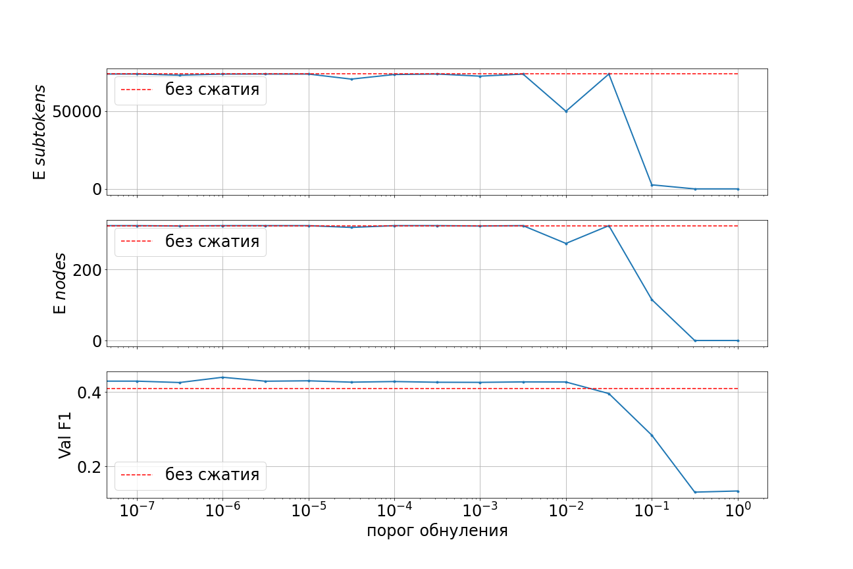
Figure 1 – An example figure. The caption is short but sufficient to understand the figure without the main text
As shown in Figure 1, … Every figure must be referenced in the text. Label the axes, add a legend, use readable fonts.

Formula example
Only formulas referenced in the text are numbered. Use Insert → Equation; put the number at the right margin with a tab:
Y = f(X₁, X₂, …, Xₙ) + ε, (1)
where Y is the dependent variable, f is some function, Xᵢ are independent variables and ε is random noise. The solution of problem (1) depends on …

Experiments
[For a software project: “Testing” – methodology, metrics, results, comparison with analogues]
Describe the data, baselines, metrics and setup. Give quantitative characteristics: sample sizes, data volume, experiment time, number of variants, code size. The comparison is given in Table 2.
Table 2 – An example table: comparison of methods
Method | Accuracy | Time, s | Memory, MB
Baseline | 0,812 | 12,4 | 210
Proposed method | 0,857 | 15,1 | 230
[Team projects only: at the end of each substantive chapter state the contribution, e.g. “Sections 5.1 and 5.2 were done by I. I. Ivanov, Section 5.3 by P. P. Smirnov”]

Work Plan
[Topic defence and checkpoint only – delete in the final report. Research: models and methods, a concrete plan of experiments. Software: decomposition, what is done (repository link), implementation and testing plan. Team: overall plan split among participants]
Table 3 – Work plan
Deadline | What will be done | Who
by 15.01.2027 | …
by 01.03.2027 | …
by 01.04.2027 | …

Conclusion
List the results of the work – both positive and negative, if any. Compare them with the goal and objectives. Describe directions for future work.

References
[For online sources give the URL and access date. Every source must be cited in the text: [1], [2; 3]]
- Vaswani A., Shazeer N., Parmar N. [et al.]. Attention Is All You Need // Advances in Neural Information Processing Systems. 2017. Vol. 30. P. 5998–6008.
- Knuth D. E. The Art of Computer Programming. Vol. 1: Fundamental Algorithms. 3rd ed. Reading, MA : Addison-Wesley, 1997.
- scikit-learn: Machine Learning in Python. – URL: https://scikit-learn.org/stable/ (accessed: 29.09.2026).

Use of Generative Models
[Mandatory if generative models were used (HSE Regulations on checking written works for plagiarism and generative models, clause 2.4). Undeclared use results in a grade of 0. Delete if no models were used. Methods: “fully generated text”, “generated text edited by the author”, “author's text using generated materials”]
Part of the text | Purpose and method of use | Model and link | Assessment of effectiveness
Section 2, paragraphs 1–3 | Author's text using generated materials: wording suggestions | Model name, URL | How much it helped

Appendix A. Code fragment example
[Appendices are labelled with letters (A, B, C…) and listed in the contents. Include only key code fragments; full code goes to the repository]
def factorial(n: int) -> int:
if n < 0:
raise ValueError("n must be non-negative")
res = 1
for i in range(2, n + 1):
res *= i
return res
Listing A.1 – An example of a key code fragment

