**TASK 2 : POSTGRE SQL**

**1.**

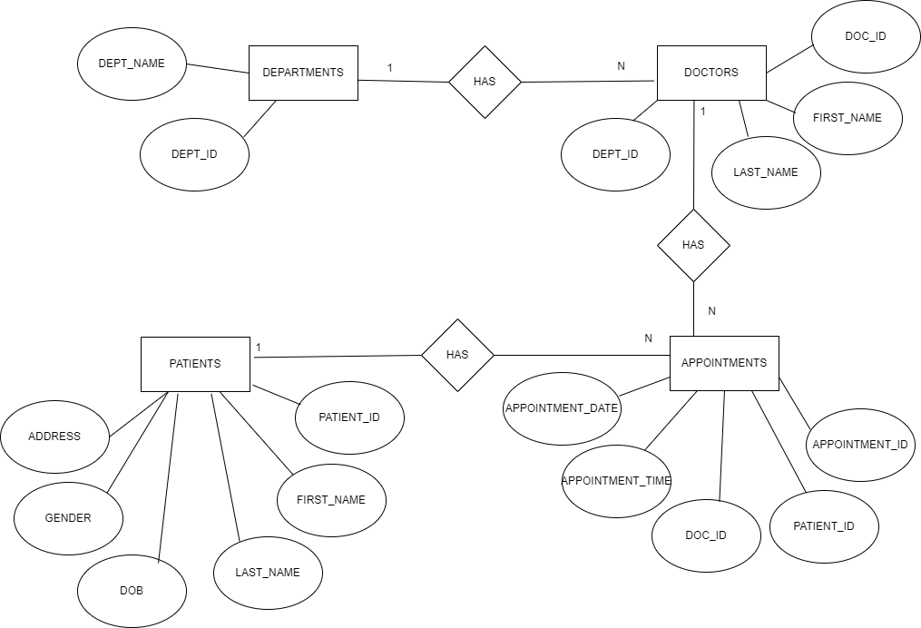

**2. & 3**

-- Create database

CREATE DATABASE hospital_management_system;

-- Create tables

CREATE TABLE departments (

department_id SERIAL PRIMARY KEY,

department_name VARCHAR(100) NOT NULL

);

CREATE TABLE doctors (

doctor_id SERIAL PRIMARY KEY,

first_name VARCHAR(50) NOT NULL,

last_name VARCHAR(50) NOT NULL,

department_id INT NOT NULL,

FOREIGN KEY (department_id) REFERENCES departments (department_id)

);

CREATE TABLE patients (

patient_id SERIAL PRIMARY KEY,

first_name VARCHAR(50) NOT NULL,

last_name VARCHAR(50) NOT NULL,

date_of_birth DATE NOT NULL,

gender VARCHAR(10) NOT NULL,

address TEXT

);

CREATE TABLE appointments (

appointment_id SERIAL PRIMARY KEY,

patient_id INT NOT NULL,

doctor_id INT NOT NULL,

appointment_date DATE NOT NULL,

appointment_time TIME NOT NULL,

FOREIGN KEY (patient_id) REFERENCES patients (patient_id),

FOREIGN KEY (doctor_id) REFERENCES doctors (doctor_id)

);

**4.**

**COPY departments (department_id, department_name) FROM 'C:\deptdata.csv' DELIMITER ',' CSV HEADER;**

**COPY doctors (doctor_id, first_name, last_name, department_id) FROM 'C:\DOCTORSDATA1.csv' DELIMITER ',' CSV HEADER;**

**COPY patients (patient_id, first_name, last_name, date_of_birth, gender, address) FROM 'C:\patientdata.csv' DELIMITER ',' CSV HEADER;**

**COPY appointments (appointment_id, patient_id, doctor_id, appointment_date, appointment_time) FROM 'C:\appdata2.csv' DELIMITER ',' CSV HEADER;**

**5.**

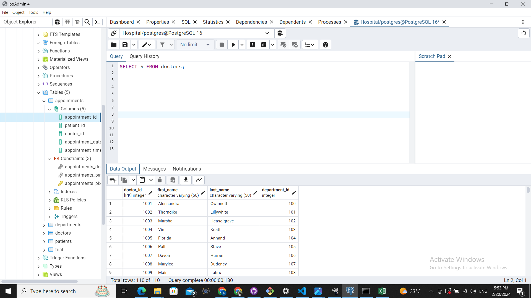

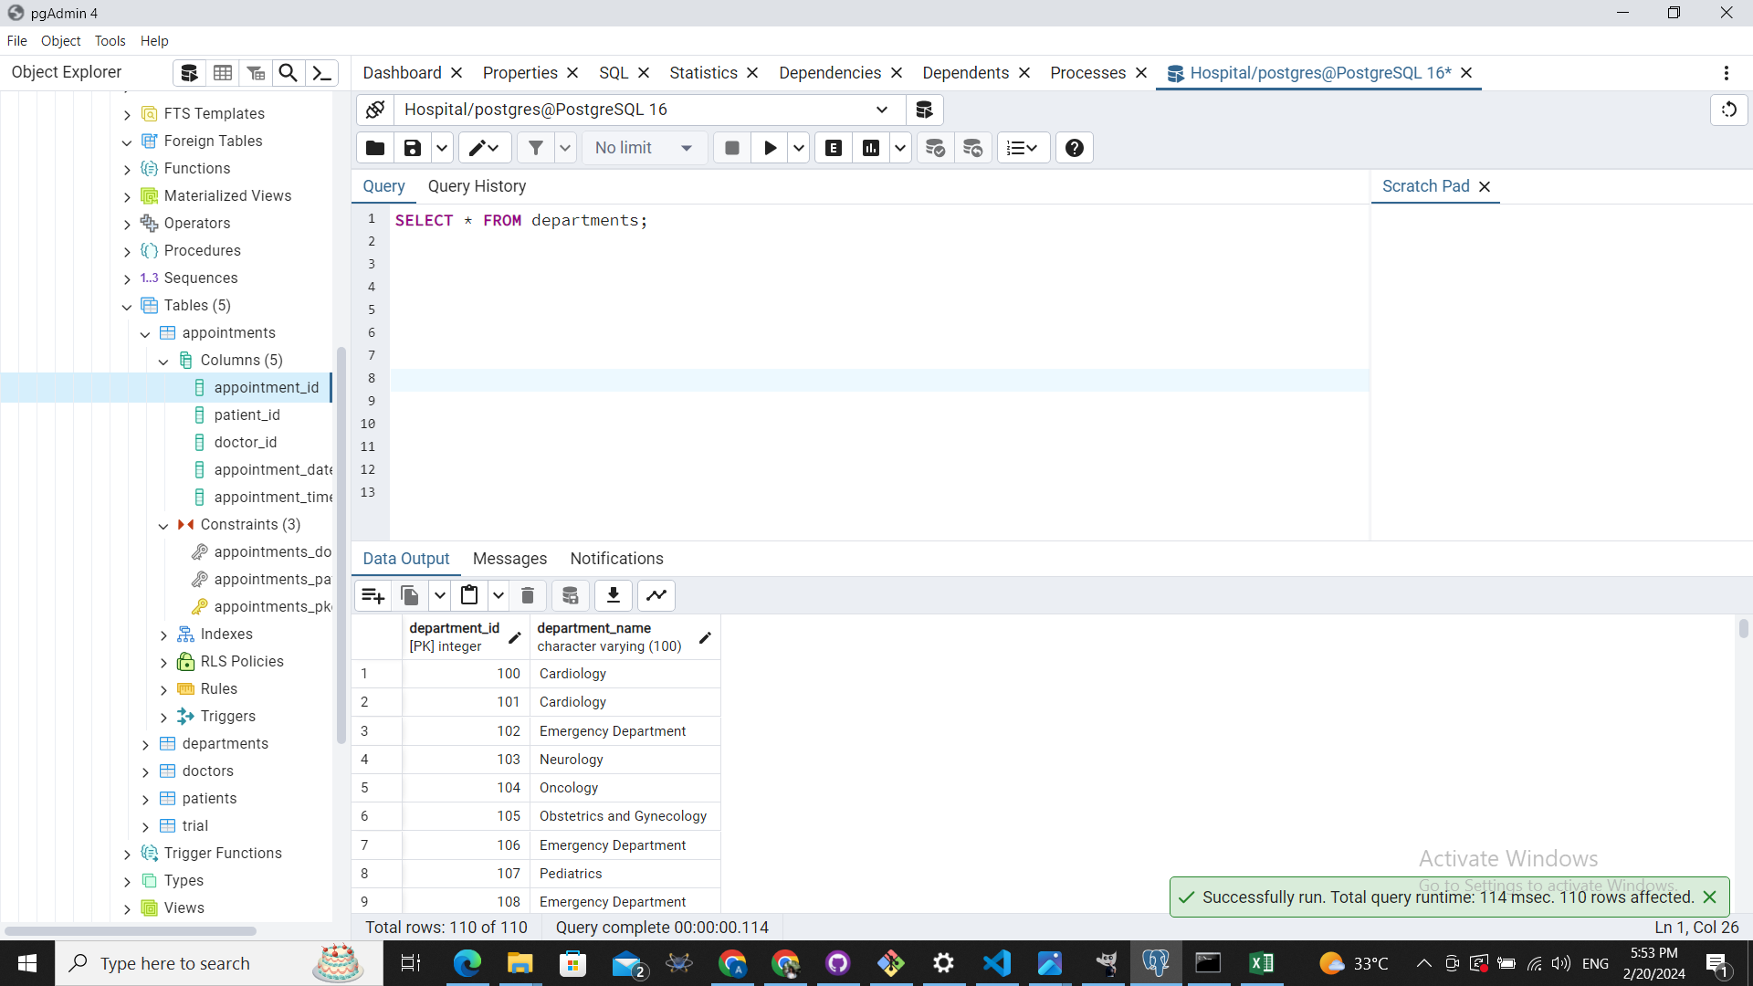

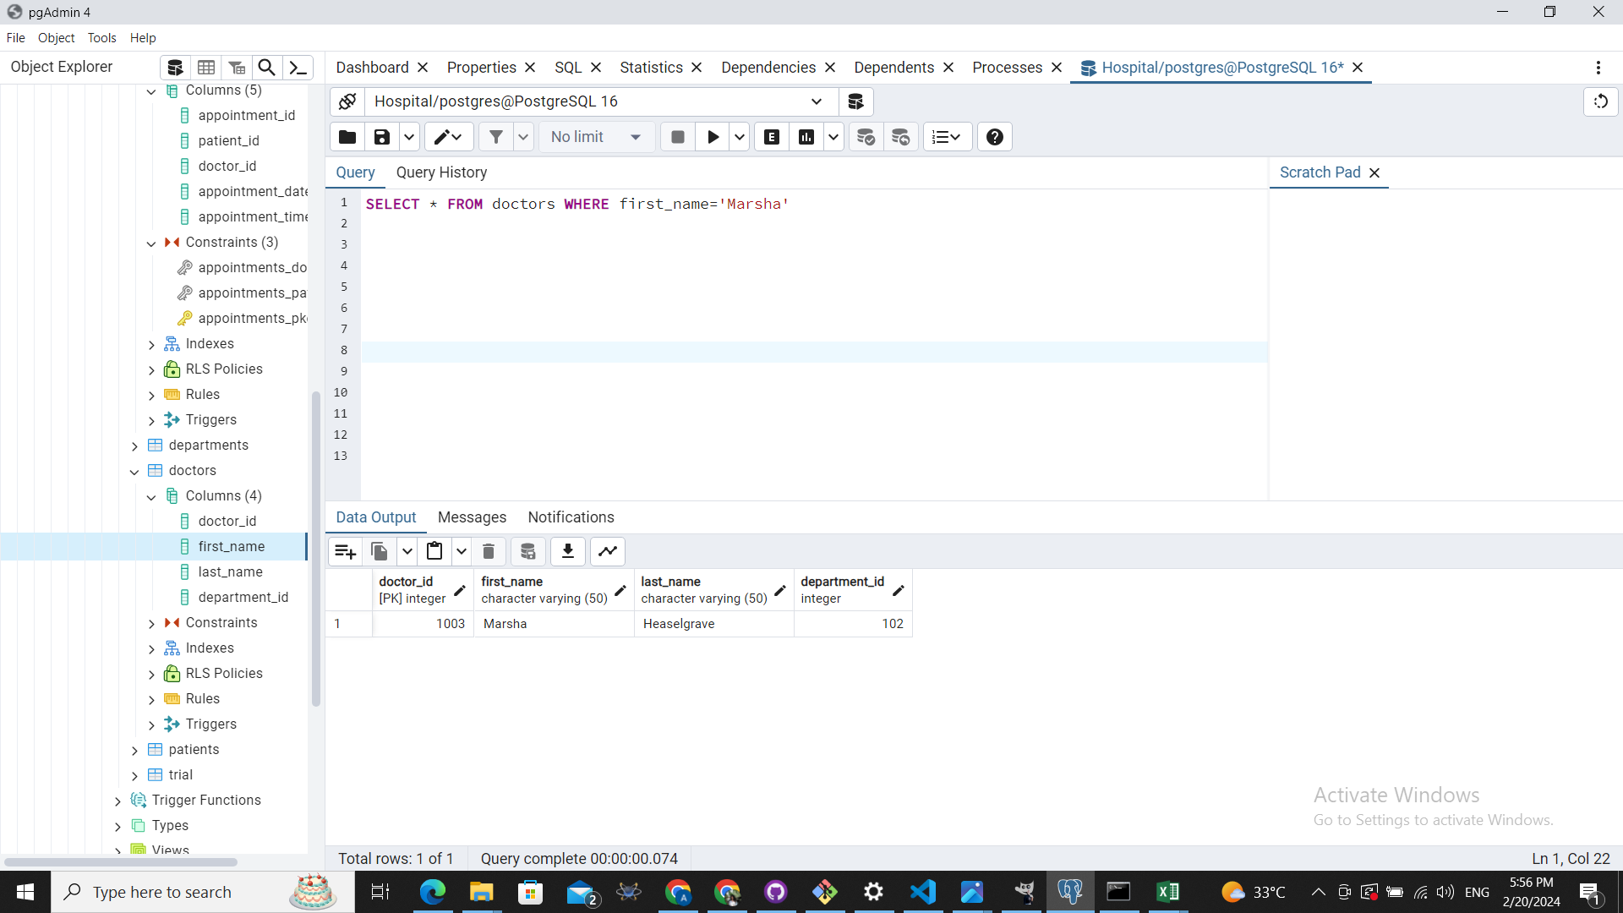

**6.**

**INSERT INTO doctors (doctor_id, first_name, last_name, department_id) VALUES**

**(1120, 'John', 'Doe', 107),**

**(1121, 'Jane', 'Smith', 108),**

**(1130, 'David', 'Jones', 109);**

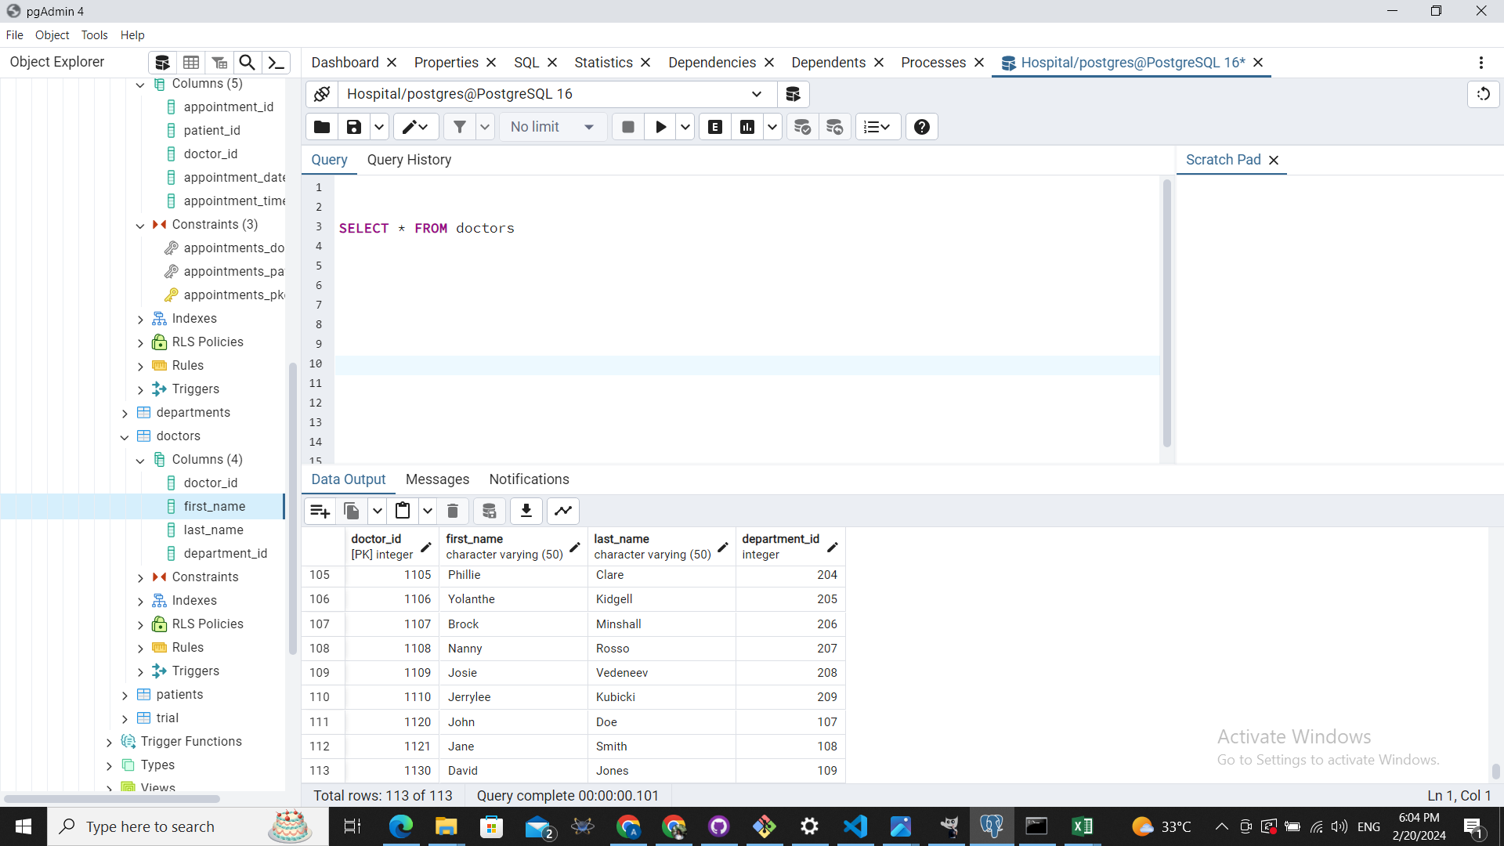

**7.**

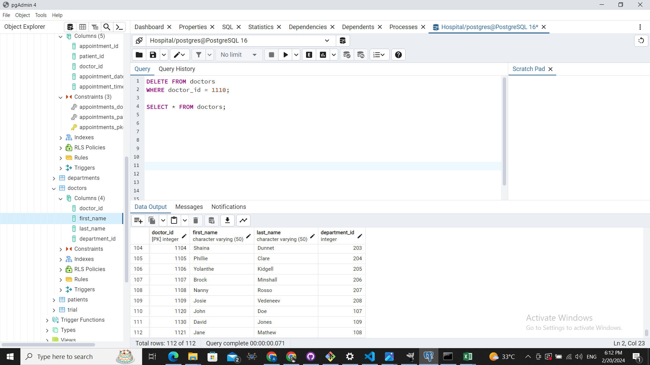

**8.**

