**eBalance-Kit additional test report**

# Scope

The purpose of this test report is to test the tax audits, export, search and filters functionalities in eBalance-Kit .

# Related Documents

**Title** **Version**

-

# Test Equipment

The test equipment used eBalance-Kit:

* eBalanceKit version 1.6 (from SVN)
* MySQL database local instance

# Test Results

## Summary

Tested functions:

* Tax audits, audit corrections
* Export
* Search
* Filters

## Passing Tests

All test results are documented in attached XLS document.

## Test Failures

All test results are documented in attached XLS document.

## Deviations from Planned Testing

-

## Defects / Problem Reports

**Tax audits**:

*Reports->Bilanz:*

* If user click to the calculator icon in Correction Datasets section in Bilanz menu, a window pops up to export them to the next year’s balance. After the user selected the datasets to export, an empty screen comes to select reconciliation datasets. I think this screens should contain some text to explain why is it empty, or should be skipped. See **Error1** screenshot at section *4.7 Error screenshots*.

*Reports->Reconciliations:*

* Importing tax audit reconciliations to the next year’s balance doesn’t works. The values simply not imported. The Bilanz tax audit corrections are imported correctly, but the reconciliation values are not.
* A strange error: Create a previous year audit correction value for a position, and after it click on the upper item on the right side. An error message will come, that makes the application frozen. This error sometimes comes on the simple audit correction setting option as well. See **Error2** screenshot at section *4.7 Error screenshots*.

**Search**:

* It doesn’t search in reconciliation datasets.
* It doesn’t search in any comments.
* The result tree could be automatically opened.
* Need some text message, if no item found.

**Filters**:

* Sometimes the filter set applying too long time, so maybe need some progressbar. For example: *Anhang* form left menu.
* Notes are always shown, independently from filter set. For example: *Anhang* form left menu.
* Should be signed on some way if a filter set is active, just like in position filter, and/or need a button to disable filter settings.

## Quality Assessment

-

## Additional information

* **Export**:

An error occurred when I tried to export the balance to a PDF, and there was reconciliation audit corrections set. I fixed this error, it seems to work well now.

* All the screenshots are available in bigger size in folder “Screenshots” of the current directory.

## Error screenshots

-

**Error1:**

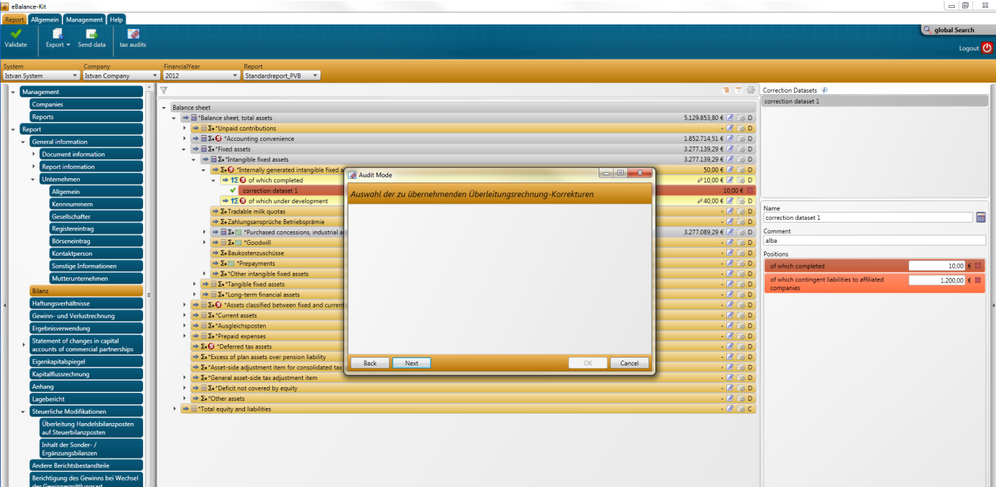

**Error2:**

