**eBalance-Kit additional test report**

# Scope

The purpose of this test report is to test the automatic credit/debit replace in templates, hypercubes, company setting, changing, global options filters, and checking missing fields in different kind of legal form types, based on official specification in eBalance-Kit .

# Related Documents

**Title** **Version**

Kerntaxonomie 5.1_de-gaap-ci-2012-06-01-shell-fiscal.xls

# Test Equipment

The test equipment used eBalance-Kit:

* eBalanceKit version 1.6 (from SVN)
* MySQL database local instance

# Test Results

All test results are documented in attached XLS document.

## Summary

Tested functions:

* automatic credit/debit replace in templates
* hypercubes
* company setting, changing
* checking missing positions in different kind of legal form types
* global options filters

## Passing Tests

All test results are documented in attached XLS document.

## Test Failures

All test results are documented in attached XLS document.

## Deviations from Planned Testing

-

## Defects / Problem Reports

**Hypercubes:**

* A FormatException is thrown, when the user tries to input a minus value to fields. See **Error1** in section *4.7 Error screenshots.*

**Company setting, changing**:

* A NullReferenceException is thrown when the user is changing financial year. See **Error2** in section *4.7 Error screenshots.*

## Quality Assessment

**-**

## Additional information

**Automatic credit/debit replace in templates:**

* All the found errors were fixed in new version.

**Checking missing positions in different kind of legal form types**:

* All the found errors were fixed in new version of definitions xls and eBalanceKit.

## Error screenshots

**Error1:**

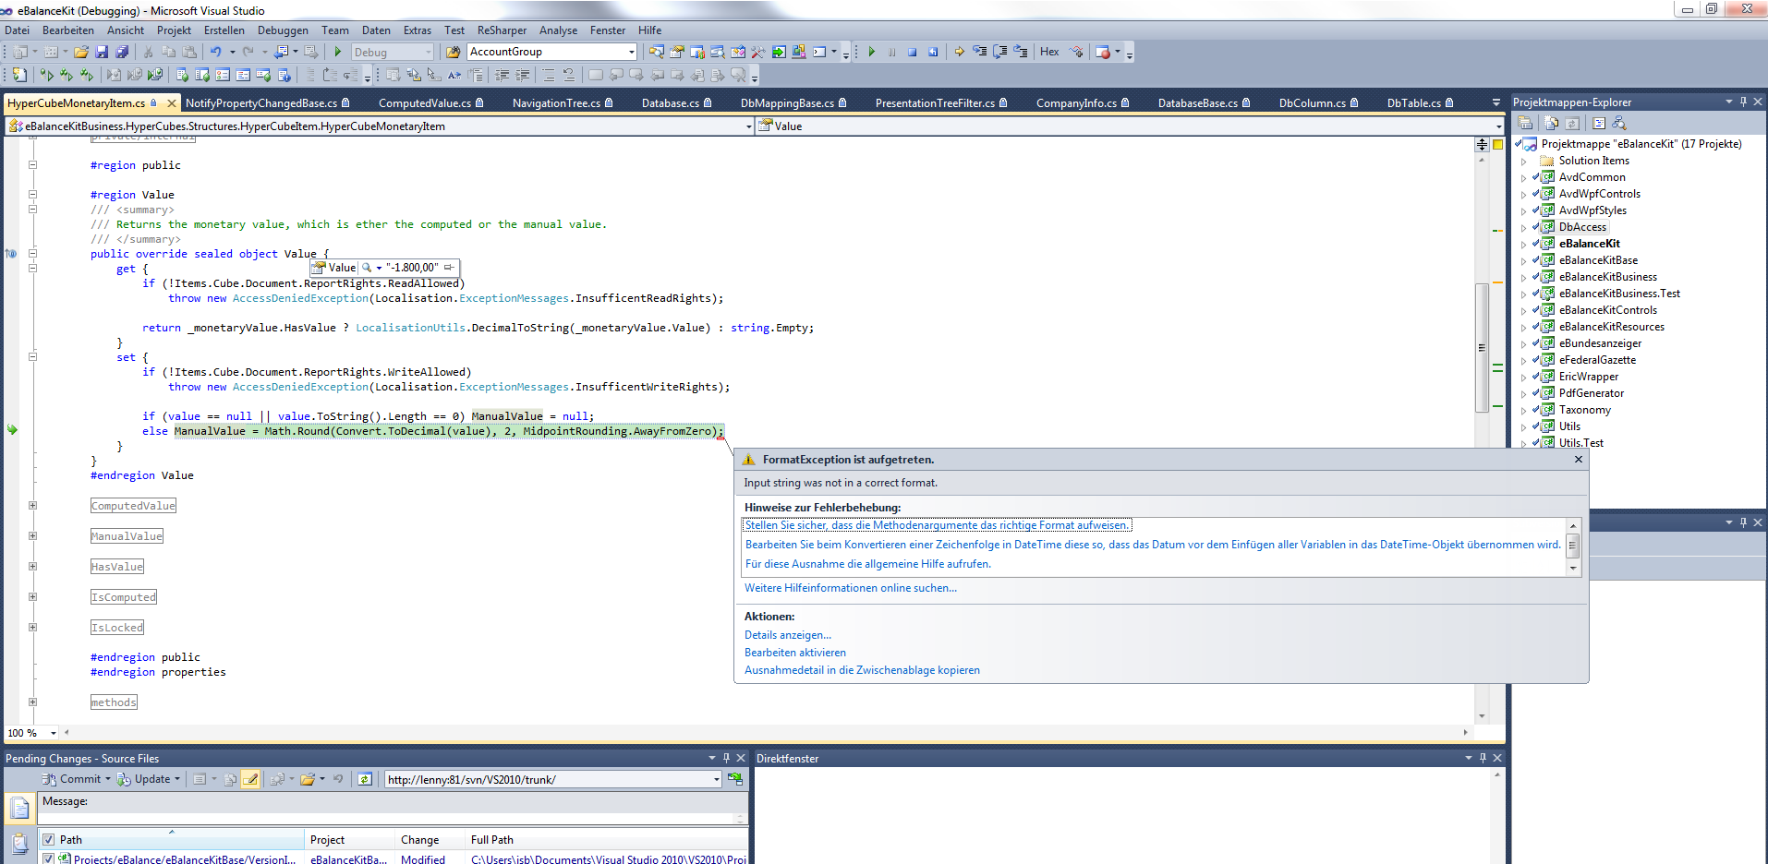

**Error2:**

