**eBalance-Kit database upgrade for branches test report**

# Scope

The purpose of this test report is to test the database upgrade for other kind of branches in eBalance-Kit .

Test method: filling the forms in version 1.5 with values (all possible fields are filled) upgrading the database to version 1.6 and checking the existence of the previously entered values in version 1.6.

# Related Documents

**Title** **Version**

-

# Test Equipment

The test equipment used eBalance-Kit test:

* eBalanceKit Config tool released 1.5.6
* eBalanceKit Database Management tool released 1.5.6
* eBalanceKit released 1.5.6
* eBalanceKit Database Management tool version 1.6 (from SVN)
* eBalanceKit version 1.6 (from SVN)
* MySQL database local instance

# Test Results

## Summary

Testing of reconciliation and balance handling functions (all menupoints under Allgemeine Informationen) of this kind of branches:

* RechKredV
* RechVersV
* PVB

Most of the values were correct in upgrade process, but one error has been found in eBalanceKit version 1.5.

## Passing Tests

All test results are documented in attached XLS document.

## Test Failures

All test results are documented in attached XLS document.

## Deviations from Planned Testing

-

## Defects / Problem Reports

-In case of RechKredV branch:

*Reports->Bilanz gemaS RechKredV->(click on pencil icon):*

* Only the “manueller Korrekturwent” and the “Kommentar” fields kept their values after closing the window. The upgrade function cannot be tested for this screen. See **Error1** screenshot at section *4.7 Error screenshots*.
* “Ubernehmen” button works only for these fields.

*Reports->Kapitalkontententwicklung fur…->unbeschrankt haftende Gesellschafter:*

* Maybe it’s a UI bug, but the window “Detailangaben Gesellschafter” cuts the textboxes. See **Error2** screenshot at section *4.7 Error screenshots*.

## Quality Assessment

-

## Additional information

All the screenshots are available in bigger size in folder “Screenshots” of the current directory.

## Error screenshots

-

**Error1:**

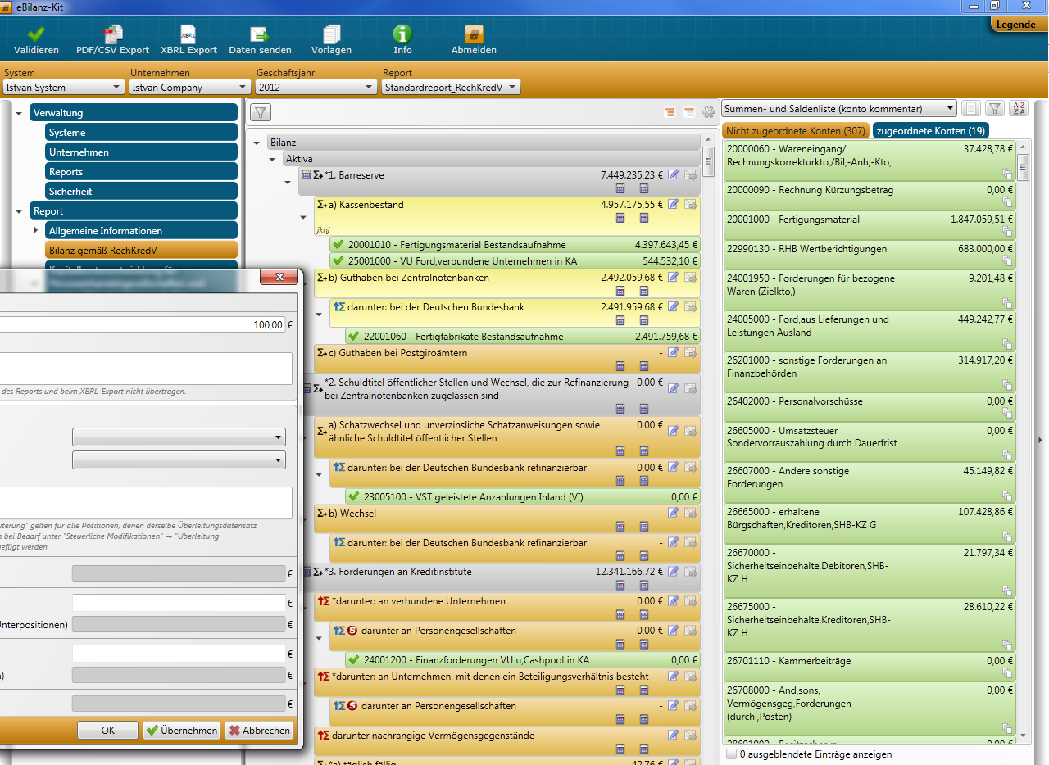

**Error2:**

