**eBalance-Kit database upgrade retest (with Oracle) report**

from version 1.5 to version 1.6

# Scope

The purpose of this test report is to test the eBalance-Kit database upgrade from version 1.5 to version 1.6.

Test method: filling the forms in version 1.5 with values (all possible fields are filled) upgrading the database to version 1.6 and checking the existence of the previously entered values in version 1.6.

# Related Documents

**Title** **Version**

Testing the database upgrade for SQLite, MySQL and SQLServer 1.0

# Test Equipment

The test equipment used eBalance-Kit test:

* eBalanceKit Config tool released 1.5.6
* eBalanceKit Database Management tool released 1.5.6
* eBalanceKit released 1.5.6
* eBalanceKit Database Management tool version 1.6 (from SVN)
* eBalanceKit version 1.6 (from SVN)
* MySQL database local instance
* MSSQL remote instance
* SQLite database local instance
* Oracle remote instance

# Test Results

## Summary

The testing process has failed because of an error message came during the upgrading process.

## Passing Tests

-

## Test Failures

During the upgrade process an error message comes to inform user about failure of the upgrading. This kind of error comes in all type of database upgrade, so the testing cannot be continued while this error is not solved. See **Error1** in *4.7 Error screenshots* section.

## Deviations from Planned Testing

-

## Defects / Problem Reports

There were found two other kind of error before the upgrade process started:

*1. Accounts:*

* During the import accounts process a huge error window comes to inform user about failure of the import. But a few accounts are imported successfully after the error. This bug only exists in Oracle database type. See **Error2** in *4.7 Error screenshots* section.
* After the user changes a company or logout and log in, all the previously imported accounts disappear from the account list and from the assigned positions as well. This bug only exists in Oracle database type.

*2. Templates:*

* An error message comes during saving a template, because it has too long name. The name was created by the TestDateGenerator. See **Error3** in *4.7 Error screenshots* section.

## Quality Assessment

-

## Additional information

* Sebastian Vetter was informed about the upgrading error, and he noticed it.
* Screenshots were made from all screens of all kind of database types, the test can be easily continued by them, after the main error (*4.2*) is solved.
* All the screenshots are available in bigger size in folder “Screenshots” of the current directory.

## Error screenshots

-

**Error1:**

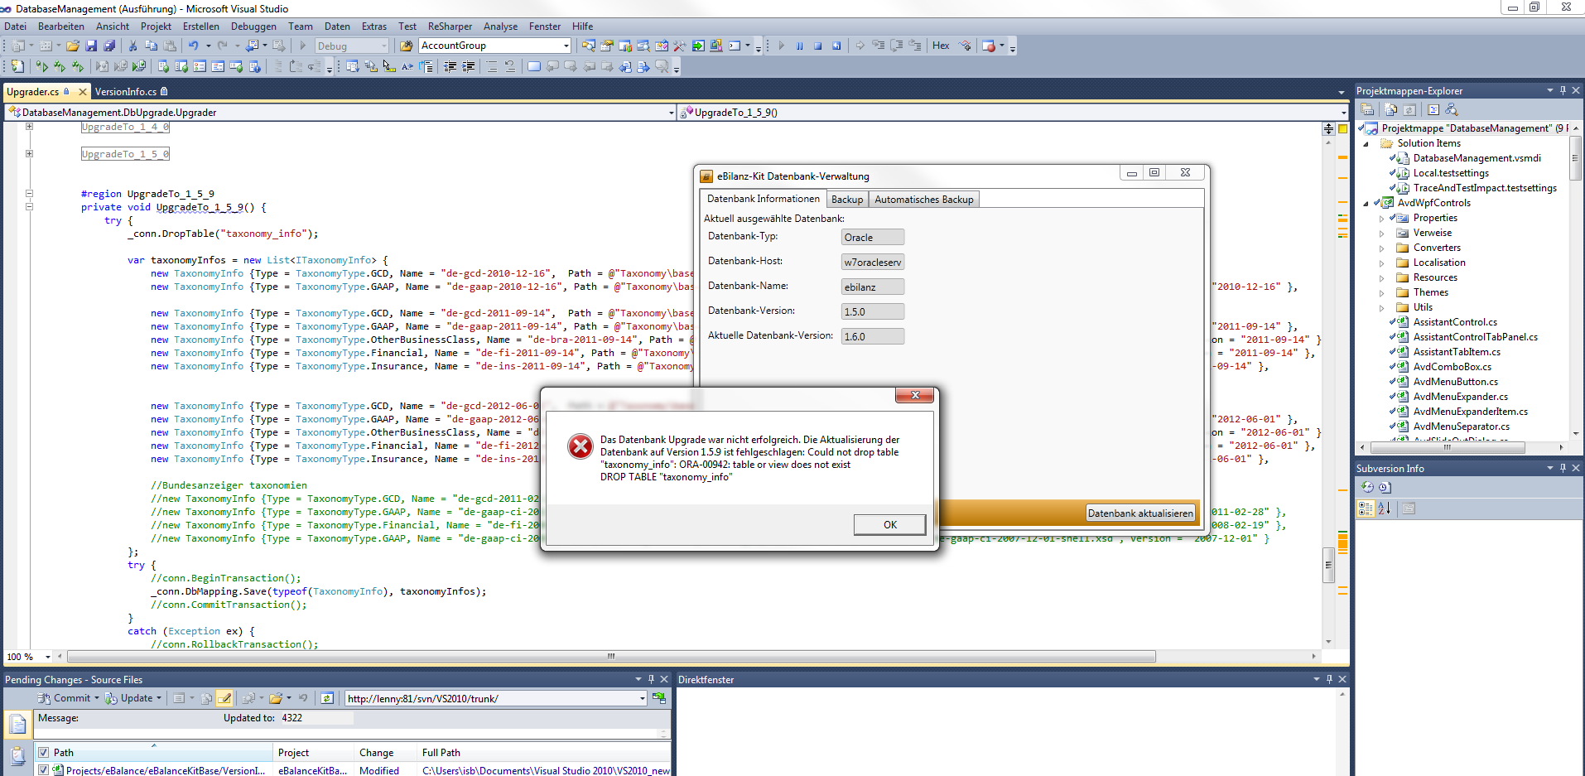

**Error2:**

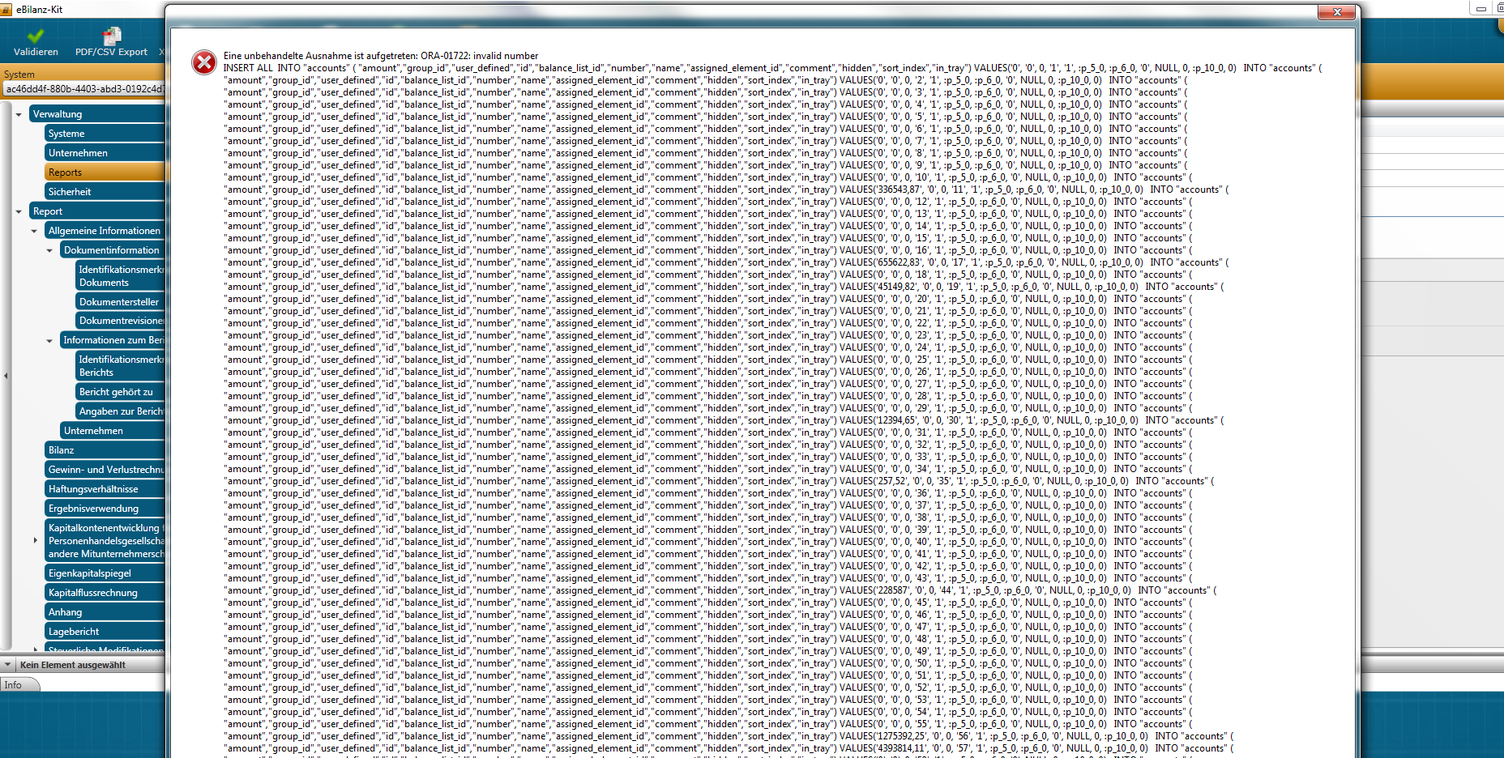

**Error3:**

