**eBalance-Kit database upgrade for Oracle report**

from version 1.5 to version 1.6

# Scope

The purpose of this test report is to test the eBalance-Kit database upgrade from version 1.5 to version 1.6.

Test method: filling the forms in version 1.5 with values (all possible fields are filled) upgrading the database to version 1.6 and checking the existence of the previously entered values in version 1.6.

# Related Documents

**Title** **Version**

-

# Test Equipment

The test equipment used eBalance-Kit test:

* eBalanceKit Config tool released 1.6
* eBalanceKit released 1.5.6
* eBalanceKit Database Management tool version 1.6 (from SVN)
* eBalanceKit version 1.6 (from SVN)
* Oracle remote instance

# Test Results

## Summary

The upgrading process finished successfully, but few values has changed or not set.

## Passing Tests

-

## Test Failures

-

## Deviations from Planned Testing

-

## Defects / Problem Reports

*1. Report->Allgemeine Informationen->Informationen zum Bericht->Identifikationsmerkmale des Berichts:*

*-*After upgrade the checkboxes on the right side don’t keep their values. See compare screenshot **Error1** (*error1.png)* in section *4.7 Error screenshots* (left side: 1.6 version, right side: 1.5 version)*.*

*2. Report->Bilanz, Report-> Haftungverhaltnisse:*

*-* After upgrade few values are rounded up in the positions. For example: On tab *Bilanz*: *Bilanz Summe, Summe active*, or on the tab *Haftungverhaltnisse: davon Verpfilchtungen gegenüber verbundenen*…  
See compare screenshot **Error2, Error4** (*error2.png, error4.png)* in section *4.7 Error screenshots* (left side: 1.6 version, right side: 1.5 version)*.*

*3. Report-> Gewinn-, und Verlustrechnung:  
-* Maybe it’s not an error, but the position values seems to be not the same, but this maybe could happened because the taxonomy structure has changed. See compare screenshot **Error3** (*error3.png,)* in section *4.7 Error screenshots* (left side: 1.6 version, right side: 1.5 version)*.*

*4. Reconciliations:   
-* One previous year value are missing for this position: *Immateriele Vermögesnsgegenstande* (55€). See compare screenshot **Error5** (*error5.png)* in section *4.7 Error screenshots* (left side: 1.6 version, right side: 1.5 version)*.*

## Quality Assessment

-

## Additional information

-All the screenshots are available in bigger size in folder “Screenshots” of the current directory.

## Error screenshots

-

**Error1:**

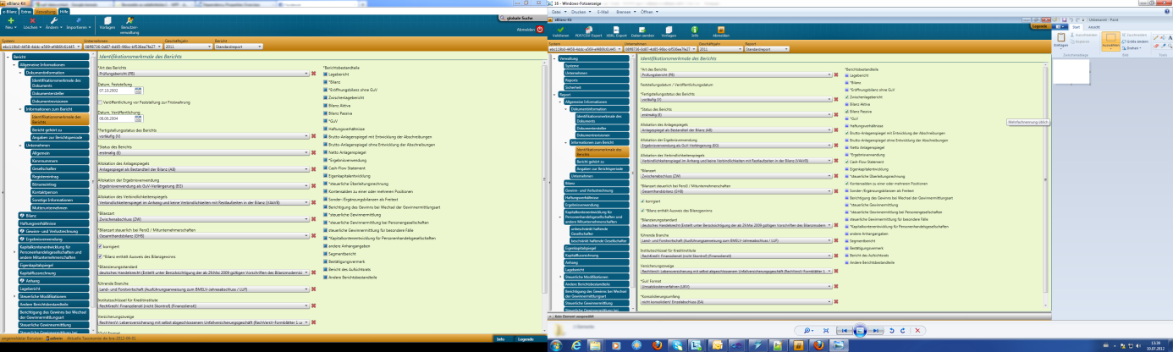

**Error2:**

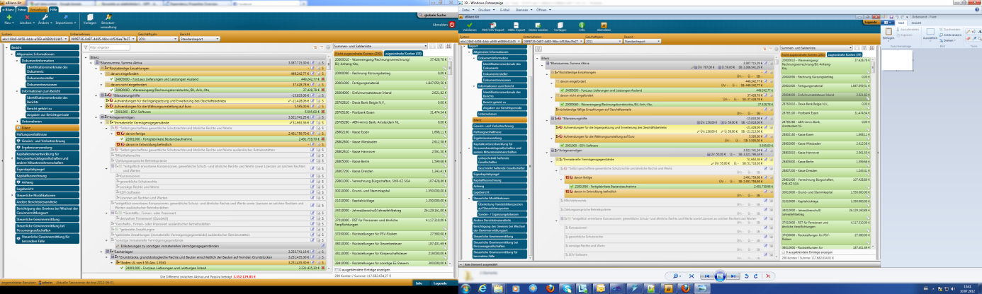

**Error3:**

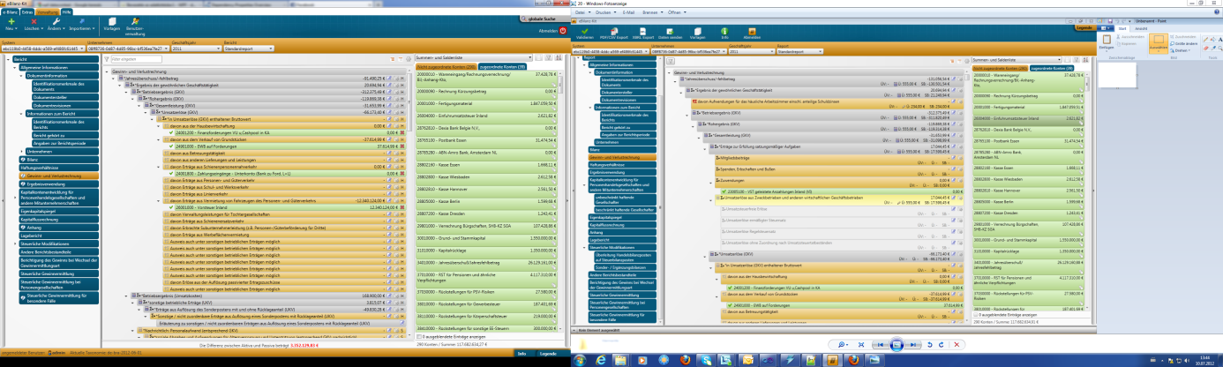

**Error4:**

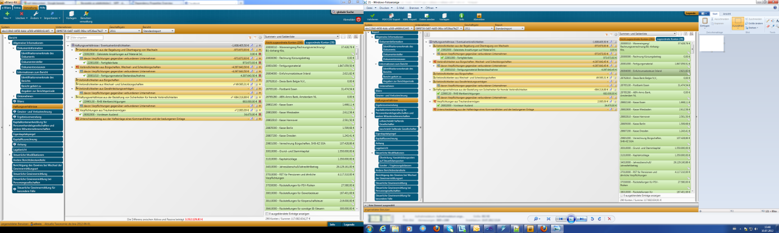

**Error5:**

