**eBalance-Kit reconciliation test report**

# Scope

The purpose of this test report is to test the reconciliation functionality of eBalance-Kit .

# Related Documents

**Title** **Version**

-

# Test Equipment

The test equipment used eBalance-Kit test:

* eBalanceKit version 1.6 (from SVN)

# Test Results

## Summary

Tested functions:

-Custom

-Reclassification

-Value change

-Imported values -> Import -> Sample CSV-Data export

-Imported values -> Export

-Imported values -> Import

-Previous year values

-Previous year values - Import

## Passing Tests

All test results are documented in attached XLS document.

## Test Failures

All test results are documented in attached XLS document.

## Deviations from Planned Testing

-

## Defects / Problem Reports

-Imported values -> Import -> Sample CSV-Data export:

* SB value is missing from export csv file. Is it a bug?
* Reconciliation values are completely missing from export csv file.
* The values of Income Statement tab are missing from export csv file.
* The two saved export csv files are completely the same. Is it good on this way?

- Imported values -> Import:

* If an empty csv is try to be imported, the application throwns an unhandled exception. See **Error1** screenshot at section *4.7 Error screenshots*.
* If a binary file is try to import be imported, the application throwns an unhandled exception. See **Error2** screenshot at section *4.7 Error screenshots*.

-Previous year values:

* If a previous year value is added manually to any of the root elements (Balance assets, Liabilities), and the green labeled reconciliation item is clicked at the postion list of the right side, the application crashes with an error. See **Error3** screenshot at section *4.7 Error screenshots*.

## Quality Assessment

-

## Additional information

All the screenshots are available in bigger size in folder “Screenshots” of the current directory.

## Error screenshots

-

**Error1:**

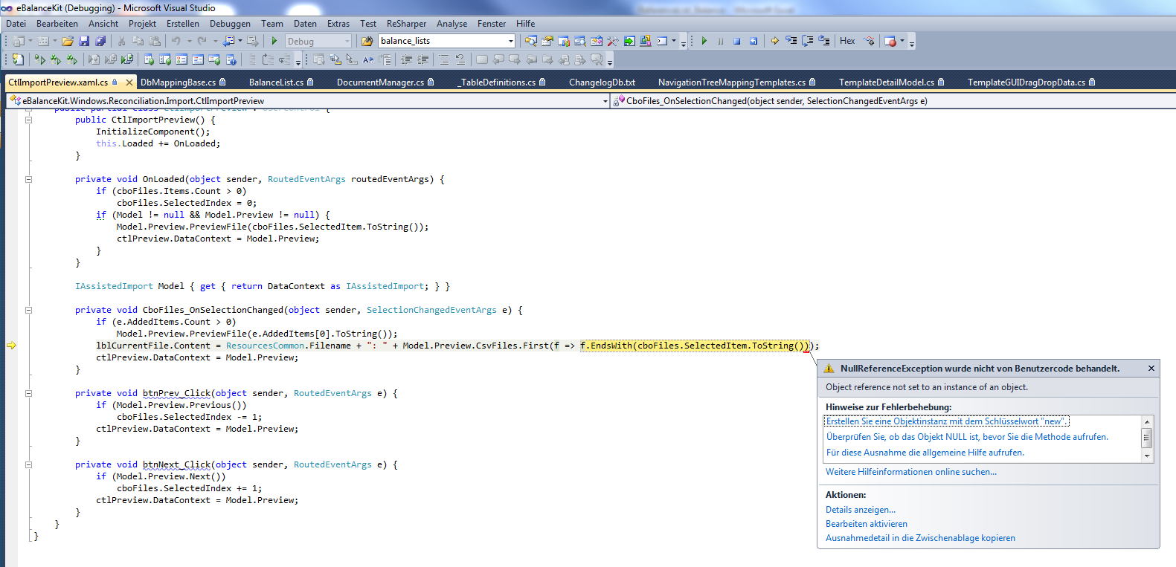

**Error2:**

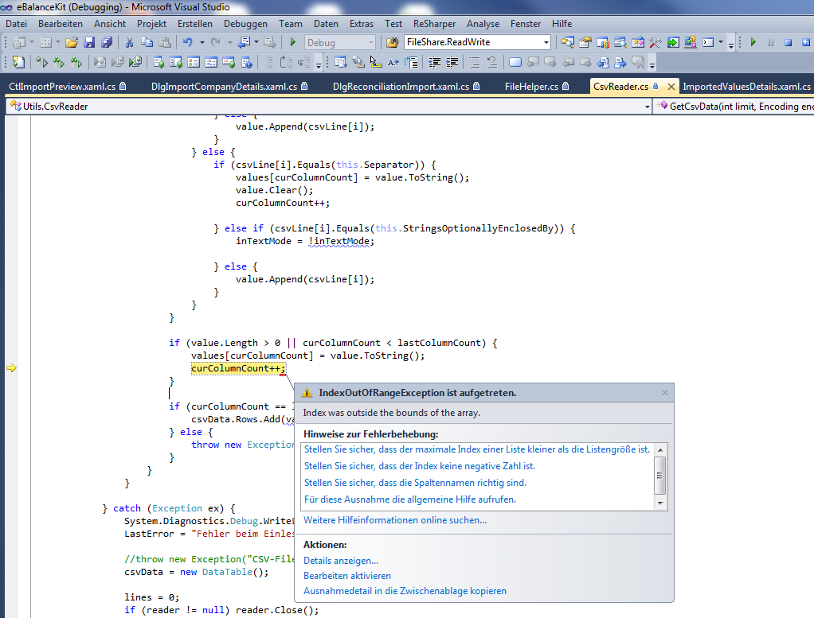

**Error3:**

