GIT architecture:-

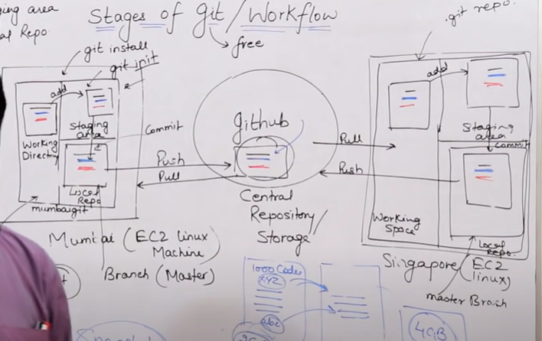

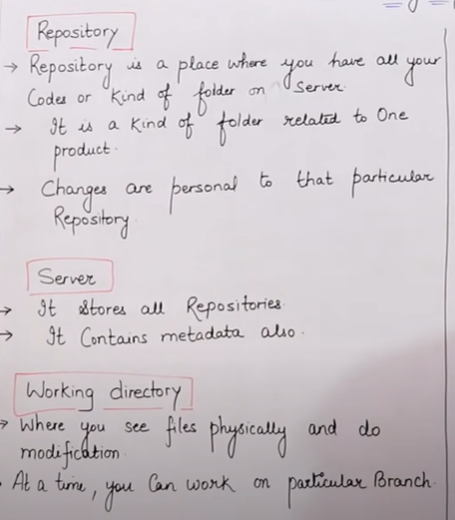

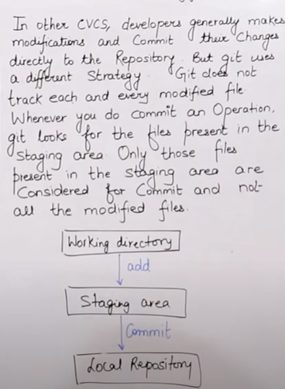

**DEMO FOR GIT:**

**STEPS TO FOLLOW:-**

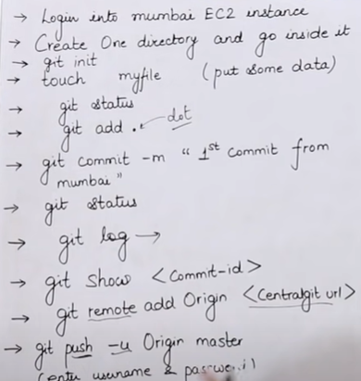

**BRANCHING THEORY:-**

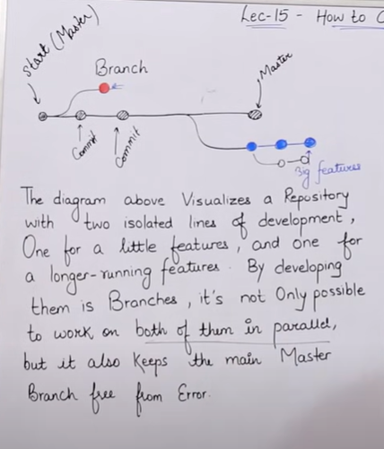

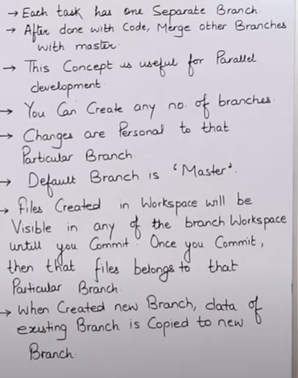

**MERGE CONFLICT:-**

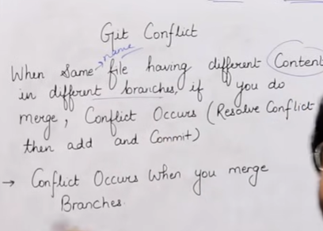

**GIT STASHING:-**



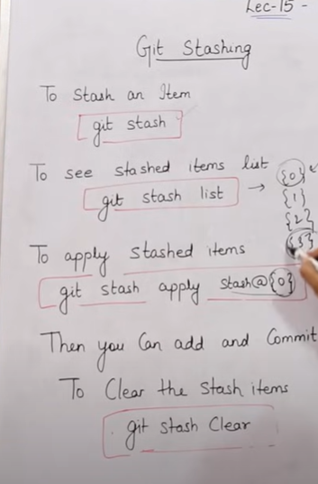

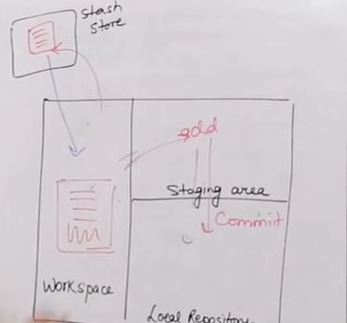

**GIT RESET:-**

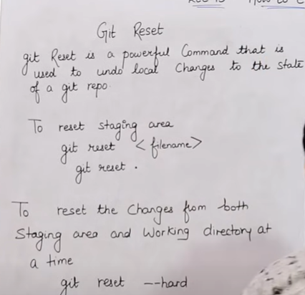

**GIT PULL AND GIT FETCH**

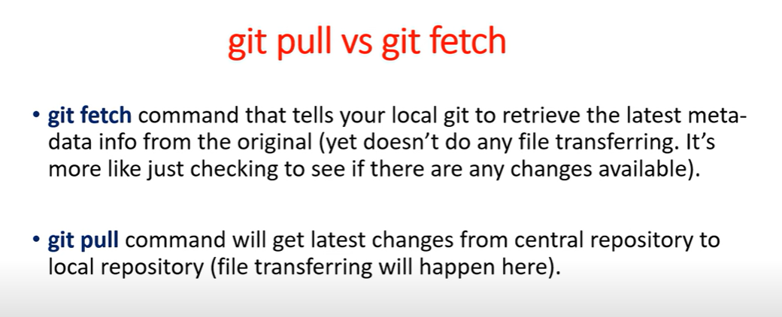

**GIT revert:-**

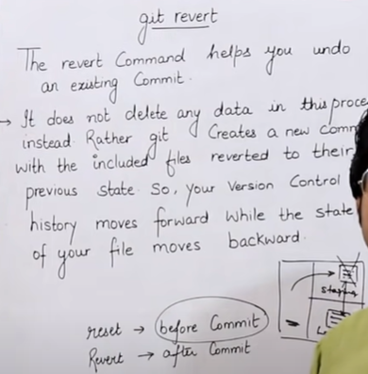

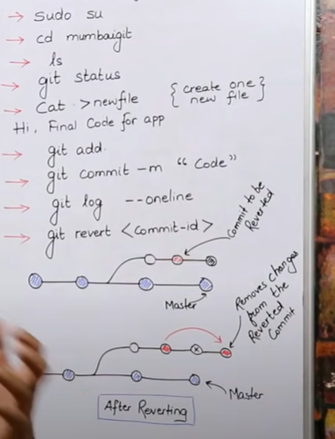

REMOVE UNTRACKED FILES:=

1.git clean -n (dry run)

2.git clean -f (forcefully)

**TAGGING TO COMMITS:-**

**Suppose you have several commits and you want to tag one of the commit to make it easy to identify**

**..git tag -a important -m “your message…” <commit id>**

**..git tag—will show all tags provided**

**..git show important----- will show all the details related to commit id which has the tag important**

**..git tag -d important—will delete the tag important**

**GIT CHERRYPICKING**

**Suppose you want to pick one of your 5 or more commits and merge to main branch, then**

**git cherry-pick <commit id>**

