Initial Game Concept & Design Document Template

## **Introduction**



Contested is a MMOG that takes place in a medieval setting that supports up to fifty versus fifty player versus player combat. There are two factions competing for control points that provide advantages. The main objective is to capture control the majority of the world map while defending your territory.

## **Game Analysi**s

|  |  |
| --- | --- |
| **Game Description** |  |
| Genre: | Multiplayer Online Battle Arena |
| Player: | Massively Multiplayer |
| Game Elements: | Hack and slash player versus player combat for objectives |
| Game Content: | Action Adventure |
| Theme: | Medieval Fantasy |
| Style: | Cartoony |
| Game Sequence: | Tutorial Quests -> Main Game |
| Player Immersion: | Tactical, Strategy, Team-work |
| Technical From: | 3D graphics |
| View: | Top-down/Isometric |
| SW Platform: | Java, Python, Windows |
| HW Platform: | PC |
| Audience | General |

## **Game Atmosphere**

Mood board:

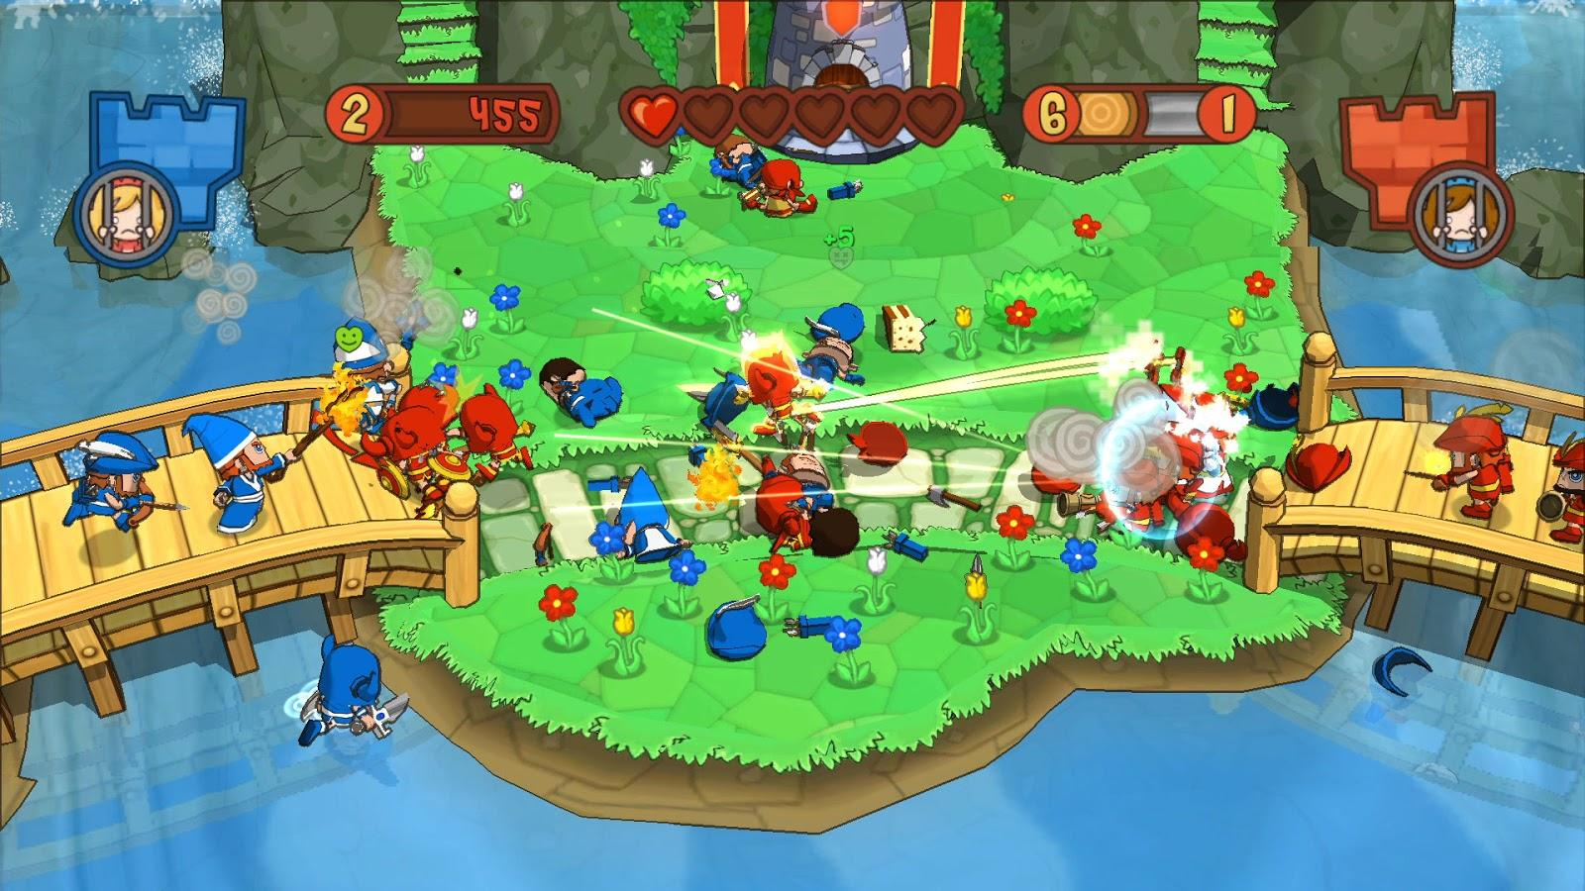

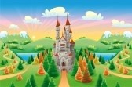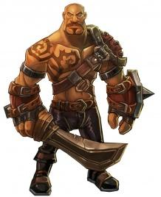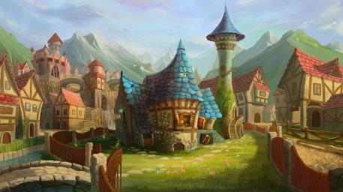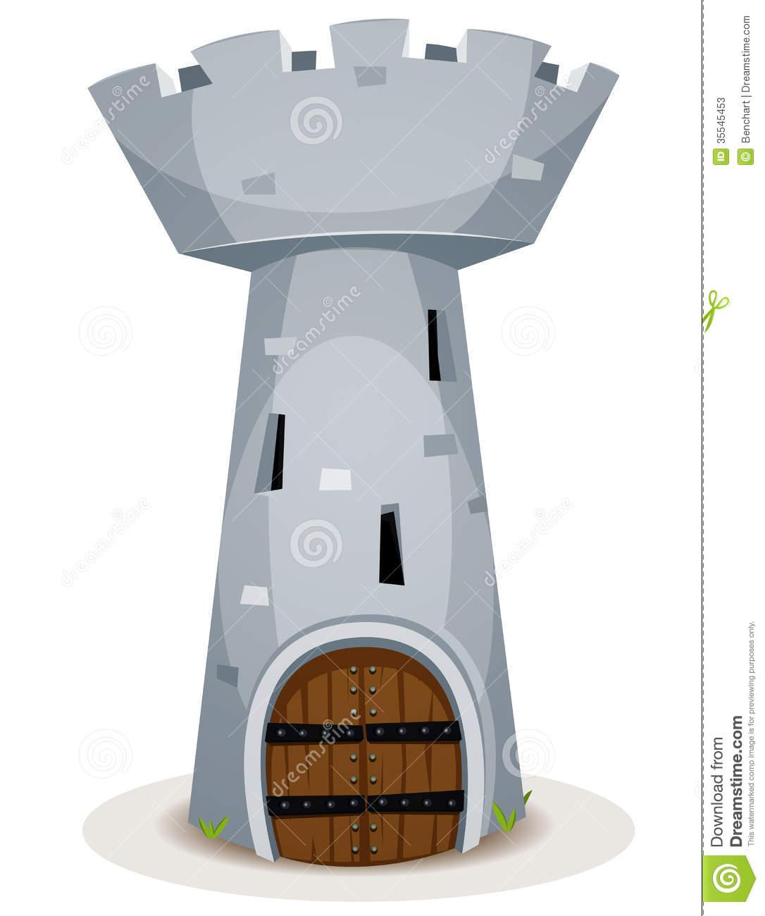

This game design aims towards a cartoony description of a medieval-fantasy world where team-work is crucial to capturing objectives and gaining the upper hand. Teams are identified by their colors (red or blue) and minimalistic character design is preferred with playable classes and NPCs guarding control points. The map is a cartoony description of a jungle or green fields with trees, hills, grass and rivers.

## **Game Play**

When the game is launched, the player is presented with a screen for character creation. There, the player can select one of two playable classes and pick (or become randomly assigned) to one of two factions(red and blue). The player is spawned in their faction’s main base/castle. To get a feel for the game and how it works a help menu has been provided with all the controls listed when the player presses the [F1] key.

In this top-down hack/slash role playing game, the player can control his/her character with basic keyboard buttons(WASD) and can activate the character’s skills with mouse button clicks. After exiting the base, the player will be directed go to one of the control points to capture or defend it from the enemy team.

The main objective of the game is total dominance of control points. In order to capture control points it is necessary to kill all enemy players and enemy NPC guards. At this point a control area will appear. By standing in that area for a set amount of time that control point will belong to your faction. However the enemy team can prevent this by contesting the point which involves them being in the control area as well. By running around the map you will encounter enemy players and hostile NPC guards. The player will hack and slash their way to victory by fighting for control of the world map. There is no end goal, end of a level or a round. The game world is persistent and hosts a never-ending struggle between teams and control of zones around the map.

***5. Key Features***

* Replay ability: Endless
* Team/World chat
* Team work/Co-op
* King of the Hill-Capture the Flag
* PvP / PvE
* Friendly Boss/NPC Spawning
* Device Compatibility: PC
* Number of Players: 50 versus 50
* Number/Type Modes: Multiplayer online battle area

## **Details of Game Design**

When starting the game the player is able to create a character through the character creation process. The two classes available are Sword and Axe. The Sword class is the faster of the two but sports less hit points and damage. The Sword has two attacks: the main attack is a forward slash that can only hit one target. The second attack is a gap closer charge attack that is able to close the distance or retreat. When activated, the character runs fast in a straight line, depending on which way the character is facing. If an enemy is encountered during this charge the animation for the charging character stops and does damage. If no enemy is encountered during the charge, the charge animation will finish. The Axe class is a slower character but has more health than its faster counterpart. The Axe has a slower basic attack that does more damage which is forward frontal cleave that can hit multiple enemies. In addition the Axe class possesses a special attack in which he raises his axe above his head and he brings it down in front of him for massive damage.

A control point is considered contested when players from both teams are standing in the control point area. A control point is in possession when only players from one team are standing in the control point area. A control point is captured when only players from one team have stood on the control point for 30 seconds.

Player combat is built upon basic ARPG elements. When two enemy characters are in close proximity with each other, their attacks cause damage depending on what buffs they possess (depending on which control zones they have under control). When a player’s hit pointsreaches zero, the character is dead.

A certain amount of time after death, the player can choose to be respawned in any one of the control point their team holds. The player can click on a control point on the minimap to make their choice. If no control points are available, then the character is respawned at their team’s main castle.

An optional objective is available through the capture of control points. While a team is in possession of control points, they are awarded resource points over time. When one thousand resource points is reached, a golem piece is spawned on the map for that team. The golem piece will spawn closer to the faction that filled up their resource quota of one thousand. The area that the golem piece spawned within becomes a neutral control point. Just like any other control point, the team has to kill the NPC guards and any other enemy players in the area and hold it under control for 45 seconds to capture that golem piece. The faction that did not spawn the golem piece can also destroy it so that the team spawning the piece goes home empty handed. After a team captures three golem pieces, they can spawn a strong NPC character that attacks the nearest enemy controlled control point. This boss/NPC character can only be brought down by strong team-work and strategy.

### **Player Properties**

1. Player Name
   1. Allows differentiation between players
   2. Displayed above the player’s head to other players
   3. Immutable, input by the player at character creation
2. Hit Points
   1. When this is reduced to 0, a player is defined as dead
   2. Differs depending on character class
   3. Decrease → Sound effect, health bar length decreases
   4. Increase → Simple regeneration animation (?), health bar length increases
3. Movement Speed
   1. Differs depending on character class
4. Skills
   1. Differs depending on character class
   2. All players have two skills, one basic attack and one special attack
   3. Each skill has a cooldown
5. Character Class - a complete player loadout
   1. Defines default number of hit points, movement speed, character model, skills and their cooldowns.
6. Team - (Red or Blue)
   1. Selected at login

**Character Properties**

*The Sword*

Hit Points - 100

Sword Jab - Damage 15 Single Target

Bull Rush - Damage 30 Single Target

*The Axe*

Hit Points - 120

Cleave - Damage 12, Multi Target (AOE frontal cone, this will be handled by distance calculation and heading values)

Skullsplitter - Damage 40, Single Target

**Control Point Properties**

The map has two of each of the following control points. Possessing both points of a particular type will provide a 250% bonus instead of 200%. E.g. each attack node provides 10% more damage, controlling both gives 25%.

Attack

Provides 5 resource points every 10 seconds

Provides a faction wide buff of +10% more damage to friendly players

Defense

Provides 5 resource points every 10 seconds

Provides a faction wide buff of +10% more hit points to friendly players

Money

Provides 10 resource points every 10 seconds

This control point is mainly for resources to build a golem

Golem Spawning Resource Points

After reaching 1000 resource points a golem piece spawns closer to the faction responsible for reaching that goal

Taking possession of a control point will spawn five NPC friendly guards to protect the area. In addition to friendly guards spawning the control point provides healing to friendly players at a rate of 20 hit points per 5 seconds

### **User Interface (UI)**

### **Heads up Display (HUD)**

When at the base/away from control point

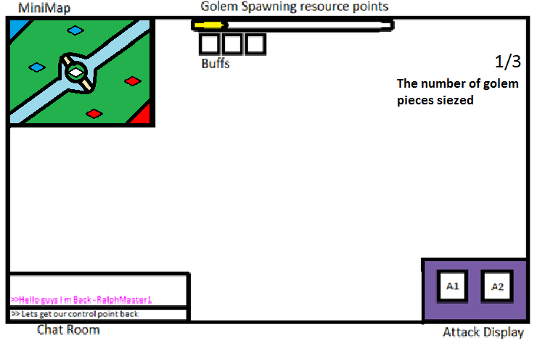

When in range of control point if contested.

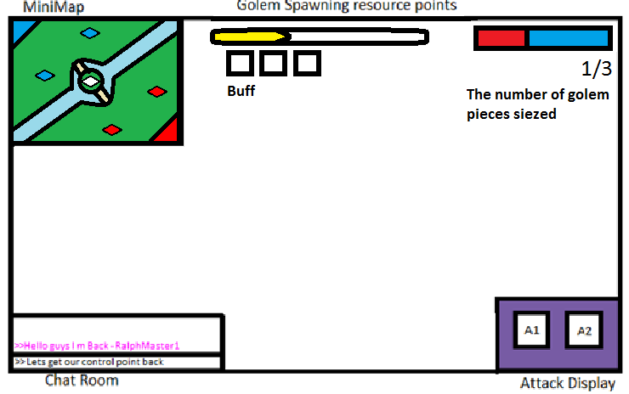

When control point is captured and player is in the range of control point.

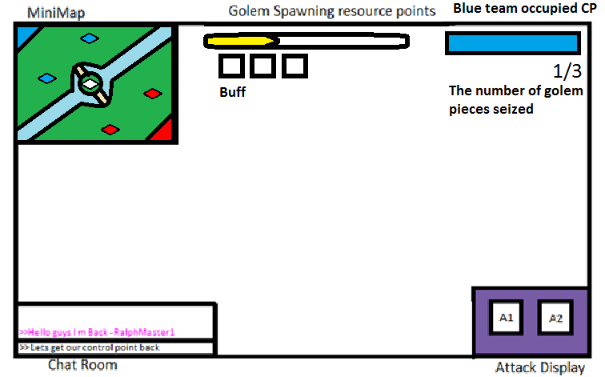

### **Player View**

The camera is centered on the player, looking at the player from above and pitched down about 30 degrees (?). The camera never rotates, but it moves across the X-Y plane, centered on the player.

### **Key map or control table**

|  |  |  |
| --- | --- | --- |
| Action | Control | Context |
| Forward | W | Main Game |
| Right | A | Main Game |
| Backward | S | Main Game |
| Left | D | Main Game |
| Basic Attack | LMB | Main Game |
| Special Attack | RMB | Main Game |
| Quit Game | Esc | Main Game/Menu |
| Select | LMB | Menu |
| Help Menu | F1 | Menu |

## **Antagonistic Elements**

This is where a list of antagonistic (enemies, opponent) objects should be listed with graphics (sketch) and written description.

### **Antagonistic Definitions**

The Golem - Friendly “Boss” NPC

High health, high damage.

Guards - Automatically spawned after taking a control point.

Main work is to defend control points and stay within control point radius.

### **Antagonistic Properties**

The Golem

Hit Points - 2500

Normal Auto Attack - 40 damage, (AOE frontal cone, this will be handled by distance calculation and heading values)

Ground Pound - 75 damage, (AOE circle around the golem, this will be handled by distance calculation)

Graphics - The golem non playable character will be many times larger than a regular player character

Guards

Hit Points - 200

Normal Auto Attack - 8 damage

Graphics - The guard non playable characters will be slightly larger than a regular player character and be of a generic design holding a spear

Golem Guards

Hit Points - 400

Normal Auto Attack - 16 damage

Graphics - The golem guard non playable characters will be double the size of a regular guard NPC be of a generic design holding a two spears

### **Antagonistic List**

A list of all the antagonistic elements goes.

### **Artificial Intelligence (AI)**

This is where visuals and written description(s) of the antagonistic element’s behaviors.

These should be labeled in such a way that they can be used in level design with out having to describe them again.

This is how an AI action could be broken down:

Normal State:

Golem: moves towards closest eneny control point, slow speed.

Guards: stay in the control point radius and protect it.

Detection State:

What does it take for this object to detect the player?

Golem: An enemy player is within the golem’s melee attack range

Guards: An enemy player is within the control point zone that the guard is assigned to.

Reaction State:

What does the object do as an action after passing the reaction state?

Golem: If the golem finds a player of enemy team within his way to control point, he attacks them. After he reaches the control point he will attack the NPC’s and the enemy player in his radius.

Guards: Guards will attack the closest enemy player within a radius around the control point they are protecting

End State:

What happens to the object after player has reacted correctly or incorrectly to object?

Golem & guards:if the player attack is successful, golem & guards HP point will get reduce based on the type of attack he was attacked with. If the player is attacked, they lose HP too..

## **Concept Art**

Sketches that are used for the concept can go into this section as visual reference. In the case of a brand, certain creative restrictions should be noted here.

## **Level Design**

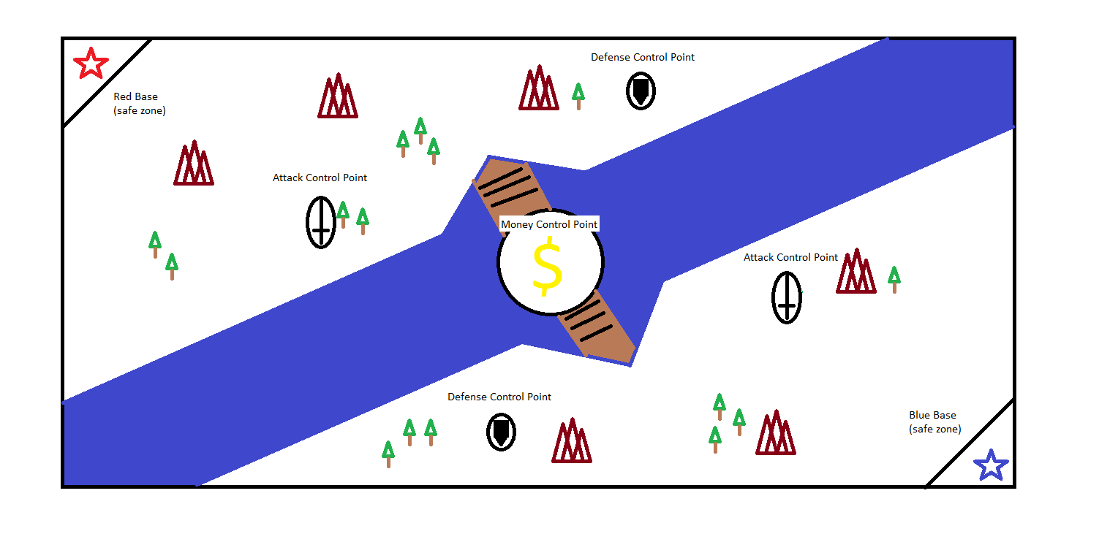

## **Game Architecture**

This is best done by a flow chart to represent the overall game.

* Title Screen
* Option Screens
* Game Modes
* End Screens

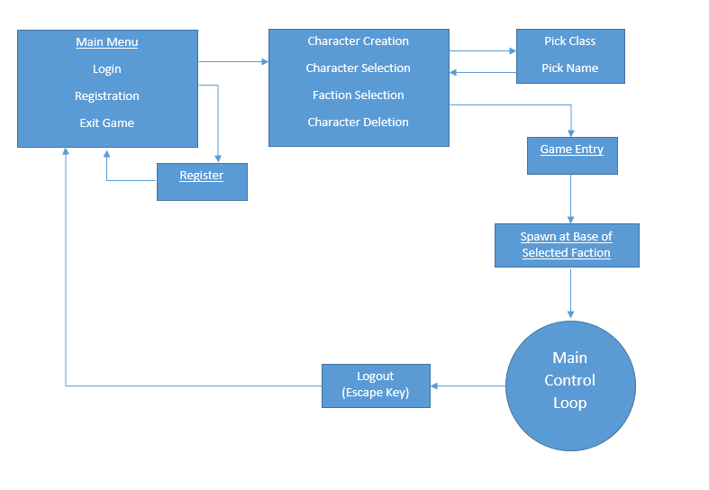

1. **Implementation**

**Client/Server Architecture:** Client and server should connect with each other.

**Protocol Implementation:** These are the basic protocol implementation that are need to be done:

* **Login:** The login is done by giving username and password. if they are correct and match with the database than the user is able to login.
* **Logout:** You will have to press the Esc key than you will have to click on the logout link to logout and than it will take you to the main page.
* **Position i.e x,y,z,h:** the position of the player.
* **Hit points of players and NPC :** Hit point can be a bar or text that appear on the head on the character(it can a player or NPC).
* **Control point state/Tracking:** We should be able to identify the state of the control point weather it is being captured or contested and it should also be able to track the resources that are generated when a control point is being captured.
* **Golem piece tracking:** You should also be able to track how many golem pieces has been capture by your team.
* **Death & Respawn:** Once your Hit point hits 0 you die. u should respawn at the near controlled point that has been captured by you.

**Character Implementation with NPC and Enemy Players:**

* **Attacks:** Character and NPC’s should be able to attack the enemy players. It should reduce points on the base of attacks describe above in the documentation.
* **Hit points:** Hit point can be a bar or text that appear on the head on the character. Based on the attack it should reduce points from the bar or text.
* **Control points**
  + **Capture:** You should be able to capture a control point. To capture a control point player has to kill and the enemy player and NPCs and than hold that control point for 30 sec without being contested.
  + **Contested:** You should be able to determine weather a control point is being contested or not.
  + **Provides buff:** Once you have captured a control point, it should be able to provide buff based on the type of control point it is.
  + **Provides resources:** With buff, it should also be able to provide you with resources once its been captured.
  + **Provides healing:** If you have lost heavy amount of hit point. you can go to the captured control point. once you are in the control point area it should be able to provide you healing.
  + **Spawn Guards:** Once you capture a control point, a friendly NPC will appear around the control point that will protect that control point for your team.
* **Spawn Golem control point**
  + **Capture/Destroy:**  Once a Golem piece spawn, if it spawn by your team you can capture it and if its spawn by opposite team you can try to destroy it. In all you need to capture 3 pieces to spawn a Golem.
  + **Guards:** once resource pointer hit a 1000 point the Golem piece will spawn. it will be protected by neutral guards. In order to destroy or capture that piece you will have to kill all guards and enemy players.

**Initial client side team work division:**

There are 2 teams:

* **Control Point Team:**

Task:

Top-down camera

1-Make a circle appear on the ground

2-Two ralphs, one friendly one enemy

3-When any ralph enters the zone, a bar appears on the upper right corner

4-if the ralph is friendly, the bar starts turning into blue

5-if the ralph is enemy, the bar starts turning into red

6-after the bar is completely blue, no one is inside it and the enemy player goes in, it s tarts turning into red

7-if the bar is completely red, no one is inside it and the friendly player walks in, it starts turning into blue

8-if both players are present at the same time, the bar is purple

* **Combat Team:**

Task:

Top-down camera

1-Make ralphs have green health bars and names on top of their heads(sword and axe), ralphs with the sword name has

100 health points, ralphs with the axe name has 120 health points

2-no collision detection, hits are acknowledged by distance and heading

3-Combat specifications for sword and axe ralphs

* when a sword ralph is close proximity to another and facing towards it, if the mouse button is clicked, the other ralph loses 15 points from their health bar. the sword ralph can only hit one ralph at a time
* when an axe ralph is close proximity to another and facing towards it, if the mouse button is clicked, the other ralph(s)
* lose(s) 12 points from their health. the axe ralph can hit multiple ralphs at once

4-if a ralph's health bar reaches zero, the ralph is destroyed and created away from the other ralph with full health

5-make some ralphs in red shade and others in blue shade, make sure same color ralphs cannot attack each other

6-make pandas as npc guards. they start walking to the nearest enemy

7-make sure that if a player is being rushed by two pandas, the third panda picks another enemy(aggroing)