Initial Game Concept & Design Document Template

## Version 0.9.1 – Fixed many typos, added specifics for implementation, respawning, and character creation

## Introduction



Contested is a MMOG that takes place in a medieval setting that supports up to fifty versus fifty player versus player combat. There are two factions competing for control points that provide advantages. The main objective is to capture control the majority of the world map while defending your territory.

## Game Analysis

|  |  |
| --- | --- |
| **Game Description** |  |
| Genre: | Multiplayer Online Battle Arena |
| Player: | Massively Multiplayer |
| Game Elements: | Hack and slash player versus player combat for objectives |
| Game Content: | Action Adventure |
| Theme: | Medieval Fantasy |
| Style: | Cartoony |
| Game Sequence: | Tutorial Quests -> Main Game |
| Player Immersion: | Tactical, Strategy, Team-work |
| Technical From: | 3D graphics |
| View: | Top-down/Isometric |
| SW Platform: | Java, Python, Windows |
| HW Platform: | PC |
| Audience | General |

## Game Atmosphere

Mood board:

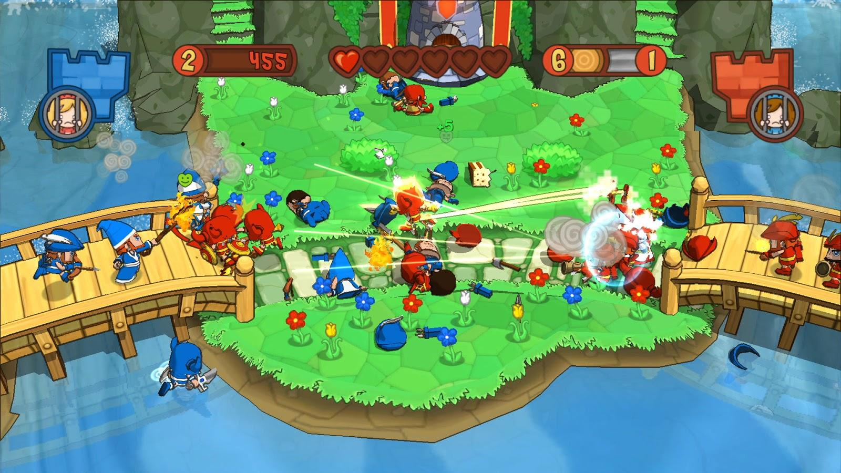

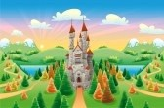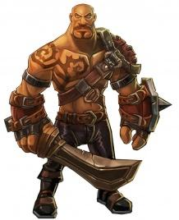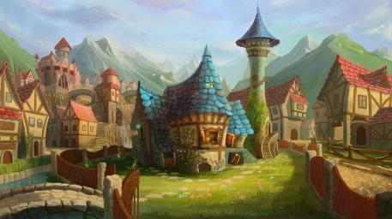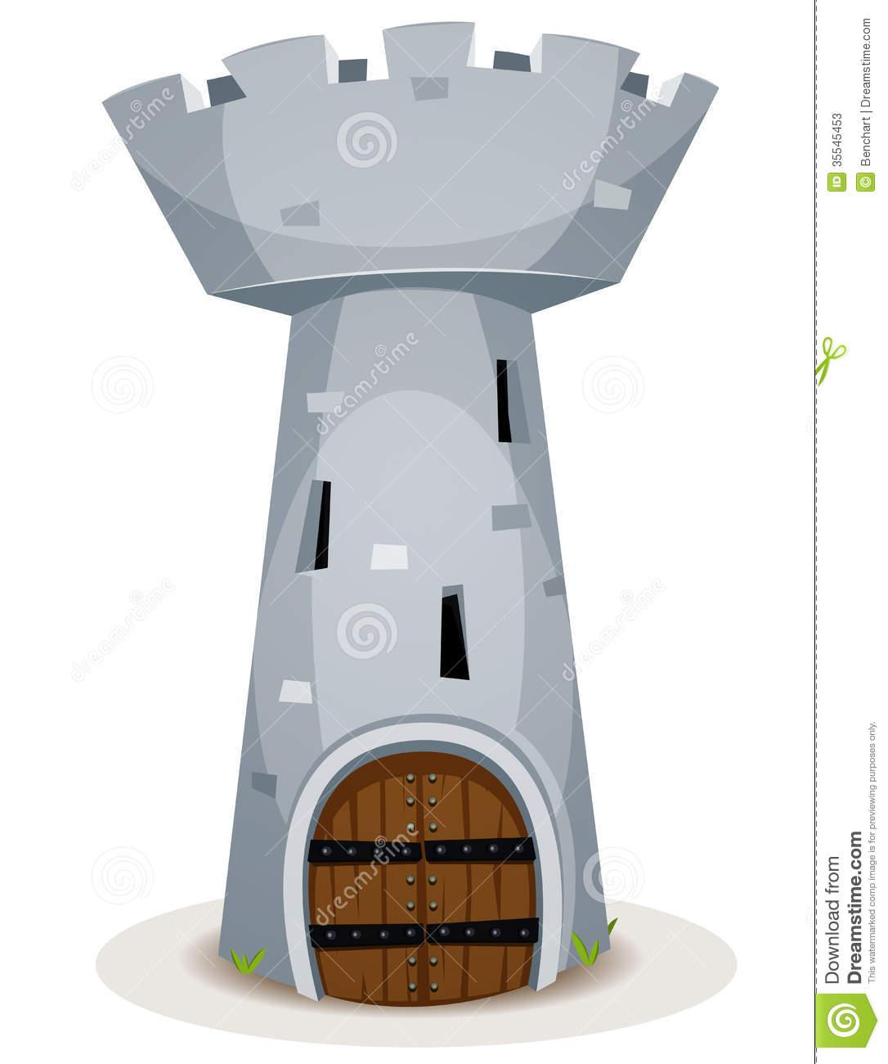

This game design aims towards a cartoon-like description of a medieval-fantasy world where team-work is crucial to capturing objectives and gaining the upper hand. Teams are identified by their colors (red or blue) and minimalistic character design is preferred with playable classes and NPCs guarding control points. The map is a cartoon-like description of a jungle or green fields with trees, hills, grass and rivers.

## Game Play

When the game is launched, the player is presented with a screen for character creation. There, the player can select one of two playable classes and pick (or become randomly assigned) to one of two factions(red and blue). The player is spawned in their faction’s main base/castle. To get a feel for the game and how it works a help menu has been provided with all the controls listed when the player presses the [F1] key.

In this top-down hack/slash role playing game, the player can control his/her character with basic keyboard buttons(WASD) and can activate the character’s skills with mouse button clicks. After exiting the base, the player will be directed go to one of the control points to capture or defend it from the enemy team.

The main objective of the game is total dominance of control points. In order to capture control points it is necessary to kill all enemy players and enemy NPC guards. At this point a control area will appear. By standing in that area for a set amount of time that control point will belong to your faction. However the enemy team can prevent this by contesting the point which involves them being in the control area as well. By running around the map you will encounter enemy players and hostile NPC guards. The player will hack and slash their way to victory by fighting for control of the world map. There is no end goal, end of a level or a round. The game world is persistent and hosts a never-ending struggle between teams and control of zones around the map. ***When a character is logged out of the game and decides to log back into the game that character will be spawned in their faction’s main base.***

***5. Key Features***

* Replay ability: Endless
* Team/World chat
* Team work/Co-op
* King of the Hill-Capture the Flag
* PvP / PvE
* Friendly Boss/NPC Spawning
* Device Compatibility: PC
* Number of Players: 50 versus 50
* Number/Type Modes: Multiplayer online battle area

## Details of Game Design

When starting the game the player is able to create a character through the character creation process. The two classes available are Sword and Axe. The Sword class is the faster of the two but sports less hit points and damage. The Sword has two attacks: the main attack is a forward slash that can only hit one target. The second attack is a gap closer charge attack that is able to close the distance or retreat. When activated, the character runs fast in a straight line, depending on which way the character is facing. If an enemy is encountered during this charge the animation for the charging character stops and does damage. If no enemy is encountered during the charge, the charge animation will finish. The Axe class is a slower character but has more health than its faster counterpart. The Axe has a slower basic attack that does more damage which is forward frontal cleave that can hit multiple enemies. In addition the Axe class possesses a special attack in which he raises his axe above his head and he brings it down in front of him for massive damage.

***Each player has the ability to create multiple characters. In addition each player can create characters that are part of either faction, Red or Blue. They also have the ability to delete these characters if they so choose.***

A control point is considered contested when players from both teams are standing in the control point area. A control point is in possession when only players from one team are standing in the control point area. A control point is captured when only players from one team have stood on the control point for 30 seconds.

Player combat is built upon basic ARPG elements. When two enemy characters are in close proximity with each other, their attacks cause damage depending on what buffs they possess (depending on which control zones they have under control). When a player’s hit points reaches zero, the character is dead.

***A certain amount of time after death, the player can choose to be respawned in the nearest friendly control point. If no control points are available, then the character is respawned at their team’s main castle.***

An optional objective is available through the capture of control points. While a team is in possession of control points, they are awarded resource points over time. When one thousand resource points is reached, a golem piece is spawned on the map for that team. The golem piece will spawn closer to the faction that filled up their resource quota of one thousand. The area that the golem piece spawned within becomes a neutral control point. Just like any other control point, the team has to kill the NPC guards and any other enemy players in the area and hold it under control for 45 seconds to capture that golem piece. The faction that did not spawn the golem piece can also destroy it so that the team spawning the piece goes home empty handed. After a team captures three golem pieces, they can spawn a strong NPC character that attacks the nearest enemy controlled control point. This boss/NPC character can only be brought down by strong team-work and strategy.

***Note the difference between Characters and Players.***

### Player Properties

User Name

1. Allows differentiation between users for login
2. Immutable, input by the player at registration

**Character Properties**

Character Name

1. Allows differentiation between characters
2. Displayed above the character’s head to other characters
3. Immutable, input by the player at character creation

Hit Points

1. When this is reduced to 0, a player is defined as dead
2. Differs depending on character class
3. Decrease → Sound effect, health bar length decreases
4. Increase → Simple regeneration animation, health bar length increases

Movement Speed

1. Differs depending on character class

Skills

1. Differs depending on character class
2. All players have two skills, one basic attack and one special attack
3. Each skill has a cool down

Character Class - a complete player load out

1. Defines default number of hit points, movement speed, character model, skills and their cool downs.

Team - (Red or Blue)

1. Selected at Character Creation

Character Class Specifics

*The Sword*

* Hit Points - 100
* Sword Jab - Damage 15 Single Target
* Bull Rush - Damage 30 Single Target

*The Axe*

* Hit Points - 120
* Cleave - Damage 12, Multi Target (AOE frontal cone, this will be handled by distance calculation and heading values)
* Skullsplitter - Damage 40, Single Target

**Control Point Properties**

The map has two attack, two defense and one money Control Point(s). Possessing both points of a particular type will provide a 250% bonus instead of 200%. E.g. each attack node provides 10% more damage, controlling both gives 25%.

Attack

Provides 5 resource points every 10 seconds

Provides a faction wide buff of +10% more damage to friendly players

Defense

Provides 5 resource points every 10 seconds

Provides a faction wide buff of +10% more hit points to friendly players

Money

Provides 10 resource points every 10 seconds

This control point is mainly for resources to build a golem

Golem Spawning Resource Points

After reaching 1000 resource points a golem piece spawns closer to the faction responsible for reaching that goal

***The requirements to take a control point are as follows:***

1. ***You must not be in possession of the control point***
2. ***All enemy NPC guards must be dead***
3. ***All enemy players must not be within the control point boundaries***
4. ***At least one friendly player must be within the control point boundary***

Taking possession of a control point will spawn five NPC friendly guards to protect the area. In addition to friendly guards spawning the control point provides healing to friendly players at a rate of 20 hit points per 5 seconds.

### User Interface (UI)

### Heads up Display (HUD)

When at the base/away from control point

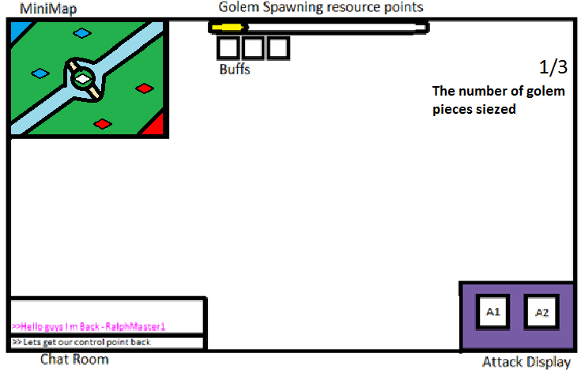

When in range of control point if contested.

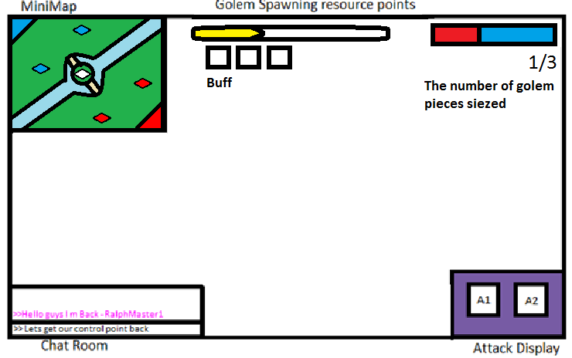

When control point is captured and player is in the range of control point.

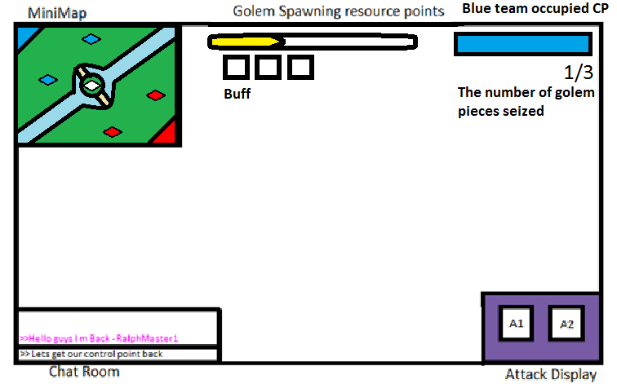

### Player View

The camera is centered on the player, looking at the player from above and pitched down about 30 degrees (?). The camera never rotates, but it moves across the X-Y plane, centered on the player.

### Key map or control table

|  |  |  |
| --- | --- | --- |
| Action | Control | Context |
| Forward | W | Main Game |
| Right | A | Main Game |
| Backward | S | Main Game |
| Left | D | Main Game |
| Basic Attack | LMB | Main Game |
| Special Attack | RMB | Main Game |
| Quit Game | Esc | Main Game/Menu |
| Select | LMB | Menu |
| Help Menu | F1 | Menu |

## Antagonistic Elements

This is where a list of antagonistic (enemies, opponent) objects should be listed with graphics (sketch) and written description.

### Antagonistic Definitions

The Golem - Friendly “Boss” NPC

High health, high damage.

Guards - Automatically spawned after taking a control point.

Main work is to defend control points and stay within control point radius.

### Antagonistic Properties

The Golem

Hit Points - 2500

Normal Auto Attack - 40 damage, (AOE frontal cone, this will be handled by distance calculation and heading values)

Ground Pound - 75 damage, (AOE circle around the golem, this will be handled by distance calculation)

Graphics - The golem non playable character will be many times larger than a regular player character

Guards

Hit Points - 200

Normal Auto Attack - 8 damage

Graphics - The guard non playable characters will be slightly larger than a regular player character and be of a generic design holding a spear

Golem Guards

Hit Points - 400

Normal Auto Attack - 16 damage

Graphics - The golem guard non playable characters will be double the size of a regular guard NPC be of a generic design holding a two spears

### Antagonistic List

A list of all the antagonistic elements goes.

### Artificial Intelligence (AI)

This is where the main of the antagonistic element’s behaviors are described. Enemies will have states depending on their proximity to other player characters and/or control points.

Normal State:

Golem: Moves towards closest enemy control point, slow speed.

Guards: Stay inside the control point in certain spots and stand still, wait for enemy players to approach.

Detection State:

Golem: An enemy player or an enemy guard is within the golem’s melee attack range

Guards: An enemy player is within the control point zone that the guard is assigned to.

Reaction State:

Golem: If the golem encounters an enemy player, he attacks them. After he reaches the control point he will attack the NPC’s and the enemy players in the control point’s radius.

Guards: Guards will attack the closest enemy player within a radius around the control point they are protecting

End State:

Golem & guards: When health reaches zero, the Golem get destroyed. Guards respawn the moment the control point switches ownership.

## Level Design

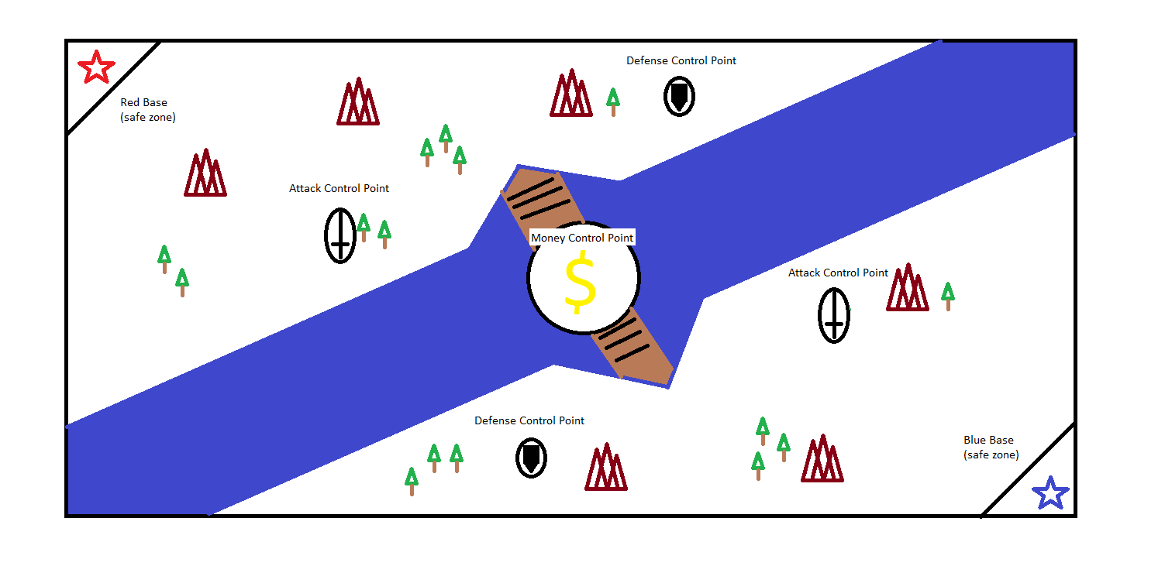

## Game Architecture

This is best done by a flow chart to represent the overall game.

* Title Screen
* Option Screens
* Game Modes
* End Screens

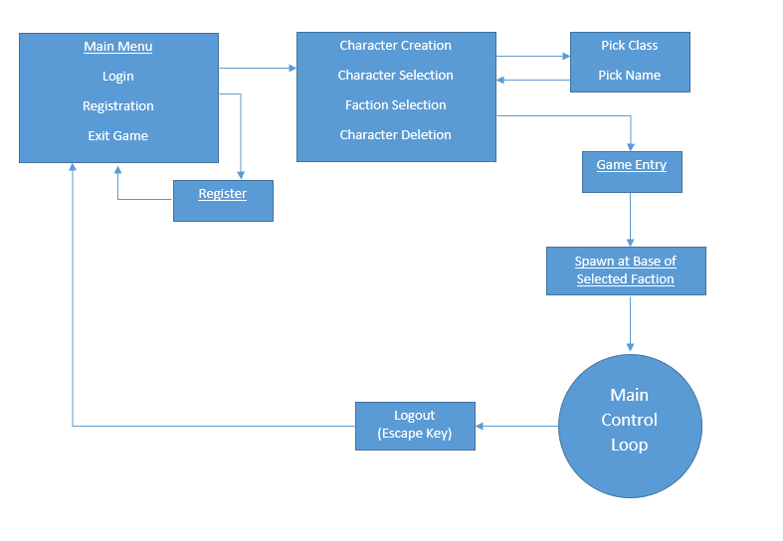

1. **Implementation**

**Client/Server Architecture:** Client and server should connect with each other.

**Protocol Implementation:** This is the basic protocol implementation

* **Login:** The user enters his/her login info(user name and password). If the information matches with the ones on the database, the user is allowed to log in.
* **Logout:** Pressing the escape key at any point presents the user with the logout option. If the link is clicked, than the user is logged out of the game and returned to the main menu.
* **Position i.e x,y,z,h:** the position of the player.
* **Hit points of players and NPC :** Hit point/health can be a green bar or text that appears on the head of the character(playable and non-playable)
* **Control point state/Tracking:** We should be able to identify the state of the control point whether it is being captured or contested and it should also be able to track the resources that are generated when a control point is being captured.
* **Golem piece tracking:** You should also be able to track how many golem pieces has been captured by your team. This can appear as numbers/text on the right side of the screen(please refer to the UI).
* **Death & Respawn:** When a character’s(player controlled) hit points(health) reach zero, the character dies and respawns at the closest control point. If no control points are available, the character respawns at their faction’s main castle. If a character logs out and logs back in, then the character is spawned at their faction’s main castle.

**Character Implementation with NPC and Enemy Players:**

* **Attacks:** Character and NPC’s should be able to attack the enemy players. It should reduce hit points(health) on the base of attacks described above in the documentation.
* **Hit points:** Hit points can be a bar or text that appear on the head on the character. Based on the attack it should reduce points from the bar or text.
* **Control points**
  + **Capture:** You should be able to capture a control point. To capture a control point player has to kill enemy players and NPC that are within the control point’s radius. After all the opposing characters are destroyed, players have to wait within the control point radius for 30 seconds to capture it for their team.
  + **Contested:** A control point is contested when player characters from both teams are present within the control point radius. All opposing characters and NPCs must be destroyed to get out of this state.
  + **Provides buff:** Once a control point is captured, it should be able to provide a buff based on the type of the control point.
  + **Provides resources:** Capturing a control point generates resources which are used to spawn Golem pieces.
  + **Provides healing:** Once a player character is within the control point radius, it is healed by the control point until it’s health is full.
  + **Spawn Guards:** Once the control point is captured, friendly NPC guards are spawned within the control point that guard the area.
* **Spawn Golem control point**
  + **Capture/Destroy:**  Once a team spawns a golem piece, it can either be captured by them or be destroyed by the enemy team. The golem piece is spawned as a smaller control point and same rules apply as far as capturing it goes.(If the friendly team captures it, they capture the piece. If the enemy team captures it, the piece is destroyed)
  + **Guards:** Once the golem piece is spawned, neutral guards also spawn within the control point it creates. Teams have to kill the guards in order to capture the control point(create/destroy the golem piece)

**Initial client side team work division:**

There are 2 teams:

* **Control Point Team:**

Task:

Top-down camera

1. Make a circle appear on the ground
2. Two ralphs, one friendly one enemy
3. When any ralph enters the zone, a bar appears on the upper right corner
4. If the ralph is friendly, the bar starts turning into blue
5. If the ralph is enemy, the bar starts turning into red
6. After the bar is completely blue, no one is inside it and the enemy player goes in, it starts turning into red
7. If the bar is completely red, no one is inside it and the friendly player walks in, it starts turning into blue
8. 8-if both players are present at the same time, the bar stops moving.

* **Combat Team:**

Task:

Top-down camera

1. Make character Ralphs have green health bars, character names, and the names of their classes on top of their heads (sword and axe). Sword Ralphs have 100 health points, Axe Ralphs have 120 health points.
2. No collision detection, hits are acknowledged by distance and heading.
3. Combat specifications for sword and axe ralphs
   1. when a sword ralph is close proximity to another and facing towards it, if the mouse button is clicked, the other ralph loses 15 points from their health bar. the sword ralph can only hit one ralph at a time
   2. when an axe ralph is close proximity to another and facing towards it, if the mouse button is clicked, the other ralph(s) lose(s) 12 points from their health. the axe ralph can hit multiple ralphs at once
4. If a ralph's health bar reaches zero, the ralph is destroyed and created away from the other ralph with full health restored.
5. Create some red Ralphs and blue Ralphs. Make sure same color Ralphs cannot attack each other (no friendly fire).
6. Create pandas as npc guards. Have them start walking to the nearest enemy.
7. Make sure that if a player is being rushed by two pandas, the third panda picks another enemy.