**HOW CAMPUS COUPONS WORKS**

***What is a coupon***

A coupon is ticket issued by a business owner (retail store or service provider), that can be redeemed for a financial discount when purchasing a product or obtaining a service.

It entitles the holders to enjoy various offers on different products and services.

***Features of a typical coupon***

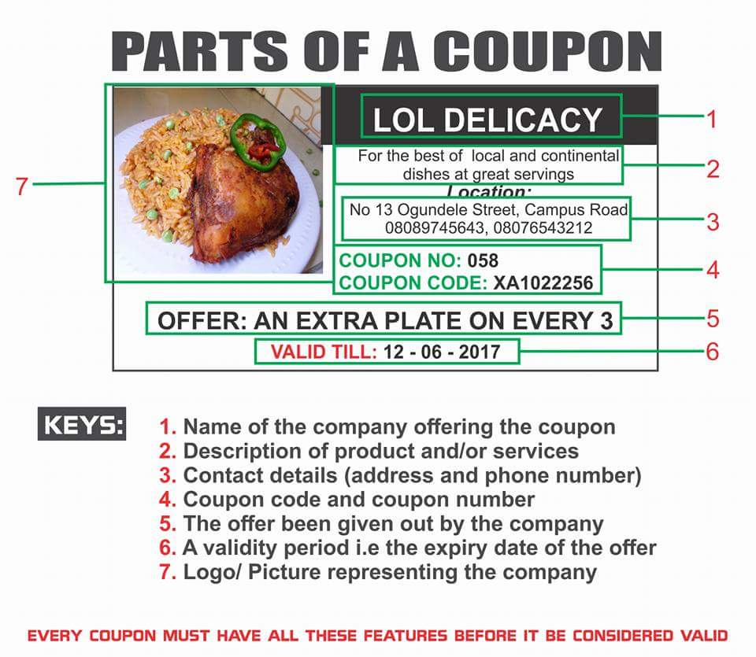

***NOTE: coupon code is the major feature on a coupon. Each coupon has a unique coupon code. The code is what qualifies the user to get the offer given by the business owner***

***The couponer’s advantage***



Just in a phrase “YOU SAVE MORE”.

Your happy shopping experience is guaranteed, how? Because you enjoy viable discounts and other offers on your favourite product at your favourite store.

You spend less, you get more……ultimately, you save more!!!

***USING THE WEBSITE (www.campuscoupons.ng)***

***Opening of Account***

Each user (Student) opens an account on the website with his/her email, phone number and username.

The email is used as login details with his/ her password.

Upon log in, the user has access to his/her specific campus but can also go through offers from other schools. Offers are sorted based on the campus. Offers from various business owners are accessible by the user.

***Tokens (kupos)***

The token which is our internal currency used to access the coupon codes of the offers on the website is popularly known as ‘KUPOS’

Upon registration, each user is given 20 kupos.

Each user will be able to purchase Kupos directly on the website once the one they have has been exhausted.

For a user without token, offers on the coupons cannot be accessed.

***Coupon Codes***

Upon using kupos to access a coupon, codes are revealed and these are downloadable. The codes generated are used to claim the offers on the coupons.

The downloaded coupons saved on the mobile phone are taken to the store owners to claim the offer.

Every coupon has expiry date. Every store is mandated to fulfil the offers on the coupons so far it has not expired.

***For further enquiries***

***contact us via email- campuscoupons@gmail.ng***

***phone number- 08062784932, 08065268937, 07058843947, 08039535364, 07069360343***