Quiz 3 (R-Studio)

Joey Simone

1. Load Data from excel file into Rstudio.

data=read.csv("pulse_rates.csv")

1. Provide summary of data.

summary(data)

## PulseRate Gender   
## Min. : 52.00 Length:29   
## 1st Qu.: 61.00 Class :character   
## Median : 75.00 Mode :character   
## Mean : 72.83   
## 3rd Qu.: 81.00   
## Max. :103.00

1. Create bar plot for Gender variable.

gender <- table(data$Gender)   
gender

##   
## Female Male   
## 13 16

barplot(gender,  
 col = "red",   
 border = "black",   
 ylim=c(0,20),  
 main = "Gender",  
 ylab = "Number of People")

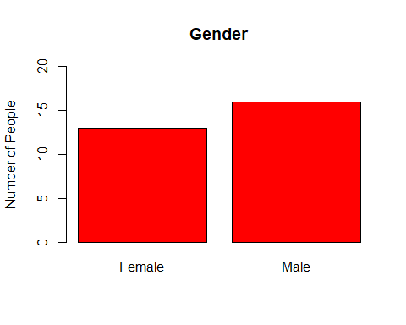

1. (2 point) Create pie chart for Gender variable.

pie(gender, main = "gender", col = rainbow(12))

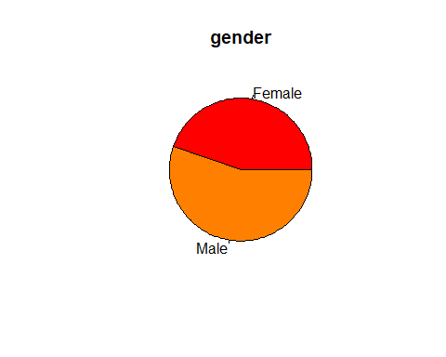

1. Construct histogram with five bars for pulse rates of Males.

hist(data$PulseRate [data$Gender=="Male"],  
   
breaks =seq(min(data$PulseRate[data$Gender=="Male"]), max(data$PulseRate[data$Gender=="Male"]), length.out=6),  
  
main="Pulse Rates of Males ",  
ylab="Frequency",  
xlab="Pulse Rates",  
xlim=c(50,110),  
col="red",   
border="blue")

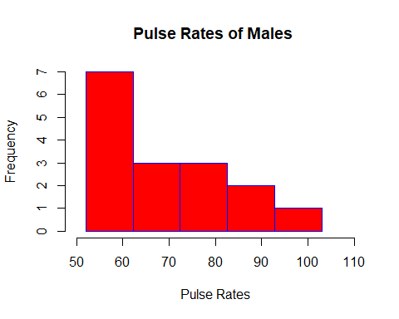

1. (2 point) Construct histogram with six bars for pulse rates of Females.

hist(data$PulseRate [data$Gender=="Female"],  
   
breaks =seq(min(data$PulseRate[data$Gender=="Female"]), max(data$PulseRate[data$Gender=="Female"]), length.out=7),  
  
main="Pulse Rates of Females ",  
ylab="Frequency",  
xlab="Pulse Rates",  
xlim=c(50,110),  
col="red",   
border="blue")

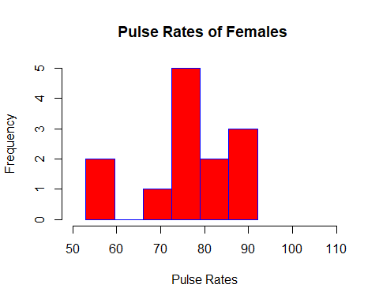

1. Find quartiles for pulse rates of Males.

quantile(data$PulseRate [data$Gender=="Male"])

## 0% 25% 50% 75% 100%   
## 52 60 65 77 103

1. Find the 37th percentile for pulse rates of Males.

quantile(data$PulseRate [data$Gender=="Male"], 0.37)

## 37%   
## 61.55

**37th percentile is**

1. (1 point) Find quartiles for pulse rates of Females.

quantile(data$PulseRate [data$Gender=="Female"])

## 0% 25% 50% 75% 100%   
## 53 74 78 83 92

10.(1 point) Find the 64th percentile for pulse rates of Females.

quantile(data$PulseRate [data$Gender=="Female"], 0.64)

## 64%   
## 80.36

**64th percentile is**

1. Find IQR for pulse rates of Males

IQR(data$PulseRate [data$Gender=="Male"])

## [1] 17

1. Find outliers for pulse rates of Males.

outliere_lower=quantile(data$PulseRate [data$Gender=="Male"], 0.25)-1.5*IQR(data$PulseRate [data$Gender=="Male"])  
data$PulseRate [data$Gender=="Male" & data$PulseRate<outliere_lower]

## integer(0)

outliere_lower=quantile(data$PulseRate [data$Gender=="Male"], 0.75)+1.5*IQR(data$PulseRate [data$Gender=="Male"])  
data$PulseRate [data$Gender=="Male" & data$PulseRate>outliere_lower]

## [1] 103

**Outlier(s) is (are)**

1. Construct BOX PLOT for pulse rates of Males.

boxplot(data$PulseRate [data$Gender=="Male"],  
 main=" Pulse Rates of Males ",  
 xlab="Pulse Rates",  
 ylim=c(50,110),  
   
 col="yellow",  
 border= "tomato1" ,  
 horizontal = T)

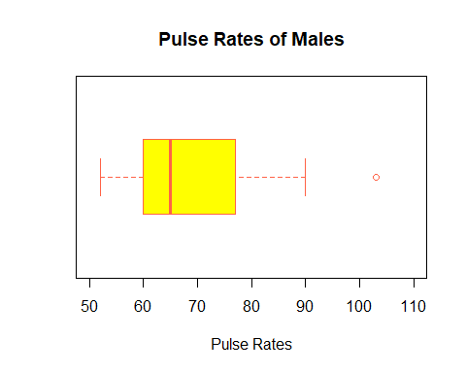

1. (1 point) Find IQR for pulse rates of Females

IQR(data$PulseRate [data$Gender=="Female"])

## [1] 9

1. (2 point) Find outliers for pulse rates of Females.

outliere_lower=quantile(data$PulseRate [data$Gender=="Female"], 0.25)-1.5*IQR(data$PulseRate [data$Gender=="Female"])  
data$PulseRate [data$Gender=="Female" & data$PulseRate<outliere_lower]

## [1] 53 54

outliere_lower=quantile(data$PulseRate [data$Gender=="Female"], 0.75)+1.5*IQR(data$PulseRate [data$Gender=="Female"])  
data$PulseRate [data$Gender=="Female" & data$PulseRate>outliere_lower]

## integer(0)

**Outlier(s) is (are)**

1. (2 point) Construct BOX PLOT for pulse rates of Females.

boxplot(data$PulseRate [data$Gender=="Female"],  
 main=" Pulse Rates of Females ",  
 xlab="Pulse Rates",  
 ylim=c(50,110),  
   
 col="yellow",  
 border= "tomato1" ,  
 horizontal = T)

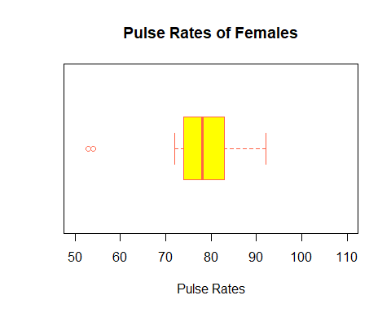

1. (2 point) Compare these two box plots and describe the differences between these two box plots.

Pulse rate of Men is lower than Women

1. (2 point) Find the mean for pules rates of Males and Females. Compare these means. Write a complite sentense.

**The mean for pulse rates of Males is**  The mean pulse of men is 0.5517241 Beats per minute. **The mean for pulse rates of Females is**

The mean pulse of women is 0.4482759 Beats per minute. **Compare these means:**

1. (2 point) Find the median for for pules rates of Males and Females. Compare these meadian values. Write a complite sentense.

**The median for pulse rates of Males is**

**The median for pulse rates of Females is**

**Compare these median values:**

1. Find the mode for pules rates of Males.

mode=table(data$PulseRate [data$Gender=="Male"])  
  
names(mode)[mode==max(mode)]

## [1] "60" "77"

**The mode(s) for pulse rates of Males is (are)**

1. (1 point) Find the mode for pules rates of Females.

**The mode(s) for pulse rates of Females is (are)**

1. (2 point) Find a standard deviation for for pules rates of Males and Females. Compare these standard deviations. Write a complite sentense. (Hint: sd(name of data$name of variable))

**The standard deviation for pulse rates of Males is**

**The standard deviation for pulse rate of Female is**

**Compare these standard deviations:**