**Analysis of Video Game Sales**

Jordan Burns

Regis University

MSDS 670 Data Visualization

John Koenig

June 5, 2022

The global market for video games is increasingly expanding with contributing factors including the success of Sony’s PlayStation 4. The PlayStation 4 was released in late 2013 and has since become one of the leading video game consoles. The sales of games for the PlayStation 4 have been staggering and continue to increase. The dataset used in this analysis consists of game releases on the PlayStation 4, the genre associated with the game, and the sales numbers in the four major categories considered for video games: North America, Europe, Japan, and Rest of World. The intent in analyzing this data is to understand the leading genres for video games, the regions they are popular in, and how publishers can use the data to change their projects or marketing campaigns.

The distribution of sales by genre of video game can be an indicator of which categories of games are most popular and generate the largest amount of revenue. Figure 1 below indicates that the Action, Shooter, Action-Adventure, and Sports genres of video games dominate the total number of sales over the other genres. Figure 1.

The North American and European markets dominate the total video game sales. The European market generates more sales for nearly every category other than Fighting and Music based games. This could indicate a lack of interest in these types of games or a general inaccessibility to them.

Figure 2.

Publishers of video games can directly benefit from understanding the percentage of sales of their games in each of the major regions. Figure 3 shows the share that each of the 10 largest publishers by sales have in each of these regions. Nearly all the publishers have a similar percentage of sales for each of the regions. The notable exception is 2K Sports, which has a much larger percentage of sales in North America than other regions. This could be contributed to the fact that 2K Sports makes sports games featuring the NBA, WWE, and PGA, all of which are more popular in the U.S. than the rest of the world.

Figure 3.

Analyzing global sales based on genre can provide insight on the most popular types of games globally and the genres that generate the most revenue. Action games generally perform well, but Shooter games are consistently the most likely to generate a lot of sales.

Figure 4.

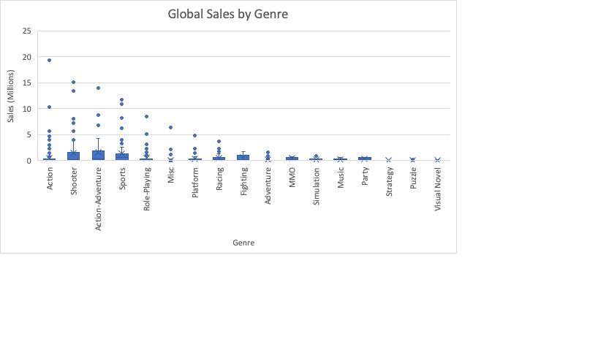

In conclusion, video game sales on the PlayStation 4 are seemingly driven by the sales of games in the Action, Shooter, Action-Adventure, and Sports categories. Games in these categories generate more revenue than the others, and more games are released in these genres than any of the others. It is unclear whether the high sales of these games are since there are more of them than other genres, or if there is less interest to play Simulation, Strategy, and Puzzle games on console. These types of games are known for being best on the PC, which could contribute to a lack of interest on the PlayStation. Publishers can analyze this type of data to determine if they should continue to develop games in the major categories or if they should explore new, lesser developed genres.