Documentation for fixing bugs

1. In class Item, unified all prices to type Double.
2. In class OrderLine, the constructor havs error on initialization.
3. In class Calculator, add instance variables grandtotal, grandtax, currentTotal and currentTax and getter for these fields for unit testing.
4. Changed the type cast in rounding method to (double) to make it works.
5. In method calculate in class Calculator, the first for loop shouldn’t set grandtotal to 0, which is used to save the total price of all the orders.
6. Move the inner loop inside the same for loop as above to method doCalculate, which makes this class more testable.
7. In the print of method doCalculate() and Calculate(), do the correct rounding of the price.
8. In the loop in method doCalculate(), there is an if case to judge whether the item is imported or not. Add .toLowerCase() behind the description because there are some capital cases.
9. In the main method, the reference to Order should allocate new memory space each time. Otherwise we are editing the existing order inside HashMap each time.
10. A type mistake in “Order 3”, it should be "box of imported chocolates" instead of "box of importd chocolates"

## The project should be like this:

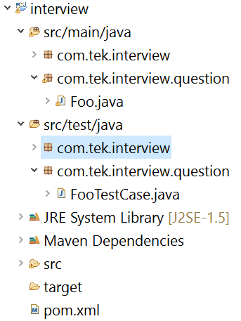

## Documentation for test cases:

There four test cases:

1. testTotalPrice() test the price of order calculation is correct or not in class Calculator.
2. testTotalTax() test the tax of order calculation is correct or not in class Calculator.
3. testOrderInitialization() test the class Order is correctly working or not.
4. testOrderLine() test the class OrderLine is correctly working or not.