TinyMCE-Button with AJAX search for www.mapsmarker.com
Aim:
Add a tinymce-Button which triggers a popup where users can search via AJAX within existing marker and layer maps and inserted the corresponding shortcode into posts or pages

Prerequisites / general
- WordPress 3.3.1
- Leaflet Maps Marker Plugin v1.6 (www.mapsmarker.com)
Users can add marker maps (=1 marker) or layer maps (=multiple markers) in the plugin backend and add them to post or pages via shortcode, e.g. [mapsmarker marker=“1“] or [mapsmarker layer=“1“]

Database structure
The plugin adds two tables to the WordPress-Database – relevant columns for the wanted functionality are marked bold:

CREATE TABLE IF NOT EXISTS `wp_ leafletmapsmarker_layers` (
`id` int(6) unsigned NOT NULL auto_increment,
`name` varchar(255) NOT NULL,
`basemap` varchar(30) NOT NULL,
`layerzoom` int(2) NOT NULL,
`mapwidth` int(4) NOT NULL,
`mapwidthunit` varchar(2) NOT NULL,
`mapheight` int(4) NOT NULL,
`panel` tinyint(1) NOT NULL,
`layerviewlat` decimal(9,6) NOT NULL,
`layerviewlon` decimal(9,6) NOT NULL,
`createdby` varchar(30) NOT NULL,
`createdon` datetime NOT NULL,
`updatedby` varchar(30) default NULL,
`updatedon` datetime default NULL,
`controlbox` int(1) NOT NULL,
`overlays_custom` tinyint(1) NOT NULL,
`overlays_custom2` tinyint(1) NOT NULL,
`overlays_custom3` tinyint(1) NOT NULL,
`overlays_custom4` tinyint(1) NOT NULL,
`wms` tinyint(1) NOT NULL,
`wms2` tinyint(1) NOT NULL,
`wms3` tinyint(1) NOT NULL,
`wms4` tinyint(1) NOT NULL,
`wms5` tinyint(1) NOT NULL,
`wms6` tinyint(1) NOT NULL,
`wms7` tinyint(1) NOT NULL,
`wms8` tinyint(1) NOT NULL,
`wms9` tinyint(1) NOT NULL,
`wms10` tinyint(1) NOT NULL,
`listmarkers` tinyint(1) NOT NULL,
`multi_layer_map` tinyint(1) NOT NULL,
`multi_layer_map_list` varchar(255) default NULL,
PRIMARY KEY (`id`)
) ENGINE=MyISAM DEFAULT CHARSET=utf8 AUTO_INCREMENT=79 ;
--
CREATE TABLE IF NOT EXISTS `wp_ leafletmapsmarker_markers` (
`id` int(6) unsigned NOT NULL auto_increment,
`markername` varchar(255) NOT NULL,
`basemap` varchar(30) NOT NULL,
`layer` int(6) unsigned NOT NULL,
`lon` decimal(9,6) NOT NULL,
`lat` decimal(9,6) NOT NULL,
`icon` varchar(255) NOT NULL,
`popuptext` text NOT NULL,
`zoom` int(2) NOT NULL,
`openpopup` tinyint(1) NOT NULL,
`mapwidth` int(4) NOT NULL,
`mapwidthunit` varchar(2) NOT NULL,
`mapheight` int(4) NOT NULL,
`panel` tinyint(1) NOT NULL,
`createdby` varchar(30) NOT NULL,
`createdon` datetime NOT NULL,
`updatedby` varchar(30) default NULL,
`updatedon` datetime default NULL,
`controlbox` int(1) NOT NULL,
`overlays_custom` tinyint(1) NOT NULL,
`overlays_custom2` tinyint(1) NOT NULL,
`overlays_custom3` tinyint(1) NOT NULL,
`overlays_custom4` tinyint(1) NOT NULL,
`wms` tinyint(1) NOT NULL,
`wms2` tinyint(1) NOT NULL,
`wms3` tinyint(1) NOT NULL,
`wms4` tinyint(1) NOT NULL,
`wms5` tinyint(1) NOT NULL,
`wms6` tinyint(1) NOT NULL,
`wms7` tinyint(1) NOT NULL,
`wms8` tinyint(1) NOT NULL,
`wms9` tinyint(1) NOT NULL,
`wms10` tinyint(1) NOT NULL,
PRIMARY KEY (`id`)
) ENGINE=MyISAM DEFAULT CHARSET=utf8 AUTO_INCREMENT=209 ;

Code delivery :
Via github / Pull request based on the current dev branch

Mockup:
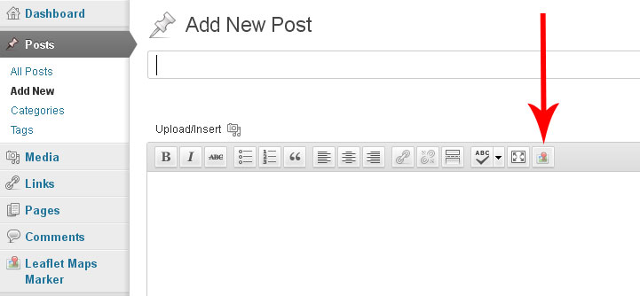
Clicking on this button should open a popup(the same type as when you click on default „Insert/Edit link“-Button):
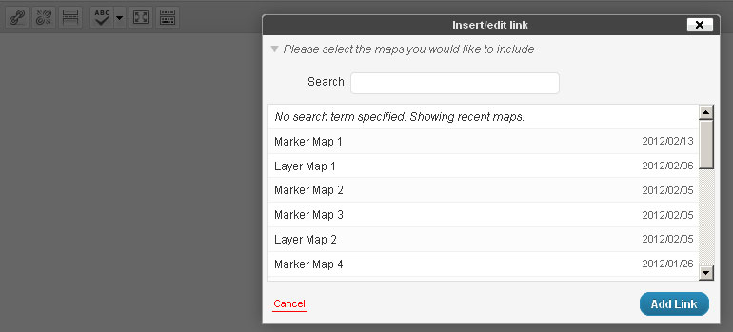
By default, the last 30 maps and their creation date should be listed, ordered by createdon desc.
If the user starts searching in the search field, an AJAX search within wp_ leafletmapsmarker_layers / name and wp_ leafletmapsmarker_markers / markers should be triggered (SQL: like %searchterm%) and only the maps which contain these searchterm in the name should be displayed instantly.
When clicking on a result, the corresponding shortcode with the id of the map should be inserted into the post or page (e.g. [mapsmarker marker=“2“] or [mapsmarker layer=“5“])

Other requirements:
- The code should be implemented within the plugin files only, using WordPress APIs if possible, no changes outside plugins directory should be necessary to use this feature

