Analyzing the Changes in Network Topology During 2020 US Presidential Election and 2021 Capitol Attacks

Masters of Science in Data Science

**Akshay Verma**

**G41140521**

Under the guidance of

**Prof. Amir Jafari Columbian College of Arts & Science The George Washington University**

Capstone Project Spring 2024 Date: April 23, 2024

### Abstract

In the digital age, online hate networks thrive as platforms for spreading extremist ideologies and hate speech, posing a significant threat to societal cohesion. This study examines the impact of key real-world events, notably the 2020 U.S. presidential election and the January 6 Capitol attack, on the evolution of online hate networks.

Using data collected from hate communities between November 1, 2020, and January 10, 2021, this research analyzes shifts in hate speech themes and network topology. Following the presidential election, an increase in hate speech targeting immigration, ethnicity, and antisemitism was observed. The January 6 Capitol attack further intensified these trends.

Central to this investigation is the examination of two key aspects of online hate networks: the content they disseminate and the underlying structure of their connections. By studying shifts in hate themes and network topology, including changes in centrality and community structure, this study seeks to uncover the mechanisms driving the evolution of online hate networks. The analysis reveals significant changes in network cohesion post-attack, characterized by increased clustering and Assortativity.

This research sheds light on the role of online platforms in radicalization and mobilization efforts, emphasizing the need for proactive measures to combat hate speech online. Despite its niche presence, Telegram has become a key hub for propagating extremist ideologies and coordinating malicious activities.

# Table of Contents

Abstract 2

Table of Contents 2

Introduction 3

Problem Statement 3

Related Work 4

Data Source 4

Results and Discussion 5

Network Cohesion 6

Change in Hate Content 9

Role of Telegram 12

How these results differ from any Random Interval 13

Dashboard with Integrated RAG LLM 14

Limitations 15

Conclusion 16

References 17

### Introduction

In the digital age, the internet has become a breeding ground for the dissemination of hate speech and extremist ideologies, fostering the formation of online hate networks [1]. These networks, characterized by their interconnected web of individuals sharing common ideologies rooted in hatred and discrimination, pose a significant threat to societal harmony and individual safety. Understanding the dynamics of these networks is paramount in combating the proliferation of hate speech and mitigating its harmful consequences.

This research looks into the intricate relationship between polarizing real-world events and the evolution of online hate networks. By analyzing the activities of hate communities online, this study aims to show how these networks undergo a transformation in the aftermath of pivotal events, specifically this research looks at the 2020 presidential election and the January 6 Capitol attack in the United States.

The highly contentious 2020 US presidential election, exacerbated by the proliferation of misinformation and divisive rhetoric, served as a catalyst for amplifying existing tensions within online communities [2]. Subsequently, the violent insurrection at the Capitol on January 6, 2021, further underscored the potency of online platforms as breeding grounds for radicalization and mobilization. Central to this investigation is the analysis of two key facets of online hate networks: the content disseminated within these networks and the under lying topology of the network by examining shifts in hate themes within hate communities, we aim to discern patterns of adaptation in response to external triggers. Furthermore, by examining alterations in network topology, including changes in centrality, community structure, and clustering, we seek to work out the structural dynamics driving the evolution of online hate network

### Problem Statement

The proliferation of online hate networks poses a significant threat to social cohesion and individual safety. These networks, characterized by interconnected individuals sharing hateful ideologies, can amplify extremist narratives, incite violence, and marginalize targeted groups. Understanding how online hate networks evolve in response to real-world events is crucial for developing effective strategies to counter hate speech and promote digital safety.

This research specifically investigates the impact of two critical events - the 2020 U.S. presidential election and the January 6 Capitol attack - on the dynamics of online hate networks. It aims to answer the following questions:

* How does the content of hate speech within online hate networks change in response to real-world events?
* Does network cohesion, measured by metrics like clustering and assortativity, increase after significant real-world events?
* How do specific online platforms contribute to the spread of hate speech within these networks?

By addressing these questions, this research seeks to shed light on the complex relationship between online and offline phenomena, ultimately informing the development of strategies to mitigate the harmful impacts of online hate networks.

### Related Work

The proliferation of online hate networks and their evolution in response to real-world events is a topic that has garnered significant attention in recent research. This study builds upon and extends the existing body of knowledge in several key ways.

One closely related line of research has examined the dynamics of online hate communities and their adaptability to external triggers. For example, Mathew et al. **[3]** investigated how hate speech on Reddit evolved in the aftermath of major events, such as mass shootings. They found that hate communities exhibited increased cohesion and a shift in the types of hate speech expressed following these events. Similarly, Zannettou et al. **[4]** analyzed the spread of hate speech across different online platforms, including 4chan**, Twitter, and Gab**, and identified patterns of coordination and cross-pollination between these communities. While these studies provide valuable insights into the general dynamics of online hate networks, this research delves deeper by specifically examining the impact of the 2020 U.S. presidential election and the January 6th Capitol attack - two pivotal events that significantly shaped the political and social landscape in the United States.

Furthermore, this study builds upon the methodological approaches employed in previous network analysis studies of online hate communities **[5]**. Researchers have utilized various network metrics, such as clustering coefficient and assortativity, to uncover the structural properties of these networks and their changes over time. This research adopts a similar analytical framework but applies it specifically to the events surrounding the 2020 U.S. presidential election and the January 6th Capitol attack, providing a unique perspective on how real-world events can shape the cohesion and evolution of online hate networks.

In summary, this study contributes to the existing literature by:

* Focusing on the impact of two pivotal events - the 2020 U.S. presidential election and the January 6th Capitol attack - on the dynamics of online hate networks, which have not been extensively explored in prior research.
* Highlighting the growing role of alternative platforms, such as Telegram, in the dissemination of hate speech and the coordination of hate-based activities within online networks.
* Employing a comprehensive network analysis approach to uncover the structural changes and shifts in hate content within these networks in response to real-world events.

By addressing these gaps in the literature, this research aims to provide a more nuanced understanding of the complex interplay between online and offline phenomena, ultimately informing the development of strategies to mitigate the harmful impacts of online hate networks.

### Data Source

The data for this study was collected by the Dynamic Online Network Lab at George Washington University (GWU). Data collection commenced with the identification of online hate communities, followed by continuous monitoring for cross-posts. For instance, if a user in a hate community posted a link to another community, a directed edge was established from the hate community towards the linked community.

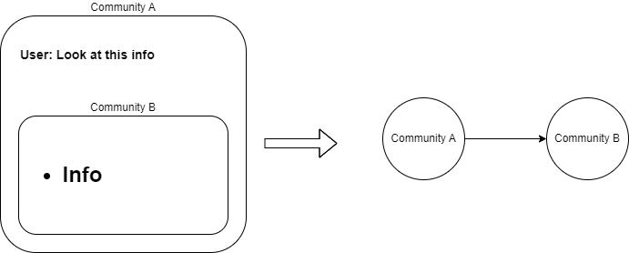

Figure 1Diagram Explaining how the nodes and edges in the network were created

While all the source nodes belong to identified hate communities, the target nodes may or may not belong to identified hate communities.

This study focuses on the period surrounding the 2020 U.S. presidential election and the events of January 6, 2021. Specifically, data was analyzed from November 1, 2020, to January 10, 2021. In addition to monitoring cross-posting activities within these hate communities, the posts were also classified to identify various types of hate speech prevalent within the posts. Seven types of hate speech were classified, targeting race, gender, religion, antisemitism, gender identity/sexual orientation (GISO), immigration, and ethnicity/identitarian/nationalism (EIN)

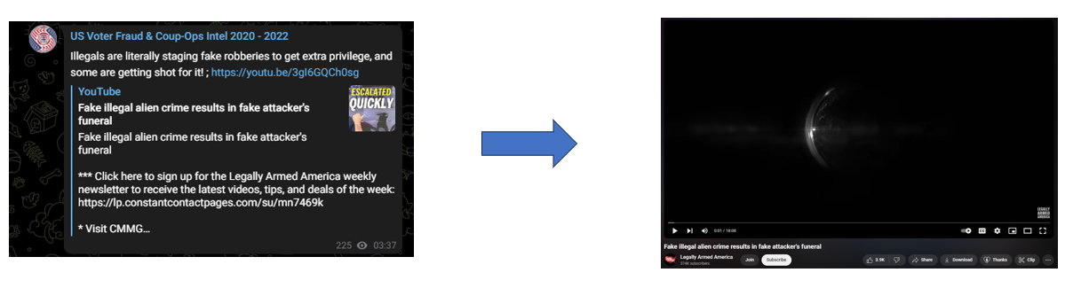

Figure 2An Example of cross-post from one hate community

## Results and Discussion

The analysis of the hate network following the 2020 presidential election on Nov 3, 2020, and the United States Capitol attack on Jan 6, 2021, sheds light on the complex interplay of online dynamics and real-world events. Through an examination of network cohesion and the change in hate content, we discover compelling insights into the transformative forces at play within this digital hate ecosystem. This section looks into the changes observed within the network.

The initial observation that stood out was the substantial increase in the number of links within the network during both time intervals. On November 3, the day of the presidential elections, there was a notable surge in hate links, showing a 41.6% increase compared to November 1. Subsequently, on November 7, when Joe Biden was declared president-elect, the number of links spiked even further, rising by 68% compared to November 1.

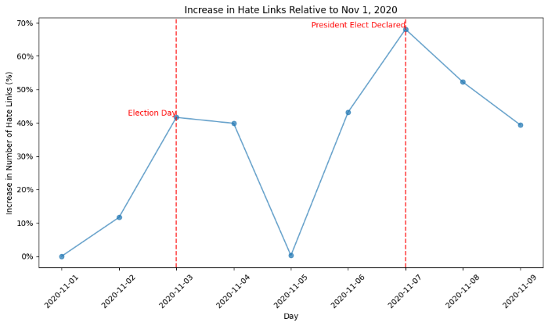

Figure 3 %Change in number of hate links relative to Nov 1, 2020. A Significant increase in links can be seen on the day of election and the day Joe Biden was declared president elect

We observed a similar spike in our network surrounding the events of the January 6th Capitol attacks. On January 6, there was a significant increase in the number of links, rising by 67.59% compared to January 1

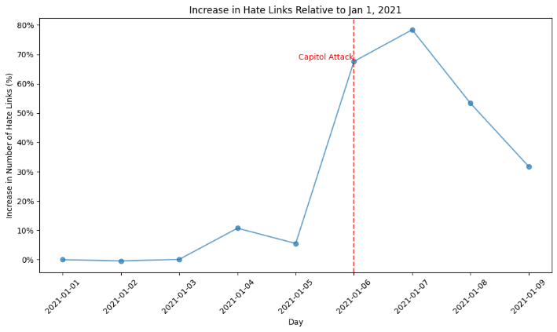

Figure 4%Change in number of hate links relative to Jan 1, 2021. A Significant increase in links can be seen on the day of Capitol Attacks

#### Network Cohesion

Our analysis of the network following the 2021 Jan 6 Capitol attacks reveals a significant increase in network cohesion. This tightening of connections is evident through three key network metrics: clustering coefficient, Assortativity, and community dynamics.

The clustering coefficient, which measures the tendency of nodes (online communities) to form triangles (connected groups of three), jumped by a substantial 159% after the Jan 6 capitol attack. This dramatic rise suggests a significant shift in the network structure. Nodes previously on the periphery formed connections with their neighbors, leading to a denser network with well-defined clusters. This implies that individual nodes within the hate network became more interconnected and entrenched within their specific groups

*Table No: 1 Comparison of Network Metrics post Jan 6 2021 Capitol Attack*

| **Property** | **Pre Jan 6 (Jan 1 to 5, 2021)** | **Post Jan 6 (Jan 6 to 10, 2021)** | **% Change** |
| --- | --- | --- | --- |
| Number of Communities | 115 | 86 | -25.2% |
| Size of the Largest Community | 5632 | 7068 | 25.1% |
| Clustering Coefficient | 0.011 | 0.028 | 159.2% |
| Assortativity | -0.49 | -0.35 | 25.5% |

Furthermore, Assortativity, which reflects the tendency of nodes to connect with similar nodes, also increased by 25.1%. This rise in Assortativity strengthens the notion of increased cohesion and homophily; Individuals within the network preferentially connected with others who shared characteristics. This potentially indicates a strengthening of existing ideologies within the network, fostering a more homogenous and an environment resilient to outside intervention [6] [7]

Finally, the observed changes in the number of communities and the size of the largest community paint a convincing picture of network consolidation. The number of communities decreased by a significant 25.2%, hinting at smaller communities merging to form larger communities. Furthermore, the size of the largest community grew by 25.5%, suggesting a convergence of individual communities towards a more dominant, potentially extreme, viewpoint. This dynamic implies a less diverse network with a more unified ideology, potentially amplifying the spread of hate speech or coordinated actions.

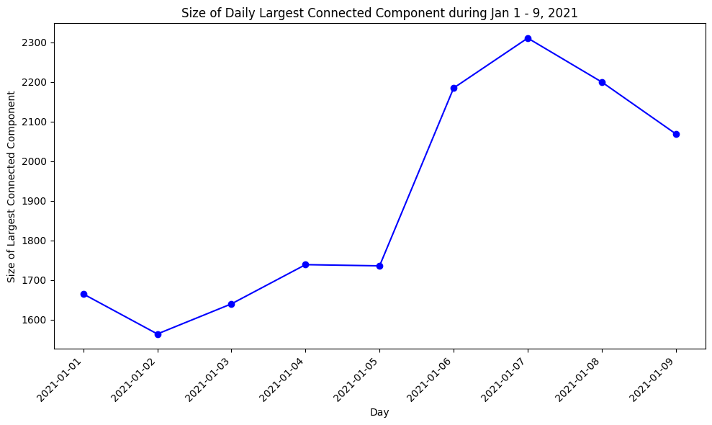

Figure 5 Line Graph showing the size of the largest connect component of each day during Jan 1 - 9 , 2021

These findings on network metrics are further supported by visualizations using network visualization tools like Gephi, employing the ForceAtlas2layout. This layout algorithm assigns forces to nodes, attracting or repelling them based on their connections, thus shaping the overall network structure. Examining these visualizations reveals a notable shift towards a more cohesively connected network structure.

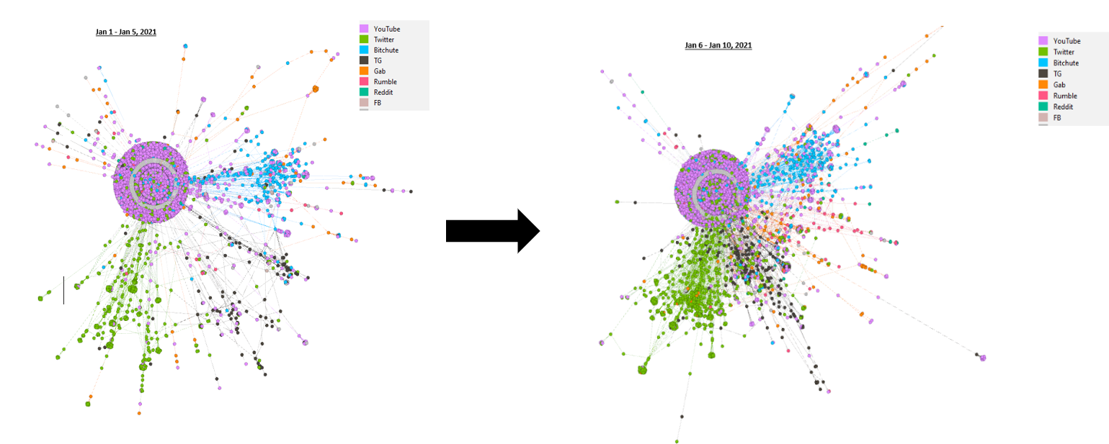

Figure 6 Network Visualization of Pre-Capitol attack contrasted with that of Post Capitol attack. Visualized through Gephi

The trends observed following the November 3, 2020 elections exhibit a similar pattern, albeit with smaller variations compared to those witnessed after the January 6 Capitol attack.

| **Property** | **Pre Nov 3 (Nov 1 to 2, 2020)** | **Post Nov 3 (Nov 3 to 4, 2020)** | **% Change** |
| --- | --- | --- | --- |
| Number of Communities | 70 | 68 | -2.85% |
| Size of the Largest Community | 4334 | 4726 | 5.3% |
| Clustering Coefficient | 0.012 | 0.014 | 9.0% |
| Assortativity | -0.52 | -0.49 | 12.4% |

The relatively smaller changes observed following the 2020 elections, compared to the upheaval witnessed after the January 6 Capitol attack, could potentially be attributed to the elections being a less unexpected event, thus resulting in more moderate alterations in the network metrics.

#### Change in Hate Content

Following the analysis of network cohesion, this subsection explores the changes in hate content within the network during the same period (November 1, 2020– January 10, 2021). Here, "hate content" refers to speech targeting individuals or groups based on characteristics like immigration status, race, or gender identity.

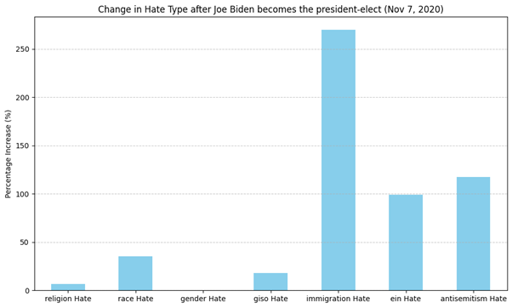

Figure 7 Change in hate type detected within the network after Nov 7, 2020

Following the declaration of Joe Biden as president-elect on No vember7,2020, a significant uptick in hate speech targeting immigration, ethnicity, and antisemitism was detected within the network.

Particularly noteworthy were the observed increases: a 269.5% surge in anti-immigration sentiments, a 98.7% rise in ethnically-based hatred, and a 117.57% escalation in expressions of antisemitism between November 7 and November 11, compared to November 2 to November 6.

These trends are indicative of the immigration anxieties harbored by far-right communities, which often align with the Great Replacement conspiracy theory, attributing perceived demographic shifts to Jewish influence [8].

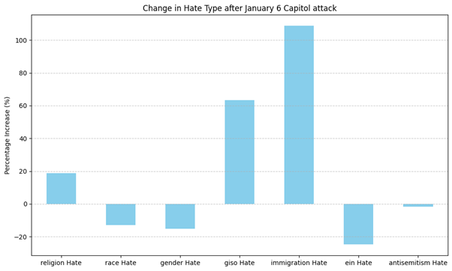

Figure 8 Change in hate type detected within the network after Jan 6

Following the Capitol attack on January 6th, a comparable surge in anti-immigration sentiments was evident, with a notable 108.69% rise in posts containing anti-immigration messages between January 6th and January 10th, in contrast to the period of January 1st to January 5th, 2020.

The analysis also reveals a strong correlation between the daily link counts originating from specific social networks and the incidence of hate speech detected within the network spanning from November 1, 2020, to January 10, 2021

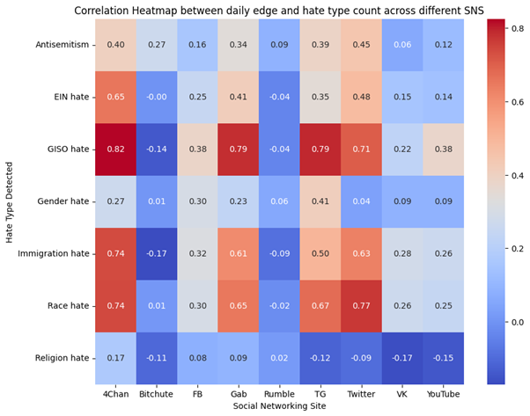

Figure 9 Correlation between increase in links for certain social networking sites and increase in hate type detected

Specifically, an increase in links originating from 4chan, Gab, Twitter, and Telegram exhibits a strong correlation with instances of hate speech targeting immigration, race, and gender and sexual identity (GISO). While the correlation suggests a potential link between these events and the rise in hate content, further investigation is needed to determine causality.

#### Role of Telegram

Following the Presidential Elections on Nov 3, Telegram emerged as a significant player in shaping the dynamics of the hate network. During November4–7, there was a remarkable surge in connectivity within the network, evidenced by a substantial 299% increase in the number of connections involving Telegram compared to November 1–3, 2020 (from 592 to 2366).

Telegram’s importance both as a target and source node within the hate network saw a considerable rise from this volume perspective. Specifically, Telegram’s representation as a target node increased from 18.22% to 33.47%, while its presence as a source node increased from 21.73% to 37.24% of all links present in the hate core network post-election. This rise in Telegram’s connections highlights its growing significance as a central platform for communication and coordination among hate groups within the network [9].

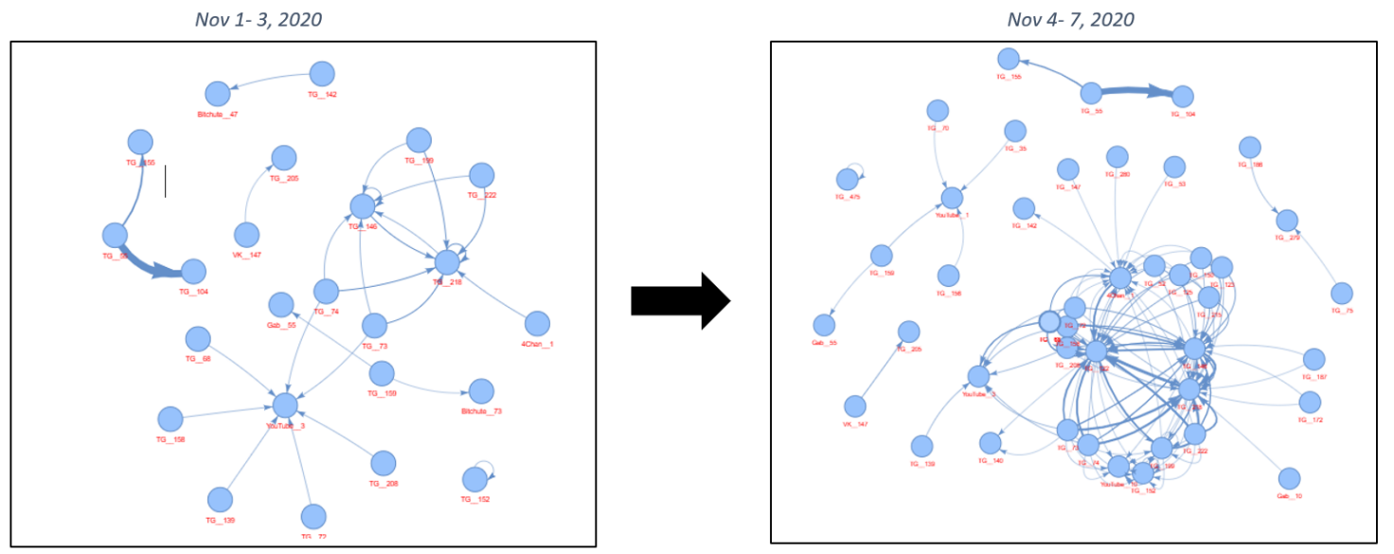

Figure 10 Change in the network of Telegram nodes after November 3, 2020

One Telegram community, identified by the codename "TG__122", warrants particular attention. "TG__122" which is now named “US Voter Fraud & Coup-Ops Intel 2020– 2022” was initially absent from the network between November 1 and 3, but rapidly ascended to become one of the most crucial and interconnected nodes within the November 4–7 network. Moreover, "TG__122" exhibits strong associations with two other Telegram channels, "TG__218", a right-wing podcast, and "TG__146", a right-wing telegram channel named "Exposing Cultural Marxism", both of which were highly active in the network before November 3. The substantial influx of links directed towards "TG__122" signifies its pivotal role as a central hub for disseminating disinformation concerning the presidential election and alleged instances of vote fraud.

Moreover, the rise of Telegram is particularly fascinating given its relatively limited ubiquity compared to mainstream social networking sites in the United States. However, as reported by CNN, Telegram has emerged as a source of concern for law enforcement agencies due to its association with ’Q-anon’ and ’Pro-Trump Conspiracy theories’ [10]. Despite its niche presence, Telegram has become a preferred platform for individuals seeking to propagate hate speech and coordinate malicious activities [11]. This association further solidifies Telegram’s significant influence on the perpetuation of extremist ideologies and the dissemination of hate speech within the studied network

#### How these results differ from any Random Interval

To ensure my findings weren't random, I conducted a randomization test. I randomly selected 50 sets of data, each spanning 10 days. Just like in my original analysis, I split each 10-day interval in half, creating two sub-intervals. Then, I calculated the changes in the number of links, clustering coefficient, number of communities, and size of the largest community for each randomly generated interval pair. By comparing these results to those from my original analysis, I found that the observed changes were statistically significant. This means the findings are unlikely due to random chance and are therefore worth reporting.

Figure 11 Increase in links in the Election and Capitol attack interval compared to 50 random intervals

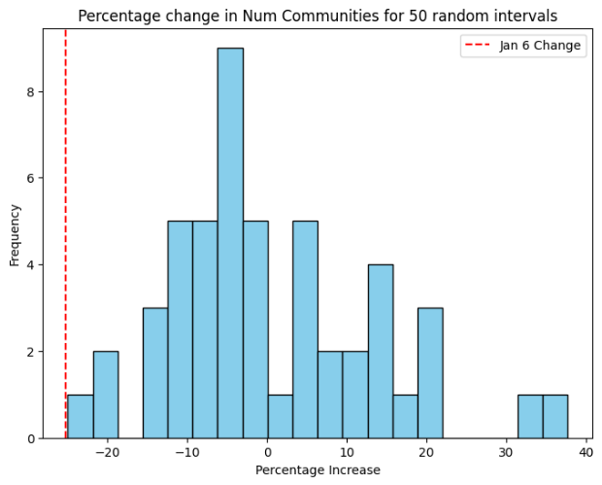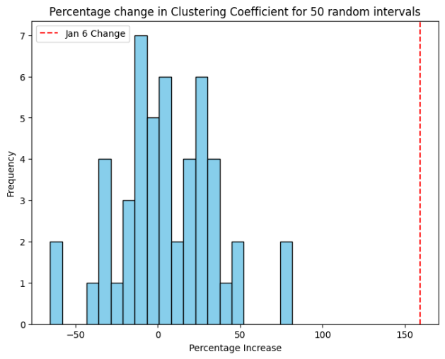

Figure 12 Change in number of communities of Jan 6 interva compared to 50 random intervals

Figure 13 Increase in clustering coefficient of Jan 6 compared to 50 random intervals

### Dashboard with Integrated RAG LLM

I developed a user-friendly dashboard using Streamlit to visualize and compare data across different time intervals. The dashboard leverages PyViz library to create network visualizations with an interactive twist: users can add "physics" simulations to the data points, simulating attraction and repulsion forces for a more intuitive grasp of the relationships

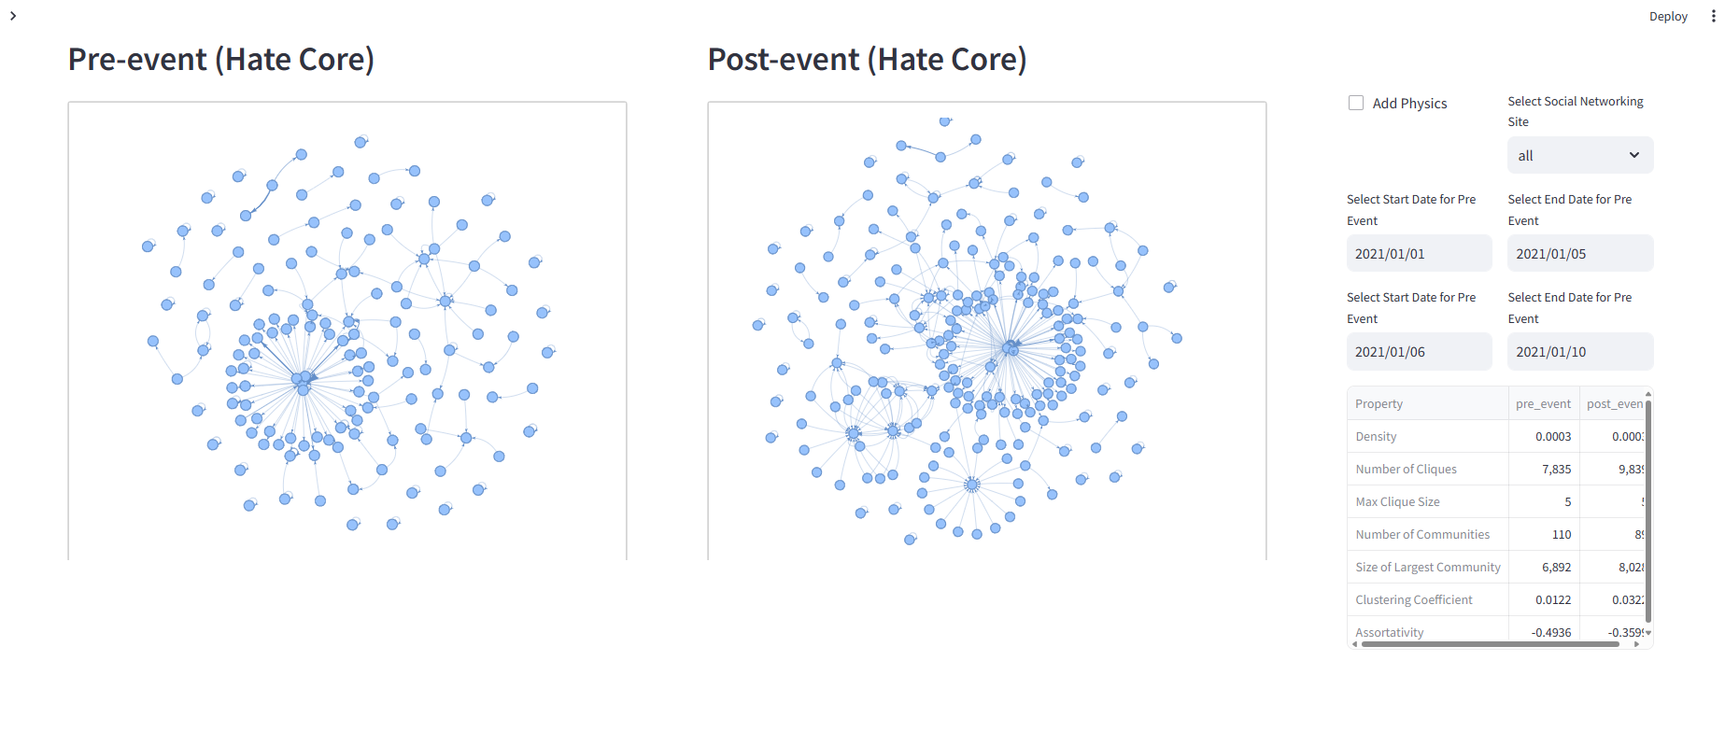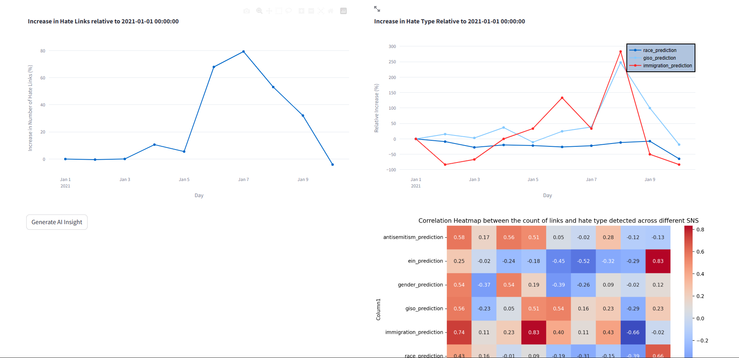

Figure 14 Screenshot of the Dashboard

To enhance user experience and cater to non-experts, I integrated an AI-powered insight generator. This Large Language Model (LLM) system utilizes OpenAI's GPT API for text generation and embedding. It analyzes the data displayed and generates insights to aid users' interpretation. For optimal querying performance, I implemented LamaIndex, a recent LLM advancement.

The dashboard goes a step further with a "Chat with Dashboard" function. This chat system employs another LLM, powered by GPT, allowing users to ask questions directly related to the visualizations. LangChain, an LLM optimized for conversational interactions, was chosen for this functionality due to its superior performance in chat-like scenarios

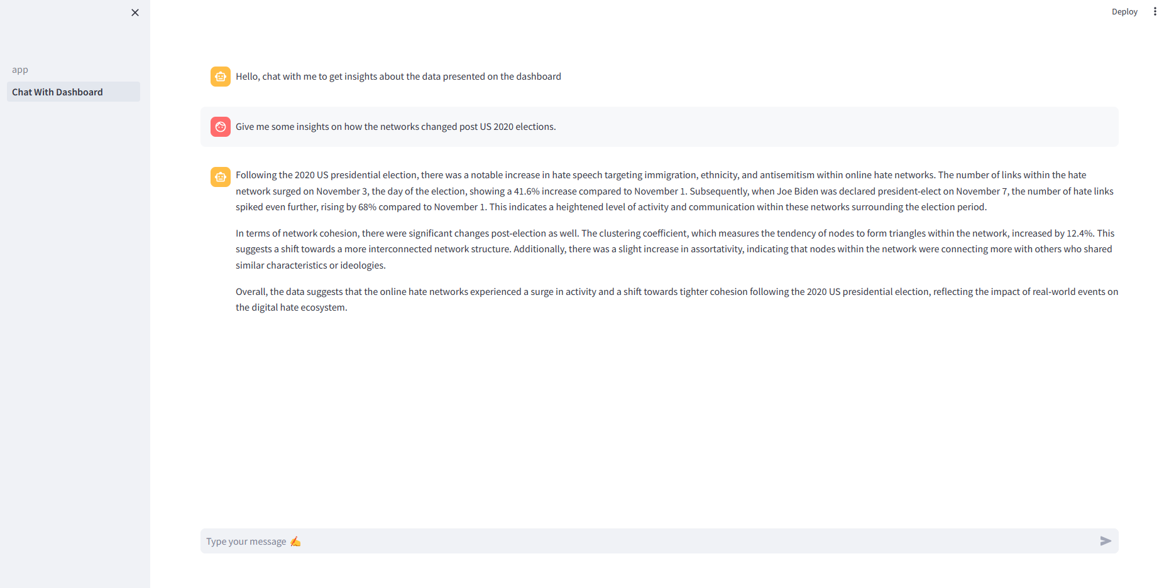

Figure 15 Screenshot of the "Chat with Dashboard" part of the dashboard

By combining these elements, the dashboard offers a comprehensive and interactive data exploration experience, making complex data accessible to a wider audience.

### Limitations

While this study provides valuable insights into the dynamics of online hate networks surrounding the 2020 U.S. presidential election and the January 6 Capitol attack, several limitations should be considered. Firstly, the observational nature of this study limits our ability to establish causal relationships between real-world events and the observed changes in online hate networks. While correlations between events and shifts in network dynamics are evident, determining causality requires more extensive experimental or longitudinal studies. Additionally, the data collection method relied on identifying and monitoring specific hate communities, potentially leading to sampling bias. Communities that were not captured or those with limited online presence may not be represented in the analysis, thus affecting the generalizability of the findings.

Moreover, the study period is confined to the period from November 1, 2020, to January 10, 2021, focusing on the aftermath of the presidential election and the Capitol attack. Consequently, longer-term trends or shifts occurring outside this timeframe are not analyzed, limiting the comprehensive understanding of hate network evolution. Furthermore, the analysis relies on data collected from online platforms, which may be subject to manipulation, censorship, or inaccuracies. Misclassification of hate speech or incomplete data could affect the accuracy of the findings.

The findings of this study may not be fully generalizable to all online hate networks or to different socio-political contexts. Factors such as regional variations, platform-specific dynamics, and ideological differences among hate communities could influence network behaviors differently.

Finally, online platforms undergo constant evolution in response to technological, regulatory, and societal changes. The findings of this study reflect a snapshot of hate network dynamics during a specific period and may not capture subsequent developments or adaptations within these networks. Addressing these limitations requires interdisciplinary approaches, including enhanced data collection methods, longitudinal studies, collaboration with platform providers, and rigorous ethical guidelines for researching online extremism. Despite these challenges, understanding the intricacies of online hate networks is crucial for devising effective strategies to combat hate speech and promote digital safety and inclusivity.

### Conclusion

In conclusion, this study illuminates the changes in online hate networks in response to significant real-world events, particularly the 2020 U.S. presidential election and the January 6 Capitol attack. Firstly, an increase in hate speech targeting immigration, ethnicity, and antisemitism following pivotal events, indicative of underlying societal tensions and extremist ideologies. The observed correlations between specific social networks and the incidence of hate speech highlight the role of online platforms in propagating extremist narratives. Secondly, network cohesion significantly increased post-attack, evidenced by tighter clustering and homophily within hate networks. This suggests a consolidation of extremist ideologies and a more resilient environment for hate speech dissemination.

Furthermore, the rise of Telegram as a central hub within hate networks underscores the evolving landscape of online extremism. Despite its niche presence in the United States, Telegram has emerged as a significant platform for coordinating malicious activities and disseminating hate speech.

Overall, this research emphasizes the urgent need for proactive measures to combat online extremism and promote digital resilience. By understanding the mechanisms driving the evolution of online hate networks, policymakers, researchers, and platform providers can develop targeted interventions to mitigate the harmful consequences of hate speech online and safeguard societal harmony and individual safety

### References

[1] A. Schackmuth, Extremism, fake news and hate: effects of social media in the post truth era. PhD thesis, DePaul University, 2018.

[2] C. S. Lee, J. Merizalde, J. D. Colautti, J. An, and H. Kwak, “Storm the capitol: linking offline political speech and online twitter extra-representational participation on qanon and the january 6 insurrection,” Frontiers in Sociology, vol. 7, p. 876070, 2022.

[3] D. J. Watts, Small worlds: the dynamics of networks between order and randomness, vol. 36. Princeton university press, 2004.

[4] Mathew, B., Saha, P., Tharad, H., Rajgaria, S., Singhania, P., Maity, S. K., ... & Mukherjee, A. (2019). Thou shalt not hate: Countering online hate speech. Proceedings of the International AAAI Conference on Web and Social Media, 13(01), 369-380.

[5] Zannettou, S., Caulfield, T., Blackburn, J., De Cristofaro, E., Sirivianos, M., Stringhini, G., & Suarez-Tangil, G. (2018). On the origins of memes by means of fringe web communities. Proceedings of the Internet Measurement Conference 2018, 188-202.

[6] P. Leifeld, “Polarization in the social sciences: Assortative mixing in social science collaboration networks is resilient to interventions,” Physica A: Statistical Mechanics and its Applications, vol. 507, pp. 510–523, 2018.

[7] M. Oehlers and B. Fabian, “Graph metrics for network robustness—a survey,” Math ematics, vol. 9, no. 8, p. 895, 2021

[8] M. Obaidi, J. Kunst, S. Ozer, and S. Y. Kimel, “The “great replacement” conspiracy: Howthe perceived ousting of whites can evoke violent extremism and islamopho bia,” Group Processes & Intergroup Relations, vol. 25, no. 7, pp. 1675–1695, 2022.

[9] H. Schulze, J. Hohner, S. Greipl, M. Girgnhuber, I. Desta, and D. Rieger, “Far-right conspiracy groups on fringe platforms: A longitudinal analysis of radicalization dynamics on telegram,” Convergence: The International Journal of Research into New Media Technologies, vol. 28, no. 4, pp. 1103–1126, 2022.

[10] D. O. Jamie Gangel, “Talk of overturning the 2020 election on new social media platforms used by qanon followers sparks fears of further violence,” 2021.

[11] J. Guhl and J. Davey, “A safe space to hate: White supremacist mobilisation on telegram,” Institute for Strategic Dialogue, vol. 26, 2020

## 