DPS970 Activity 2: Written Answers and Report
Student: Ashutosh Verma Textbook: Russell and Norvig, Artificial Intelligence: A Modern Approach, 4th edition (AIMA)
The code, tests and instructions for running them are described in README.md.

Question 1: Monte Carlo Tree Search for Connect Four

1.1 Design
The game is defined in connect_four/game.py with the six components of a game from AIMA Section 5.1, and the move generator in connect_four/mcts.py follows Figure 5.11:
function MONTE-CARLO-TREE-SEARCH(state) returns an action
tree <- NODE(state)
while IS-TIME-REMAINING() do
leaf <- SELECT(tree)
child <- EXPAND(leaf)
result <- SIMULATE(child)
BACK-PROPAGATE(result, child)
return the move in ACTIONS(state) whose node has highest number of playouts
Textbook | Code
S0, TO-MOVE, ACTIONS, RESULT, IS-TERMINAL, UTILITY (Section 5.1) | ConnectFour.initial, to_move, actions, result, is_terminal, utility
MONTE-CARLO-TREE-SEARCH (Figure 5.11) | MCTSPlayer.monte_carlo_tree_search
IS-TIME-REMAINING() | a fixed number of cycles (configurable)
SELECT | MCTSPlayer.select using MCTSPlayer.utility
EXPAND | MCTSPlayer.expand (creates x children)
SIMULATE | MCTSPlayer.simulate (random playout)
BACK-PROPAGATE | MCTSPlayer.back_propagate
N(n), U(n) (Section 5.4) | Node.N, Node.U
final choice: most playouts | max(tree.children, key=N)
All settings are in MCTSConfig:
Setting | Meaning | Baseline
cycles | iterations of the main loop | 1000
expansion_width (x) | children created when a node is expanded | 7 (all moves)
max_depth | height of the tree | 42 (no limit)
c | UCB1 exploration constant C | 1.414 (√2)
w_objective (W) | weight of the objective part of the utility | 1.0
expansion_order | which x moves get expanded: by objective score or at random | objective
Selection utility. The activity asks for a utility with a playout part and an objective part. The playout part is UCB1 from Section 5.4. The objective part is a rule based evaluation of the position:
UTILITY(n) = U(n)/N(n) exploitation (playouts)
+ C * sqrt( ln N(PARENT(n)) / N(n) ) exploration (playouts)
+ W * H(n) / (N(n) + 1) objective (rules)
- U(n) is the number of wins (a draw counts ½) for the player who made the move into n, and N(n) the number of playouts through n. Both are stored in the tree from previous cycles.
- H(n) comes from the rules of Connect Four (ConnectFour.evaluate): every line of four cells that still only holds one player's pieces is a possible win for that player. A line with 3 pieces scores 5, a line with 2 pieces scores 2, a piece in the centre column scores 3 (it belongs to the most lines), and the opponent's lines count against the player. A won position scores ±1000. The score is squashed into [0, 1] with 0.5 + 0.5 tanh(score / 20) so it is on the same scale as the win rate.
- Dividing the objective part by N(n) + 1 means the rules guide the search while a node has few playouts, and the playout results take over as they build up. W = 0 turns the utility into plain UCB1 (plain UCT).
- An unvisited child is always selected before visited ones (its UCB1 value is infinite); with W > 0 the one with the best objective score goes first.
Expansion. When SELECT reaches a leaf, EXPAND creates x children at once. With expansion_order = "objective" these are the x moves with the best objective score for the player to move (so a winning or blocking move is always included when one exists); with "random" they are x random moves. No other moves are ever searched below that node, so x is the width of the tree at every level. EXPAND returns one of the new children for SIMULATE.
Fixed tree height. A leaf at depth max_depth (or a terminal position) is not expanded. SIMULATE runs from the leaf itself, so with a small height more and more playouts are run from the same few nodes.
Simulation. The playout policy is uniform random: each player drops a piece in a random non-full column until someone wins or the board is full.
Back-propagation. Every node on the path gets N + 1, and U + 1 if the player who moved into that node won (U + ½ for a draw).
Final move. As in Figure 5.11, the root child with the most playouts.
Repeat a configurable number of times. cycles sets the number of iterations, and last_stats records the playouts, win rate and objective score of every root move, the tree size and height, and the time taken.

1.2 Experiments
python -m connect_four.experiments changes one setting at a time from the baseline (1000 cycles, x = 7, no depth limit, C = 1.414, W = 1, objective expansion order), so each difference comes from that setting alone. All raw data is in results/ (consistency_runs.csv has every single search, match_games.csv every game, summary.md the full tables, and agreement.png / strength.png the charts).
Experiment 1, consistency and tactics. Each configuration searched four positions 20 times, with seeds 0 to 19:
Position | Moves played (columns) | Correct move
empty | none | (centre, column 3, is the known best opening)
must_block | 0 6 1 6 2: X has three on the bottom row | 3 (O must block)
win_now | 0 1 0 1 0 2: X has three stacked in column 0 | 0 (X wins)
midgame | 3 3 2 4 4 2 5 1: no immediate threats | none
Agreement is the share of the 20 runs that picked the most common move. Accuracy is the share that picked the correct move.
Experiment 2, strength. Each configuration played 10 games against a fixed reference player (plain UCT: W = 0, x = 7, no depth limit, 300 cycles) and 5 games against a random player, alternating who moves first. To keep run time reasonable every configuration used 300 cycles in the matches, except in the cycles experiment where the cycle count is the thing being tested.

1.3 Results
Number of cycles
Cycles | Agreement: empty | Agreement: midgame | Accuracy: must_block | Accuracy: win_now | Tree size (empty) | Score vs reference
50 | 0.35 (7 different moves) | 0.60 | 0.75 | 1.00 | 351 | 0.10
200 | 0.50 (6 different moves) | 0.85 | 1.00 | 1.00 | 1,401 | 0.35
1000 | 0.80 (3 different moves) | 1.00 | 1.00 | 1.00 | 7,001 | 0.30
3000 | 0.95 (2 different moves) | 1.00 | 1.00 | 1.00 | 21,001 | 1.00 (10-0)
Expansion width x (nodes expanded per level)
x | Agreement: empty | Agreement: midgame | Tree size (empty) | Score vs reference
1 | 1.00 | 1.00 | 13 | 0.30
2 | 1.00 | 0.90 | 1,493 | 0.90
3 | 1.00 | 1.00 | 2,815 | 0.40
5 | 0.95 | 1.00 | 5,001 | 0.60
7 (all) | 0.80 | 1.00 | 7,001 | 0.40
3, random order | 0.35 | 0.35 | 2,976 | 0.00 (accuracy on both tactics: 0.40)
Tree height
Max depth | Agreement: empty | Tree size (empty) | Score vs reference
1 | 0.85 | 8 | 0.20
2 | 0.90 | 57 | 0.50
4 | 0.85 | 2,735 | 0.40
8 | 0.80 | 7,001 | 0.40
42 (none) | 0.80 | 7,001 | 0.40
Utility function
Setting | Agreement: empty | Accuracy (both tactics) | Score vs reference
W = 0 (playout part only, plain UCT) | 0.80 | 1.00 | 0.45
W = 1 (baseline) | 0.80 | 1.00 | 0.40
W = 5 | 1.00 | 1.00 | 0.35
W = 20 | 0.85 | 1.00 | 0.40
C = 0.5 (little exploration) | 0.90 | 1.00 | 0.20
C = 1.414 | 0.80 | 1.00 | 0.40
C = 3 (a lot of exploration) | 0.85 | 1.00 | 0.10
Every configuration beat the random player in all 5 games.

1.4 Analysis and reflection
Does the simulator always generate the same move? No. With a different random seed it often picks a different move: on the empty board the baseline picked column 3 in 16 of 20 runs and columns 2 or 4 in the other 4; with only 50 cycles it picked 7 different moves out of 20 runs. But with the same seed it always gives exactly the same move and tree: the program is fully deterministic once the random number generator is fixed (a test checks this, and the configurations that were identical to the baseline, such as depth=8, W=1 and C=1.414, produced identical numbers). So the differences come only from the randomness, never from anything else.
What causes the differences?
- Random playouts. The value of a move is estimated by averaging random games, so it is a noisy estimate. When two moves are nearly equally good (columns 2, 3 and 4 at the start), the noise decides which one gets the most playouts. This is the main source of variation.
- Random choices inside the tree. EXPAND returns a random new child, and ties in SELECT are broken at random, so different runs grow different trees.
- Too few cycles. The noise in an average falls roughly with 1/√N. At 50 cycles each root move gets about 7 playouts, so the choice is almost random (agreement 0.35). At 3000 cycles agreement on the empty board is 0.95 and the generator won all 10 games against the reference. More cycles is the clearest way to make the move both more consistent and stronger.
What causes the similarities?
- Forced moves. When there is an immediate win or a forced block, every configuration agrees (accuracy 1.00 from 200 cycles up). An immediate win is a terminal child whose playouts always return a win, so its win rate is 1.0 after one visit. A missed block shows up as a child whose playouts almost always lose. These moves have a big gap in value over the alternatives, so the noise cannot hide them. Even 50 cycles found the win every time.
- The objective part of the utility. The rule based score always prefers the centre column and lines of three, so it pushes every run toward the same moves. With W = 5 agreement on the empty board went from 0.80 to 1.00.
- A narrow tree. With small x the same few moves (the ones with the best objective score) are searched every time, so agreement is 1.00 for x = 1, 2 and 3. With x = 1 the "search" only ever has one move to pick, so the result is simply the rule based choice and it never varies.
Expansion width. x controls a trade off between width and depth. Picking the best x moves by the objective score cuts away weak moves and lets the cycles go deeper on the good ones: x = 2 won 9 of 10 games against the reference. But it is a gamble on the rules: x = 1 throws search away entirely and lost 7 of 10. The most striking result is x = 3 with a random order: the tree can miss the only good move, so it found the forced block and the immediate win only 40% of the time and lost all 10 games. Pruning only helps when the moves kept are chosen well.
Tree height. With 1000 cycles the baseline tree only reaches about 6 levels, so limits of 8 or 42 change nothing (the numbers are identical). A height of 1 means each root move is valued only by random playouts started right after it, which is "pure Monte Carlo" with no tree, and it was the weakest of the height settings (0.20 vs the reference). Even so it still found the forced block and the win, because the random playouts already show a big difference for those moves. Height matters more in quiet positions where the best move only pays off a few moves later.
Utility function. C balances trying new moves against repeating good ones. C = 0.5 explores too little (it can lock onto a move that looked good early) and C = 3 explores too much (it spreads playouts over bad moves); both played worse than C = √2 against the reference (0.20 and 0.10). The objective weight W had little effect on match results at 300 cycles (all between 0.35 and 0.45), while making the move choice more consistent. That is what the design aims for: the objective part is divided by N(n) + 1, so it mostly steers the early visits and the playout statistics decide in the end.
Charts. Move agreement for every setting, and the match score against the reference player:
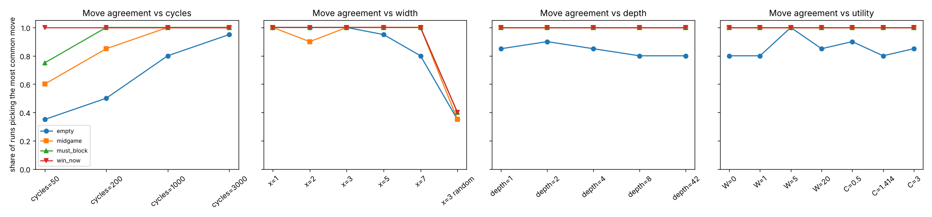
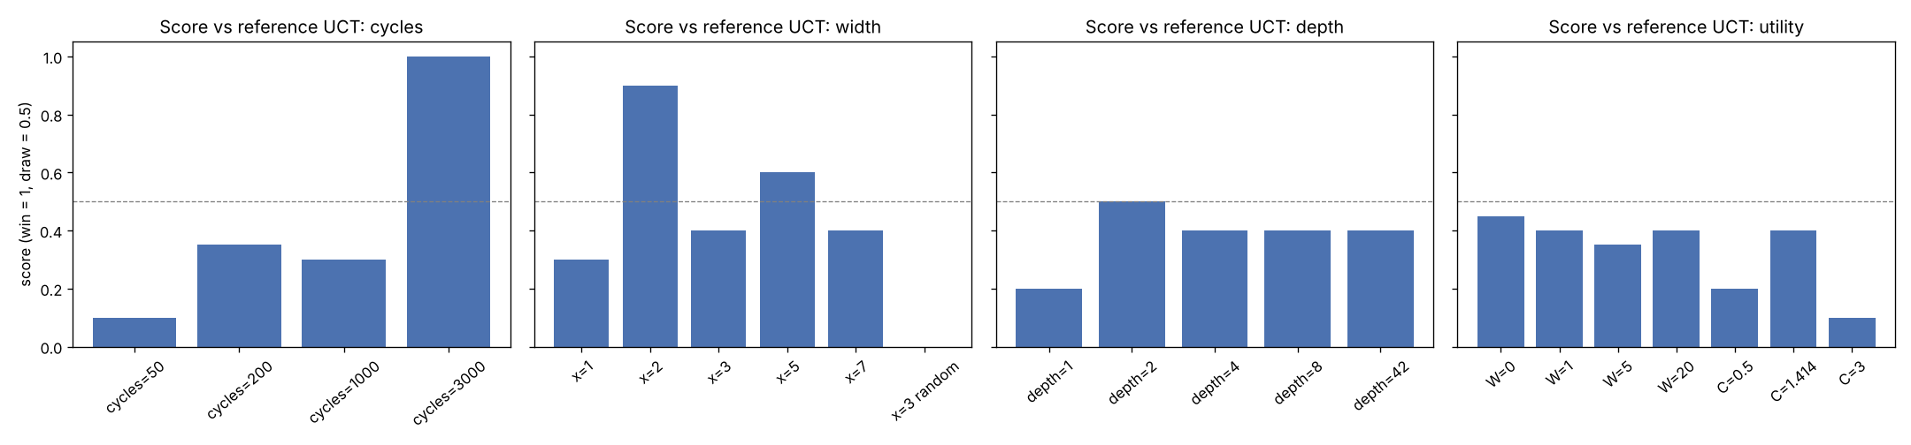
Limitations. Each match is only 10 games, so a score difference of 0.1 or 0.2 (one or two games) is within random noise; only the large differences (cycles 50 vs 3000, x = 2, x = 3 random, C = 3) should be taken as real. Times in summary.md were measured with two experiments running in parallel, so they are only roughly comparable. A stronger simulator would use a smarter playout policy (for example, always take an immediate win or block during the playout), which would cut the noise from point 1 above.

1.5 Running the tests
All 59 tests pass (python -m pytest -v, see README.md). The same tests run on GitHub Actions on every push (.github/workflows/tests.yml).
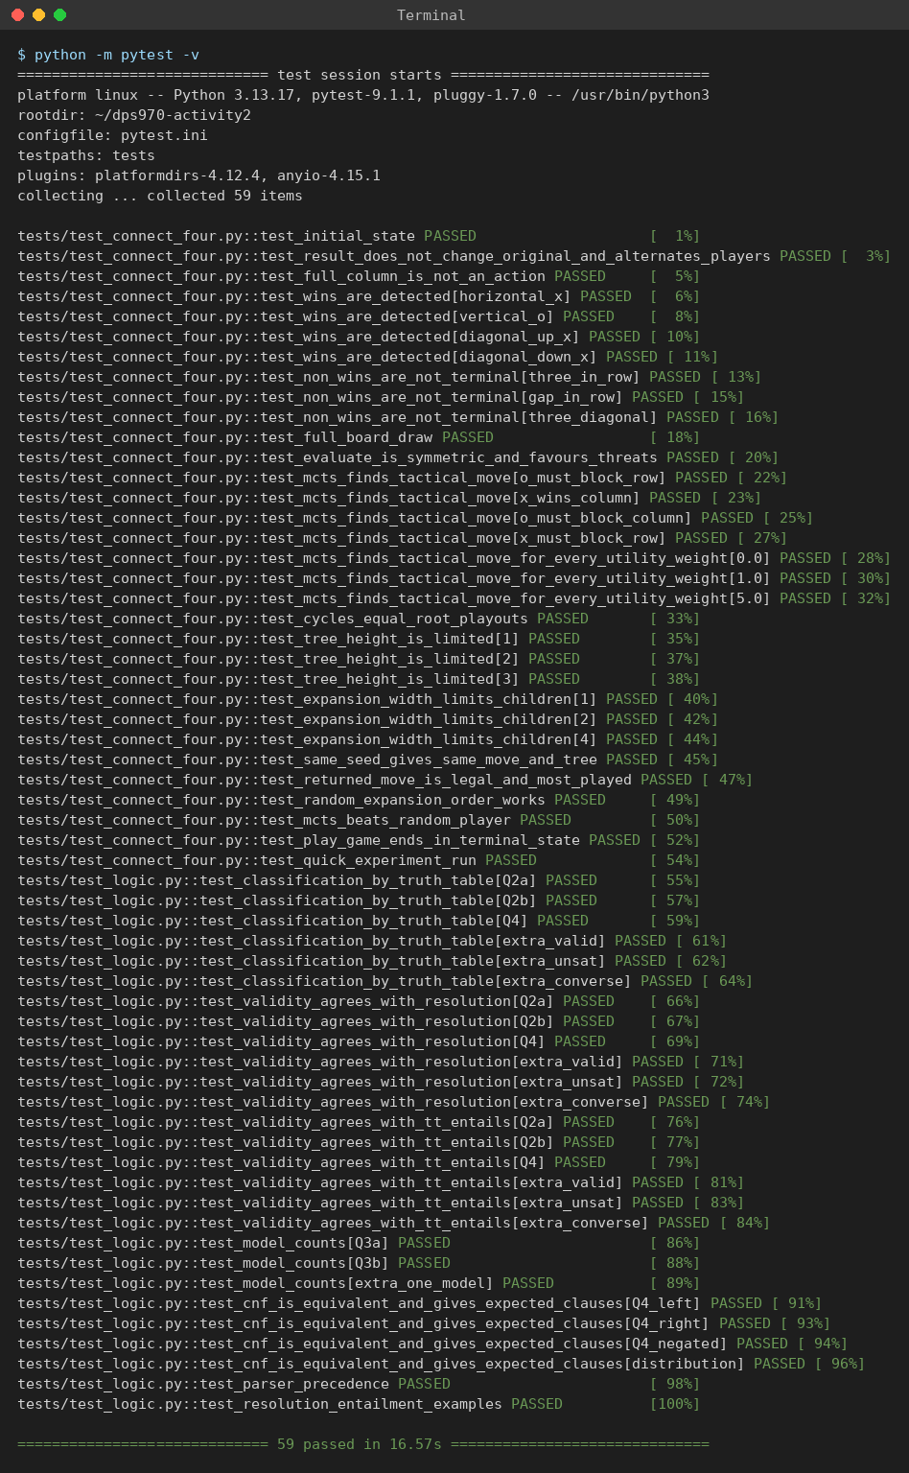
A quick experiment run (also run by GitHub Actions):
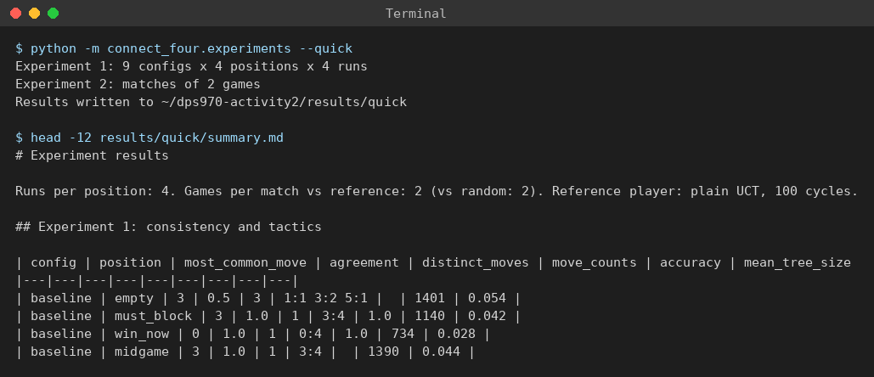
One search on the must-block position. Column 3 gets 678 of the 1000 playouts and the highest win rate (0.673) and objective score (0.668):
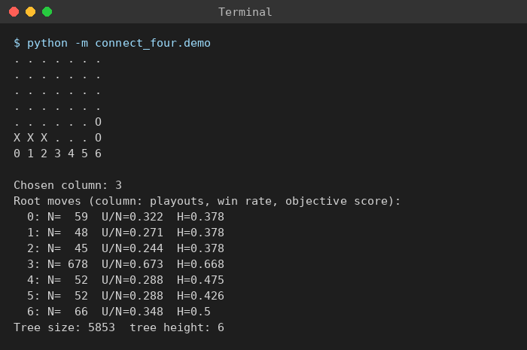

Question 2: Propositional Logic, Satisfiability
A sentence is valid if it is true in every model, unsatisfiable if it is true in no model, and neither (satisfiable but not valid) otherwise (AIMA Section 7.5.1).

(a) Smoke ⇒ Fire: neither (satisfiable, not valid)
Smoke | Fire | Smoke ⇒ Fire
T | T | T
T | F | F
F | T | T
F | F | T
It is true in three models, so it is satisfiable. It is false when Smoke is true and Fire is false, so it is not valid.

(b) ((Smoke ∧ Heat) ⇒ Fire) ⇔ ((Smoke ⇒ Fire) ∨ (Heat ⇒ Fire)): valid
Let L = (Smoke ∧ Heat) ⇒ Fire and R = (Smoke ⇒ Fire) ∨ (Heat ⇒ Fire).
Smoke | Heat | Fire | L | Smoke ⇒ Fire | Heat ⇒ Fire | R | L ⇔ R
T | T | T | T | T | T | T | T
T | T | F | F | F | F | F | T
T | F | T | T | T | T | T | T
T | F | F | T | F | T | T | T
F | T | T | T | T | T | T | T
F | T | F | T | T | F | T | T
F | F | T | T | T | T | T | T
F | F | F | T | T | T | T | T
L and R have the same value in all 8 models, so L ⇔ R is true in every model.
Check with equivalence rules:
- L = (Smoke ∧ Heat) ⇒ Fire ≡ ¬(Smoke ∧ Heat) ∨ Fire (implication elimination) ≡ ¬Smoke ∨ ¬Heat ∨ Fire (De Morgan)
- R = (Smoke ⇒ Fire) ∨ (Heat ⇒ Fire) ≡ (¬Smoke ∨ Fire) ∨ (¬Heat ∨ Fire) (implication elimination) ≡ ¬Smoke ∨ ¬Heat ∨ Fire ∨ Fire (associativity, commutativity) ≡ ¬Smoke ∨ ¬Heat ∨ Fire (idempotence)
Both sides are the same sentence, so L ⇔ R is valid.

Question 3: Models
With four propositions A, B, C, D there are 2⁴ = 16 models in total.

(a) B ∨ C: 12 models
B ∨ C is false only when B and C are both false. That fixes B and C, and A and D can be anything, so 2 × 2 = 4 models make it false. 16 − 4 = 12 models make it true. (Equivalently, 3 of the 4 combinations of B and C make it true, times 4 combinations of A and D.)

(b) (A ⇒ B) ∧ A ∧ ¬B ∧ C ∧ D: 0 models
A conjunction needs every part true. A and ¬B force A = T and B = F. Then A ⇒ B is T ⇒ F, which is false. So no model makes the sentence true: it is unsatisfiable and has 0 models. (This is Modus Ponens: A ⇒ B and A entail B, which contradicts ¬B.)
Both counts are checked by enumerating all 16 models in tests/test_logic.py::test_model_counts.

Question 4: Propositional Logic, Resolution
Sentence: [(Food ⇒ Party) ∨ (Drinks ⇒ Party)] ⇒ [(Food ∧ Drinks) ⇒ Party]
Let L be the left-hand side and R the right-hand side.

(a) Enumeration: valid
Food | Drinks | Party | Food ⇒ Party | Drinks ⇒ Party | L | Food ∧ Drinks | R | L ⇒ R
T | T | T | T | T | T | T | T | T
T | T | F | F | F | F | T | F | T
T | F | T | T | T | T | F | T | T
T | F | F | F | T | T | F | T | T
F | T | T | T | T | T | F | T | T
F | T | F | T | F | T | F | T | T
F | F | T | T | T | T | F | T | T
F | F | F | T | T | T | F | T | T
The sentence is true in all 8 models, so it is valid (and therefore also satisfiable). The only model where R is false (Food = T, Drinks = T, Party = F) is also the only model where L is false, so the implication is never T ⇒ F.

(b) CNF of each side
Using the steps from AIMA Section 7.5.2: (1) eliminate ⇔, (2) eliminate ⇒, (3) move ¬ inwards, (4) distribute ∨ over ∧.
Left-hand side: (Food ⇒ Party) ∨ (Drinks ⇒ Party)
- No ⇔, so nothing changes.
- (¬Food ∨ Party) ∨ (¬Drinks ∨ Party)
- ¬ is already only on symbols.
- There is no ∧, so it is already one clause. Removing the repeated literal: ¬Food ∨ ¬Drinks ∨ Party
Right-hand side: (Food ∧ Drinks) ⇒ Party
- No ⇔, so nothing changes.
- ¬(Food ∧ Drinks) ∨ Party
- De Morgan: (¬Food ∨ ¬Drinks) ∨ Party
- No ∧ left: ¬Food ∨ ¬Drinks ∨ Party
How this confirms (a): both sides become the same clause, ¬Food ∨ ¬Drinks ∨ Party. So the whole sentence has the form X ⇒ X, which is true in every model. That is exactly what the truth table in (a) showed: L and R are false in the same single model. (In fact L ⇔ R also holds, which is the same identity as Question 2b with different names.)
The code prints these steps with to_cnf_steps and a test checks that each CNF is equivalent to the original sentence in every model.

(c) Proof by resolution
To show a sentence α is valid, show that ¬α is unsatisfiable: resolution must derive the empty clause from the CNF of ¬α (PL-RESOLUTION, Figure 7.12, with an empty KB).
¬α = ¬(L ⇒ R) ≡ ¬(¬L ∨ R) ≡ L ∧ ¬R
- L in CNF: ¬Food ∨ ¬Drinks ∨ Party
- ¬R = ¬(¬Food ∨ ¬Drinks ∨ Party) ≡ Food ∧ Drinks ∧ ¬Party (De Morgan)
Clauses:
# | Clause | From
C1 | ¬Food ∨ ¬Drinks ∨ Party | L
C2 | Food | ¬R
C3 | Drinks | ¬R
C4 | ¬Party | ¬R
Resolution steps:
# | Resolve | On | Resolvent
C5 | C1, C2 | Food | ¬Drinks ∨ Party
C6 | C5, C3 | Drinks | Party
C7 | C6, C4 | Party | empty clause
The empty clause means ¬α is unsatisfiable, so α is valid, confirming (a).
pl_resolution in logic/propositional.py finds the same refutation, and the tests check that resolution, TT-ENTAILS and the truth table all give the same answer for Questions 2 and 4.

