Admin Profile Page - UX Report
Table of Contents:
- Overview
- Major Findings
- Risk & Governance Observations
- UX Maturity Assessment
- Current Workflow (Observed)
- Workflow Challenges
- Recommended Workflow (UX Optimized)
- Final Summary

1. Page Structure Overview
Four horizontal tabs: Personal Info, Business Details, Tax & Legal, Security.
Logical separation is well structured and reduces vertical clutter.

2. Major Strategic Findings
- All fields are editable, including Username (high-risk design decision).
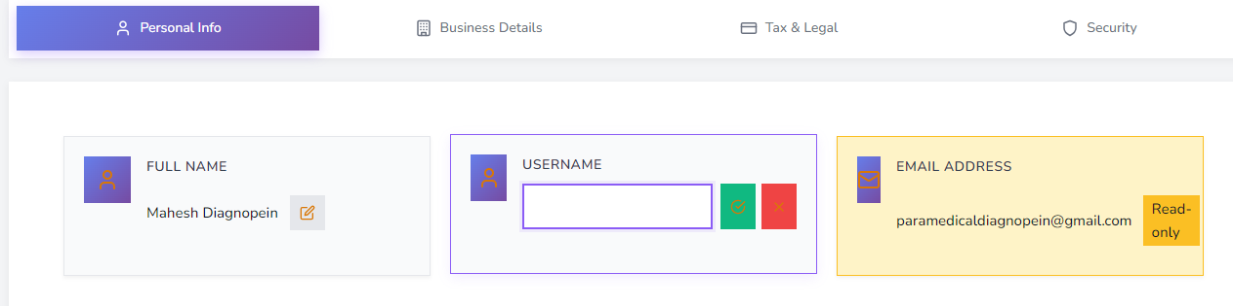
- Email is read-only (positive control decision).
- Phone field accepts invalid characters (no input validation present).
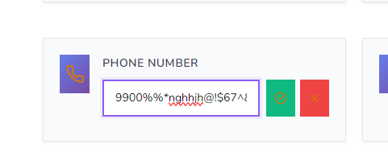
- Form architecture uses card-per-field pattern, increasing visual fragmentation.
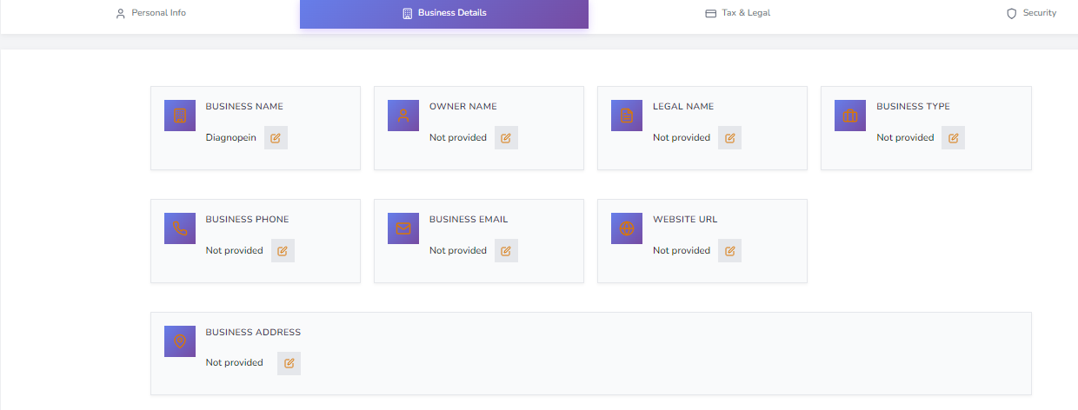

- Security tab limited to password change only (basic security maturity).

3. Risk & Governance Observations
- Editable username may impact identity integrity and system consistency.
- Lack of phone validation introduces data integrity risk.
- Tax/legal fields likely require stronger format validation (GST/PAN).
- Security controls appear minimal for an admin-level system.

4. UX Maturity Assessment
- Information Architecture: Strong (clear tab separation).
- Form Structure: Moderate (over-fragmented layout).
- Data Validation: Weak (missing input constraints).
- Security Layer: Basic (password-only security).
Estimated UX Score (Admin Profile Page): 3.2 – 3.6 / 5

5. Current Workflow (Observed)
- User opens Admin Profile page and selects a tab (Personal / Business / Tax & Legal / Security).
- User edits fields directly (all fields editable).
- User expects validation and guidance (format, required fields), but phone input accepts invalid characters.
- User proceeds to next tab and repeats edits; risk of inconsistent or accidental changes increases (e.g., Username).
- In Security tab, user can only change password; no broader account/security controls are available.

6. Workflow Challenges
- No clear guardrails for identity fields (Username editable).
- Weak data-quality gates (missing input constraints/format validation).
- Card-per-field layout can slow scanning and editing when multiple fields must be updated.
- Security workflow limited to password change; missing session/device controls reduces admin confidence.

7. Recommended Workflow (UX Optimized)
- Tab entry shows section summary + clear edit mode (Edit / Save / Cancel) at section level.
- Identity-critical fields (Username) are locked or change-controlled (verification/approval) with clear consequences.
- Strong field validation (phone masking, allowed characters, GST/PAN format) with inline error messages.
- Progress feedback on save(success message, last-updated timestamp).
- Security tab expands to include 2FA, active sessions, last login, and logout-all for admin-grade control.

8. Final Summary
The Admin Profile page demonstrates good structural organization but requires stronger validation logic, governance controls, and enhanced security layers to reach enterprise-grade maturity. Improvements should prioritize input validation, identity integrity safeguards, and enhanced security mechanisms.

