Admin Call Logs & Analytics – Strategic UX Evaluation

Table of Contents:
- Overview
- Major Strategic Findings
- Current Workflow
- Recommended Workflow
- UX Maturity Evaluation

1. Screen Overview
Screen Purpose: View and analyze calls across all franchises.
Components: KPI cards, analytics graphs, filter controls, search, timeline CTA, data table, pagination.

2. Major Strategic Findings
- KPI cards show hover effects but are non-clickable (false affordance, interaction inconsistency).
- No drill-down behavior from KPI metrics to filtered call logs.
- Filters apply only to table, not to graphs (data layer inconsistency).

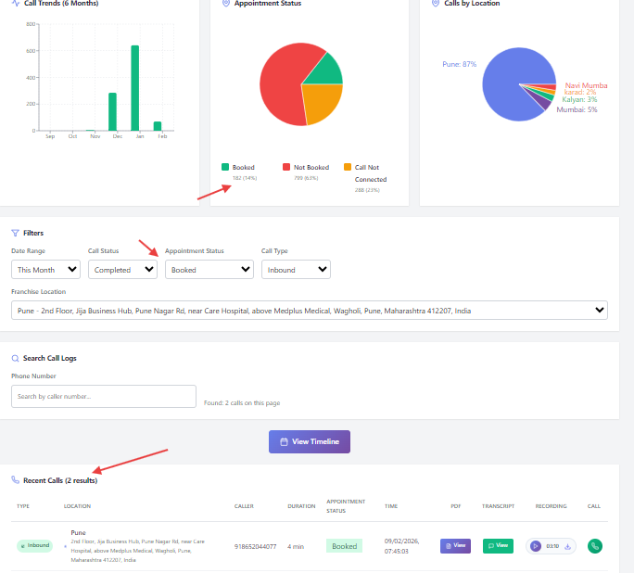
- Analytics and operational logs are vertically stacked, causing excessive scroll.
- No synchronized interaction between graphs and data.
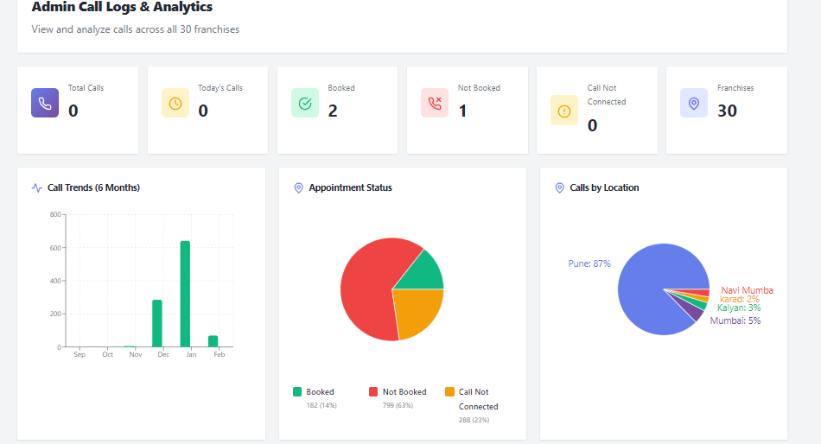
- Pagination visible only at bottom; record count visibility unclear.
- Strong backend data capability but limited insight-to-action flow.

3. Current Workflow (Observed)
Login → View KPI → Scroll → Apply Filter → Review Table → Scroll → Pagination
Issue: Metrics do not directly lead to actionable exploration.

4. Recommended Workflow (UX Optimized)
Login → Click KPI / Graph → Auto-filter → View Updated Analytics + Logs → Take Action

5. UX Maturity Evaluation
- Data Depth: Strong (multi-franchise tracking, trend graphs).
- Interaction Layer: Moderate (inconsistent drill-down patterns).
- Layout Efficiency: Needs structural segmentation.
- Enterprise Readiness: Moderate, requires export/reporting enhancement.
Estimated UX Score (Analytics Screen): 3.2 – 3.6 / 5

