Main Dashboard UX Audit Report
Table of Contents:
- Executive Summary
- Key Dashboard Findings
- Current Workflow (Observed)
- Recommended Workflow (UX Optimized)
- Dashboard Usability Scorecard
- Competitor Benchmark Overview
- Summary

Executive Summary:
This document evaluates the usability and workflow maturity of the dashboard. The goal is to assess insight-to-action flow, navigation clarity, KPI interactivity, and enterprise readiness. The dashboard is functionally structured but lacks drill-down capability and workflow continuity.

Key Dashboard Findings:
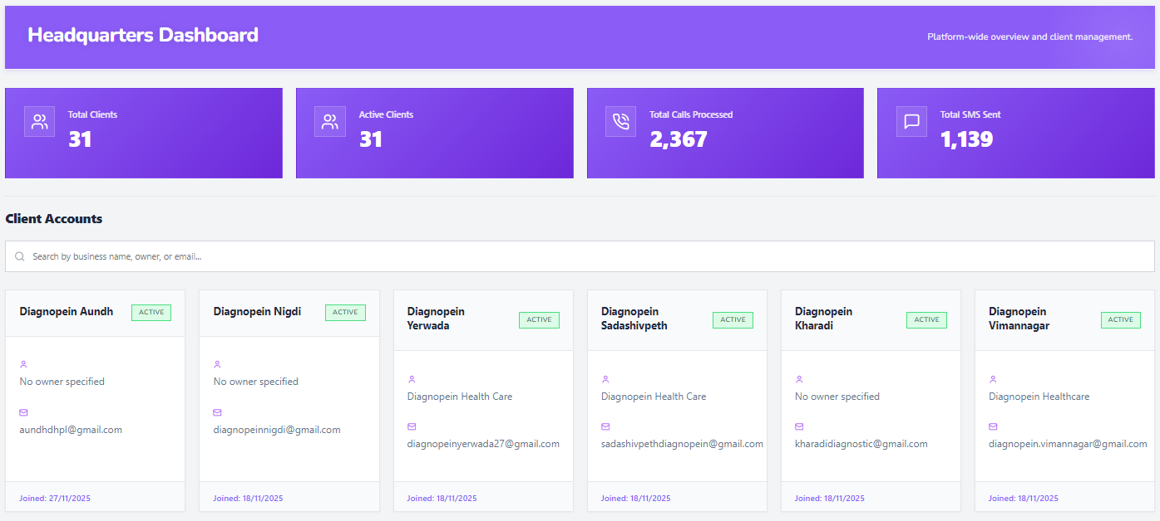
- KPI cards (Total Clients, Active Clients, Calls Processed, SMS Sent) show hover effects but are not clickable (false affordance).
- For page architecture – need to balance cognitive load discoverability
- No drill-down view for Calls Processed and SMS Sent.
- Search filters only client; not clearly connected to KPI metrics.
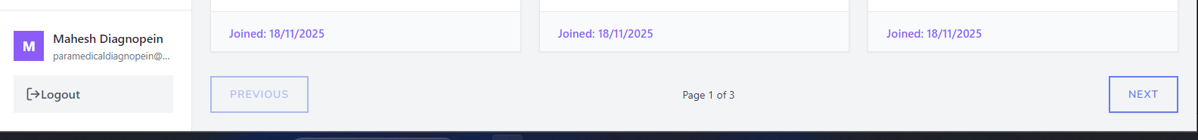
- Pagination/Logout - visible only after scroll (discoverability issue).
- Dashboard provides summary metrics but does not support deeper investigation.

Current Workflow (Observed):
STEP 1: Login → User lands on dashboard with KPI summary.
STEP 2: View KPI Cards → Metrics visible but not interactive.
STEP 3: Scroll → Search bar and client cards displayed.
STEP 4: Scroll Further → Pagination becomes visible.
Issue: Insight-to-action flow is incomplete. Metrics do not lead to actionable views.

Recommended Improved Workflow (UX Optimized):
STEP 1: Login → Dashboard Overview with interactive KPI cards.
STEP 2: Click KPI (e.g., Calls Processed) → Navigate to filtered Call Logs.
STEP 3: Drill-down into detailed analytics view (filters, date range, export).
STEP 4: Take action (adjust campaign, export report, modify AI flow).
STEP 5: Return to dashboard with contextual breadcrumb navigation.

Dashboard Usability Scorecard:
Area | Score | Observation
Visual Hierarchy | 3.5/5 | Clear KPI placement but weak data grouping alignment
Discoverability | 3/5 | Search visible, pagination hidden on scroll
Interaction Consistency | 2.5/5 | Hover effects without click ability create false affordance
Data Actionability | 2/5 | No drill-down for Calls Processed & SMS Sent
Navigation Efficiency | 3/5 | Functional but requires extra scrolling/navigation
Overall Dashboard UX Score: Estimated Score: 2.8 – 3.2 / 5

Competitor Benchmark Overview:
Compared against platforms such as Exotel, Twilio, and Dialogflow.
- Competitors provide clickable KPI drill-down navigation.
- Advanced analytics dashboards with export and filtering.
- Visual workflow builders with preview/simulation.
- Clear enterprise-grade reporting and audit logs.

Summary:
The dashboard currently answers 'How many?' but does not support 'Which?' or 'Why?'. Enabling KPI drill-down would strengthen insight-to-action flow and improve product maturity perception.

