

Safety Plan Lane Assistance

**Document Version: [001]**

**Template Version 1.0, Released on 2017-06-21**



# Document history

**[Instructions: Fill in the date, version and description fields. You can fill out the Editor field with your name if you want to do so. Keep track of your editing as if this were a real world project.**

**For example, if this were your first draft or first submission, you might say version 1.0. If this is a second submission attempt, then you'd add a second line with a new date and version 2.0]**

|  |  |  |  |
| --- | --- | --- | --- |
| Date | Version | Editor | Description |
| 01/18/2019 | 1.0 | Vern Francisco | Homework for SDC NanoDegree |
|  |  |  |  |
|  |  |  |  |
|  |  |  |  |
|  |  |  |  |

# Table of Contents

**[Instructions: We have provided a table of contents. If the table of contents is not showing up correctly in your word processor of choice, please update it. The table of contents should show each section of the document and page numbers or links. Most word processors can do this for you. In** [**Google Docs**](https://support.google.com/docs/answer/116338?co=GENIE.Platform%3DDesktop&hl=en)**, you can use headings for each section and then go to Insert > Table of Contents.** [**Microsoft Word**](https://support.microsoft.com/en-us/help/285059/how-to-create-a-table-of-contents-by-marking-text-in-word) **has similar capabilities]**

Document history

Table of Contents

Introduction

Purpose of the Safety Plan

Scope of the Project

Deliverables of the Project

Item Definition

Goals and Measures

Goals

Measures

Safety Culture

Safety Lifecycle Tailoring

Roles

Development Interface Agreement

Confirmation Measures

# Introduction

## Purpose of the Safety Plan

**[Instructions: Answer what is the purpose of a safety plan?]**

**The Safety Plan defines roles and outlines the steps needed to achieve functional safety**

## Scope of the Project

**[Instructions: Nothing to do here. This is for your information.]**

For the lane assistance project, the following safety lifecycle phases are in scope:

Concept phase

Product Development at the System Level

Product Development at the Software Level

The following phases are out of scope:

Product Development at the Hardware Level

Production and Operation

## Deliverables of the Project

**[Instructions: Nothing to do here. This is for your information.]**

The deliverables of the project are:

Safety Plan

Hazard Analysis and Risk Assessment

Functional Safety Concept

Technical Safety Concept

Software Safety Requirements and Architecture

# Item Definition

**[Instructions:**

**REQUIRED**

**Discuss these key points about the system:**

**What is the item in question, and what does the item do?**

**The item is a Lane Assistance System. In Adavanced Driver Assistance Systems (ADAS), the system will alert the driver to potentially dangerous situations and take over the vehicle to prevent accidents from occuring. The Lane Assistance System is a simplified ADAS system**

**What are its two main functions? How do they work?**

**The Lane Assistance System will have two functions:**

1. **Lane departure warning**
2. **Lane keeping assistance**

When the driver drifts towards the edge of the lane, two things will happen:

* the **lane departure warning function** will vibrate the steering wheel
* the **lane keeping assistance function** will move the steering wheel so that the wheels turn towards the center of the lane

**Which subsystems are responsible for each function?**

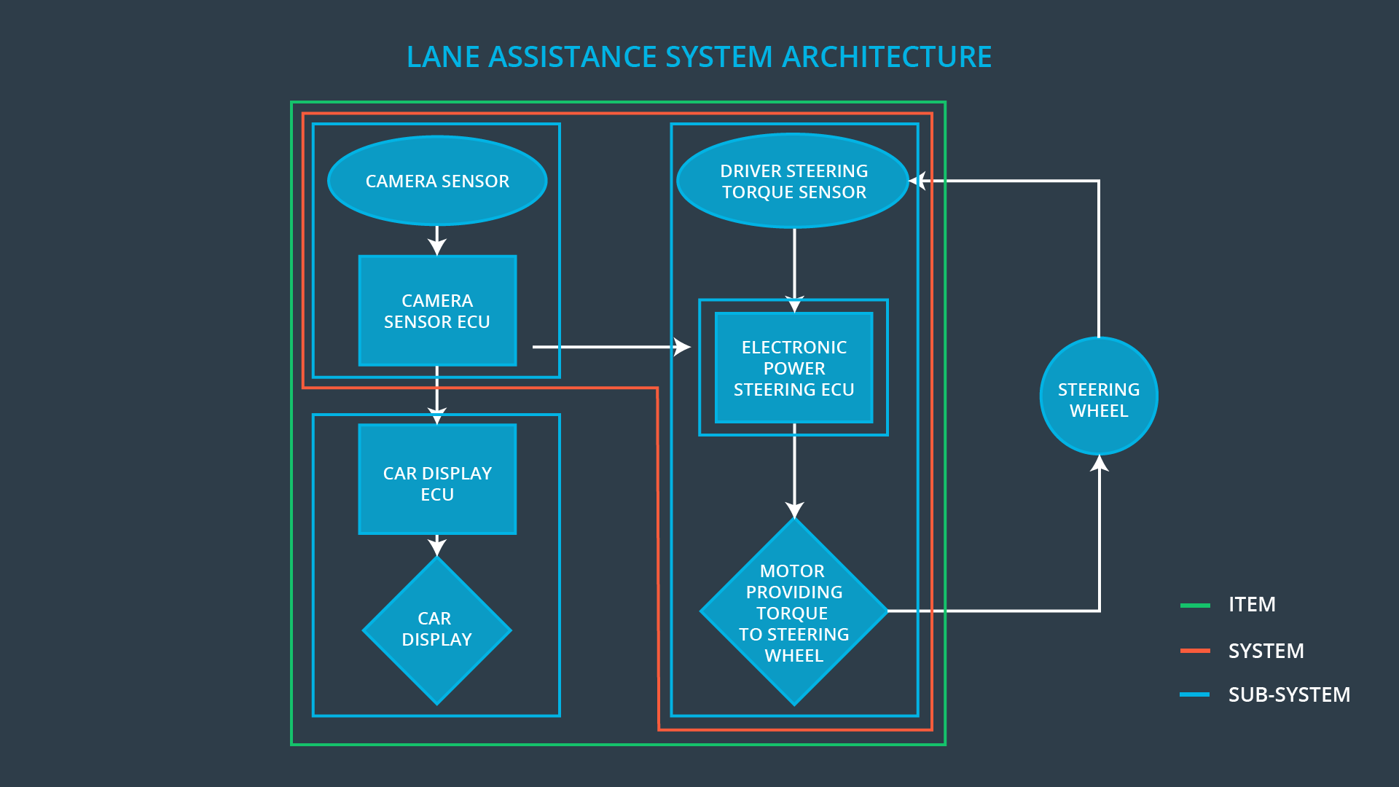

To summarize the functionality, the camera system detects lane departures and tells the steering wheel how hard to turn. The driver receives a warning on the vehicle display and also receives a warning via a steering wheel vibrating. Simultaneously, the wheel adds extra steering torque to help the driver move back towards the center of the lane.

**What are the boundaries of the item? What subsystems are inside the item? What elements or subsystems are outside of the item?**

In this case, the item is the lane assistance system

The three sub-systems are:

* Camera system
  + A Camera ECU
  + A Camera Sensor
* Electronic Power Steering system
  + The electronic power steering ECU
  + The steering motor
* Car Display system
  + Warning lights
  + Car Display ECU

**OPTIONAL**

**Optionally, include information about these points as well. These were not included in the lectures, but you might be able to find this information online:**

* **Operational and Environmental Constraints. This could especially be limited to camera performance; lane lines are difficult to detect in snow, fog, etc**
* **Legal requirements in your country for lane assistance technology**
* **National and International Standards Related to the Item**
* **Records of previously known safety-related incidents or behavioral shortfalls**

**]**

# Goals and Measures

## Goals

**[Instructions:**

**Describe the major goal of this project; what are we trying to accomplish by analyzing the lane assistance functions with ISO 26262?]**

**The main goal in analyzing the lane assistance functions with ISO 26262 is to reduce risk of lane assistance functions to acceptable levels**

## Measures

**[Instructions:**

**Fill in who will be responsible for each measure or activity. Hint: The lesson on Safety Management Roles and Responsibilities.**

**The options are:**

**All Team Members**

**Safety Manager**

**Project Manager**

**Safety Auditor**

**Safety Assessor**

**]**

|  |  |  |
| --- | --- | --- |
| Measures and Activities | Responsibility | Timeline |
| Follow safety processes | All Team Members | Constantly |
| Create and sustain a safety culture | All Team Members | Constantly |
| Coordinate and document the planned safety activities | Safety Manager | Constantly |
| Allocate resources with adequate functional safety competency | Project Manager | Within 2 weeks of start of project |
| Tailor the safety lifecycle | Safety Manager | Within 4 weeks of start of project |
| Plan the safety activities of the safety lifecycle | Safety Manager | Within 4 weeks of start of project |
| Perform regular functional safety audits | Safety Auditor | Once every 2 months |
| Perform functional safety pre-assessment prior to audit by external functional safety assessor | Safety Manager | 3 months prior to main assessment |
| Perform functional safety assessment | Safety Assessor | Conclusion of functional safety activities |

# Safety Culture

**[Instructions:**

**Describe the characteristics of your company's safety culture. How do these characteristics help maintain your safety culture. Hint: See the lesson about Safety Culture**

**]**

The characteristics of the company’s safety culture are the following:

High priority- The company puts safety as its highest priority over controlling cost and increased productivity

Accountability-The processes in place ensure accountability and decisions can be traced back to the people and teams taht made the decisions

Rewards-The organization rewards the achievement of functional safety

Penalties-The organization penalizes shortcuts that jeopardize safety or quality

Independence-Teams who design and develop are independent from the teams who audit the work

Well defined processes-Company design and management processes are clearly defined

Resources-Projects have necessary resources as well as people with appropriate skills

Diversity-Intellectual diversity is sought after, valued and integrated into company processes

Communication-The company encourages disclosure of problems through its communications channels

# Safety Lifecycle Tailoring

**[Instructions:**

**Describe which phases of the safety lifecycle are in scope and which are out of scope for this particular project. Hint: See the** **Intro section** **of this document**

**]**

For the lane assistance project, the following safety lifecycle phases are in scope:

* Concept phase
* Product Development at the System Level
* Product Development at the Software Level

The following phases are out of scope:

* Product Development at the Hardware Level
* Production and Operation

# Roles

**[Instructions:**

**This section is here for your reference. You do not need to do anything here. It is provided to help with filling out the development interface agreement section.**

**]**

|  |  |
| --- | --- |
| Role | Org |
| Functional Safety Manager- Item Level | OEM |
| Functional Safety Engineer- Item Level | OEM |
| Project Manager - Item Level | OEM |
| Functional Safety Manager- Component Level | Tier-1 |
| Functional Safety Engineer- Component Level | Tier-1 |
| Functional Safety Auditor | OEM or external |
| Functional Safety Assessor | OEM or external |

# Development Interface Agreement

**[Instructions:**

**Assume in this project that you work for the tier-1 organization as described in the above roles table. You are taking on the role of both the functional safety manager and functional safety engineer.**

Safety Manager

* **Planning**, **coordinating** and **documenting** of the development phase of the safety lifecycle
* **Tailors** the safety lifecycle
* Maintains the safety plan
* Monitors progress against the safety plan
* Performs pre-audits before the safety auditor

Safety Engineer

* Product development
* Integration
* Testing at the hardware, software and system levels

**Please answer the following questions:**

1. **What is the purpose of a development interface agreement?**

**The purpose of a development interface agreement is to define the roles and responsibilities between companies involved in developing a product**

1. **What will be the responsibilities of your company versus the responsibilities of the OEM? Hint: In this project, the OEM is supplying a functioning lane assistance system. Your company needs to analyze and modify the various sub-systems from a functional safety viewpoint.**

* Appointment of customer and supplier safety managers
* Joint tailoring of the safety lifecycle
* Activities and processes to be performed by the customer; activities and processes to be performed by the supplier
  + Customer: **Supply a functioning lane assistance system**
  + Supplier: **Analyze and modify the various sub-systems from a functional safety viewpoint**
* Information and work products to be exchanged
* Parties or persons responsible for each activity in design and production
* Any supporting processes or tools to ensure compatibility between customer and supplier technologies

# Confirmation Measures

**[Instructions:**

**Please answer the following questions:**

1. What is the main purpose of confirmation measures?

* Ensure processes comply with the functional safety standard
* Ensure project execution is following the safety plan
* Ensure that the project really does make the vehicle more safe

1. What is a confirmation review?

* An independent person ensures that the project complies with ISO 26262.

1. What is a functional safety audit?

* Checks to make sure that the actual implementation of the project conforms to the safety plan

1. What is a functional safety assessment?

* Confirms that plans , designs and developed products actually achieve functional safety

A safety plan could have other sections that we are not including here. For example, a safety plan would probably contain a complete project schedule.

There might also be a "Supporting Process Management" section that would cover "Part 8: Supporting Processes" of the ISO 26262 functional safety standard. This would include descriptions of how the company handles requirements management, change management, configuration management, documentation management, and software tool usage and confidence.

Similarly, a confirmation measures section would go into more detail about how each confirmation will be carried out.