

Functional Safety Concept Lane Assistance

**Document Version: [Version]**

**Template Version 1.0, Released on 2017-06-21**



# Document history

**[Instructions: Fill in the date, version and description fields. You can fill out the Editor field with your name if you want to do so. Keep track of your editing as if this were a real world project.**

**For example, if this were your first draft or first submission, you might say version 1.0. If this is a second submission attempt, then you'd add a second line with a new date and version 2.0]**

|  |  |  |  |
| --- | --- | --- | --- |
| Date | Version | Editor | Description |
| 2019-01-30 | 1.0 | Vern Francisco | 1st attempt at completing the assignment |
|  |  |  |  |
|  |  |  |  |
|  |  |  |  |
|  |  |  |  |

# Table of Contents

**[Instructions: We have provided a table of contents. If you change the document structure, please update the table of contents accordingly. The table of contents should show each section of the document and page numbers or links. Most word processors can do this for you. In** [**Google Docs**](https://support.google.com/docs/answer/116338?co=GENIE.Platform%3DDesktop&hl=en)**, you can use headings for each section and then go to Insert > Table of Contents.** [**Microsoft Word**](https://support.microsoft.com/en-us/help/285059/how-to-create-a-table-of-contents-by-marking-text-in-word) **has similar capabilities]**

Document history

Table of Contents

Purpose of the Functional Safety Concept

Inputs to the Functional Safety Analysis

Safety goals from the Hazard Analysis and Risk Assessment

Preliminary Architecture

Description of architecture elements

Functional Safety Concept

Functional Safety Analysis

Functional Safety Requirements

Refinement of the System Architecture

Allocation of Functional Safety Requirements to Architecture Elements

Warning and Degradation Concept

# Purpose of the Functional Safety Concept

**[Instructions: Answer what is the purpose of a functional safety concept?]**

The purpose of the Functional Safety Concept is to avoid accidents by reducing risk to acceptable levels. The Functional Safety Concept reduces risk by doucmenting functional safety requirements derived from safety goals and allocates the requirement to the appropriate place in the architecture.

# Inputs to the Functional Safety Concept

## Safety goals from the Hazard Analysis and Risk Assessment

**[Instructions:**

**REQUIRED:**

**Provide the lane departure warning and lane keeping assistance safety goals as discussed in the lessons and derived in the hazard analysis and risk assessment.**

**OPTIONAL:**

**If you expanded the hazard analysis and risk assessment to include other safety goals, include them here.**

**]**

|  |  |
| --- | --- |
| **ID** | **Safety Goal** |
| Safety_Goal_01 | The oscillating torque to the steering wheel from teh lane departure function shall be limited |
| Safety_Goal_02 | **The land keeping assistance function shall be time limited and the additional steering torque shall end after a given time interval so that the driver cannot misuse the system for autonomous driving** |

## Preliminary Architecture

**[Instructions: Provide a preliminary architecture for the lane assistance item. Hint: See Lesson 3: Item Definition]**

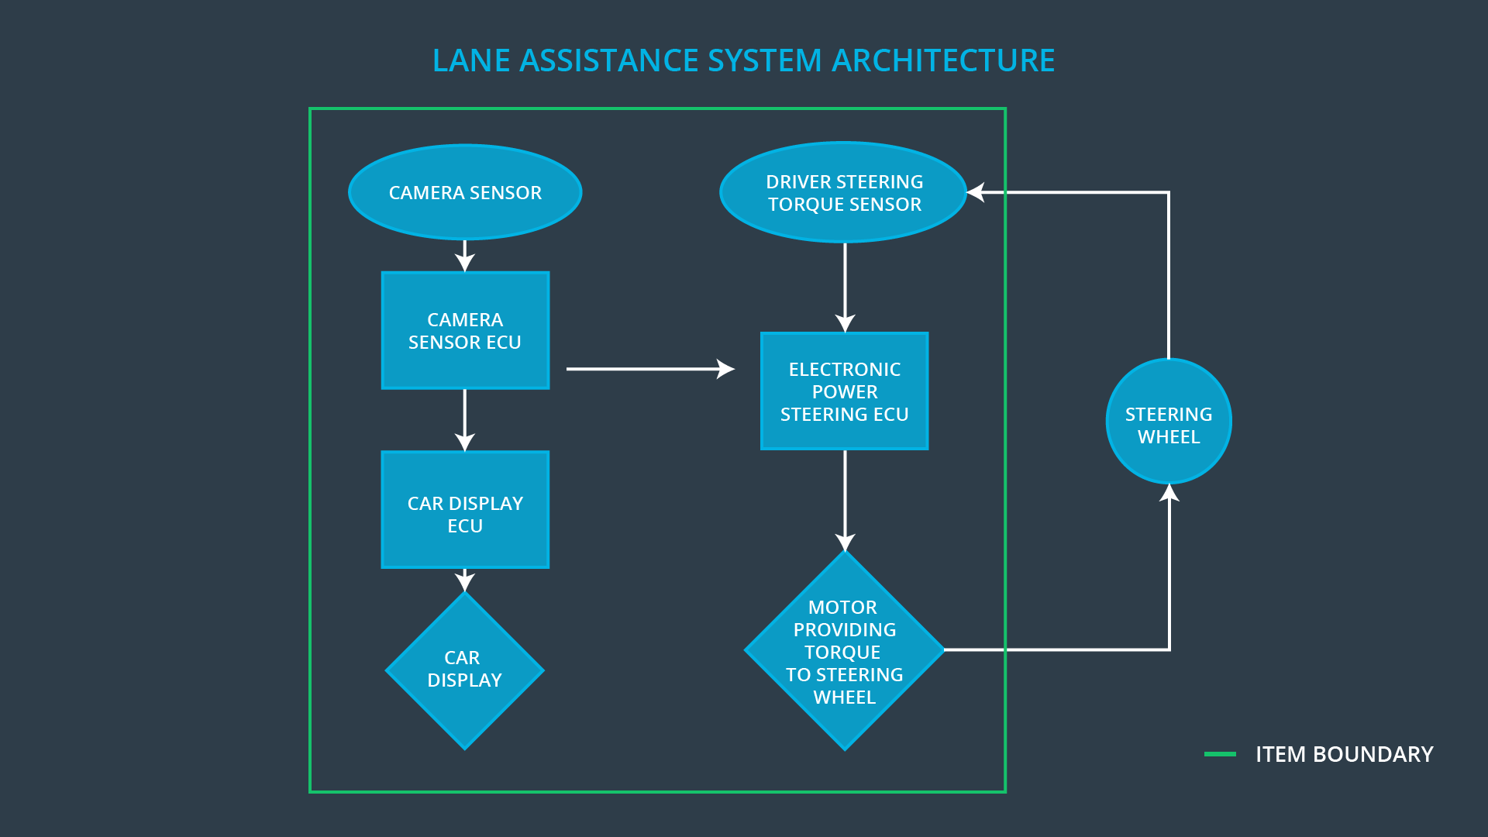

### Description of architecture elements

**[Instructions: Provide a description for each of the item elements; what is each element's purpose in the lane assistance item? ]**

|  |  |
| --- | --- |
| **Element** | **Description** |
| Camera Sensor | Responsible for detecting lane lines and other objects in the road |
| Camera Sensor ECU | Determines when the vehicle leaves the lane by mistake by processsing images from the camera sensor. It senses the lane and creates a torque request for the Electronic Power Steering ECU |
| Car Display | Informs the driver of vehicle status and warnings |
| Car Display ECU | Takes input from the Camera Sensor ECU and other ECUs and generates commands to activate lights and guages in the car display:  It controls a light that shows the on/off status of the Lane Assistance system and a light showing whether the Lane Assistance system is active or inactive |
| Driver Steering Torque Sensor | Senses the torque that the driver is imparting on the steering wheel |
| Electronic Power Steering ECU | The Electronic Power Steering ECU receives the torque request from the camera sensor ECU and receives information about the driver’s steering torque. It adds these torque values and sends the final torque request to the Motor |
| Motor | Adds torque to the steering wheel |

# Functional Safety Concept

The functionalncept consists of:

* Functional safety analysis
* Functional safety requirements
* Functional safety architecture
* Warning and degradation concept

## Functional Safety Analysis

**[Instructions: Fill in the functional safety analysis table below.]**

|  |  |  |  |
| --- | --- | --- | --- |
| **Malfunction ID** | **Main Function of the Item Related to Safety Goal Violations** | **Guidewords (NO, WRONG, EARLY, LATE, MORE, LESS)** | **Resulting Malfunction** |
| Malfunction_01 | Lane Departure Warning (LDW) function shall apply an oscillating steering torque to provide the driver a haptic feedback | MORE | The lane departure warning function applies an oscillating torque with very high torque amplitude (above limit) |
| Malfunction_02 | Lane Departure Warning (LDW) function shall apply an oscillating steering torque to provide the driver a haptic feedback | MORE | The lane departure warning function applies an oscillating torque with very high torque frequency (above limit) |
| Malfunction_03 | Lane Keeping Assistance (LKA) function shall apply the steering torque when active in order to stay in ego lane | NO | The lane keeping assistance function is not limited in time duration which leads to misuse as an autonomous driving function. |

## Functional Safety Requirements

**[Instructions: Fill in the functional safety requirements for the lane departure warning ]**

Lane Departure Warning (LDW) Requirements:

|  |  |  |  |  |
| --- | --- | --- | --- | --- |
| **ID** | **Functional Safety Requirement** | **ASIL** | **Fault Tolerant Time Interval** | **Safe State** |
| Functional  Safety  Requirement  01-01 | The lane keeping item shall ensure that he lane departure oscillating toqrue ampliteude is below Max_Torque_Amplitude | C | 50ms | System is turned off |
| Functional  Safety  Requirement  01-02 | The lane keeping item shall ensure tha the lane departure oscillating torque frequency is belwo Max_Torque_Frequency | C | 50ms | System is turned off |

Lane Departure Warning (LDW) Verification and Validation Acceptance Criteria:

|  |  |  |
| --- | --- | --- |
| **ID** | **Validation Acceptance**  **Criteria and Method** | **Verification Acceptance**  **Criteria and Method** |
| Functional  Safety  Requirement  01-01 |  |  |
| Functional  Safety  Requirement  01-02 |  |  |

**[Instructions: Fill in the functional safety requirements for the lane keeping assistance]**

Lane Keeping Assistance (LKA) Requirements:

|  |  |  |  |  |
| --- | --- | --- | --- | --- |
| **ID** | **Functional Safety Requirement** | **ASIL** | **Fault Tolerant Time Interval** | **Safe State** |
| Functional  Safety  Requirement  02-01 | The electronic power steering ECU shall ensure that the lane keeping assistance torque is applied for only a Max_Duration | B | 500ms | System is turned off |

Lane Keeping Assistance (LKA) Verification and Validation Acceptance Criteria:

|  |  |  |
| --- | --- | --- |
| **ID** | **Validation Acceptance**  **Criteria and Method** | **Verification Acceptance**  **Criteria and Method** |
| Functional  Safety  Requirement  02-01 |  |  |

## Refinement of the System Architecture

**[Instructions: Include the refined system architecture. Hint: The refined system architecture should include the system architecture from the end of the functional safety lesson including all of the ASIL labels.]**

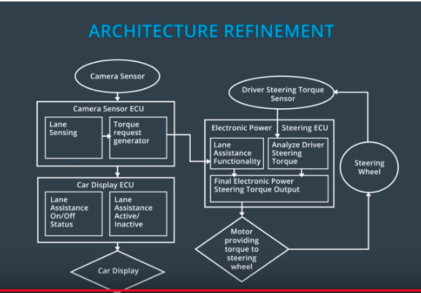

## Allocation of Functional Safety Requirements to Architecture Elements

**[Instructions: Mark which element or elements are responsible for meeting the functional safety requirement. Hint: Only one ECU is responsible for meeting all of the requirements.]**

|  |  |  |  |  |
| --- | --- | --- | --- | --- |
| **ID** | **Functional Safety Requirement** | **Electronic Power Steering ECU** | **Camera ECU** | **Car Display ECU** |
| Functional  Safety  Requirement  01-01 | The electronic power steering ECU shall ensure that he lane departure oscillating toqrue ampliteude is below Max_Torque_Amplitude | **X** |  |  |
| Functional  Safety  Requirement  01-02 | The electronic power steering ECU shall ensure tha the lane departure oscillating torque frequency is below Max_Torque_Frequency | **X** |  |  |
| Functional  Safety  Requirement  02-01 | The electronic power steering ECU shall ensure that the lane keeping assistance torque is applied for only a Max_Duration | **X** |  |  |

## Warning and Degradation Concept

**[Instructions: Fill in the warning and degradation concept.]**

|  |  |  |  |  |
| --- | --- | --- | --- | --- |
| **ID** | **Degradation Mode** | **Trigger for Degradation Mode** | **Safe State invoked?** | **Driver Warning** |
| WDC-01 | Turn off the lane departure warning function | The frequency of the oscillating torque or the magnitude of the oscillating torque have exceeded their limits | Yes | Warning Light |
| WDC-02 | Turn off the lane keeping assistance function | The max duration of driver hands off the wheel has been exceeded | Yes | Warning Light |