AUTHORIZATION LETTER

June 13, 2024

To whom it may concern,

This is to authorize John Mark B. Cabillon to process the payment for my assessment processing fee.

In view thereof, John Mark B. Cabillon is authorized to process and accomplished the said activity.

Thank you for your kind assistance to the bearer of this letter.

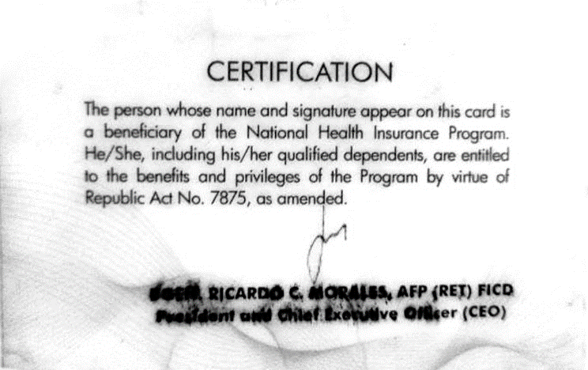
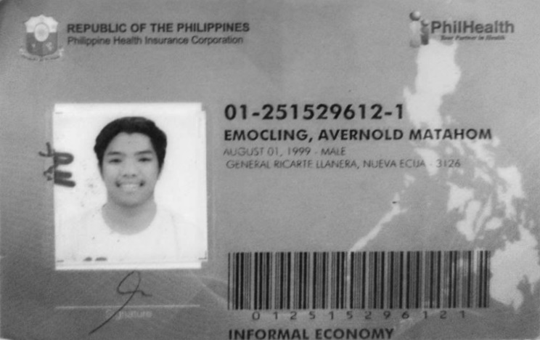
Sincerely,
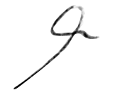

Avernold M. Emocling

