Ongoing Observational Method Applied to a Brine Pond
René Matías Calvente, Alejo Oscar Sfriso
SRK Consulting, Argentine Republic, rcalvente@srk.com.ar
ABSTRACT: This contribution examines the application of the observational method to the construction of a 4 km circular ring dam for the storage of spent brine at a lithium project located in the arid Puna region of Salta province, Argentina. Due to time constraints, construction started before a detailed geotechnical site investigation was completed. A base case design was developed for the most likely soil conditions, using basic geotechnical data derived from previous site investigations. Extra design features, in the form of adjustments in the cross sections compatible with the base case, were specified to accommodate for several conceivable deviations in soil behavior. During construction, a combination of additional geotechnical exploration and observation of the embankment performance allowed for a final design, variable along the ring dam. To reduce the risk of long-term large deformation or failure, a monitoring system was specified, along with a trigger action response plan which informs if additional actions are required. The application of the observational method in this project saved precious time in the development of the facility, without compromising its long-term safety and performance.
KEYWORDS: Brine, mine waste, embankment, foundation, lithium.

introduction
The process called Direct Lithium Extraction (DLE) requires large facilities to dispose the spend brine after the extraction of the lithium from the brine solution using chemical or physical processes. This paper presents a case study on the construction of a circular ring dam with a diameter of about 1.3 km (a perimeter of 4 km) and an average height of 2.5 m for a spent brine storage facility at a lithium project located in the Puna region of Salta province in Argentina, an arid, high-altitude plateau with complex geological and geotechnical conditions.
The facility design was completed using a limited set of geotechnical data because of time constraints. To evaluate the potential changes on the design, a sensitivity assessment of the geotechnical foundation parameters was included in the scope. Based on this information the client decided to go ahead with the construction.
Designing with very limited information introduces considerable uncertainty, usually beyond what geotechnical engineers are comfortable with. To address these uncertainties in a manner that maintains both safety and cost-effectiveness, the Observational Method (OM) was adopted.
The Observational Method in geotechnical engineering, formally defined by Ralph Peck in his 1969 Rankine Lecture (Peck, 1969), provides a structured approach to design and construction under high uncertainty. It allows for the design to be based on the most probable ground conditions, with pre-defined modifications to be implemented if observations during construction reveal different behaviors.
This "learn-as-you-go" approach is particularly well-suited for large-scale geotechnical projects like dams and tunnels, where ground conditions can be highly variable. This paper details the application of the OM to the embankment construction, demonstrating its effectiveness in accelerating project delivery without compromising safety.

THE OBSERVATIONAL METHOD: PRINCIPLES AND ADVANTAGES
The OM in geotechnical engineering can have two approaches (Peck, 1969); ab initio where the intention is to use the OM from the start of the project, and the best way out where construction has already started and some intervention is required to prevent a failure from occurring. In this study the ab initio approach was applied.
The application of the method, as outlined by Peck (1969), involves the following key steps:
- Sufficient site investigation to establish the general nature, pattern, and properties of the foundation, but not necessarily in detail.
- Assessment of the most probable conditions and the most unfavorable conceivable deviations from these conditions.
- Establishment of the design based on a working hypothesis of behavior under the most probable conditions.
- Selection of quantities to be observed as construction proceeds and calculation of their anticipated values on the basis of the working hypothesis.
- Calculation of values of the same quantities under the most unfavorable conditions compatible with the available data concerning the subsurface conditions.
- Selection in advance of a course of action or modification of design for every foreseeable significant deviation of the observational findings from those predicted on the basis of the working hypothesis.
- Measurement of the observed quantities and evaluation of actual conditions.
- Modification of the design to suit actual conditions.
The primary advantage of the OM is that it can lead to significant cost and time savings by avoiding overly conservative designs based on worst-case-scenarios that may be materialized only in a small part of the 4-kilometer-long dam. It is a powerful tool for managing risk, allowing the design to be adapted based on the actual performance of the structure. However, its successful application requires the following key aspects: i) OM’s application and probable design changes should be clearly communicated to all the stakeholders; ii) commitment to comprehensive monitoring; and iii) a plan of contingency actions shall be devised.

PROJECT SETTING AND INITIAL DESIGN STRATEGY

Geology, ground models
The geology of the Argentine Puna region is complex, characterized by volcanic and sedimentary deposits with significant variability in soil types and properties. To accommodate for this fact, a range of credible ground profiles was sketched, where various layers of halite deposits, fine sands, gravelly sands, colluvial silts and thin layers of clays were included, in a proportion similar to that of the geological and geotechnical data available.
Once the various scenarios of ground models were defined, the stability assessment of the embankment was undertaken using standard limit equilibrium analyses in Slide2 (Rocscience, 2003). Deterministic analyses for non-circular surfaces were performed to identify potential failure surfaces and the associated factor of safety (FoS) using the GLE/Morgenstern & Price and Spencer methods.
A steady state groundwater flow was computed to determine the pore pressure distribution along the embankment and foundation terrain. In every scenario, the free brine level upstream of the embankment was adopted 0.40 m above the crystallized halite and downstream was adopted 0.50 m below natural ground level as an upper bound of the water level reported on site.

Base Case Design
A "base case" design was developed based on the most probable soil conditions identified during the initial site investigations.
Actions controlling design were:
- foundation settlement;
- wind and rain induced erosion of the exposed slopes; and
- internal piping.
The typical embankment cross-section is shown in Figure 1, featuring an interior slope of 2H:1V and an exterior slope of 3H:1V. The contained material is a high concentration brine which precipitates as a highly porous body of crystallized salt. This precipitate, deposited adjacent to the upstream wall of the embankment, reduces the geotechnical risk, a fact that supports the adoption of a steeper angle for the upstream slope. On the other side, water scarcity, environmental concerns and internal erosion resulted in the adoption of a geomembrane lining in all sectors where the upper foundation soils are not fine-grained materials. This design was the initial working hypothesis employed when the dam's construction started.
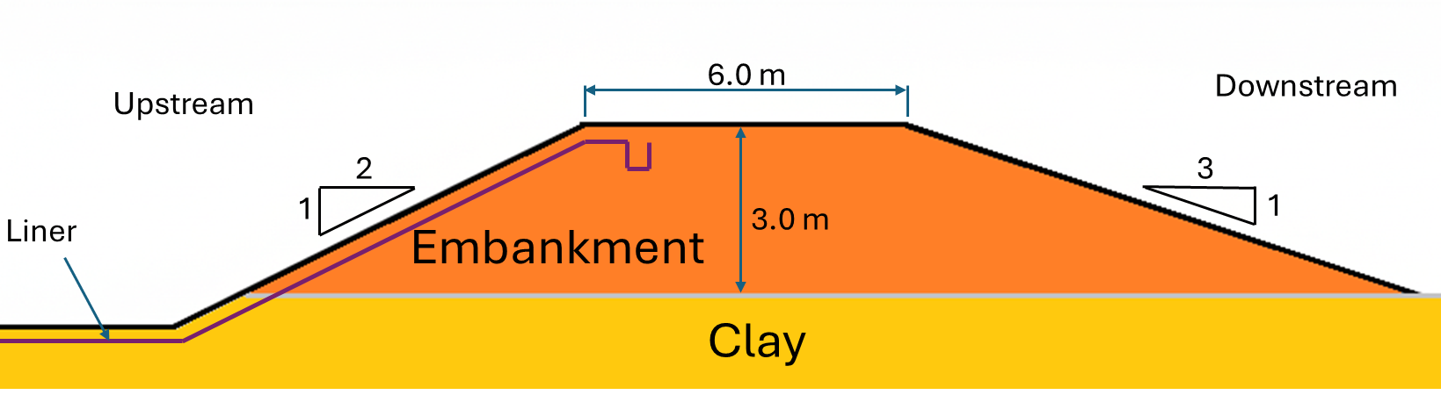
- Base case design’s cross-section

Contingency Planning: Pre-defined Design Modifications
Recognizing the significant uncertainties in the foundation conditions, a key element of the OM was to establish a set of pre-defined design modifications. These modifications consisted of alternative embankment cross-sections, superficial ground treatment and liner design to be implemented if the observed soil conditions deviated from the "most probable" case.
In terms of embankment geometry, the controlling factor is the undrained shear strength ratio of the foundation soils (s_{u}/σ’_{v}). Three main scenarios were considered:
- Favorable (s_{u}/σ’_{v} ≥ 0.5): A cross-section design with 2H:1V slopes on both sides would be used.
- Most Probable (0.3 < s_{u}/σ’_{v} < 0.5): Base case design’s cross-section would be used (as per Figure 1);
- Unfavorable (0.2 ≤ s_{u}/σ’_{v} ≤ 0.3): The exterior slope would be further flattened to 4H:1V and an interior slope remaining at 2H:1V, but adopting a rate of construction compatible with the increase of shear strength of the foundation soils due to partial consolidation.

IMPLEMENTATION AND RESULTS
Trigger Action Response Plans were put in place to implement this OM design during the construction of the dam. For such a long structure, the construction phase ended up being a dynamic process involving continuous investigation, observation, and design adaptation.

Construction Phase Geotechnical Investigations
As construction progressed, further geotechnical investigations were carried out along the axis of the embankment footprint wherever clays were found as the upper geotechnical unit. 53 in-situ vane shear tests (VST) (ASTM D2573) distributed at variable intervals between 50 m and 100 m were performed for a fast estimate of the undrained shear strength of the foundation soils.
While VST provided rapid strength assessment during construction, several limitations must be acknowledged when testing unsaturated soils with significant suction:
- The VST method was developed for saturated soils and may overestimate long-term strength in suction-enhanced soils due to apparent cohesion effects.
- Suction-induced strength is temporary and will decrease as the foundation soils approach saturation from brine infiltration.
- The test doesn't directly measure matric suction, making it difficult to separate the contributions of effective stress and suction to the measured strength.
Due to a high variability in the position of the phreatic surface and the existence of free draining pockets and lenses, the suction, preconsolidation pressure proved to be highly variable but, in most cases, the foundation clays were stronger than initially assumed. Given that this apparent high undrained shear strength is suction-induced, and that the spent brine will yield water to the foundation and reduce suction, a conservative approach was adopted, to cap the undrained shear strength ratio with a conservative estimate of drained strength s_{u}/σ’_{v} = 0.5. Therefore, all sectors deemed to be in “favourable” scenarios were designed with this capped shear strength ratio. VST results are shown in Figure 2.
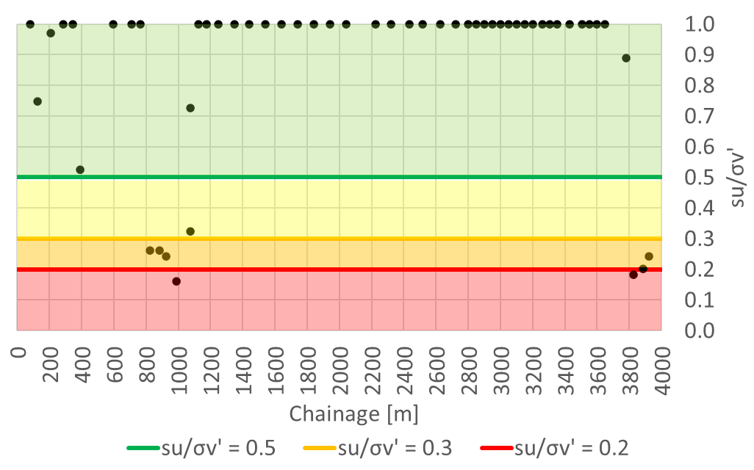
- VST results
This site investigation program, while crude and expeditive in nature, allowed for an ongoing data collection that enriched the body of available geotechnical data. Complemented by the observation of settlement during construction and of the overall behavior of the completed stages of the dam, it provided the information required to select the appropriate pre-defined cross-section for different segments of the dam.

Final Design
The VST results and the observations during the embankment construction confirmed the variability of the foundation conditions along the 4 km alignment. Consequently, the final design of the ring dam was not uniform.
The final design configuration incorporates two distinct cross-section profiles: one featuring 2H:1V slopes on both sides, and another with a 4H:1V exterior slope and a 2H:1V interior slope. Noticeably and perhaps surprisingly, the base case cross-section design with a 3H:1V outer slope, shown in Figure 1 was not employed in the ground.
This result is entirely driven by the preconsolidation and cementation of the superficial clay layers. It was already expected that all sectors founded on coarse soils would classify as “favourable”, but it was not expected that most of the clayley soils would be equaly strong, even after accounting for potential softening due to loss of suction.
Flattened slopes were required in areas where the VST recorded the lowest results (between chainages 800–1100 and 3800–4000, in turn controlled by a higher phreatic surface, see Figure 2. plus a safety margin on both sides. Overall, about 15% of the embankment was constructed with the flattened slope (4H:1V outer, 2H:1V inner slope). This tailored approach, a direct outcome of the OM, optimized the design by ensuring that the required level of safety was achieved everywhere without unnecessary conservatism. If a classical approach had been applied, a thorough ground investigation program would have been required, introducing a delay in the construction that was avoided by the old and well accepted OM. The savings were about 12% in volume of earthworks and several months in schedule.

LONG-TERM RISK MANAGEMENT AND MONITORING
To ensure the long-term safety and performance of the facility, a comprehensive risk management strategy was established. This strategy is centered around a robust monitoring system and a Trigger Action Response Plan (TARP).
The monitoring system is designed to track key performance indicators, such as pore water pressure and deformations, over the life of the dam. The TARP define specific trigger levels for these indicators. If a trigger level is reached, it initiates a pre-defined response, which could range from increased monitoring frequency to the implementation of further engineering works, such as additional earthworks.
This proactive approach to long-term risk management ensures that any potential issues can be identified and addressed before they can compromise the safety of the structure. This aligns with modern dam safety philosophies that emphasize the importance of ongoing monitoring and risk assessment throughout a dam's life cycle.
The monitoring program of the dam is expected to monitor the pore pressure along dam sections, which will provide the data required to trigger the implementation of mitigation measures (i.e., placement of filter/buttress material) in the event of unexpected conditions. The regular inspections of the SBDF during operation as specified in the Operating, Maintenance and Surveillance (OMS) manual will contribute to detect potential anomalies that could lead to internal piping. The TARP provides trigger levels and potential consequences, predefined actions, and persons to be notified for each trigger level. Following the MAC guidelines (MAC, 2021b), the following trigger levels (or risk levels) were defined:
- Abnormal operation: low risk. involves the execution of risk management measures predefined conditions or an increase in the frequency of monitoring and analysis.
- Moderate risk: Predefined risk management measures are implemented. They intensify surveillance activities, and the effectiveness of the risk management measure is verified applied.
- High risk: Depending on the potential consequences, safety measures are implemented. predefined risk management (e.g., temporary cessation of operations) or Action Plan During Emergencies.
On top of the monuments, standpipe piezometers and survey points installed along the dam during construction, five instrumented cross-sections were constructed along the embankment footprint, in sectors deemed representative of the prevalent ground conditions. Each cross-section contains six vibrating wire piezometers (VWP): three located upstream of the embankment, two in the foundation, and one within the embankment itself. Casagrande piezometers were installed to provide system redundancy. Prisms were also placed to monitor settlements both in the embankment and downstream at locations far enough away to serve as reference points for settlement measurements. Figure 3 shows a typical instru-mented cross-section.

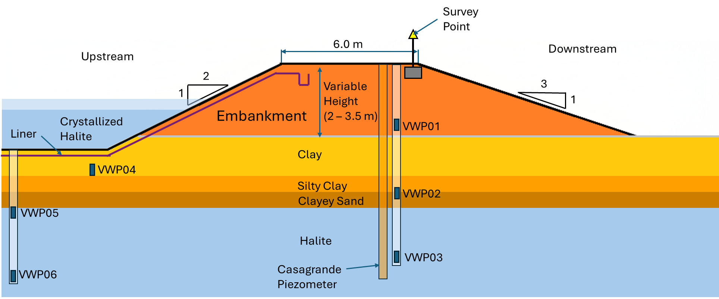
- Typical cross section showing ground model, dam geometry, liner, and instrumentation.

CONCLUSIONS
The application of the Observational Method to the construction of a spent brine tailings dam in the Puna region proved successful. In a project where time was of the essence, the Observational Method provided a framework to proceed with construction safely and efficiently, despite the initial lack of the geotechnical information that would be required to perform a conventional design.
The key to this success was the rigorous and systematic application of the method's core principles. The establishment of a clear base case design, coupled with a well-defined set of pre-planned contingencies, provided the necessary flexibility to adapt to the variable ground conditions. The continuous process of investigation, observation, and design review during construction ensured that the final structure was tailored to the actual conditions encountered, optimizing the design for both safety and economy.
This case study serves as a powerful illustration of the benefits of the Observational Method in modern geotechnical engineering. It demonstrates that, when applied correctly, the OM is not merely a "best way out" of unforeseen difficulties, but a proactive and powerful design philosophy that can be embraced from the inception of a project. By formally incorporating observation and adaptation into the design and construction process, it is possible to manage the inherent uncertainties of ground engineering, save precious time and resources, and deliver safe, reliable, and economical infrastructure. The successful construction of this critical tailings dam for the Salta lithium project stands as a testament to the enduring value of Ralph Peck's seminal contribution to our field.
Finally, this article does not present results on the performance of the embankment, as this information is still being compiled and interpreted. Also, at the time of presentation of the article, CPT tests were carried out in the three areas where ‘soft’ soil was observed to corroborate the results. A new paper will be published with all the monitoring data at a later date.

references
Peck, R B., 1969. Advantages and limitations of the observational method in applied soil mechanics. Ninth Rankine Lecture, Geotechnique, vol 19, no 2, pp 171-187.
Rocscience 2003. Slide, Stability Analysis for Soil and Rocks Slopes. User’s Guide. Geomechanics, Software Solutions. Rocscience Inc, St, Toronto, Canada.
MAC, 2021. Developing an Operation, Maintenance, and Surveillance Manual for Tailings and Water Management Facilities.
ASTM, 2018. D2573. Standard Test Method for Field Vane Shear Test in Saturated Fine-Grained Soils.

