Induction Tiling Puzzle:

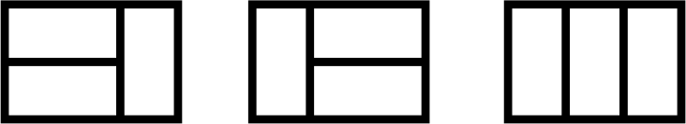

There are 3 distinct ways to tile a 2x3 board with 2x1 tiles.
How many distinct ways are there to tile 2x10 board with 2x1 tiles? Find a proof for the correctness of your answer.
Hint: consider at the Fibonacci sequence

