Tiling Puzzle

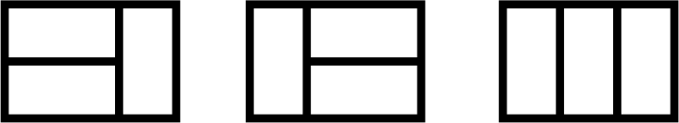

There are 3 distinct ways to tile a 2x3 board with 2x1 tiles.
How many distinct ways are there to tile 2x10 board with 2x1 tiles? Find a proof for the correctness of your answer.

Size | Number of Tilings
2 x 0
2 x 1
2 x 2
2 x 3 | 3
2 x 4
2 x 5
2 x 6
2 x 7
2 x 8
2 x 9
2 x 10

