12(3)4 Puzzle
Starting with a number n, you have two choices:

- You can subtract 3 from n:
n = n – 3

- You can multiply n by 2:
n = n * 2

You may repeat this process as many times as you like.

Starting from n = 1, can you reach n = 24? Either find a sequence of transitions using the rules above that gets you from 1 to 24, or prove that none exists.

Hint: Look for a pattern in what numbers can and can't be reached starting from 1 using these rules. Prove that this pattern always holds no matter how many times the rules are applied.

Chessboard Tiling Puzzle:
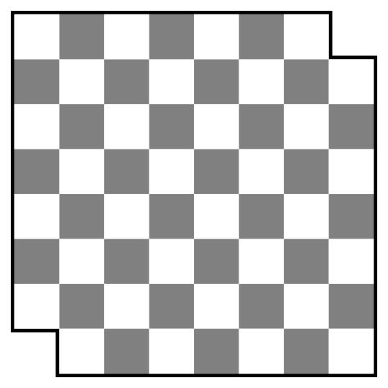

You have a chessboard (an 8x8 grid of checkered light and dark squares) which is missing its two dark corner squares, leaving 62 squares remaining. Can you tile this board with 2x1 tiles? Provide a tiling, or a proof that none exists.

In this problem, "tiling" means covering the board with tiles so that each tile covers two squares, each square is covered by a tile, and no tiles overlap or hang off the edge of the board.

Hint: use the fact that checkered pattern to your advantage.

