CAPSTONE PROJECT: MangoJR Library

**Design**

**Tables**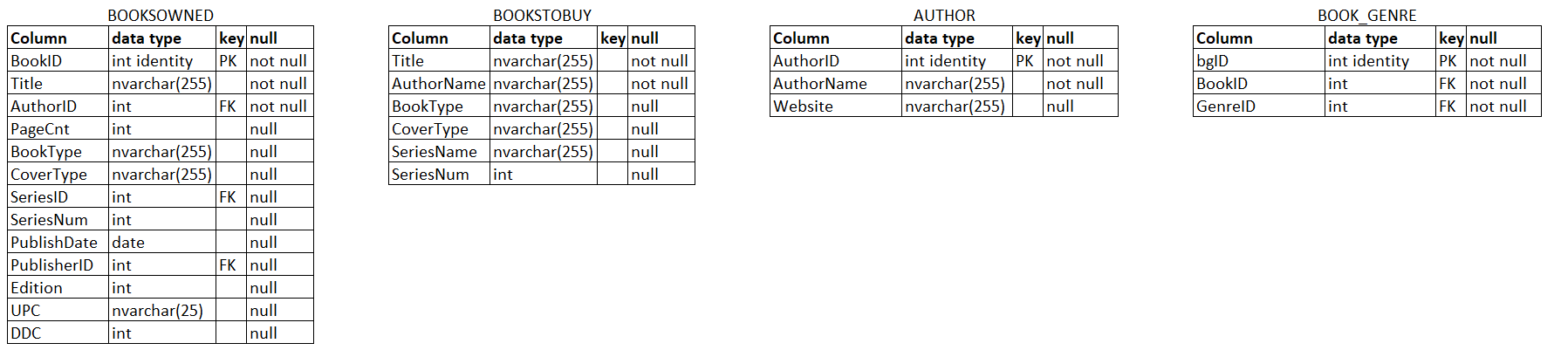

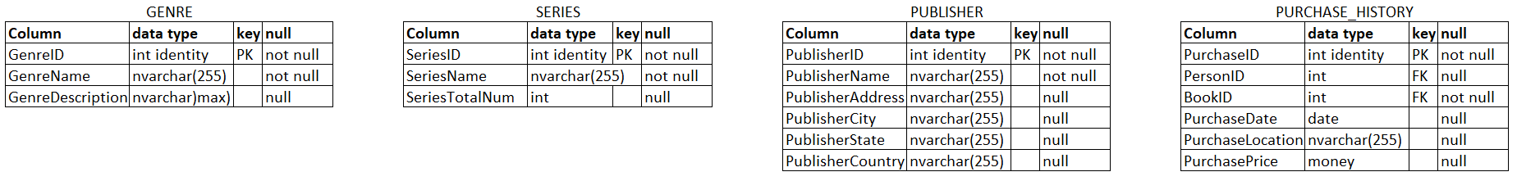

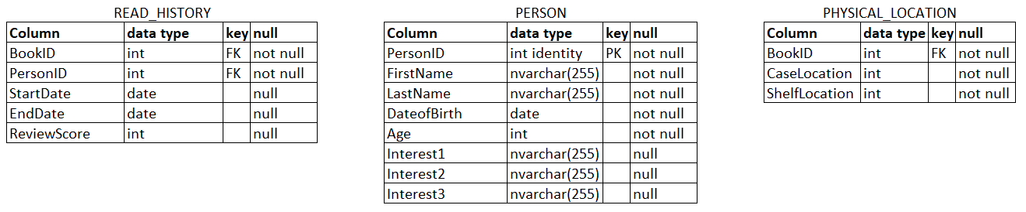

Book: information about the individual books

Author: information about the author

*Books with multiple authors have authors listed together in one entry

Book_Genre: connects the book with the genre information

Genre: information about the genres

Series: information about the series

Publisher: information about the publishers

Purchase_History: tracks the purchase history of the books in the library

Read_History: tracks the read history of the books in the library

Person: information about the people who use the library

Physical_Location: connects the book with physical location in the library

**Views**

dbo.BooksReadInLastYear: Pulls all read history from the last year

**Programmability**

Stored Procedures

Dbo.usp_BooksReadByPerson: Pulls list of books read by a person ID

Dbo.usp_LocationByGenre: Pulls list of locations based on genre ID

Dbo.usp_BooksByGenre: Pull list of books based on genre ID

**Security**

Users

Averym

Mattm

Eylam

Roles

Reader: access to tables with read and book information only

Granted to Eylam

Owner: access to tables with person, purchase, read and book information

Granted to Averym, Mattm

**Server Objects**

Linked Servers

Servers can be connected to another instance using linked servers.

However, this database does not currently have a need for this.

If another server and database were created that held similar information and the two wanted to be compared, this would be a useful way to do that.

**Backups**

Disaster Recovery Design

While the database is designed for home use, it is still susceptible to data loss and therefore will need backups and a disaster recovery plan.

The main idea is to have a weekly full backup along with daily log files saved to a local hard drive. Since there will not likely be large insertions of data at a time, this plan is inexpensive and should still provide adequate storage.

This design will be implemented using Maintenance Plans.

**SCRIPTS**

A: Create

1. Tables
2. Stored Procedures
3. Views

B: Insert

1. Data

C: Security

1. Give permissions
2. Create and assign roles

D: Backups

1. Create full and log backups
2. Schedule future full and log backups