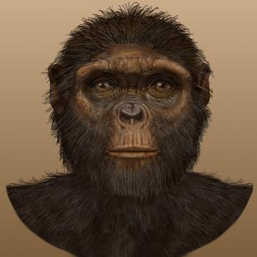

Howdy!

My name is Ardipithecus ramidus! I lived mostly in East Africa, and while I have a small brain, I am one of your ancestors! I’m a bit shorter, at only around 4 feet tall, but walked like you sometimes, on my own two feet. I could also swing through the trees. Isn’t that neat I could do both? Go check out my descendants, they have some cool information too!