**IF STATEMENTS:**

**Problem 1**: Create an if…elseif statement that outputs “number is small” if the number is less than or equal to five. If the number is between 6 and 20 (exclusive) output “the number is average”. If the number is greater than or equal to 20 output the number is “the number is large”.

If we test the if…elseif statement with x = 15, what would be the output?

**Problem 2:** What are the 6 equality & relational operators? -

**Problem 3:** What are the 2 conditional operators? -

**Problem 4:** Using the ternary operator output “Passed” or “Failed” based on the studentGrade(70). (A failing grade is 60).

**DEBUGGING IF STATEMENTS**

**Problem 1:**

(if x > 5)

x++;

else

x--;

**Problem 2:**

if (x > 5)

if(y > 5)

System.out.println(“x and y are > 5”)

else

System.out.println(“y is <= 5”)

**SWITCH STATEMENT**

**Problem 1:**  Using a switch statement take the grade input and display the corresponding letter grade.

**FOR LOOP**

**Problem 1:** Using a for loop output a table with numbers 1-20 & output if the number is even/odd

Ex. Index Even/Odd

1 Odd

2 Even

**WHILE LOOP**

**Problem 1:** Why use a while loop instead of a for loop?-

**Problem 2:** What is the difference between a while loop and a do-while loop?-

**Problem 3:** Write a do-while loop that outputs the number 1 through 5, with your counter as the loop sentinel. Change your initial value for counter to 6 & see what is output.

**Problem 4:** Inside a while loop, print out the even numbers between 0-20. Use a Boolean sentinel and break out the loop by changing the Boolean value.

**RANDOM & SCANNER**

**Problem 1:** Where should you place the random and scanner import statement? –

**Problem 2:** Receive 2 numbers from the user, generate a random number, output the random number to the user, add all 3 numbers & output the total.

**ARRAYS**

* Group of elements containing values of the same type
* Individual element accessed by its index
* Index starts at 0, last element would be length – 1
* Create array as follows:
  + int[] c = new int[4];
    - Array by the variable name “c” initialized it to size 4 (index 0-3)
  + int[] d = {0,1,2,3}
    - Array by the variable name “d” initialized with 4 values
* Use for loops to iterate through/manipulate arrays
* To print the array values:
  + for(int i = 0; i < array1.length; i++)
    - System.out.printf(“%d “, array1[i]);
* Use nested for loops to manipulate multidimensional arrays

**Problem 1:** Create an array (array1) with a length of 10. Fill it with random numbers (0-10). Total the array’s values, get an average then output the array, its total and its average.

**Problem 2:** Create a multidimensional array and {{1,2,3}, {4,5,6}}. Output the array in its rows and columns, total and average the values.

**Problem 3:** Re-create the array expansion.

**METHODS & CLASSES**

**Problem 1:** What are the two types of methods?-

**Problem 2:** What are the two things are needed to create a method?-

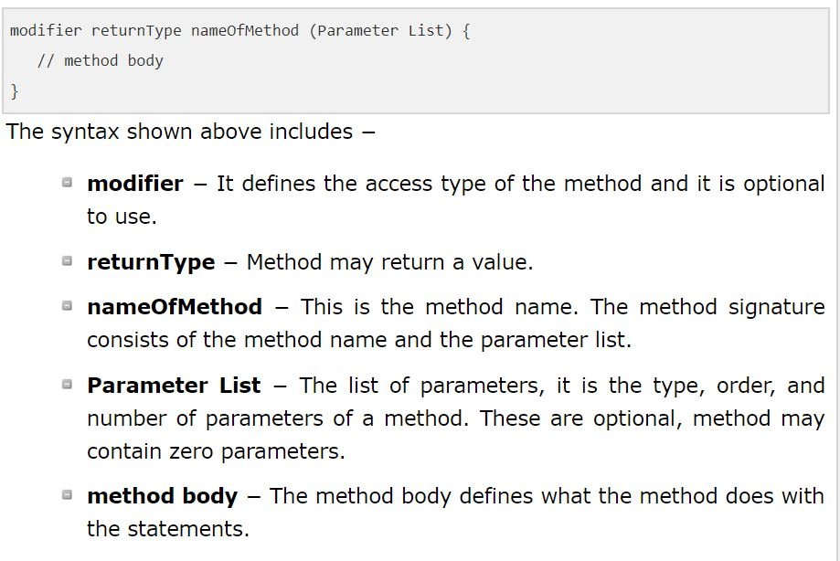

**Problem 3:** Why should you use methods and classes-

**Note: None-static vs static methods:** None static methods execute in response to method calls on specific objects, static methods perform tasks without depending on an object.

**Note: Methods can take multiple parameters**

**Problem 4:** Create a findMax method using 3 parameters. Find and return the max of the 3 integer arguments.

**Classes**

* Class declaration is: public class className{ }
* Constructors can be used to initialize data for the class
  + Constructor declaration is: public className(parameters are optional)
* Instance variables (attributes) should be declared private (encapsulation)
  + Get/set methods should be used to access the instance variables
* Classes must be in the same directory as the class containing the main method
  + Must create an instance of the class to use
    - Ex. Time2 t1 = new Time2();

**Problem 5:** (On paper) Create a student class that has instance variables for name, age, and major. Also create the get set methods for the variables. Create three parameters for the constructor(name,age,major).When creating an object of the class, set name to “Clark Kent”, age to 25, and degree to “Journalism”. Print out the values. Add one to his age and print out the new age.

**COMPOUNDING INTERESTS:**

Part 1.  You are a new graduate of the University of Houston-Clear Lake and you just landed your first job earning about $60K/year.  You vaguely recall one of your professors saying, 'You should start investing with your first pay check.'  He said something like, “10% or $500.00 a month for 40 years and you would be a millionaire.”

Use the Problem Solving Process to develop a Java Application that you will use to calculate the compounding-interest with a ***for*** loop.   You will use an interest rate of 6% (.06) and start with a principal investment of $2000.00 (That is what’s left from graduation gifts after putting money down on a new car).  You will run your code for 40 years and output annual totals.

Your compounding interest equation should look something like:

Principal = (Principal + (Monthly * 12)) * IntRate

Please re-write your application so that you can change the interest rate, allow for a different initial principal investment, and output the total amounts invested verses the total amount earned.

**FILE I/O**

* Review GradeLevelAssignment

**RECURSION**

What are the 3 conditions needed for recursion?-

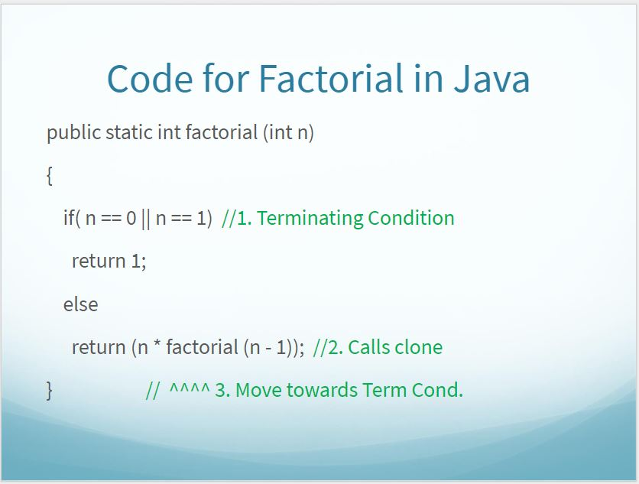

* Review factorial, Fibonacci, and palindrome code

**SORTING/SEARCHING**

* Insertion, Selection, Bubble Sort