Website Intentional Design (A1) Report

Avery Lee

Miguel Fernandez

Matthew Groover

Garrett Turner

August 21, 2023

**Link to Website**

<https://pet-rock-camp.com>

**Design Choices**

1. At least 5 real websites you found useful as examples, and what you chose to do similarly for each one

* <https://www.fetchpetcare.com/chicago/>

This page inspired some of the design behind our website’s home page. For instance, the idea of a curved border line was taken from here. We also modeled a similar call-to-action paragraph and listed reasons why our business is the best. However, this website lists their services on their home page; this seemed redundant to our team, so we instead included a button to take users to our services page.

* <https://dogcitynyc.com/about/blog/>

This website was used as inspiration for the ‘blog’ section of our website. The cards to hold the photo and information were modeled after this site, with the photo on the left and the title/author on the right. We chose not to follow their design for the articles themselves. We didn’t want the title behind the photo, as that could reduce readability, so we put it below instead.

1. What color palette you chose, and why those colors work well in this design

Our team used this color palette in our design. We drew inspiration from geography websites such as <https://www.geosociety.org/>, which use mostly natural colors for their pages. This gave us the brown and blue/green options. Furthermore, seafoam green is considered a very calming color; this aligned with our goal of conveying ease and trustworthiness to our users. The eggshell color was added to replace white, which can appear quite stark on web pages. Finally, we added coral-orange for a pop of color and a bit of contrast. Looking at the color wheel, we can see that teal and orange are on opposite sides; this makes them complementary colors, and thus perfect to add contrast.

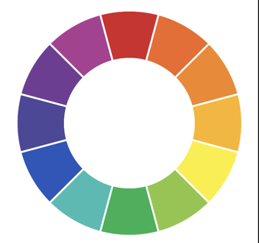

1. What fonts and sizes you chose, and why those work well in this design

We considered six different fonts for our site: Arial, Helvetica, Verdana, Times New Roman, Baskerville, and Didot. However, we ultimately chose to use the Verdana font throughout our web pages. The sans-serif design aligns with our goal of creating a minimalistic website. It is also a web-safe font; this means that it is already pre-installed on most devices and operating systems, allowing our pages to support localization to a wide variety of users. Finally, Verdana has slightly more kerning than its counterparts. This extra space makes it more readable, especially for small text.

Throughout our design, we use various font sizes, depending on the purpose. For titles and headers, we use large fonts. For paragraphs, the letters are much smaller. Additionally, we utilize bold and italic letters to draw the users’ eyes to specific parts of the text, such as the different responsibilities of each job under our ‘Careers’ tab. Our text also scales dynamically with the size of the display.

1. What layout you used, and why this works well in your design.

In general, we kept our page designs linear, so that they make sense as the user scrolls towards the bottom. Each one also includes our navigation bar. This allows people to jump between the various pages with ease; the site is thus easier to navigate and understand, which was a main goal in our user interface design.

1. Describe how your design works on both desktop and mobile screens. What changes do you make to the layout to make your site easy to use on small touch screens?

The elements of our website scale depending on the size of the display. When a user shrinks their window or views the site on a mobile device, then, the components shrink as well. On small touch screens, everything is condensed to the center of the screen. This means that users must scroll down through the page, but not sideways to see all our components. Finally, we made our navigation bar dynamic for different-sized pages. On smaller display windows, the various tabs are replaced with a hamburger menu; this provides the navigation functionality without having to squash the tabs into a small heading.