BECA / Huson / 10.3 Geometry Name:

Classwork 3.9: Systems of Linear Inequalities - WORD PROBLEMS Wednesday

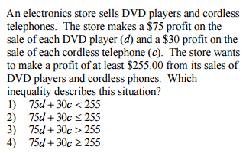

1.

a. What key word told you to pick the inequality that you did?

*For #2-4, create a system of inequalities that models the following situations. Define your variables. Do NOT solve (yet!)*

2. You can work at most 20 hours next week. You need to earn at least $92 to cover your weekly expenses. Your dog-walking job pays $7.50 per hour and your job as a library assistant pays $8 per hour. Write a system of linear inequalities to model the situation.

*Let x = Let y =*

*“Money” Inequality: ________________________________*

*“# of Hours” Inequality:* ________________________________

3. Jocelyn is going to the store to buy candles for her quinceanera. Small candles cost $3.50 and large candles cost $5.00. She needs to buy at least 30 candles, and she cannot spend more than $80. Write a system of linear inequalities that represents the situation.

Inequality #1: ________________________________

Inequality #2: _________________________________

4. Elkin is packing books into boxes. Each box can hold either 15 small books or 8 large books. He needs to pack at least 35 boxes and at least 350 books. Write a system of linear inequalities to represent the situation.

Inequality #1: ________________________________

Inequality #2: _________________________________

**MEDIUM**

5. BECA’s IB Film class is looking to show one of their final films at Concourse Plaza Multiplex Cinemas on 161st. The theater has 200 seats. The film class would sell adult tickets for $12.50 and child tickets for $6.25. Their goal is to sell at least $1500 worth of tickets, to put toward an end-of-year field trip.

1. Write a system of linear inequalities that can be used to find the possible combinations of adult tickets, x, and child tickets, y, that would satisfy the cinema’s goal.
2. Rearrange the inequalities (solve for y):
3. Graph the solution to this system of inequalities on the axes below.

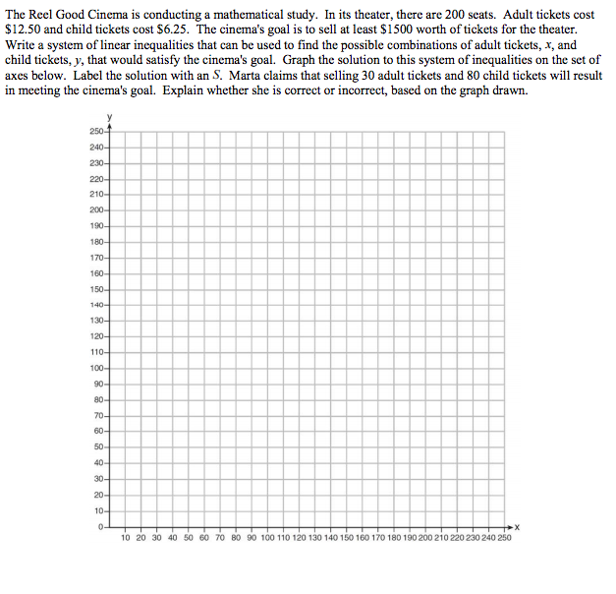

1. Ms. Navalany claims that selling 30 adult tickets and 80 child tickets will result in meeting the cinema’s goal. Explain whether she is correct or incorrect, based on the graph drawn.

**3.9 SPICY**

6. Student Council is planning this year’s talent show and is selling tickets for $3 for students and $6 for adults. The student council must bring in at least $480 in sales to make a profit. The auditorium has a maximum capacity of 120 seats. Let *x* represent the number of student tickets and *y* represent the number of adult tickets.

1. Write the system of inequalities representing this situation.
2. Rearrange the inequalities in order to graph (isolate y).
3. Graph the system of inequalities below. Create an appropriate scale.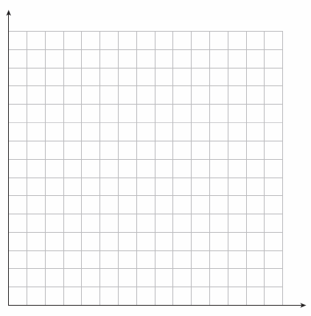
4. If 20 adults come to the show, how many students must come to reach the desired amount of sales? Use the graph to determine a solution.