BECA / Huson / 10.3 Geometry Name:

5 December 2018

**Classwork 3.4: Solving Systems of Equations Using Elimination**

When equations are written in _________________ form (Ax + By = C), _________________ is the most efficient method to use to solve.

*\*Goal to Eliminate EITHER variable: ____________ coefficients/variable (4x & 4x)*

*____________ signs (+/-)*

Solve the following systems of equations using the Elimination Method:

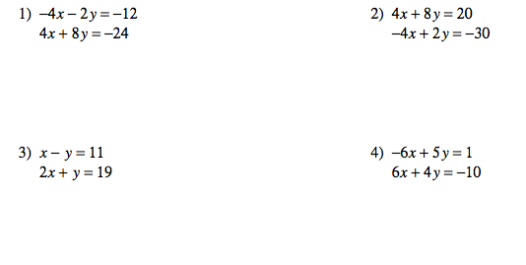

Solution: ____________ Solution: ____________

Solution: ____________ Solution: ____________

**LEVEL 2 - EXAMPLE**:

5) -4x + 9y = 9 → 6) ___ (-7x + y = -19) →

___ ( x - 3y = -6 ) → -2x + 3y = -19 →

Solution: _________ Solution: __________

7) ____ ( -3x + 7y = -16) → 8) 16x - 10y = 10

-9x + 5y = 16 -8x - 6y = 6

Solution: ____________ Solution: ____________

**\*Challenge**: What would you have to manipulate in order to “eliminate” a variable in the following system?

3x - 2y = 2

5x - 5y = 1

Solution: ____________

BECA / Huson / 10.3 Geometry Name:

5 December 2018

**Homework 3.4: Solving Systems of Equations Using Elimination**

