BECA / Huson / 10.3 Geometry Name:

**Classwork: Number Classification**

***Part 1:*** Add numerical examples to the following number classification flow-chart: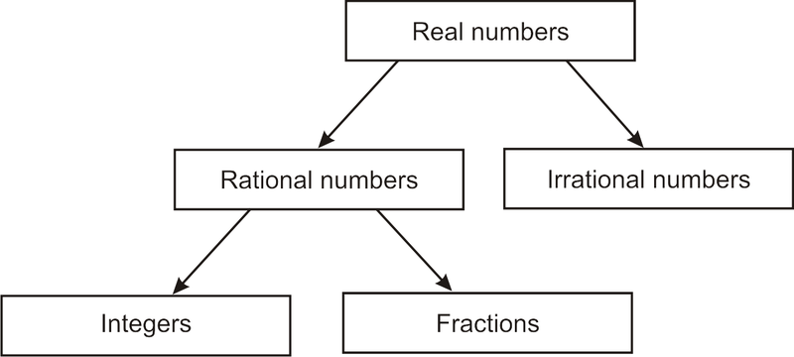

***Part 2:*** *Fill out the table below, characterizing each number as either rational or irrational:*

|  |  |  |  |
| --- | --- | --- | --- |
| **#** | **Simplified Answer**  **(use calculator)** | **Rational Number** | **Irrational Number** |
| *Example*) $8+\frac{2}{3}$ | *8.666666… = $8\frac{2}{3}$* | ✓ |  |
| 1) 14 |  |  |  |
| 2) $-\frac{2}{5}$ |  |  |  |
| 3) $\sqrt{5}$ |  |  |  |
| 4) $6∙6$ |  |  |  |
| 5) 6 ¾ + 2 ¾ |  |  |  |
| 6) -12.5 + 2 $π$ |  |  |  |
| 7) $-12∙0$ |  |  |  |
| 8) $12∙\sqrt{2}$ |  |  |  |
| 9) 1 + $3\frac{1}{3}$ |  |  |  |
| 10) $4∙π$ |  |  |  |
| 11) $\frac{1}{\sqrt{2}}∙\frac{1}{\sqrt{2}}$ |  |  |  |
| 12) $\sqrt{4}+\sqrt{16}$ |  |  |  |

***Part 3. Regents Review Practice***

1. Is the product of $3\sqrt{2}$ and $4\sqrt{2}$ rational or irrational? Explain your answer.
2. Is the sum of 4 and $\sqrt{5}$ rational or irrational? Explain your answer.

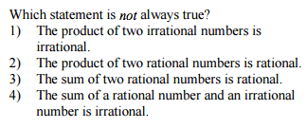

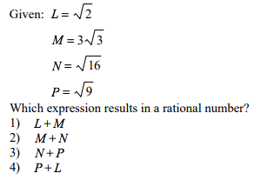

4.

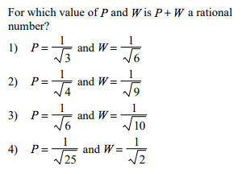

5.