**4.3 Homework: SAS and SSS Practice**

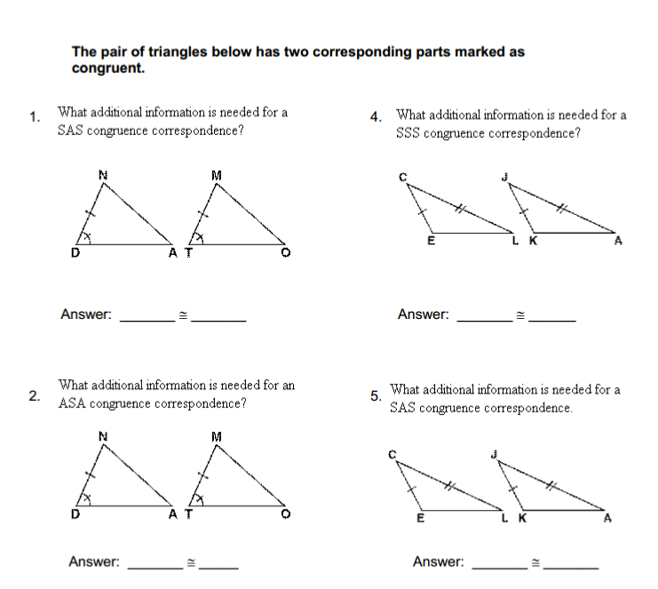Part 1:

  
Part 2:

1. Mark up the triangles with the given information
2. State if you can prove the triangles congruent
3. State how you know they are congruent (SAS or SSS)

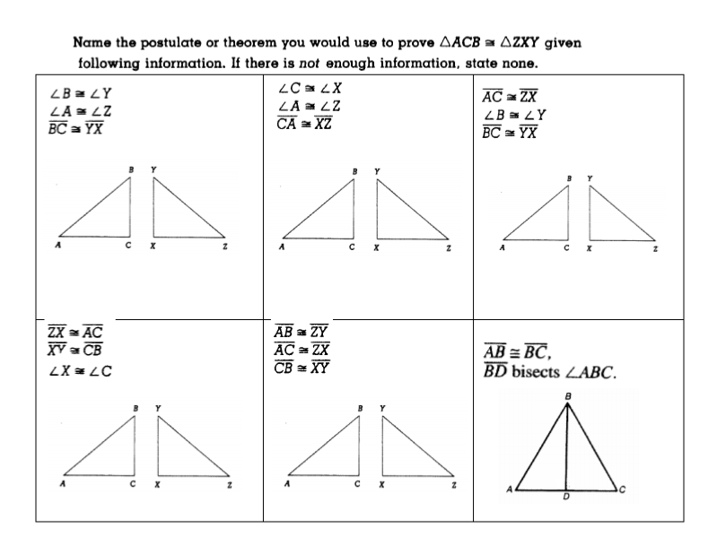 

 

Part 3:

