* 1. Segment Addition Postulate Classwork & HW

*10 points*

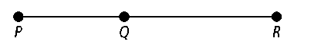**For Exercises 1–5, use the figure at the right.**

**1.** If *PQ* = 7 and *QR* = 10, then *PR* = .

**2.** If *PQ* = 20 and *QR* = 22, then *PR* = .

**3.** If *PR* = 25 and *PQ* = 12, then *QR* = .

**4.** If *PR* = 19 and *QR* = 12, then *PQ* = *.*

**5.** If *PR* = 10 and *PQ* = 4, then *QR* = .

**6. Reasoning** Points *A, Q,* and *O* are collinear. *AO* = 10, *AQ* = 15, and   
*OQ* = 5. What does the line have to look like and what is the position of each point? Draw it.

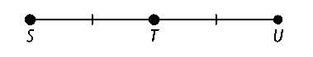**For Exercises 7 and 8, use the figure at the right.**

**7.** Given: *ST* = 3*x* + 3 and *TU* = 2*x* + 9.

**a.** What is the value of *ST?*

**b.** What is the value of *TU?*

**8.** Given: *ST* = *x* + 3 and *TU* = 4*x* − 6.

**a.** What is the value of *ST?*

**b.** What is the value of *SU?*

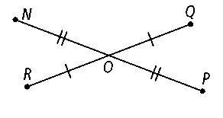**Use the diagram at the right for Exercises 9–10.**

**9.** If *NO* = 17 and *NP =* 5*x −* 6, find the value of *x.*

Then find *NP* and *OP.*

**10.** If *RO =* 6 + *x* and *OQ =* 2*x +* 1, find the value of *x.* Then find *RO, OQ,* and *RQ.*